Local Stop Smoking Services in Oxfordshire – A Potted History

Note – This is supporting information only to assist suppliers with the Invitation to Tender (ITT) but will not form part of the Contract)

1. Background - In May 2020, Oxfordshire County Council (the Council) issued an invitation to have a conversation with suppliers in the market to help develop the future delivery model of a Local Stop Smoking Service (the Service). In doing so it shared a document that aimed to give suppliers access to a curated library of local data and insight on smoking and tobacco control in Oxfordshire:
Feedback from suppliers during the video-based conversation via Microsoft Teams with the Council on either Wednesday 17th or Thursday 18th June 2020 was a request that, prior to the planned Invitation to Tender (ITT) in the summer 2020, additional historic Service activity level details were summarised and shared with the market to assist with the activity profiling during the tender. This paper therefore aims to summarise key Service activity, primarily since April 2013, when the Council took over the role of providing the Service under the Health and Social Care Act 2012.

2. A Brief Potted History
- April 2013 to March 2015 – From 1st April 2013 Oxford Health NHS Foundation Trust retained the core Contract, initially awarded under the then Primary Care Trust, to provide a universal specialist Service until 31st March 2015. In 2014, a pilot with Solutions4Health Ltd. provided additional specialist targeted community outreach until 31st March 2015. In addition to the specialist Services, there was also Local Enhanced Services with Primary Care settings (GP and Community Pharmacy) to provide access to behavioural support and pharmacotherapy between 1st April 2013 and 31st March 2014.

- April 2014 to March 2018 – On 1st April 2014 an Approved Provider List Framework Agreement with Primary Care settings (GPs and Community Pharmacies) was let to continue to provide access to behavioural support and pharmacotherapy under Call-off Contracts. In the last year (2017/18), 70 (out of the 71) GP providers and 88 (out of 116) Community Pharmacies held a Call-off Contract to provide the Service under the Agreements. These Call-off Contracts expired on 31st March 2018 and were not retendered by the Council from 1st April 2018 following a period of public and stakeholder engagement/consultation that changed the Service delivery model, a summary of this process can be found here. Note that from 2016/17, activity recording within these Primary Care settings was moved from paper-based monitoring forms to electronic forms via EMIS for GP’s and PharmOutcomes by Community Pharmacies. On 1st April 2015, Solutions4Health Ltd. (trading as Smokefreelife Oxfordshire) were successfully awarded a Contract to provide a universal specialist Service that included the provision of training and support to the Primary Care settings. This Contract expired on 31st March 2018 due to the changed Service delivery model (as outlined above) from 1st April 2018.

- April 2018 to March 2021 – On 1st April 2018, Solutions4Health Ltd. (still trading as Smokefreelife Oxfordshire) were successfully awarded a new Contract to continue to provide a universal specialist Service but with an aim to ensure those in priority populations are now offered the most effective type of support (face-to-face) to maximise reductions in health inequalities. Priority populations include children and young people, pregnant women, people with mental health problems, those with drug and alcohol dependency, routine and manual workers and those living with long term conditions. As part of this Contract, Solutions4Health Ltd. sub-contracted with 8 GPs from 1st April 2018 under a Service Level Agreement (SLA) to continue to provide access to behavioural support and pharmacotherapy, these SLA’s were all ended by 31st August 2019. Note that since April 2018, GPs in Oxfordshire have been no longer able to prescribe stop smoking pharmacotherapy without that GP practice being sub-contracted to provide the behavioural support under an SLA with Solutions4Health Ltd. (see here). Varenicline (Champix) is currently provided by Solutions4Health Ltd. using on a Patient Group Directive (PGD) and SLA with Community Pharmacies. There were initially 15 signed up to provide this but as of April 2020, this is now 5. Since May 2020, the recording of activity (and associated invoicing) under the PGD/SLA by Community Pharmacies is provided on PharmOutcomes.

3. Oxfordshire Primary (GP and Community Pharmacy) and Secondary Care Settings - In this area, the Integrated Care System (ICS) covers Buckinghamshire, Oxfordshire and Berkshire West; otherwise referred to as BOB. This report on Improving Health and Care in Buckinghamshire Oxfordshire and Berkshire West describes the range of organisations involved in the BOB ICS, how they work together and how they are developing their priorities and plans for the next five years.

As of April 2020, within Oxfordshire Clinical Commissioning Group there were 69 GP Practices (see further details here) and 19 newly formed Primary Care Networks. There are also four GP Federations; Principal Medical Limited, Oxford Federation (OxFed), Abingdon Federation and South East Oxfordshire (SEOx) Federation. There is the Berkshire, Buckinghamshire and Oxfordshire Local Medical Committee (BBOLMC) that represent the GP Practices in Oxfordshire.

The 2018 Oxfordshire Pharmaceutical Needs Assessment outlined that there were 98 standard Community Pharmacies, 12 100 hours’ Community Pharmacies, 2 distance selling / internet pharmacy, 1 dispensing appliance contractor and 25 dispensing GP Practices. There is the Pharmacy Thames Valley Local Pharmaceutical Committee that represents the Community Pharmacies in Oxfordshire.
There are two NHS Trusts in Oxfordshire with Oxford Health NHS Foundation Trust and Oxford University Hospitals NHS Foundation Trust providing acute hospital (including maternity) and community care (including mental health) services. Oxford Health NHS Foundation Trust is made up of four hospitals - the John Radcliffe Hospital, the Churchill Hospital and the Nuffield Orthopaedic Centre, all located in Oxford City, and the Horton General Hospital in Banbury, north Oxfordshire. Oxford Health NHS Foundation Trust have the Here for Health Centre, this is a Health Improvement Advice Centre for patients, staff and visitors and currently includes provision of the Service.

4. Referral Activity – The incumbent Service Provider (Solutions4Health Ltd.) produce Quarterly Service Quality Performance Reports for Contract Review purposes. The table below summarises the number of Service Users referred into the Service between 2018/19 and 2019/20.

Year | Indicator | Quarter 1 | Quarter 2 | Quarter 3 | Quarter 4 | Total
2019/20 | Number of Service Users referred into the Service | 1143 | 1085 | 1186 | 1324 | 4738
2018/19 |  | 351 | 755 | 814 | 864 | 2784

5. Trend in Service Activity – The graph below summarises the number of Service Users successfully quitting at four weeks delivered by the Service compared to the target set by the Primary Care Trust (2003/04 to 2013/14) and the Council (2013/14 to 2019/20).

6. Service Activity and Service Spend - The table below summarises the number of Service Users setting a quit date, successfully quitting at four weeks, spend of pharmacotherapy and Service delivery between 2016/17 and 2019/20

Year | Setting a quit date | Target set successful quits at four weeks | Actual successful quits at four weeks | Pharmacotherapy Spend Only | Service Delivery Spend (Not including Pharmacotherapy Spend) | Total Spend
2016/17 | 5024 | 3650 | 2037 | £360,090 | £423,338 | £783,428
2017/18 | 4060 | 3650 | 1569 | £348,443 | £400,272 | £749,155
2018/19 | 3018 | 2000 | 2000 | £110,000 | £333,000 | £443,000
2019/20 | 2815 | 2000 | 1952 | £72,666 | £438,443 | £511,109

7. Stop Smoking Services Quarterly Return - The Stop Smoking Services Quarterly Return is a Public Health England (PHE) central return used to monitor the delivery of Stop Smoking Services (prior to 1 April 2013 this was a Department of Health (DH) return). The return is collected from Local Authorities by NHS Digital (formerly the HSCIC). The following tables include extracts from the return between 2017/18 and 2019/20.

7.1 Pregnant Women - Breakdown of number of pregnant Service Users setting a quit date and successfully quitting at four weeks during 2017/18 to 2019/20 as reported to NHS Digital by the Council:

2017/18 | 2018/19 | 2019/20
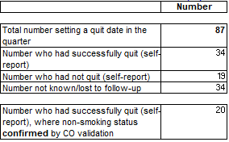 | 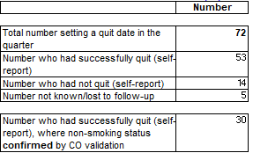 | 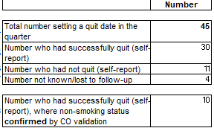

7.2 Free Prescriptions - Breakdown of number of Service Users receiving free prescriptions setting a quit date and successfully quitting at four weeks during 2017/18 to 2019/20 as reported to NHS Digital by the Council:

2017/18 | 2018/19 | 2019/20
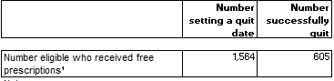 | 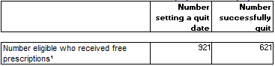 | 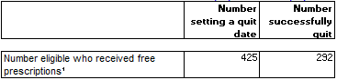

7.3 Intervention Type - Breakdown of number of Service Users setting a quit date and successfully quitting at four weeks by Intervention Type during 2017/18 to 2019/20 as reported to NHS Digital by the Council:

2017/18 | 2018/19 | 2019/20
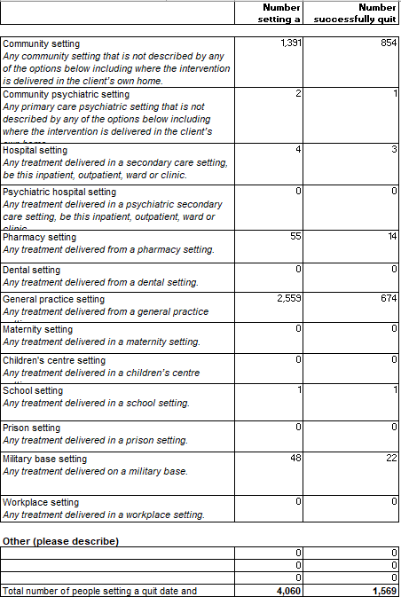 | 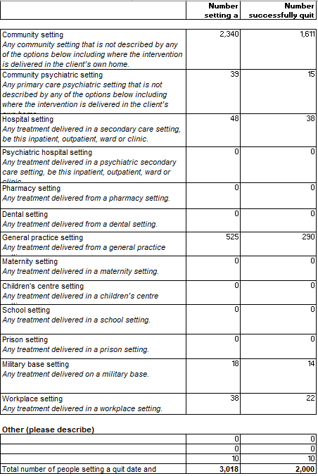 | 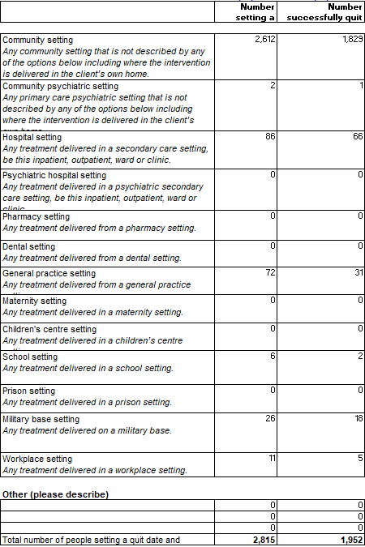

7.4 Intervention Setting - Breakdown of number of Service Users setting a quit date with the Service and successfully quitting at four weeks by Intervention Setting during 2017/18 to 2019/20 as reported to NHS Digital by the Council:

2017/18 | 2018/19 | 2019/20
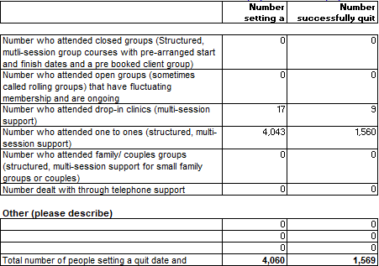 | 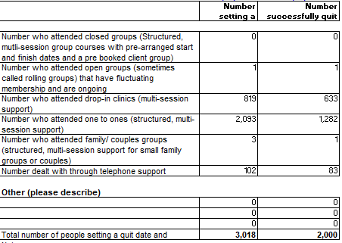 | 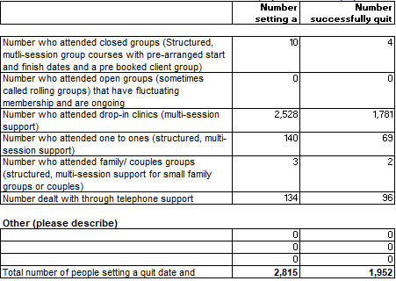

7.5 Socio-Economic Classifications - Breakdown of number of Service Users setting a quit date with the Service and successfully quitting at four weeks by Socio-Economic Classifications during 2017/18 to 2019/20 as reported to NHS Digital by the Council:

2017/18 | 2018/19 | 2019/20
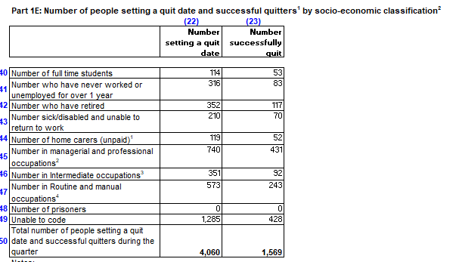 | 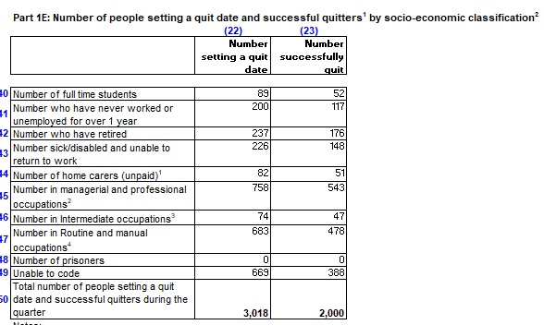 | 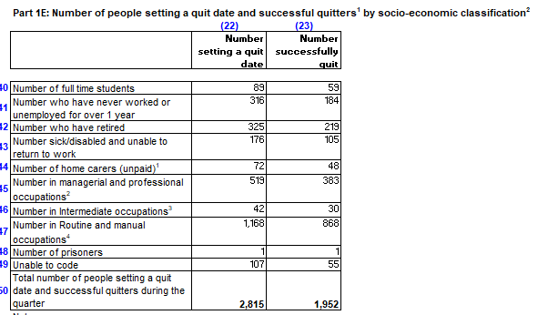

7.6 Pharmacotherapy Type - Breakdown of number of Service Users setting a quit date with the Service and successfully quitting at four weeks by pharmacotherapy type 2017/18 to 2019/20 as reported to NHS Digital by the Council:

2017/18 | 2018/19 | 2019/20
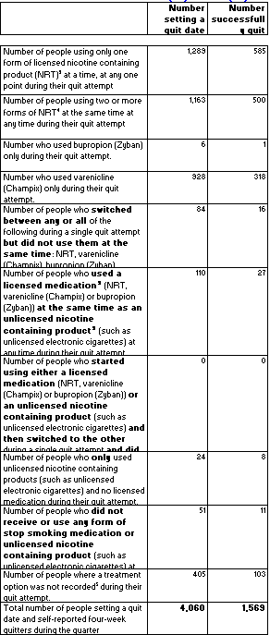 | 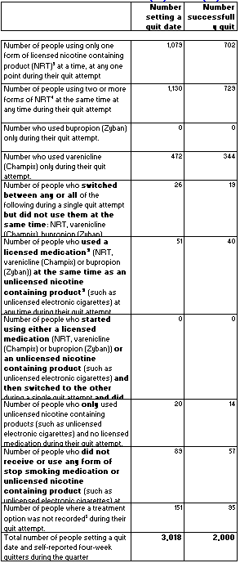 | 