QUOTATION REQUEST FOR SUPPLY, INSTALLATION OF A BUNDED FUEL TANK - GOSPORT
Gosport Borough Council invites quotations to supply and install an above ground 2000 L bunded fuel tank to include a fuel dispensing system.
GENERAL CONSIDERATIONS
The contractor must take the physical constraints of the works locations into account when submitting their quotation.
The works are required to be completed within 4 weeks following project award.
Services
It is not envisaged that underground services will be disturbed by these works.
The contractor is to satisfy themselves that the appropriate energy supply to the tank is available.
Materials
All materials are to be supplied by the contractor and should conform to relevant BS EN standards or equivalent.
The contractor shall be responsible for calculating required quantities.
The contractor will specify the materials to be used within their returned quotation. The specified materials will be installed as specified by the manufacturer or industry good practice to produce the required outcomes.
Site Safety
Please include site risk assessment for the works detailing how public and employee safety will be maintained during the works and including relevant PPE.
Note - the Risk assessment should also include covid-19 social distancing guidance.
Documents
The contractor shall provide evidence of Public Liability Insurance with minimum cover of £5 million along with employer’s liability insurance, appropriate industry accreditation for these works along with a valid waste carriers licence with details for the disposal of the waste generated by these works or a valid trade waste agreement.

DETAIL OF REQUIRED WORKS
Site information
Grange Farm, Little Woodham Lane, Gosport PO13 8AB
Maps
Overview of location of Grange Farm – marked by the red filled circle.
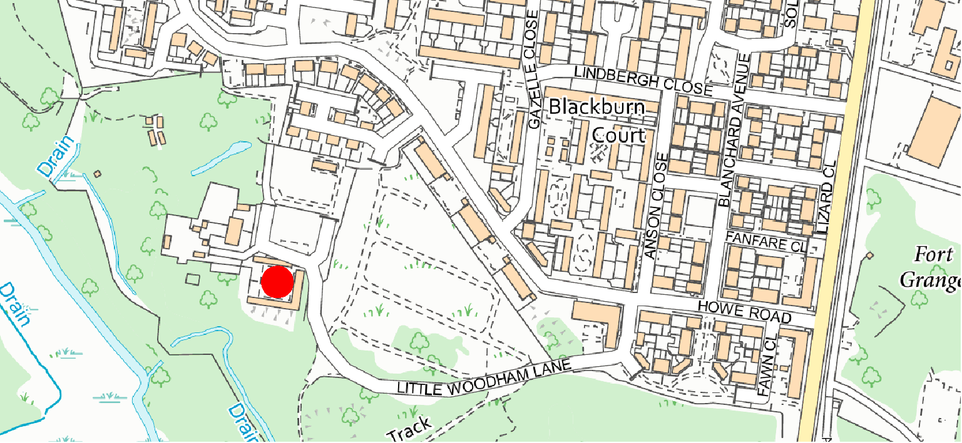
Detail of location for installation.
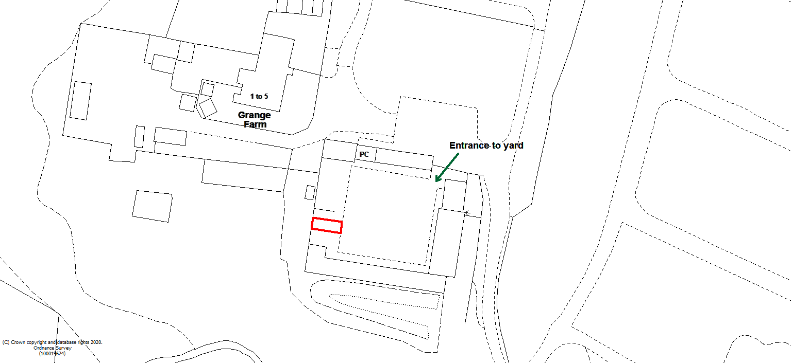

Requirements
- Supply 1 no. above ground dispensing bunded fuel tank with a 2000 L capacity and a keypad fuel dispensing system.
- Install Fuel Tank and system on concrete surface in the location detailed above.

QUOTATION PROCESS
Please return quotes through the South East Business Portal, also known as Proactis, and break the quote down to show cost of materials and labour, this must be your full and final price.
Please also supply the documentation requested above and two testimonials of previous projects of this nature.
Quotes are to be returned by 22nd April 2021.
Evaluation
These works will be awarded on best value price, provided the quotation covers all of the required considerations detailed above and evidence of previous successfully completed works of this nature.
.

