Request for Quotation (RFQ)

for the service provision of

On-Street Electric Vehicle Charge Points

Ref DDCEV01

Issue Date: November 2019

Return Date: 9th December 2019
Daventry District Council
Lodge Road
Daventry
Northampton
NN11 4FP

Version | Date
Dv06 | 26.2.2019

CONTENTS

- Preamble

- Award Criteria

- Specification

- Supplier Questionnaire

- Contract Specific Questionnaire

- Pricing Schedule

- Form of Quotation and Quotation Certificate

- Supporting Documents

8.1 List of Drawings
8.2 Schedule of Known Hazards

8.3 Service Information

8.4 Section 50 Licence Application Form

GLOSSARY OF KEY TERMS

Detailed descriptions of the proposed contract, together with formal definitions of the most important terms and phrases, are given in the rest of the document and in the enclosed Conditions of Contract. For Contractors’ convenience, however, the following key terms, which are used throughout this documentation, are defined as thus:

Commencement Date | Commencement date of the Contract
Conditions of Contract | The Conditions of Contract shall be the Standard Conditions for the Supply of Goods and Services to Daventry District plus the additional clauses listed below.
Contract | The Contract entered into between the Employer and the Contractor comprising the Conditions of the Contract, RFQ Specification and Quote.
Contract Term | Five Weeks
Contractor | The appointed Contractor
Employer | Daventry District Council
Employer’s Requirements | The information set out in the Specification that specifies the requirements of the Employer.
Request for Quotation (RFQ) | This suite of documents inviting suitable Contractors to participate in this procurement process
Management Information | Files, usage records, changing information, and such other management information, as the Contractor is obliged to provide to the Employer
Pricing Schedule | The prices, fees and rates as detailed in the Contractor’s quote, to represent the Contractor’s financial offer to provide the requirements as set out in compliance with the Works Information
Quote | The Quote submitted by a Contractor in response to this RFQ.
Services | The detailed description of the Services required by the Employer
SMEs | Small and medium sized enterprises
Specification | Information herein referred in Section 3 of this RFQ, and supplied herewith
Supplier | A contractor submitting a quote to the employer

1 - PREAMBLE

- GENERAL REQUIREMENTS

Quotations are invited for the supply of On-Street Electric Vehicle Charge Points at three identified locations in Daventry District – Long Buckby, Welford and Woodford Halse. The chargepoints should be Fast AC 7kW dual points

The project is intended to be largely funded through the Office for Low Emission Vehicles (OLEV) On-street Residential Chargepoint grant Scheme (ORCS) which if successful will provide 75% funding towards capital costs up to a maximum of £7,500. Where available the Council will be looking for the successful contractor to provide the remaining funding. The chargepoints will be operated on a fully commercial basis with all future maintenance responsibilities with the contractor. The contractor will be required to enter into a licence agreement with Northamptonshire County Council to operate the equipment within the public highway.

The Council’s detailed requirements are defined in the Specification.

- PROCUREMENT TIMETABLE

The Council proposes to follow the timetable below, but reserves the right to depart from it at any time.

Stage | Date
Issue of quotation | 11 Nov 2019
Last date for submission of queries | 02 Dec 2019 17:00
Closing date (& time) for returns | 09 Dec 2019 17:00
Evaluation to be completed by | 18 Dec 2019
Contract awarded | 20 Dec 2019
Contract start date For installation works (Assuming 5 week installation period) | Not later than 24 Feb 2020
Contract completion date | 31 Mar 2020

- SUBMISSION OF QUOTATION

Quotations, which should be received no later than 09 December 2019 17:00 and any queries, should be addressed via the portal link. Final date to receive queries should be no later than 02 December 2019 17:00.

- FREEDOM OF INFORMATION

The Supplier recognises that the Employer has information disclosure obligations under the Freedom of Information Act 2010 (“FOIA”) and the Environmental Information Regulations (“EIR”).

The Supplier acknowledges the Employer may be obliged under the FOIA or EIR to disclose information to third parties, including information relating to the appointment of the Supplier to provide the Services under this Agreement, and the terms of this Agreement, subject to certain exemptions. The Supplier further acknowledges and accepts that the decision to disclose information and the application of any such exemptions under the FOIA or EIR will be at the Employer’s sole discretion provided that the Employer shall act reasonably and proportionately in determining whether any exemptions under the FOIA or EIR may apply to protect the Supplier’s legitimate commercial interests trade secrets.

- OPEN DATA PROVISION

The Supplier acknowledges that the Employer has information publication obligations under the Local Government Transparency Code 2015, and agrees that this Agreement (including the Schedules), and any documentation including but not limited to this RFQ, the Quote (the “Procurement Documents”) are not confidential information, and may be published by the Employer, save where in the reasonable opinion of the Employer the contents of the Agreement or the Procurement Documents are exempt from disclosure under the FOIA or EIR in which case, the Supplier consents to the Agreement or Procurement Documents being redacted by the Employer to the extent necessary to remove or obscure the exempt content, and to publication subject to those redactions.

- CONFIDENTIALITY

- All documentation or information issued by the Council shall be treated as private and confidential for use only in connection with any resulting contract and shall not be disclosed in whole or in part to any third party without the prior written consent of the Council.

- The documents which constitute the Contract and all copies thereof are and shall remain the property of the Council and must not be copied or reproduced in whole or in part and must be returned to the Council upon demand.

- TERMS AND CONDITIONS

- The Conditions of Contract shall be the Standard Conditions for the Supply of Goods and Services to Daventry District plus the additional clauses listed below.
- A copy of the Standard Conditions for the Supply of Goods and Services to Daventry District is provided as a separate document to accompany this RFQ

- Alternatively a copy of the Standard Conditions for the Supply of Goods and Services to Daventry District Council are available on Daventry District Council’s website https://www.daventrydc.gov.uk/business/procurement

ADDITIONAL CONDITIONS OF CONTRACT

  - Client Contract Manager
The Client Contract Manager is Steve Whelton
Telephone 01327 302445
E-mail address swhelton@daventrydc.gov.uk

7.2 Certificate of Completion
The Certificate of Completion shall be issued by the Council and will certify that the work has been completed satisfactorily. The certificate shall include a date, the Date of Completion which is the date that the Council is satisfied that the work was completed satisfactorily.
  - Defects Correction Period
The defects correction period is for one calendar year after the Date of Completion of the works.
During the defects correction period, the contractor shall remain liable for any defects in construction and/or materials which come to light and shall repair, replace or otherwise correct defects within 2 weeks of receiving notification.

By submitting a Quotation, Contractors are agreeing to be bound by the terms of Conditions of this Contract without further negotiation or amendment.

2 - AWARD CRITERIA

The Award Criteria is made up of two elements:

- Pricing Schedule.
(Abnormally low bids will be excluded unless they can be justified).

- The quality element.

This will be measured by an assessment of the response to the Contract specific questionnaire.

The Council will accept the bid which it considers to be the most economically advantageous. The Council also reserves the right not to award the Contract to any Supplier or to terminate the RFQ process at any stage.

Contractor Questionnaire evaluation (Table 1)

Section | Assessment
- Potential Contractor Information | Not scored
- Exclusion Grounds | Pass / Fail
- Selection Questions | Pass / Fail

Suppliers should satisfy themselves of the accuracy of all fees, rates and prices quoted, since Contractors will be required to hold these or withdraw their quote in the event of errors being identified after the submission of quotes.

Price Evaluation – 25%

The maximum price score will then be given to the lowest submitted total price. Other price scores will then be calculated as a percentage of the maximum score based on their price in relation to the lowest price.

For example the lowest bid is £12, and scores 25%. Bid A is £15 and scores 20% (12/15*25%).

Quality Evaluation – 75%

Contractors will be scored on their responses to the contract specific questions in Section 5 in relation to the requirements of the specification.

Each response will be scored using the following scale of awarding marks between 0 and 5.

Contract specific questionnaire evaluation (Table 2)

The following scoring system will be applied to measure the quality of your response

Score
5 | Excellent – Exceeds the requirement. Exceptional demonstration by the tenderer of the relevant ability, understanding, experience, skills, resource and quality measures required to provide the suppliers/services. Response identifies factors that will offer potential added value, with evidence to support the response.
4 | Good – Satisfies the requirement with minor additional benefits. Above average demonstration by the Tenderer of the relevant ability, understanding, experience, skills, resource and quality measures required to provide the supplies/services. Response identifies factors that will offer potential added value, with evidence to support the response.
3 | Acceptable – Satisfies the requirement. Demonstration by the Tenderer of the relevant ability, understanding, experience, skills, resource and quality measures required to provide the supplies/services, with evidence to support the response.
2 | Minor Reservations – Satisfies the requirement with minor reservations. Some minor reservations of the Tenderer’s relevant ability, understanding, experience, skills, resource and quality measures required to provide the supplies/services, with little or no evidence to support the response.
1 | Serious Reservations – Satisfies the requirement with major reservations. Considerable reservations of the Tenderer’s relevant ability, understanding, experience, skills, resource and quality measures required to provide the supplies/services, with little or no evidence to support the response.
0 | Unacceptable – Does not meet the requirement. Does not comply and/or insufficient information provided to demonstrate that the Tenderer has the ability, understanding, experience, skills, resource and quality measures required to provide the supplies/services, with little or no evidence to support the response.

Contract specific questionnaire weighting & scoring (Table 3)

No | Question | Weighting
  - RELEVANT EXPERIENCE & QUALITY ASSURANCE
5.1.1 | Depth & breadth | 10
5.1.2 | Quality assurance | 6
5.1.3 | Environmental Management | 6
5.1.4 | Professional affiliation | 2
  - SERVICE DELIVERY
5.2.1 | Implementation | 8
5.2.2 | Monitoring | 5
5.2.3 | Contingency | 5
5.2.4 | Customer support | 3
5.2.5 | Resource | 4
5.2.6 | Handling of complaints | 2
5.2.7 | Contracts manager | 10
5.2.8 | Working on the highway | 5
5.2.9 | References | 9
 | Total Quality Score | 75%

Winning Quotation

Contractors final Price and Quality scores will be added together to give a final score out of 100 points. Taking the evaluation process as a whole, the Supplier that achieves the highest score will be the winning contractor. (Provided they have not submitted an abnormally low price which cannot be justified, or failed any of the pass/fail tests).

3 - SPECIFICATION

- Background

Daventry District Council has committed to providing additional EV charging infrastructure for residents of our District. This project intends to provide on-street chargepoints in three rural villages enabling residents who already have an EV to access chargepoints, and to also incentivise those who are considering the transition to an EV but have been inhibited by the lack of public charging locations.

Funding through OLEV is available for 75% of the project capital costs, where available the Council will be looking for the successful contractor to provide the remaining 25% funding.

- Specification of requirements

This engagement will require the Contractor to undertake the following works:

Installation of Fast Charge Points
A total of three dual-socket fast charge points. All of which to be installed within the Public Highway and are to meet the specifications of the On-street Residential Chargepoint grant Scheme guidance. Installation to include steel crash protection to each charge point.
Erection of Regulatory Signing and Placement of Road Markings

The District Council will provide signage in accordance with the drawings for the Contractor to install. The contractor shall place road markings in accordance with the drawings
Data Production

The Contractor shall provide a system for the recording of data as described in the On-street Residential Chargepoint grant Scheme to be accessed by both OLEV and Daventry District Council

Future Maintenance and Repair

It is a condition of the Highway Authority that all on-street chargepoints installed within the public highway are managed and maintained on a fully commercial basis. The successful contractor will be required to provide chargepoints that operate on a chargeable basis and will own and maintain the equipment in perpetuity. The contractor will retain all payments received by users and will be responsible for the provision of energy to the chargepoints.

The contractor will be required to enter into a Section 50 (New Roads and Street Works Act) Licence with Northamptonshire County Council for the operation of each chargepoint within the public highway. Contractors must note there are fees associated with this process.

- Contract management- roles and responsibilities

Contractor’s Responsibilities

- To provide a designated Client Manager who will be responsible for ensuring that the product\service provided meets the requirements of the specification.

- The Client Manager is to make them-selves available to meet with the Contract Manager formally on a regular basis to discuss issues in relation to the successful running of the contract as deemed appropriate by either party.

- To forward any particular concerns, written or verbal, back to the client’s Contract Manager without any undue delay.

- To provide the necessary management information as specified and without any undue delay.

Employer’s Responsibilities

- To provide a designated Client Contract Manager who will be responsible in ensuring that the contractor delivers the service meeting the requirements of the specification

- To monitor the contractor’s performance and to review the quality of the service being undertaken against the specification\SLA.

- To forward any particular concerns, written or verbal, back to the Client Manager without any undue delay.

- To provide the necessary management information for the contractors as specified without any undue delay.

- To agree and implement such changes to the contract as deemed necessary in line with contract procedures having taken advice from Procurement, Legal or Audit Services

- In relation to any performance issues and formal proceedings that they are addressed in accordance with the process stated in the terms and conditions\special terms and conditions\specification

- Contract Meetings

- The Service Provider Contract Manager and the Council Contract Manager shall hold service review meetings

- Payment details and arrangements

The Council’s standard payment terms are 30 days from date of invoice.
The contractor will be paid upon receipt of an invoice accompanied by such documentation as proof of delivery of the service, and will be paid retrospectively for the contracted work, therefore it is envisaged, unless other arrangement are agreed with the successful contractor, for payment to be monthly.

No invoices will be accepted from any contractor without an official written order from the Council and the order number in full being quoted on all invoices.
Hard\electronic copy invoices should be submitted:
- In arrears, consolidated
- In UK Pounds Sterling
- Accompanied by a full breakdown of charges relating to the Goods and Services provided

All invoices should be addressed to:

Daventry District Council
Accountancy
Civic Offices
Lodge Road
Daventry
NN11 4FP

Failure to do so may lead to delay in payment.

All payments will be made by BACS

  - WORKS SPECIFICATION

Health and Safety

This project is considered to fall within the terms of the Construction (Design and Management) Regulations 2015 (CDM 2015).
The Contractor shall carry out appropriate risk assessments for activities that expose his staff or the wider public to potential hazards and prepare a method statement for undertaking the work. The Council will supply a schedule of known hazards that have been identified in association with the works but the Contractor must still undertake his own assessments.
The Contractor shall prepare a Construction Phase Health and Safety Plan for the work. Guidance on preparation of an appropriate H&S plan can be obtained from the Health & Safety Executive. http://www.hse.gov.uk/pubns/cis80.pdf

Existing Data and Pre-Construction Information

The Council will supply location plans for the work area. The plans will incorporate Ordnance Survey (OS) 2D data. OS data is Crown copyright and its use is subject to the Council’s agreement with the OS. A supplementary license agreement must be entered into by the Contractor should he wish to distribute OS data for any reason.
Individual areas of work are identified on the drawings. The Contractor must inspect the sites to satisfy himself of the work required.

The Council will supply details of underground an overhead services in the vicinity of the work. The plans are not definitive as they will only cover plant operated by the public utility companies. The contractor must take appropriate precautions to avoid damaging potential unrecorded service pipes and cables.

Site Access

The work areas are all accessed from the public highway and involve work that affects the highway. The Council will arrange all necessary approvals to undertake works with the highway prior to commencement of the Contract. During the period of the contract the Contractor shall establish and maintain 1.8m high steel mesh fencing around the perimeter of all active work areas, including overnight. The proposed location at Welford is constrained and the Contractor shall make provision to divert pedestrians across West Street during the work.

Specifications and Standards

SPECIFICATION FOR CHARGEPOINTS

Chargepoints shall meet the requirements of Annex B: Minimum Technical Specifications: On-Street Residential Technical Specifications (Unrestricted) of the ORCS.

The proposed chargepoints shall allow users to use on an ad hoc basis and include provision for contactless payments.

WORKS WITHIN THE PUBLIC HIGHWAY

The works will be undertaken within the public highway.

The Council will agree Traffic Regulation Orders for all sites prior to construction commencing. The Council will submit notices in accordance with the New Roads and Street Works Act but the Contractor will provide adequate notice to enable the notices to be served in a timely manner.

The contractor will be required to have at least one appropriately qualified operative accredited in compliance with the New Roads and Street works Act on site at all times.

SPECIFICATION FOR UNDERTAKING ROAD MARKING WORK

All road markings shall be hot-applied thermoplastic screed material in accordance with BS EN 1871. Markings shall be reflectorized by the application of solid glass beads at a rate of 400-500g/m2

SPECIFICATION FOR HIGHWAY REINSTATEMENT

Surfacing materials shall comply with the provisions of the Specification for Highway Works.

Binder Course shall be AC20 Dense Binder 100/150 to BS EN 13108-1
Surface Course shall be AC6 Dense Surf 100/150 to BS EN 13108-1
Granular sub-base shall be Type 1 to BS EN 13285

Joints shall be vertically saw-cut and uniformly painted with bitumen emulsion to ensure a watertight joint. Overbanding will not be required.

Construction thicknesses for reinstatements shall be:

Backfill Type 1 granular material or mass concrete
Sub-Base 150mm
Binder Course 75mm
Surface Course 20mm

Environmental & Archaeological Issues

There are no significant environmental or archaeological matters in connection with the project. However, the Contractor shall deliver the project in accordance with best environmental management practice in terms of inter-alia, selection of materials, manufacturing processes, Use of labour/plant/equipment resource, transportation and other environmental impacts.

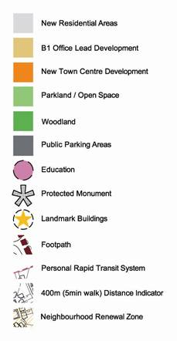
Client/Contractor Liaison
general layout
town centre

Copies of general correspondence should be forwarded to the Client Contract Manager at the discretion of the Contract or on a ‘need to know’ basis. However, the following information shall be forwarded at all times:

- Matters of political or public sensitivity.
- Matters having an important effect on time and/or finances.
- Copies of any statutory notices.

Additional Information to be Submitted with Quotation

The submission shall include:

- A draft programme
- Specifications of the proposed chargepoints

Hours of Work

Hours of Work shall be 08:00 to 17:00 Monday to Friday. No weekend working shall be permitted.

- Duration of the contract

The contract will commence no later than Monday 24th February and must be completed no later than 31st March 2020. A later commencement will only be permitted if the contractor is able to guarantee completion by 31st March

The Contract Period will be 5 weeks

4 SUPPLIER QUESTIONNAIRE

Part 1: Potential Contractor Information
Please answer the following questions in full. Note that every organisation that is being relied on to meet the selection must complete and submit the Part 1 and Part 2 self-declaration.

Section 1 | Contractor information
Question Number | Question |  | Response
1.1 (a) | Full name of contractor submitting the information
1.1 (b) – (i) | Registered office address (if applicable)
1.1 (b) – (ii) | Registered website address (if applicable)
1.1 (c) | Trading status  - public limited company  - limited company  - limited liability partnership  - other partnership  - sole trader  - third sector  - other (please specify your trading status)
1.1 (d) | Date of registration in country of origin
1.1 (e) | Company registration number (if applicable)
1.1 (f) | Charity registration number (if applicable)
1.1 (g) | Head office DUNS number (if applicable)
1.1 (h) | Registered VAT number
1.1 (i) – (i) | If applicable, is your organisation registered with the appropriate professional or trade register(s) in the member state where it is established? |  |  | Yes No N/A
1.1 (i) – (ii) | If you responded yes to 1.1 (i) – (i), please provide the relevant details, including the registration number(s).
1.1 (j) – (i) | Is it a legal requirement in the state where you are established for you to possess a particular authorisation, or be a member of a particular organisation in order to provide the services specified in this procurement? |  |  | Yes No
1.1 (j) – (ii) | If you responded yes to 1.1 (j) – (i), please provide additional details of what is required and confirmation that you have complied with this.
1.1 (k) | Trading name(s) that will be used if successful in this procurement
1.1 (l) | Relevant classifications (state whether you fall within one of these, and if so which one)  - Voluntary Community Social Enterprise (VCSE)  - Sheltered Workshop  - Public service mutual
1.1 (m) | Are you a Small, Medium or Micro Enterprise (SME)? |  |  | Yes No
1.1 (n) | Details of Persons of Significant Control (PSC), where appropriate: 6  - Name;  - Date of birth;  - Nationality;  - Country, state or part of the UK where the PSC usually lives;  - Service address;  - The date he or she became a PSC in relation to the company (for existing companies the 6 April 2016 should be used);  - Which conditions for being a PSC are met;  - Over 25% up to (and including) 50%,  - More than 50% and less than 75%,  - 75% or more. 7  (Please enter N/A if not applicable)
1.1 (o) | Details of immediate parent company:  - Full name of the immediate parent company  - Registered office address (if applicable)  - Registration number (if applicable)  - Head office DUNS number (if applicable)  - Head office VAT number (if applicable)  (Please enter N/A if not applicable)
1.1 (p) | Details of ultimate parent company:  - Full name of the ultimate parent company  - Registered office address (if applicable)  - Registration number (if applicable)  - Head office DUNS number (if applicable)  - Head office VAT number (if applicable)  (Please enter N/A if not applicable)
Please note: A criminal record check for relevant convictions may be undertaken for the preferred contractors and the persons of significant in control of them.
Section 1 | Bidding Model
Question Number | Question |  |  | Response
1.2 (a) – (i) | Are you bidding as the lead contact for a group of economic operators? |  |  | Yes ☐  No ☐  If yes, please provide details listed in questions 1.2(a) (ii), (a) (iii) and to 1.2(b) (i), (b) (ii), 1.3, Section 2 and 3.  If no, and you are a supporting contractor please provide the name of your group at 1.2(a) (ii) for reference purposes, and complete 1.3, Section 2 and 3.
1.2(a) - (ii) | Name of group of economic operators (if applicable)
1.2(a) - (iii) | Proposed legal structure if the group of economic operators intends to form a named single legal entity prior to signing a contract, if awarded. If you do not propose to form a single legal entity, please explain the legal structure.
1.2(b) - (i) | Are you or, if applicable, the group of economic operators proposing to use sub-contractors? |  |  | Yes ☐  No ☐
1.2(b) - (ii) | If you responded yes to 1.2(b)-(i) please provide additional details for each sub-contractor in the following table: we may ask them to complete this form as well.  Name  Registered address  Trading status  Company registration number  Head Office DNS number (if applicable  Registered VAT number  Type of organisation  SME (yes/no)  The role each sub-contractor will take in providing the works and/or supplies e.g. key/deliverables  The approximate % of contractual obligations assigned to each sub-contractor
Contact details and declaration

I declare that to the best of my knowledge the answers submitted and information contained in this document are correct and accurate.
I declare that, upon request and without delay I will provide the certificates or documentary evidence referred to in this document.
I understand that the information will be used in the selection process to assess my organisation’s suitability to be invited to participate further in this procurement.
I understand that the authority may reject this submission in its entirety if there is a failure to answer all the relevant questions fully, or if false/misleading information or content is provided in any section.
I am aware of the consequences of serious misrepresentation.

Section 1 | Contact Details and declaration
Question number | Question | Response
1.3 (a) | Contact name
1.3 (b) | Name of organisation
1.3 (c) | Role in organisation
1.3 (d) | Phone number
1.3 (e) | E-mail address
1.3 (f) | Postal address
1.3 (g) | Signature (electronic is acceptable)
1.3 (h) | Date
Part 2: Exclusion Grounds
Please answer the following questions in full. Note that every organisation that is being relied on to meet the selection must complete and submit the Part 1 and Part 2 self-declaration.
Section 2 | Grounds for mandatory exclusion
Question number | Question | Response
2.1 (a) | Regulations 57(1) and (2)  The detailed grounds for mandatory exclusion of an organisation are set out on this webpage, which should be referred to before completing these questions.  Please indicate if, within the past five years you, your organisation or any other person who has powers of representation, decision or control in the organisation been convicted anywhere in the world of any of the offences within the summary below and listed on the webpage.
 | Participation in a criminal organisation. |  |  |  | Yes No
 | Corruption |  |  |  | Yes No
 | Fraud |  |  |  | Yes No
 | Terrorist offences or offences linked to terrorist activities |  |  |  | Yes No
 | Money laundering or terrorist financing |  |  |  | Yes No
 | Child labour and other forms of trafficking in human beings |  |  |  | Yes No
2.1 (b) | If you have answered yes to question 2.1(a), please provide further details.  Date of conviction, specify which of the grounds listed the conviction was for, and the reasons for conviction,  Identity of who has been convicted  If the relevant documentation is available electronically please provide the web address, issuing authority, precise reference of the documents.
2.2 | If you have answered Yes to any of the points above have measures been taken to demonstrate the reliability of the organisation despite the existence of a relevant ground for exclusion? (Self-Cleaning) |  |  |  | Yes ☐ No ☐
2.3 (a) | Regulation 57 (3)  Has it been established, for your organisation by a judicial or administrative decision having final and binding effect in accordance with the legal provisions of any part of the United Kingdom or the legal provisions of the country in which the organisation is established (if outside the UK), that the organisation is in breach of obligations related to the payment of tax or social security contributions? |  |  |  | Yes ☐ No ☐
2.3 (b) | If you have answered yes to question 2.3(a), please provide further details. Please also confirm you have paid, or have entered into a binding arrangement with a view to paying, the outstanding sum including where applicable any accrued interest and/or fines.
Please Note: The authority reserves the right to use its discretion to exclude a potential contractor where it can demonstrate by any appropriate means that the potential contractor is in breach of its obligations relating to the non-payment of taxes or social security contributions.
Section 3 | Grounds for discretionary exclusion
Question number | Question | Response
3.1 | Regulation 57 (8)  The detailed grounds for discretionary exclusion of an organisation are set out on this webpage, which should be referred to before completing these questions.  Please indicate if, within the past three years, anywhere in the world any of the following situations have applied to you, your organisation or any other person who has powers of representation, decision or control in the organisation.
3.1 (a) | Breach of environmental obligations |  |  |  | Yes No  If yes please provide details at 3.2
3.1 (b) | Breach of social obligations |  |  |  | Yes No  If yes please provide details at 3.2
3.1 (c) | Breach of labour law obligations |  |  |  | Yes No  If yes please provide details at 3.2
3.1 (d) | Bankrupt or is the subject of insolvency or winding-up proceedings, where the organisation’s assets are being administered by a liquidator or by the court, where it is in an arrangement with creditors, where its business activities are suspended or it is in any analogous situation arising from a similar procedure under the laws and regulations of any State |  |  |  | Yes No  If yes please provide details at 3.2
3.1 (e) | Guilty of grave professional misconduct |  |  |  | Yes No  If yes please provide details at 3.2
3.1 (f) | Entered into agreements with other economic operators aimed at distorting competition |  |  |  | Yes No  If yes please provide details at 3.2
3.1 (g) | Aware of any conflict of interest within the meaning of regulation 24 due to the participation in the procurement procedure? |  |  |  | Yes No  If yes please provide details at 3.2
3.1 (h) | Been involved in the preparation of the procurement procedure? |  |  |  | Yes No  If yes please provide details at 3.2
3.1 (i) | Shown significant or persistent deficiencies in the performance of a substantive requirement under a prior public contract, a prior contract with a contracting entity, or a prior concession contract, which led to early termination of that prior contract, damages or other comparable sanctions? |  |  |  | Yes No  If yes please provide details at 3.2
3.1(j)  3.1 (j)–(i)  3.1 (j)-(ii)  3.1 (j)-(iii)  3.1 (j)-(iv) | Please answer the following statements  The organisation is guilty of serious misrepresentation in supplying the information required for the verification of the absence of grounds for exclusion or the fulfilment of the selection criteria.  The organisation has withheld such information.  The organisation is not able to submit supporting documents required under regulation 59 of the Public Contracts Regulations 2015.  The organisation has influenced the decision-making process of the contracting authority to obtain confidential information that may confer upon the organisation undue advantages in the procurement procedure, or to negligently provide misleading information that may have a material influence on decisions concerning exclusion, selection or award. |  |  |  | Yes No  If yes please provide details at 3.2  Yes No  If yes please provide details at 3.2  Yes No  If yes please provide details at 3.2  Yes No  If yes please provide details at 3.2
3.2 | If you have answered Yes to any of the above, explain what measures been taken to demonstrate the reliability of the organisation despite the existence of a relevant ground for exclusion? (Self-Cleaning)

Part 3: Selection Questions

Section 4 | Economic and Financial Standing
Question number | Question |  |  |  | Response
4.1 | Are you able to provide a copy of your audited accounts for the last two years, if requested?  If no, can you provide one of the following: answer with Y/N in the relevant box. |  |  |  |  | Yes No
 | (a) A statement of the turnover, Profit and Loss Account/Income Statement, Balance Sheet/Statement of Financial Position and Statement of Cash Flow for the most recent year of trading for this organisation. |  |  |  |  | Yes No
 | (b) A statement of the cash flow forecast for the current year and a bank letter outlining the current cash and credit position. |  |  |  |  | Yes No
 | (c) Alternative means of demonstrating financial status if any of the above is not available (e.g. forecast of turnover for the current year and a statement of funding provided by the owners and/or the bank, charity accruals accounts or an alternative means of demonstrating financial status). |  |  |  |  | Yes No
4.2 | Where we have specified a minimum level of economic and financial standing and/ or a minimum financial threshold within the evaluation criteria for this procurement, please self-certify by answering ‘Yes’ or ‘No’ that you meet the requirements set out. |  |  |  |  | Yes No
Section 5 | If you have indicated in the Selection Questionnaire question 1.2 that you are part of a wider group, please provide further details below:
Name of organisation
Relationship to the Contractor completing these questions
5.1 | Are you able to provide parent company accounts if requested to at a later stage? |  |  |  |  | Yes No
5.2 | If yes, would the parent company be willing to provide a guarantee if necessary? |  |  |  |  | Yes No
5.3 | If no, would you be able to obtain a guarantee elsewhere (e.g. from a bank)? |  |  |  |  | Yes No
Section 6 | Technical and Professional Ability
6.1 | Relevant experience and contract examples Please provide details of up to three contracts, in any combination from either the public or private sector; voluntary, charity or social enterprise (VCSE) that are relevant to our requirement. VCSEs may include samples of grant-funded work. Contracts for supplies or services should have been performed during the past three years. Works contracts may be from the past five years. The named contact provided should be able to provide written evidence to confirm the accuracy of the information provided below. Consortia bids should provide relevant examples of where the consortium has delivered similar requirements. If this is not possible (e.g. the consortium is newly formed or a Special Purpose Vehicle is to be created for this contract) then three separate examples should be provided between the principal member(s) of the proposed consortium or Special Purpose Vehicle (three examples are not required from each member). Where the Contractor is a Special Purpose Vehicle, or a managing agent not intending to be the main provider of the supplies or services, the information requested should be provided in respect of the main intended provider(s) or sub-contractor(s) who will deliver the contract.  If you cannot provide examples see question 6.3
 |  | Contact 1 | Contact 2 |  |  |  | Contact 3
Name of customer organisation
Point of contact in the organisation
Position in the organisation
E-mail address
Description of contract
Contract start date
Contract completion date
Estimated contract value
6.2 | Where you intend to sub-contract a proportion of the contract, please demonstrate how you have previously maintained healthy supply chains with your sub-contractor(s)  Evidence should include, but is not limited to, details of your supply chain management tracking systems to ensure performance of the contract and including prompt payment or membership of the UK Prompt Payment Code (or equivalent schemes in other countries)
 | Response:
6.3 | If you cannot provide at least one example for questions 6.1, in no more than 500 words please provide an explanation for this e.g. your organisation is a new start-up or you have provided services in the past but not under a contract.
 | Response:
Section 7 | Modern Slavery Act 2015: Requirements under Modern Slavery Act 2015
7.1 | Are you a relevant commercial organisation as defined by section 54 ("Transparency in supply chains etc.") of the Modern Slavery Act 2015 ("the Act")? |  |  | Yes ☐  N/A ☐
7.2 | If you have answered yes to question 7.1 are you compliant with the annual reporting requirements contained within Section 54 of the Act 2015? |  |  | Yes ☐  Please provide the relevant url to view the statement …  No ☐  Please provide an explanation
Contractors who self-certify that they meet the requirements to these additional questions will be required to provide evidence of this if they are successful at contract award stage.
Section 8 | Additional Questions
8.1 | Insurance
(a) | Please self-certify whether you already have, or can commit to obtain, prior to the commencement of the contract, the levels of insurance cover indicated below:  Y/N  Employer’s (Compulsory) Liability Insurance = £5,000,000 in each and every event  Public Liability Insurance = £5,000,000 Professional Indemnity Insurance = £2,000,000  *It is a legal requirement that all companies hold Employer’s (Compulsory) Liability Insurance of £5 million as a minimum. Please note this requirement is not applicable to Sole Traders.

5 – CONTRACT SPECIFIC QUESTIONNAIRE

5.1 | RELEVANT EXPERIENCE & QUALITY ASSURANCE
5.1.1 | Depth & breadth  Please describe your relevant experience in provision of on-street electric vehicle chargepoints and provide examples of recent work. Your examples should describe the nature, scale and scope of previous projects including any projects delivered under the OLEV ORCS.
Weighting  10 | Contractors response:
5.1.2 | Quality assurance  Please provide details of any quality assurance accreditation that your organisation holds i.e. ISO 9001  OR  If your organisation does not have an accreditation please provide a description of your quality management system which will ensure that the commodity that you would be providing will be legal, comply with industry standards and meet the council’s requirements.
Weighting  6 | Contractor response:
5.1.3 | Environmental management  Please provide details of any environmental accreditation that your organisation holds i.e. ISO 14001  OR  If your organisation does not have an accreditation please provide a description of your environmental management system which will ensure that the commodity that you would be providing will manage the environmental impact of the project.
Weighting  6 | Contractor response:
5.1.4 | Professional affiliation  Please provide details of regulatory membership, professional or trade bodies in which you are registered, including registration numbers.
Weighting  2 | Contractor response:
5.2 | SERVICE DELIVERY
5.2.1 | Implementation  Please detail the implementation methodology you would adopt, should you be awarded the contract, in order to be ready to start delivering the service. The OLEV ORCS requires all chargepoints to be installed by 31 March 2020.
Weighting  8 | Contractor response:
5.2.2 | Monitoring  Please detail what control measures and procedures you will put in place to monitor and manage performance to ensure that target deadlines are being achieved.
Weighting  4 | Contractor response:
5.2.3 | Contingency arrangements  Please detail what arrangements you will have in place in the event of an unforeseen problem i.e. unplanned staff absence, vehicle breakdown.
Weighting  5 | Contractor response:
5.2.4 | Customer Support  What is the address of your operational base(s) for delivering these services and your customer contact service set up/arrangements during normal and outside office hours.
Weighting  3 | Contractor response:
5.2.5 | Resource  Please state number of employees under the following categories that will service this contract:
Weighting  4 | Contractor response
 | Management:
 | Back office (IT accountancy\admin\HR) etc.:
 | Operatives:
- 5.2.6 | Handling of complaints  What is your policy on dealing with complaints?
Weighting  2 | Contractor response:
5.2.7 | Co-Funding  Should you be successful, please state the amount of co-funding, if any you will be able to contribute to the cost of the project
Weighting  10 | Contractor response:
5.2.8 | Working on the Highway  Please provide details of your experience with construction works within the public highway; particularly traffic management, signing, lighting and guarding. Please indicate the number and level of NRSWA qualified personnel that will be engaged on the project.
Weighting  5 | Contractor response:
5.2.9 | References  The quality of responses from the contacts supplied in Section 6.1 above will be assessed as part of this section. Contractors may wish to use the Contractor response field below to add any information they consider relevant.
Weighting  9 | Contractor response:

6 - PRICING SCHEDULE *

Item | Description | Price  (£) | Balance Funding  (£)
1 | Long Buckby Market Place
2 | West Street, Welford
3 | School Street, Woodford Halse
4 | Annual cost for the provision of usage data to Daventry District Council in the specified format outlined in the ORCS guidance Annex D in perpetuity
 | Quotation Price:

Prices for Items 1, 2 and 3 shall include
- Provision, installation and commissioning of chargepoint units
- Road markings and signage
- Management of the provision of the electric supplies
- Liaison with the Highways Authority under the New Roads and Street Works Act and establishment of Section 50 Licences for each location
- Provision of usage data to OLEV in the specified format and for the period outlined in the ORCS guidance Annex D

The price for Item 4 shall be for the first year after commissioning. Prices for subsequent years may be subject to increase in accordance with the Consumer Price Index for the previous September.

All prices should be exclusive of Value Added Tax.

*Contractors shall note that they are expected to provide the balance of funding beyond the limit of the OLEV ORCS grant (See General Requirements above) For the purposes of the quotation, the prices entered above shall be the FULL prices for all items. The figures entered in the Balance funding column shall be limit of funding that the Contractor is able to provide for each item

7 - FORM OF QUOTATION AND QUOTATION CERTIFICATE

Note: Refusal to give this declaration and undertaking means that your quote will not be considered.

To: Daventry District Council (the “Authority”) Date: …………………………

Provision of: On-street Residential electric Vehicle Chargepoints

Reference Number: DDCEV01

We: [INSERT COMPANY NAME]
…………………………………………………………………………………………………

The undersigned, having examined the RFQ and all other associated documentation, do hereby offer to provide three Fast AC 7kW dual points as specified in those documents and in accordance with the attached documentation to the Employer.

If this offer is accepted, we will execute such documents in the form of the Contract prescribed.

We agree that before executing the Contract substantially in the form set out in the RFQ the formal acceptance of this Quotation in writing by the Employer, together with the RFQ, Specification and the specified Condition of Contract shall comprise a binding contract between the Employer and the company.

We further undertake and it shall be a condition of any Contract, that:
- The amount of our Quotation has not been calculated by agreement or arrangement with any person other than the Authority and that the amount of our Quotation has not been communicated to any person until after the closing date for the submission of Quotations and in any event not without the consent of the Employer.
- We have not canvassed and will not, before the evaluation process, canvass or solicit any member or officer, employee or agent of the Authority or other contracting authority in connection with the award of the Contract and that no person employed by us has done or will do any such act.
I warrant that I have all requisite authority to sign this Form of Quotation and confirm that I have complied with all the requirements of the RFQ.

Signature
_______________________________________________
Name and status

_______________________________________________

I/We declare that:

1. This is a bona fide quotation, intended to be competitive, and that I/we have not fixed or adjusted the amount of the quotation by or in accordance with any agreement or arrangement with any other person.

2. I/We have not done and I/we undertake that I/we will not do at any time before the hour and date specified for the return of this quotation any of the following acts:

  - Communicating to a person other than the person calling for those quotations the amount or approximate amount of the proposed quotation except where disclosure, in confidence, of the approximate amount of the quotation was necessary to obtain premium quotations required for the preparation of the quotation.

  - Entering into any agreement or arrangement with any other persons that they shall refrain from quoting or as to the amount of any quotation to be submitted.

  - Offering or paying or giving or agreeing to pay or give any sum of money or valuable consideration directly or indirectly to any person for doing or having done or causing or having caused to be done in relation to any other quotation or proposed quotation for the said work any act or thing of the sort described above. We acknowledge that if we, or anyone who acts on our behalf behaves improperly or commits an offence under the Bribery Act 2010, the Employer may cancel the contract and recover all costs and losses.

In this certificate, the word ‘person’ includes any persons or anybody or associated, corporate or unincorporated, and ‘any agreement or arrangement’ includes any such transaction, formal or informal, and whether legally binding or not.

Dated this……………………………day of ………………………..

Signature …………………………………………………………………………..

For and on behalf of ………………………………………………………………
(Name of firm or Company)

Status of signatory…………………………………………………………………
(E.g. Partner or Director)

8– SUPPORTING DOCUMENTATION

8.1 LIST OF DRAWINGS

DDCEV01/01 LONG BUCKBY SITE PLAN
DDCEV01/02 WELFORD SITE PLAN
DDCEV01/03 WOODFORD HALSE SITE PLAN

8.2 SCHEDULE OF KNOWN HAZARDS

JOB INFORMATION SHEET

CLIENT DIRECTORATE: Development & Property
JOB NO: DDCEV01 |  |  | DATE: OCTOBER 2019
DDC OFFICER: STEVE WHELTON
(To be signed by Officer issuing works)

Contractor:
(Print name of company)
Signed: |  |  | Print Name

BRIEF DESCRIPTION OF WORKS:
Installation of electric vehicle chargepoints

Erection of signage

Installation of road markings

LOCATION OF WORKS:
Market Place, Long Buckby. West Street, Welford. School Street, Woodford Halse

SIGNIFICANT RISKS IDENTIFIED BY CLIENT
RISKS | YES | RA/MS req’d |  | Comments/Controls
Site boundaries
Vehicle movements | ✓ | YES |  | Works within public highway
Access difficulties | ✓ | YES |  | Narrow access at West Street, Welford
Proximity of general public | ✓ | YES |  | Pedestrians to be excluded from work areas
Vermin (biological hazards)
Proximity to highway, footpath | ✓ | YES |  | As above

Delivery, waste restrictions, etc
Other

Adjacent land use
No hazards identified

On site hazardous materials
No hazards identified

Location of services
Electricity | ✓ |  |  | See contract information plans. Beware private services
Gas | ✓
Water | ✓
Other | ✓

Ground Conditions
No hazards identified

Existing structures
N/A

Damage to structure
N/A

On site obstructions
No hazards identified
RISKS | YES | RA/MS req’d |  | Comments/Controls

Client activities
No hazards identified
Work Risks
Working at height
M and E elements | ✓ | YES |  | Installation, commissioning & operation of chargepoint
Portable power tools | ✓ | YES |  | All power tools to be well maintained and only operated by trained personnel
Excavations | ✓ | YES |  | Shallow excavations chargepoint pillar. When using compressed air tools for breaking/cutting consider vibration.
Works near water |  |  |  | None
Manual handling | ✓ | YES |  | Chargepoint pillar, cementitious and bituminous materials
Hot works | ✓ | YES |  | Hot bitumen.  Thermoplastic road markings
Confined spaces |  |  |  | None
Temporary works |  |  |  | None
Plant, machinery use etc | ✓ | YES |  | All plant to be well maintained and only operated by trained personnel. Consider vibration from compaction plant
Potentially hazardous materials | ✓ | YES |  | Cement, Bitumen.
Awkward, unusual materials |  | No
Lone working |  |  |  | No lone working will be permitted
Poor mobile phone reception |  | No |  | Some villages have poor reception on some networks. Consider appropriate network for areas
Other contractors on site |  | No |  | No other DDC contractors will be on site
RISKS | YES | RA/MS req’d |  | Comments/Controls
Trees, vegetation |  |  |  | None
Other

Contractors Guidance

Contractors should make themselves and their staff aware, that this document should only be used as a guide to the work area described. Unforeseen hazards may be present on site and may not become obvious, until works have commenced. If a Contractor is unsure how to proceed or has any queries regarding Health and safety on site, they should contact the Council officer that issued the works order before continuing. Alternatively the Councils Health and Safety offer can advise.

Contractors are advised to ensure they are in compliance with their duties under:

The Health and safety at Work etc. Act 1974

The Construction (Health, Safety and Welfare) Regulations 1996

The Construction Design Management Regulations 2007

The Control of Asbestos at Work Regulations 2006

Or any other relevant legislation.

Council Officers Guidance

Contractors should be given all relevant information relating to Health and Safety that DDC should reasonably be able to locate. Asbestos register and Underground service information is available from Development & Property databases. Contractors should be given access to as-built drawings and details of properties under DDC ownership (This information may not be required for works of a simple nature).

8.3 SERVICE INFORMATION

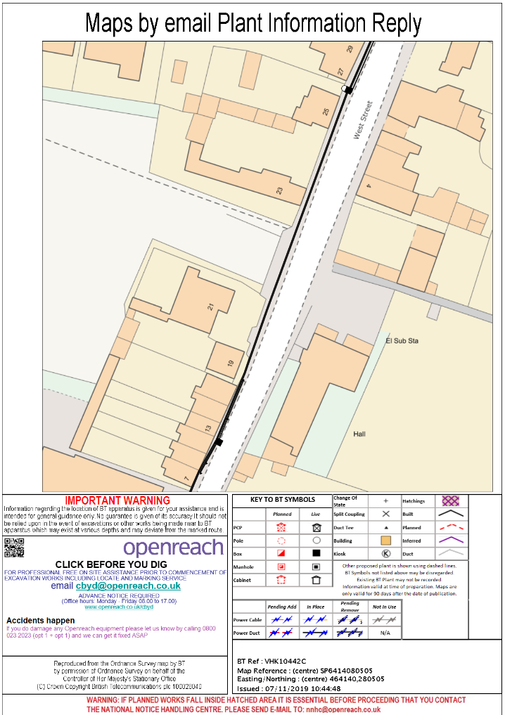
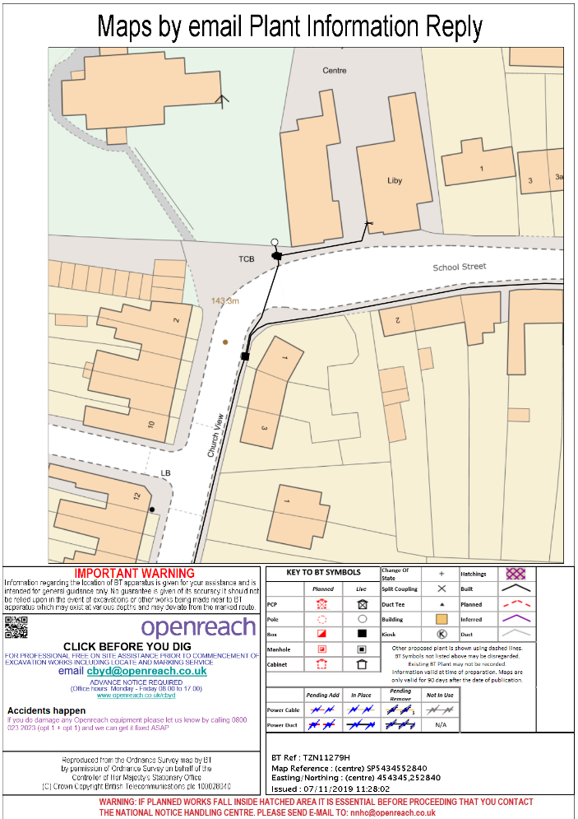

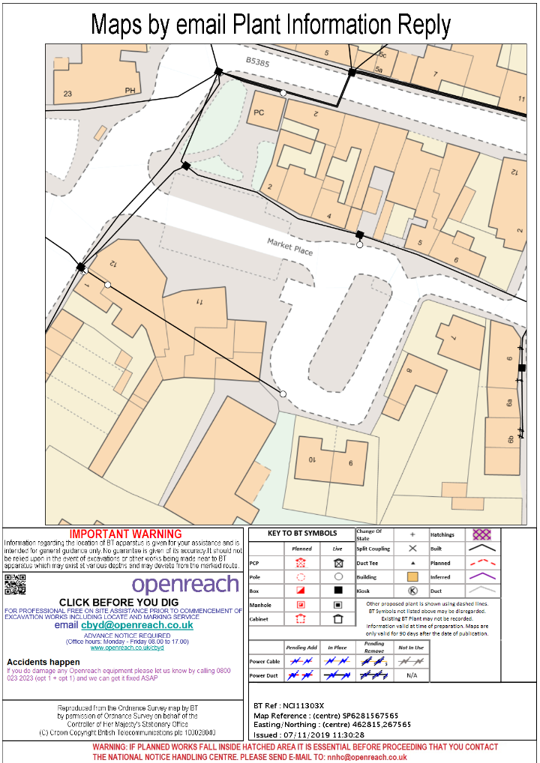

8.4 SECTION 50 LICENCE APPLICATION

