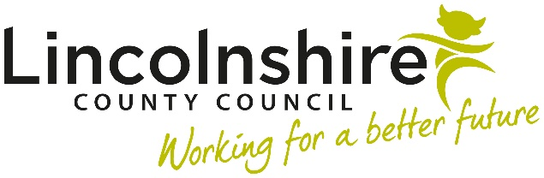

Dear Supplier,
As part of our commitment to fostering collaboration and ensuring successful procurement processes, we are pleased to invite you to participate in our pre-market engagement initiative.
Lincolnshire County Council are in the process of procuring a new traffic signals partner to join the Lincolnshire Highways Partnership to provide all traffic signals services within Lincolnshire
Pre-market engagement, also known as soft market testing, involves early interactions between buyers and potential suppliers before the formal procurement process begins. During this phase, we seek to gather valuable insights, feedback, and market intelligence to inform our procurement strategy.
By engaging with us at this early stage, you’ll have the opportunity to:

- Influence the Specification: Share your expertise and insights to help shape the project requirements. Your input will contribute to a more robust and tailored procurement process.

- Understand Our Needs: Gain a deeper understanding of our organisation’s goals, challenges, and specific requirements. This knowledge will empower you to prepare effectively for future opportunities.

- Explore Innovation: Discuss innovative solutions, best practices, and potential areas for improvement. We value creativity and welcome ideas that enhance value for both parties.

The session will last for approximately 2 hours, we will start by sharing with you some information regarding Lincolnshire County Council and our Highways Partnership. We would then ask that you prepare a presentation ready to demonstrate the below to us on the day:
- Summary of what services you provide.
- Examples of other contracts including solutions and best working practices you have with local authorities.
- Any innovation you can bring to Lincolnshire.
A preliminary date of the 20th May is proposed. We are inviting expressions of interest, slots will be reserved on a first come first served basis, up to a maximum of three suppliers. If demand significantly outweighs availability we reserve the right to add additional slots and dates.
Please confirm your interest by messaging the project team via the procontract messaging portal.

