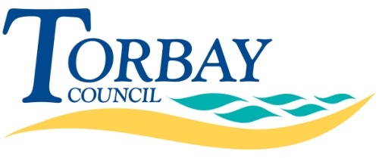
Part 4 Award Questionnaire
Contract Reference
TTDA118
Contract Title
SW Consultants Framework Call Off:
Design Team for a 100-120 Bedroom Hotel, Harbour View, Terrace Car Park, Torquay
Maximum Period of Contract
Two Years
Return Date
Monday 23 February 2018
Return Time
12:00 Noon
Return To
www.supplyingthesouthwest.org.uk
Applicant Name

Contents
Contact Details 3
Stage Two – Award 4
Section A. Method Statements 4

Contact Details
Applicants are required to provide details of the organisation contact to whom the outcome letter should be addressed.
If this section is not completed the letter will addressed to the contact named when the Framework was set up or, where the Authority did not set up the Framework, to the portal contact for this further competition.
Contact Name:
Name of Organisation:
Role in Organisation:
Phone Number:
Email Address:
Signature (electronic is acceptable):
Date

Stage Two – Award

Method Statements
Applicants are required to submit Method Statements. They should be drafted in such a manner so as to be able to form part of the Contract. They should be submitted containing sufficient of detail to demonstrate that the stated outcomes will be deliverable, as defined within Part 2 Specification.
Responses must be relevant to the question and be appropriate in length. Supporting information may be submitted, provided that it is clearly referenced in the question to which it relates and appended to the main submission.
The evaluation of the response will not go beyond the word limit that has been set, if applicable.
Method Statement Number | Method Statement | % Score
1 | Experience – Please provide a method statement demonstrating that a knowledgeable and experienced Design Team will be assembled, capable of delivering a high-quality hotel scheme within the parameters defined.  Your response should include but not be limited to:  - Evidence of relevant experience and delivery of budget hotel schemes by your proposed Team;  - Key resources / Team members;  - CVs of the proposed Team; and  - A Draft Programme Plan showing the anticipated outputs, methodology and timelines. | 30%
Response:

2 | Expertise – Please provide a method statement evidencing how your proven track-record in delivering hotel developments and budget hotels specifically through adopting innovative design solutions will enable you to deliver this Contract.  Your response should include but not be limited to examples of how previous projects have delivered design, cost and operational efficiencies. |  | 20%
Response:

3 | Quality – Please provide a method statement demonstrating a clear understanding of the high quality development requirements required by Torbay Council and hotel operators specifically.  Your response must Illustrate how the successful delivery of previous relevant projects will enable you to demonstrate how the design tools and technology advances used will be applied to this particular project. |  | 40%
Response:

