SUBMITTING A RESPONSE ON THE SOUTH EAST BUSINESS PORTAL

- Log into the portal
- Open the opportunity homepage
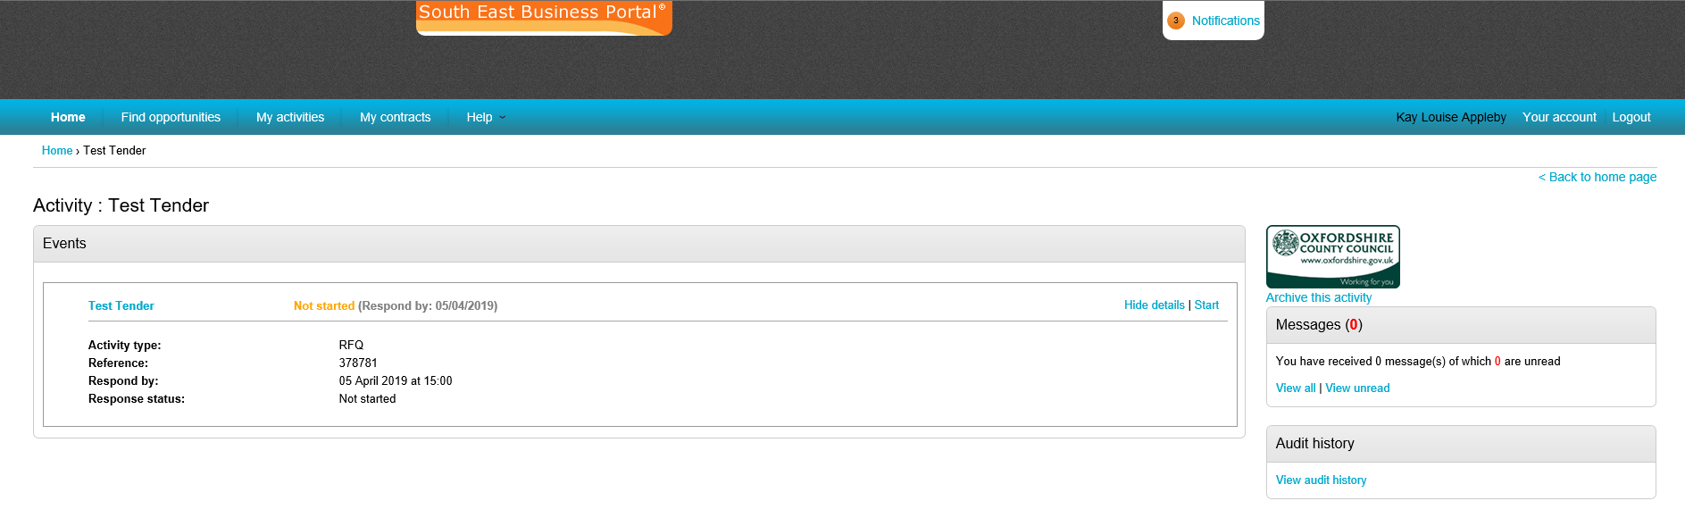
- The opportunity homepage opens
- Select Start under the Tender/Quote event
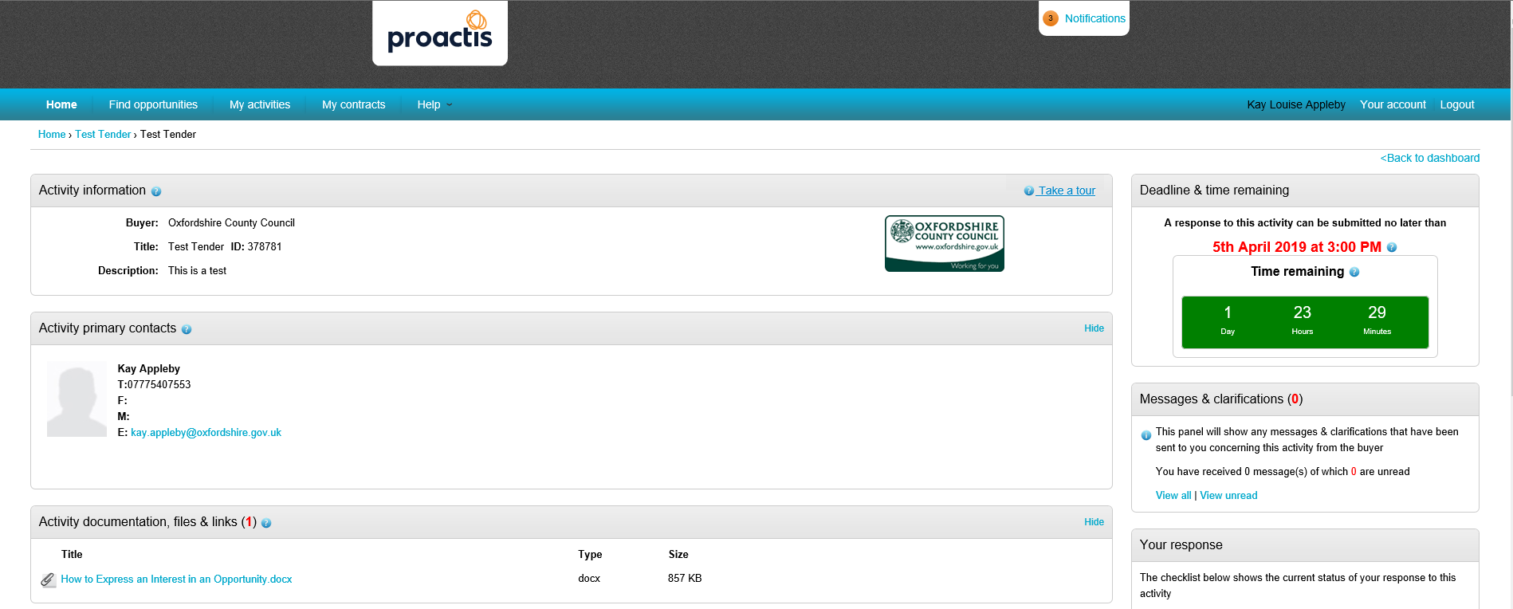

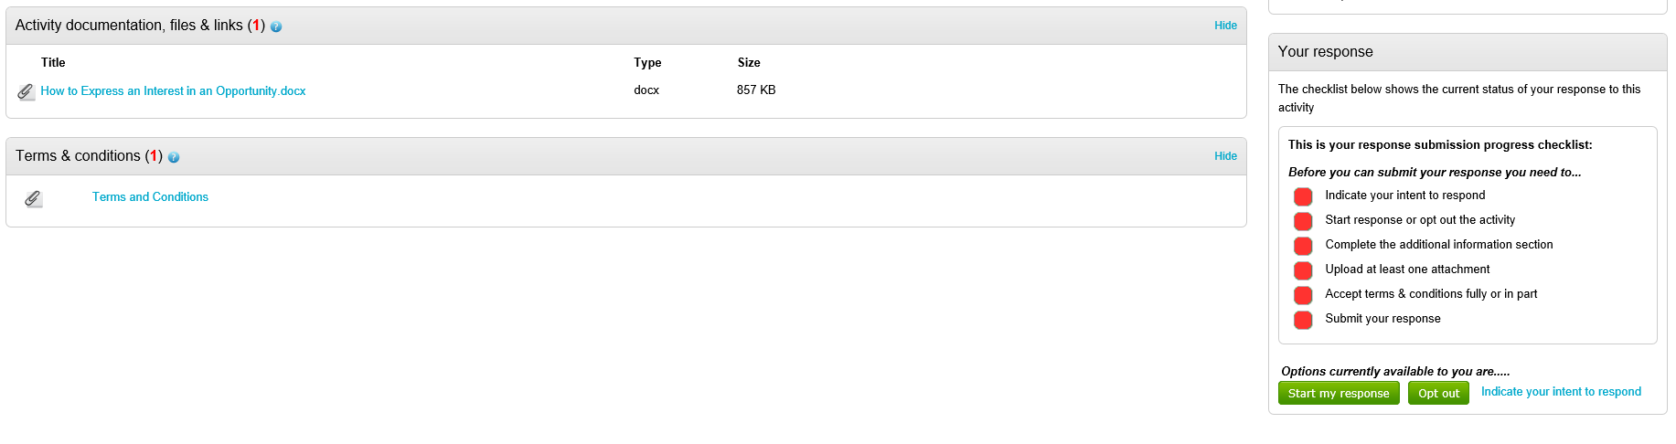
- The tender/quote page opens
- You will see traffic lights on the right side of the page. You must complete all actions which will turn to light green before you can submit your response
- To start your response select Start My Response

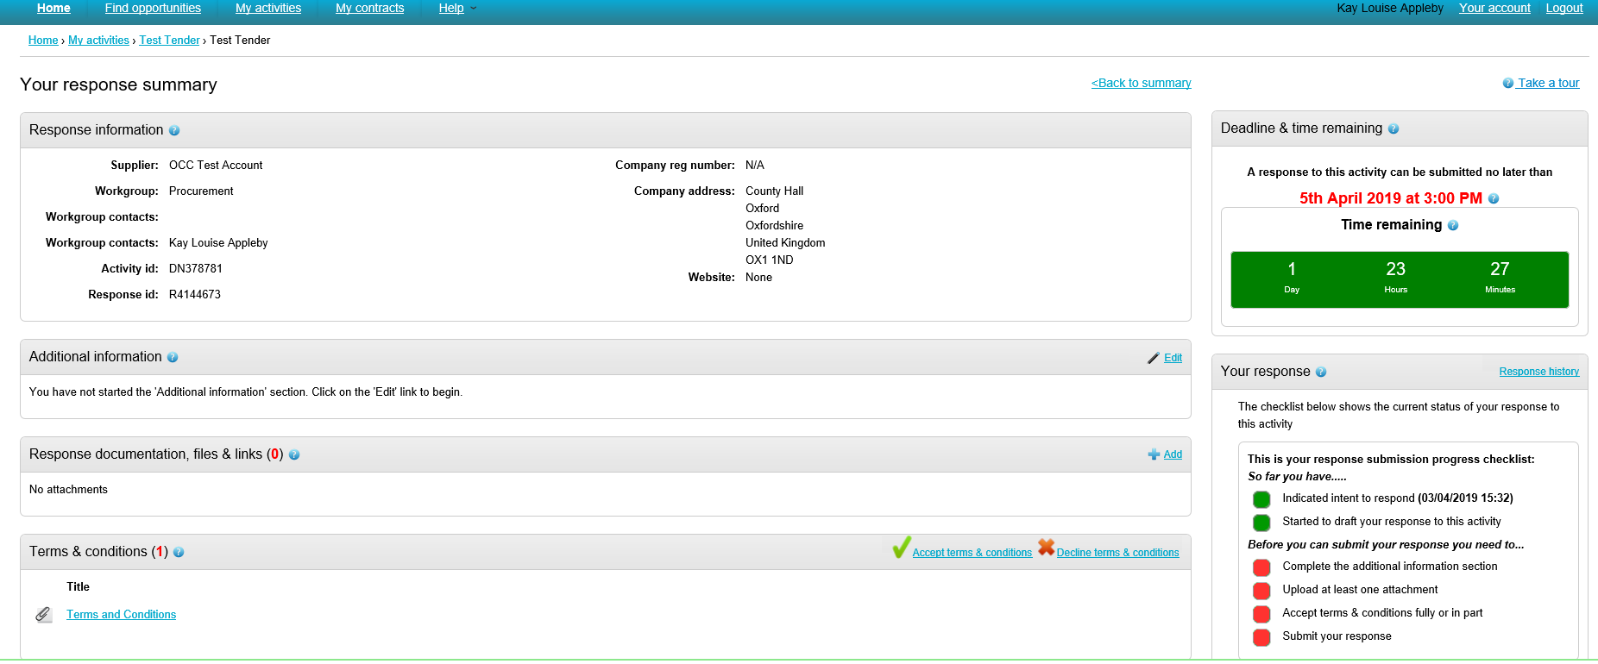
- Response screen opens.
- The 1st and 2nd traffic lights will turn green.
- Click Edit Additional Info
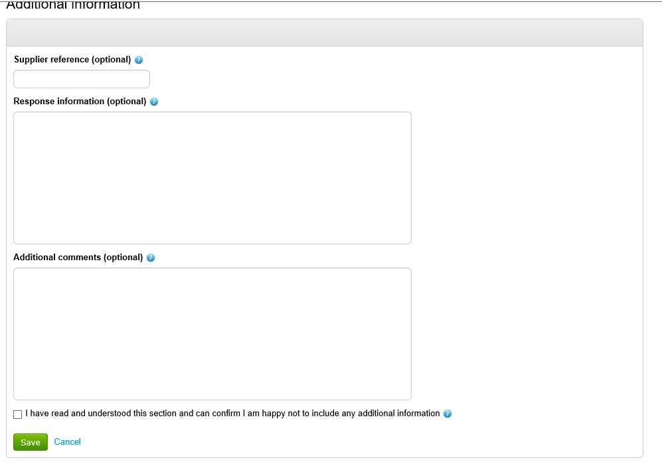
- The Additional Information screen opens.
- Tick check box
- Select Save
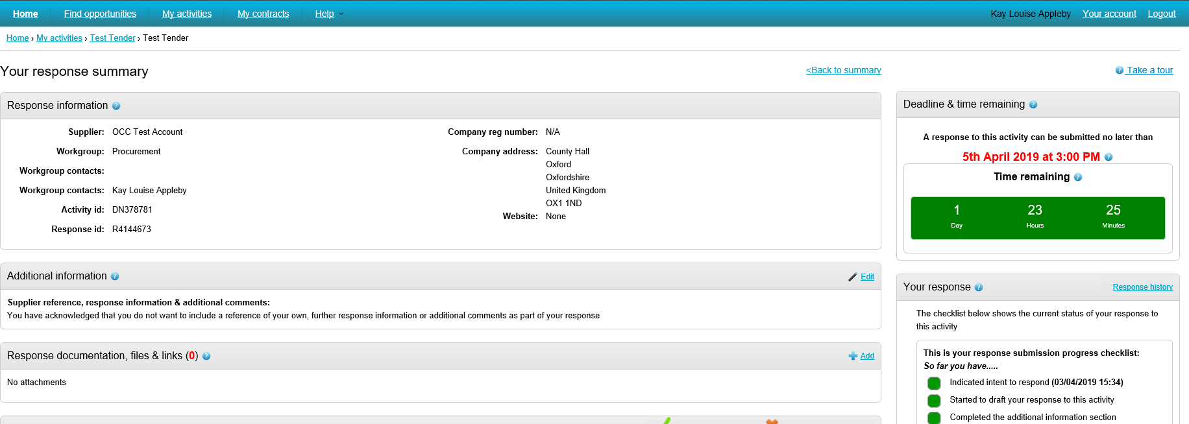
- The Response screen opens.
- The complete additional information traffic light turns green.
- To add an attachment (your tender/quote response), select Add under the Response documentation, files and link header
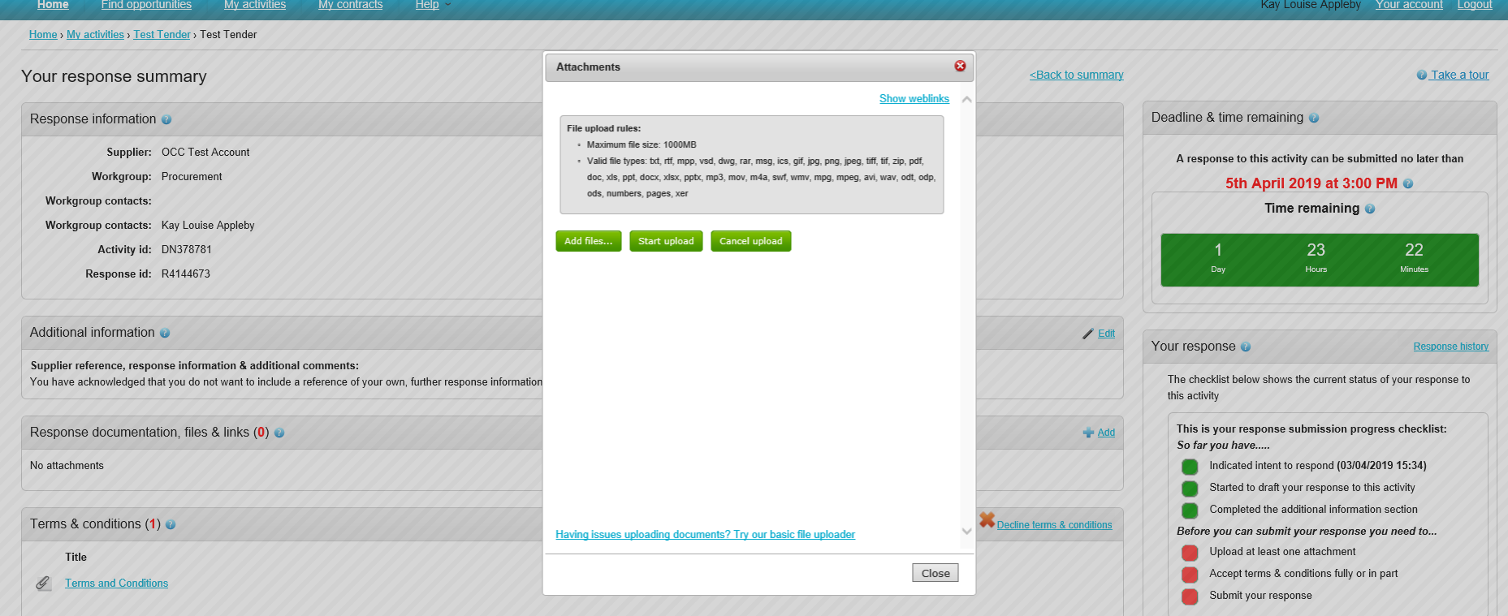
- To add files select Add Files (Please remember to check what types of document format are permitted)
- Select the file from your system and select Start Upload

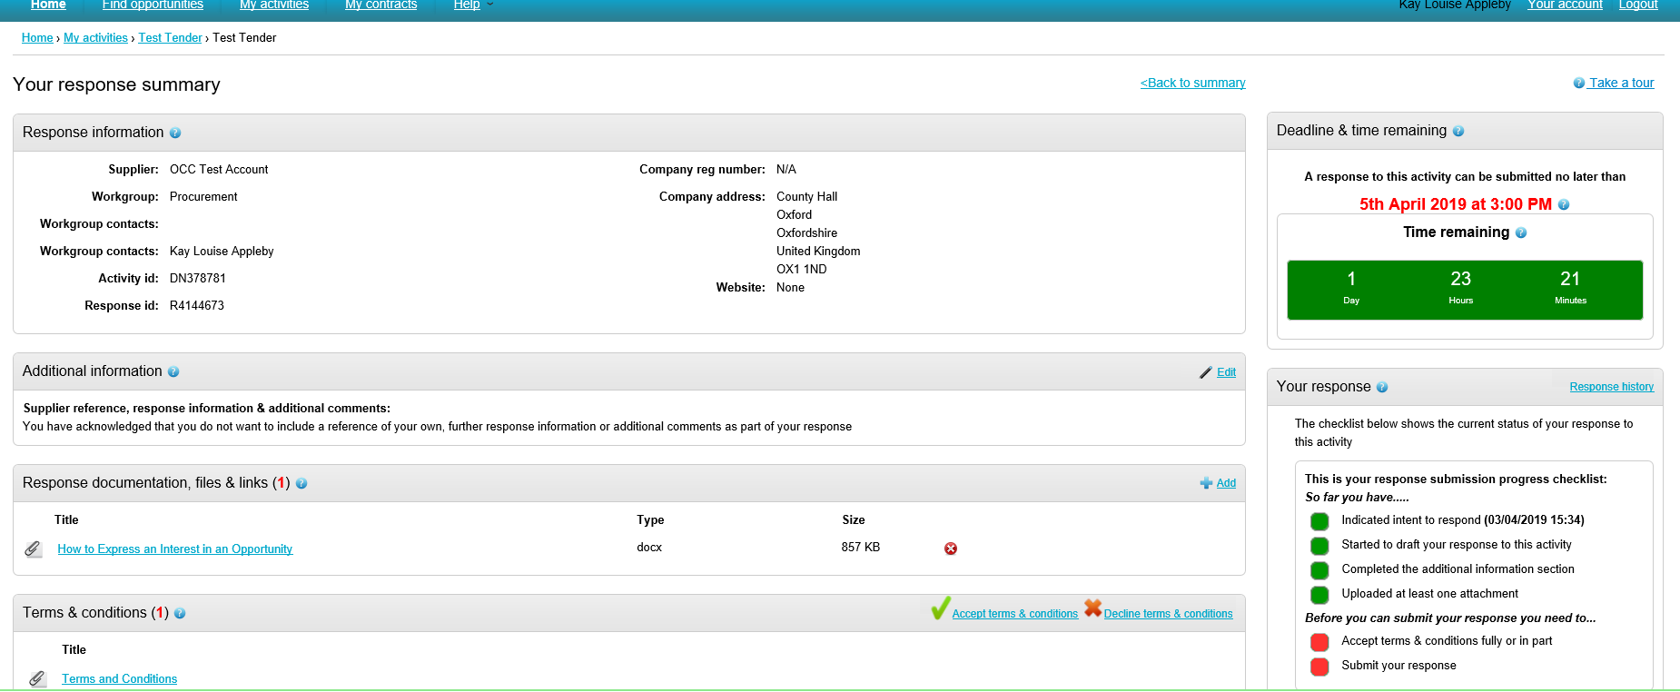
- You need to accept the term and conditions of contract for your bid to be valid. Select Accept terms & conditions
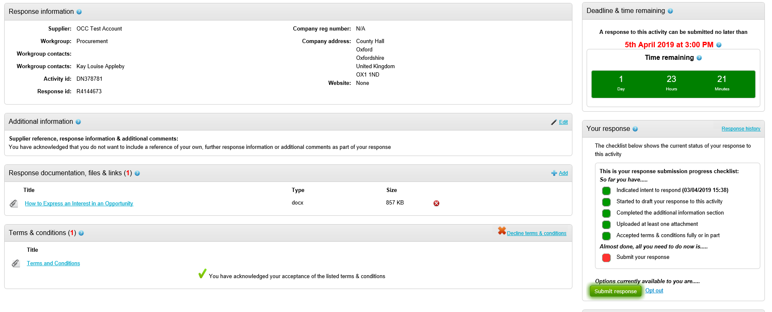
- All traffic lights will show as green.
- Select Submit response
- A message will pop up asking if you want to submit your response. Select Submit response

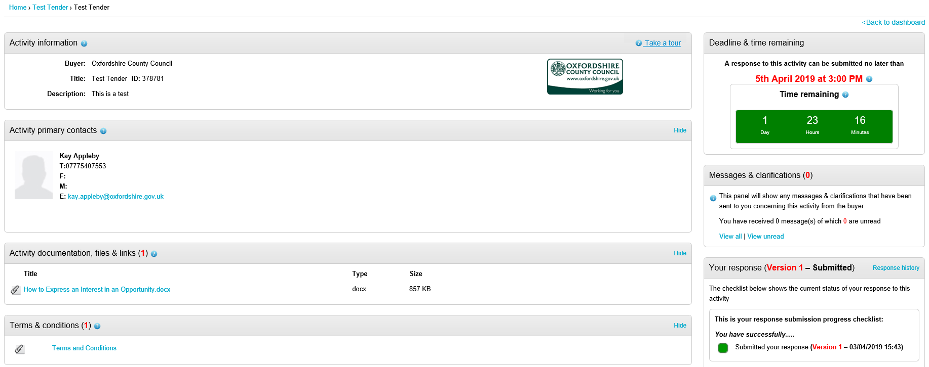
- On the opportunity homepage, you will see that you have submitted a response.

Remember if you have any queries please raise the issue via the portal Messages & Clarifications section.

