How to submit a DPS Application in ProContract - Suppliers

Dynamic Purchasing System Contents
- What is a Dynamic Purchasing System (DPS)?
- Creating a profile
- How to log in to your profile
- How to find opportunities
- How to access documents and submit DPS applications
- Successful DPS applications
- Unsuccessful/New DPS applications

Dynamic Purchasing System
- A Dynamic Purchasing System (often abbreviated to a DPS) is a procurement procedure that allows the Council to approve suppliers for the potential future procurements of various commonly purchased items available on the market. These items are often split into categories called Lots, and suppliers can submit an application via an electronic means using the ProContract procurement portal for whichever Lot suits their needs.
- If you are familiar with a Procurement Framework there are similarities, but where a DPS differs from a Framework is that bidders can join at any time through the life of the DPS. This allows new companies to take part, and the Council can take advantage of changes in the market as they happen.
- When a DPS is created, the Council will advertise the opportunity on the Find a Tender Service website to give an overview of the requirement, and bidders must have a ProContract profile created to take part in all procurement exercises by registering on the website here. This process is entirely free. Once your profile has been created and approved, then you can express interest electronically via the portal and access the DPS and its documentation.

Dynamic Purchasing System
- If your DPS application is successful, this is not a commitment to a contract. Suppliers whose DPS application is successful, will be invited to bid on various contracts in future as and when it is suitable to tender. We would therefore advise that you should keep your email notifications from the ProContract portal switched on at all times so that you do not miss any new opportunities to bid on competitive procurement exercises.
- Please note that suppliers must provide electronic submissions which are uploaded to the portal. No supplier will be able to participate using documents printed off to send to the Council as these submissions must be rejected.

East Midlands Tender Portal
- https://www.eastmidstenders.org/
- This portal is used across the East Midlands to carry out electronic tenders bringing buyers and suppliers together making it easier for businesses to grow, develop and benefit the local economy.
- You will receive automatic tender notifications - register your details and you'll receive alerts when opportunities arise. You can view our advertised opportunities if you are a registered supplier, if you don't have an account, you can register here.
- If you have an existing account, you can continue to login here.
- To be able to bid for Contracts, your organisation will need to register for an account.
- RECOMMENDATIONS –
  - either use a generic email address for notifications i.e. Procurement@suppliername.com or have someone responsible for changing the users as and when people leave (all notifications will go to this email address)
  - We advise you to leave notifications switched on or you may miss out on award notifications, important bid clarifications from buyers, and opportunities to bid on.

Log in to your profile
- Firstly, log in to your supplier profile. Visit the website https://www.eastmidstenders.org/
- From the Home page, click on the Supplier Login button show below.
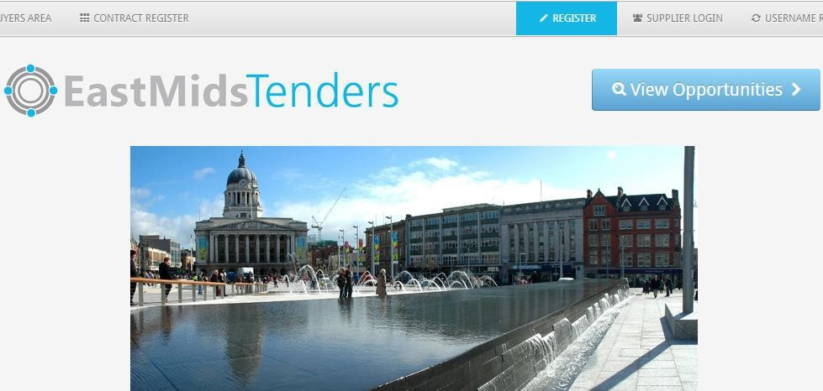

Log in to your profile
- Enter your user name and password.
- If you cannot remember either the user name or password, use the link as shown underneath called “Forgotten username or password?” and follow the instructions to reset your password, or gain a reminder of your user name.
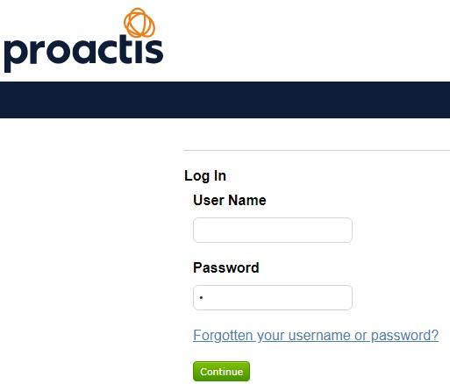

- Once logged in, you can find suitable opportunities for your business by clicking on either of the Find Opportunities links as shown below.
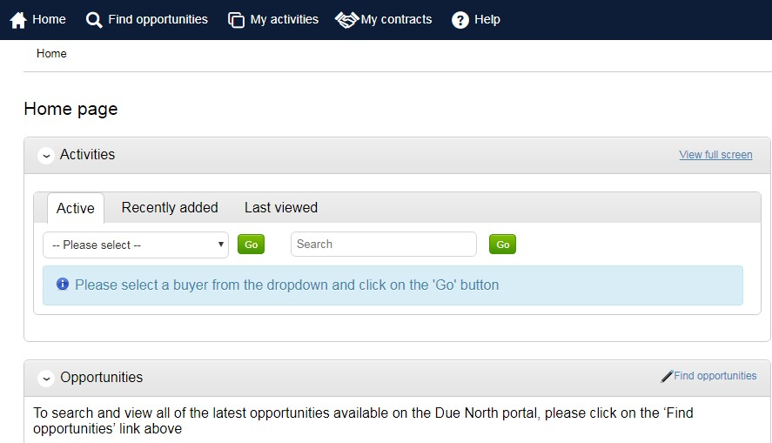
- You can search using the filters provided in the website in multiple ways. Options include:
  - Project title
  - Buying organisation
  - Keywords
  - Project dates
- Look for a project using the main search box provided and enter text appropriate to what you supply
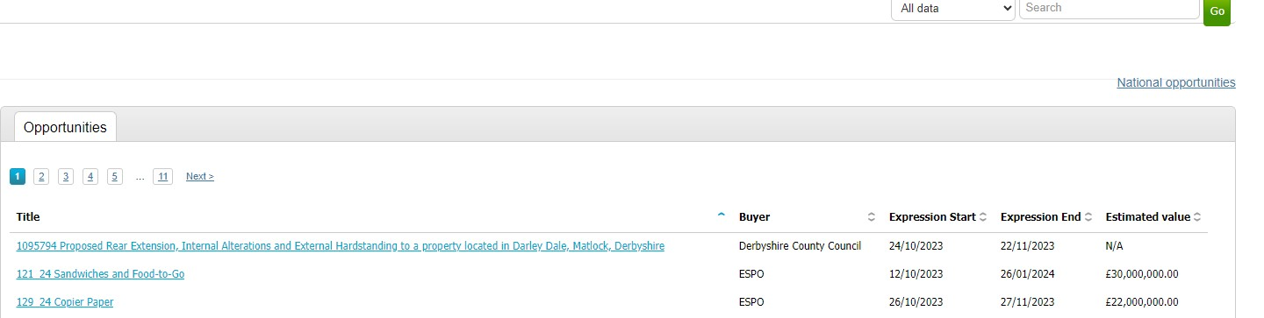
then click on Go.
- Searching by the buying organisation is quickly done by selecting them from the Organisation dropdown menu on the left side. Select Nottingham City Council from the options and the screen will auto-refresh to show you all current opportunities that are advertised by the Council
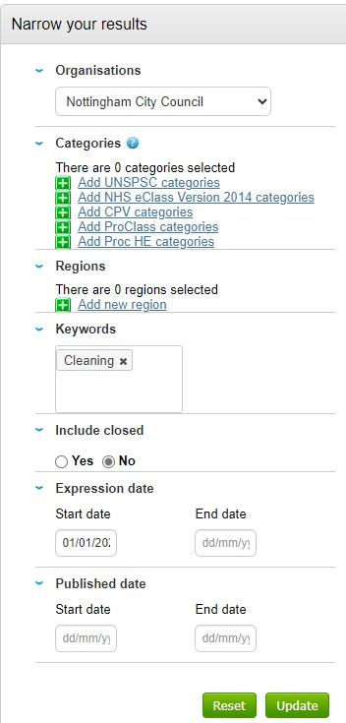
Alternatively use keywords and project dates in the search fields , and click on the Update button to refresh your screen with more specific opportunities.
•
- Once you find an opportunity that interests you, all expressions of interest must be done electronically. Click on the name of the project to do this, and you can read some basic information provided.
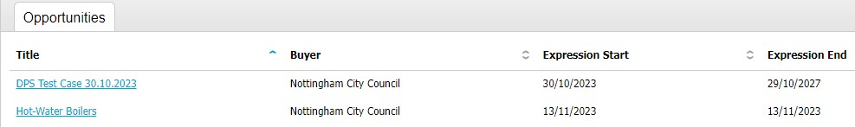
- Click on the button called “Register interest in the opportunity”. You will not be able to take part in an advertised project without registering interest this way. You can withdraw interest later if you wish.
- Note that by simply expressing interest in an opportunity, it does not equate to making a bid/application and does not stop/delay the required submission deadline stated in the advert.
- Please do not email the officer details within the advert. We ask that all questions are put into the portal via the messaging area so that we have an effective audit trail of all FAQs.
- After registering interest, you will see the below pop up screen. By clicking on the link shown, you will have immediate access to all of the procurement documentation and you can start your response by
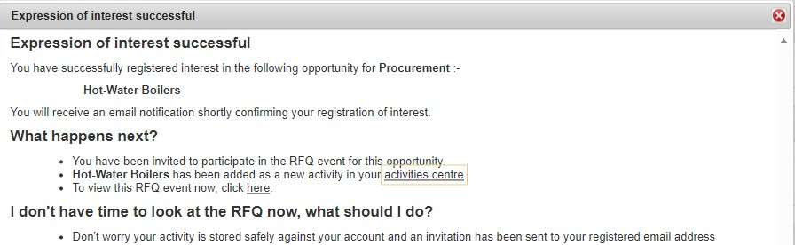
clicking on the start my response button.
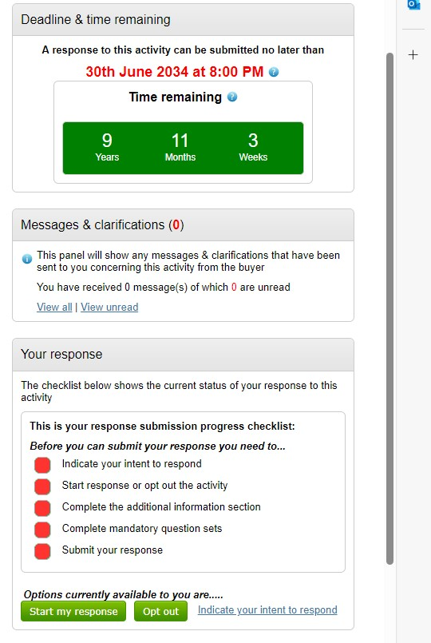
- You can start your response by clicking on the start my response button in the resulting screen.

- At any time you can return to a project you have registered interest in. Log in, and from the Home page, select projects by firstly selecting Nottingham City Council from the dropdown menu under the “Active” project area, then click on Go.
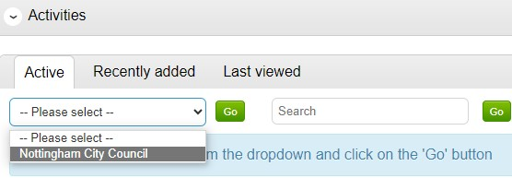
- A list of projects you have expressed interest in will now be displayed. Projects that you have not viewed before are listed and display a small blue star next to them. Click on the title to enter the
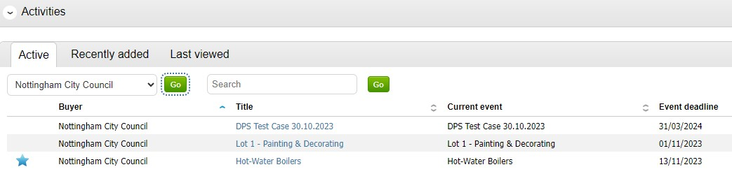
project.
- Projects are split into a series of steps called Events. You have completed the first step to register your interest. The next step we need to follow is accessing the procurement pack. To do this, click on the link entitled “Open” as shown.
- Note that you can access the Messages area at any time to send the Council a question. Click on the “View all” link to send an email.
- After opening the required step, you will see a list of procurement documentation that you can read and download by clicking on them.
- Also note the timer in the top corner of the screen showing when your submission must be received
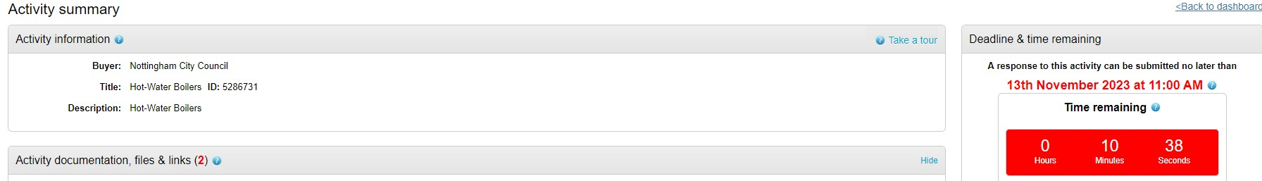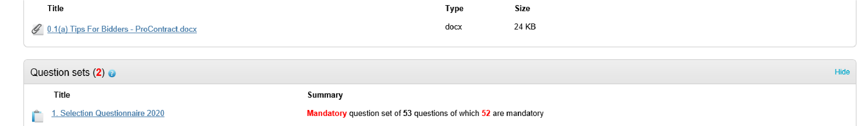
by.
•
A Selection Questionnaire is also used in all DPS application which you must access and complete as
part of your submission
- There is a traffic light system in the top right of the screen to use as a checklist to help you understand the outstanding tasks you have to complete before submitting your response.
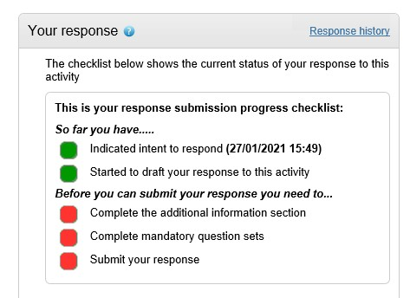
- To start your response, click on the green coloured ‘Start response’ button beneath this area. If the button is not immediately visible, scroll down until it appears.
- The Selection Questionnaire (sometimes abbreviated to SQ), contains a number of important questions where your responses are treated in different ways. Some responses are for information only and don’t change the outcome, some questions can lead to you passing or failing the procurement process.
- When a potential response to a question could or will lead you being eliminated from the procurement process, you will see that in the help sections of the questionnaire there is guidance to outline the consequences of your response. Please also see the tender pack for guidance on this.
- We would advise you complete the Selection Questionnaire first to help you understand the minimum requirements of the Council.
- Click on the Edit link to view and answer the questions.
- After clicking on ‘Edit’, the page will display each question that you must answer. Please see the Key to the right side of the questions to advise you where actions are required.
- After completing a Selection Questionnaire once, you will see that some questions pre-populate for you next time so that you do not have to re-type. You should however check your responses in all cases in case your organisation’s circumstances have changed, or if there are any inaccuracies or specifics you need to update for the contract you are bidding for before you submit your response.
- Questions are split into sections and in some cases there may appear to be gaps in question numbers. This is because the Selection Questionnaire is created as a template and irrelevant questions can sometimes be removed where they are not relevant to the requirement.
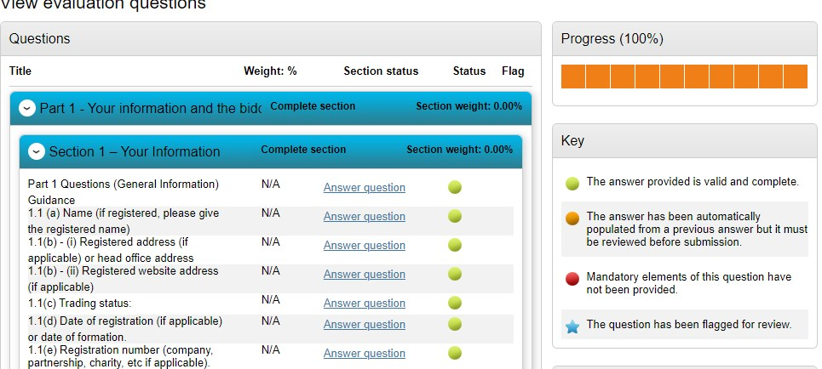

Accessing Documents & Submitting
- Click on the ‘Answer question’ link for each question and answer each in turn. There are various formats you can answer questions by, and the formats for this are controlled. You may be required to answer with:
  - Checking a Radio Button where you choose one answer only o A Dropdown menu where you choose one answer only o A Yes / No answer
  - A Text box where you can free-type (some may have word limit restrictions) o Date fields o Checkboxes where you can select more than one answer.
- Some questions will contain attached documents for you to read. Click on these to open them.
- Where questions are mandatory you will see an indicator to show this in the Question help area.

Accessing Documents & Submitting
- When a question uses a dropdown menu, click on the ‘Please select’ area to display the options and select the required response before saving and moving on.
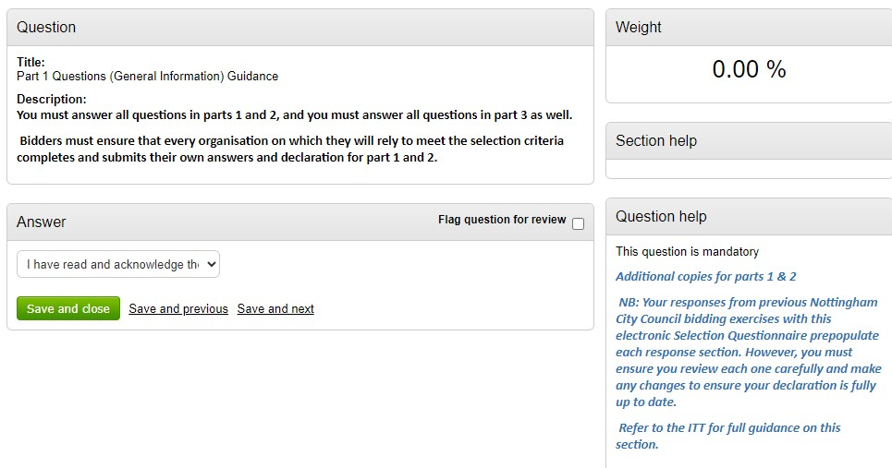
- Some questions may allow you to select multiple options and give you the option of uploading a document to support the response. In these cases you will see a green button in the attachments
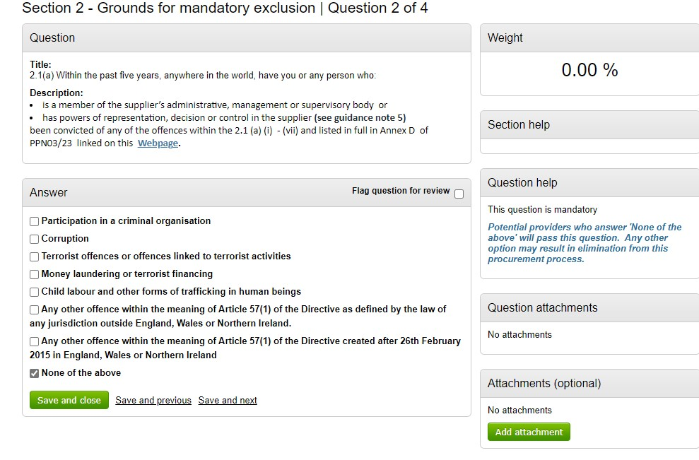
section to allow this.
Information on potential disqualifications shows in question help
.

- As part of the Council’s due-diligence checks, the successful bidder will need to have/obtain a minimum level of insurance to undertake the task, which must be in place prior to commencement of any contract. Minimum requirements will be displayed in this question and will be specified in the tender pack. Please select the appropriate option. You will be required to provide evidence of this if successful.
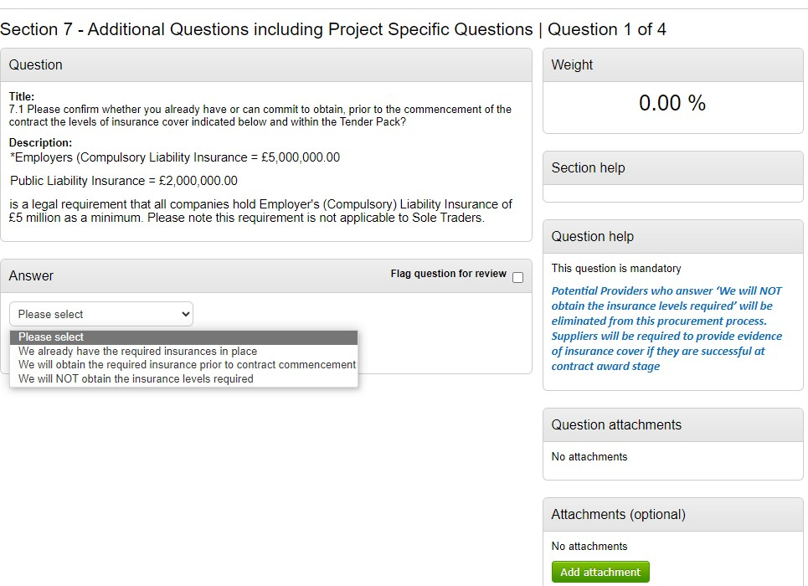
- You can save your progress after each question by using the Save and Next, Save and Previous, or Save and Close buttons found beneath each question.
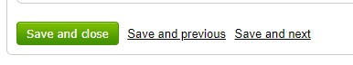
- Once all questions have been answered, you will see a progress bar at the top of the screen which will fill up to 100%. Once done, scroll to the bottom of the screen and click on the Back button.
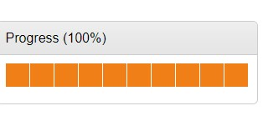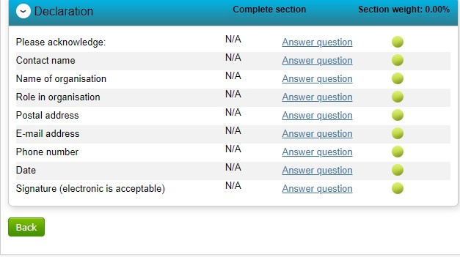
- In some cases you may be prompted to add in any additional information that are general details you may wish to present. Click on the Edit button on this area.
- If this section appears, you must enter this part even if you don’t want to add anything to check the box stating no further information is required. Note that this area is not scored as part of your response.
- There will be key elements that you need to be aware of when submitting a DPS application for Nottingham City Council regarding the completion of the Selection Questionnaire. Please ensure you read the documentation pack thoroughly for additional documents to complete. These will typically include the Form of Tender. This document must be completed and uploaded in the Response documentation section as shown below. Please check the procurement documentation to ensure you have all the required documentation available.
•
To add all your response documents in the ‘Response documentation, files & links’ area. Click on
+
Add.
- You can add one document at a time using the ‘Add files’ button identified below, or you can drag and drop multiple items at once onto the Attachments frame below, then click on the Start Upload button.
Please be aware of the uploading document rules
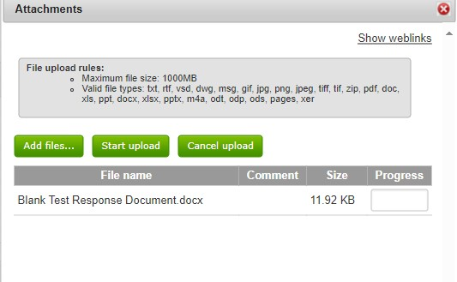
- Check the response panel on the right side of the screen to make sure you have completed all required actions. When ready, click on Submit response.
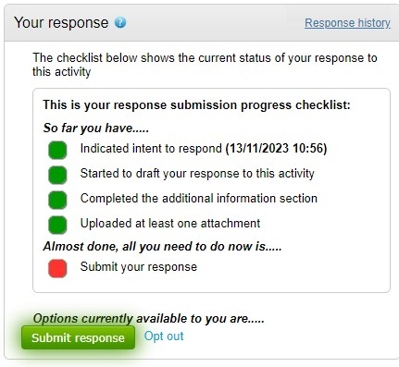

Successful DPS Applications
- If your application is successful and your organisation passes all criteria for the DPS, you will be advised of this via the portal.
- A DPS comprises of several ‘Rounds’, and the first Round applications will be reviewed within a period of at least 30 days. When the Council receives new applications after Round 1, the Council will close the existing Round so that new applications can be accessed and evaluated. This will open a new Round automatically and will notify all suppliers.
- From this point, successful suppliers do not need to re-complete a new DPS application unless their circumstances have changed, or the supplier wishes to apply to a different Lot.
- A successful DPS application is not a contract award. The Council will commence competitive procurement exercises as and when required, on completion of Round 1 of the DPS onwards and will invite successful suppliers to participate. You will receive separate notifications via the ProContract system to invite you to these procurement processes, so we advise you to ensure that your organisations profile has all email notifications switched on at all times so that you do not miss out of opportunities to bid.
- The Council may reject applications to join a DPS. When this happens, the Council will provide feedback to all organisations to advise why this is the case. This may be because:
- You did not meet the minimum requirements of the DPS
- You did not submit the Form of Tender
- Documentation is missing, incomplete, or a response lacks sufficient information to make a decision or pass the identified criteria
- The DPS will allow suppliers to re-apply to the DPS and you can do this at any point. Log in to your profile and select Nottingham City Council from the Home page as shown.
- A list of projects you have expressed interest in will now be displayed. Projects that you have not viewed before are listed and display a small blue star next to them. Click on the title to enter the
project.
- The next screen display the steps involved in a project and the Rounds that the DPS has both completed and are currently open. To submit a new application, click on the link called Open in the latest Round. In the example below, this will be Round 2.
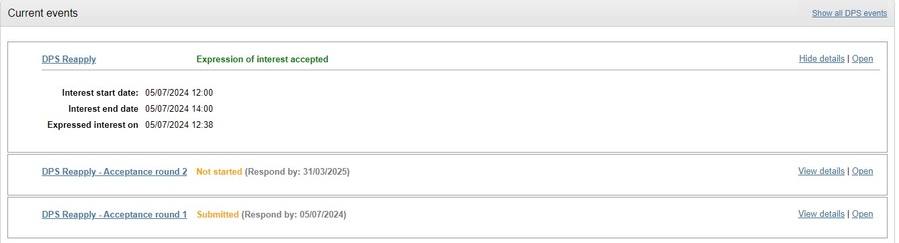
- You will then see a summary of the documentation available on this project. On the right side of the screen, scroll down until you see the green Start my response button and click on this.
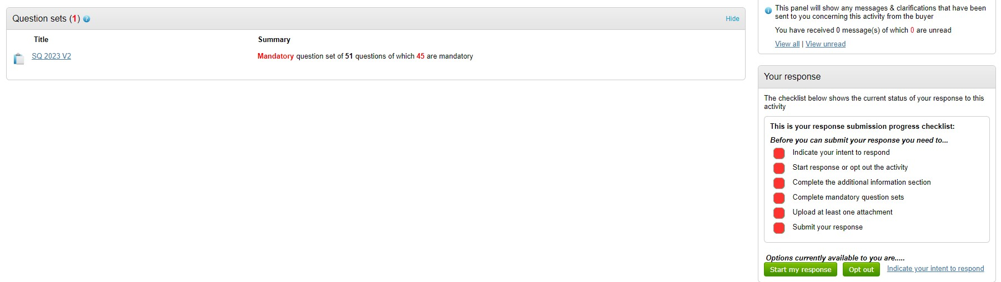
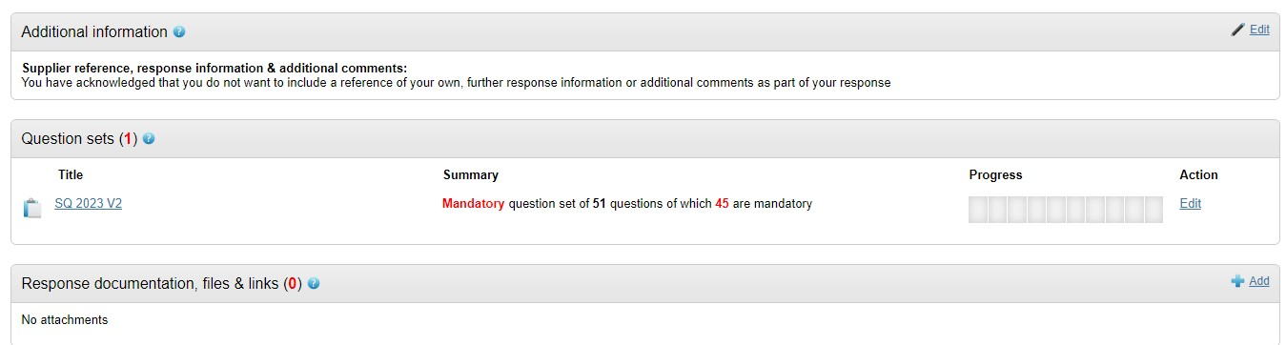
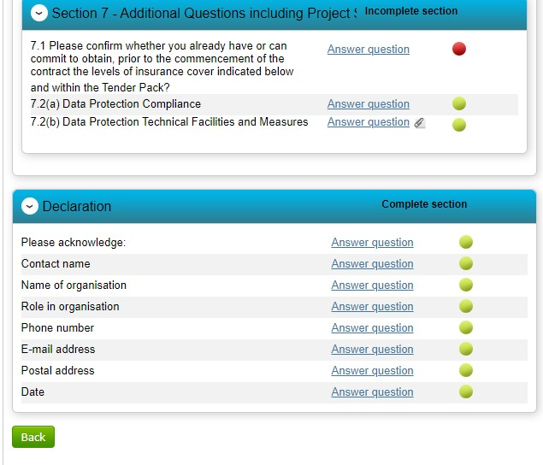
- Complete the Additional information section as you did in your original response, adding in any information that would be useful to the Council such as applying for a different Lot/amended
application.
•
Access the Selection Questionnaire by clicking on the Edit button
to the right of it. Check the answers you have given based on
any feedback you have had and update any answers you can
justify by clicking on the Answer question link. Update and save
accordingly. Click on the Back button at the very bottom of the
screen once you are satisfied with your response.
- Upload ALL documents required for your application (including anything you provided in the previous application) by clicking on the + Add button in the Response documentation section as shown.
- When all areas have been completed, the Submit response button will become available again. Click on this to submit.
