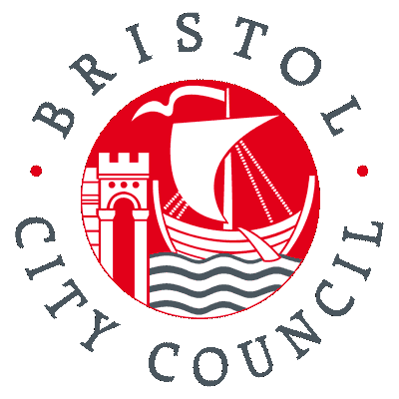
Bristol City Council Equality Impact Assessment Form
Annex 7

Name of proposal | R-PP-009 Commissioning Home Care against Maximising Independence Outcomes
Directorate and Service Area | Health and Social Care
Name of Lead Officer | Leon Goddard

Step 1: What is the proposal?
Please explain your proposal in Plain English, avoiding acronyms and jargon. This section should explain how the proposal will impact service users, staff and/or the wider community.
1.1 What is the proposal?
To award contracts for Independent Providers to deliver home care services in Bristol that support service users, help them achieve their identified outcomes and remain as independent as possible in their own home.

The aim of this proposal is to create home care provision in zones 5 and 9 in Bristol

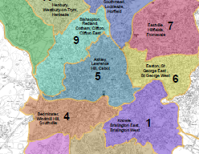

The services must be reliable, predictable and flexible for the service user. This should enable service users to remain as independent and in their own homes for as long as possible. It is expected that this will be achieved by the provision of services that focus on meeting the outcomes of the service user and focussing on a reablement approach to maintain or improve their health wellbeing and independence (maximising independence outcomes). This could include help with personal care, help to learn new skills that will help them live more independently and facilitating the service user to access community activities.

Each Main Provider will be given the tools and support from Bristol City Council to enable them to deliver services to Service Users in a creative and innovative way. Following a Care Management assessment from Health and Social Care to identify the outcomes that are important to the service user. Providers will work with the service user to put together and work towards delivering an Outcomes Based Support Plan.

Each individualised Support Plan will focus on the outcomes of the service user and will draw on the Provider’s expertise to establish what steps need to be taken to achieve these outcomes and how this can be done to reflect the service user’s needs, circumstances and lifestyle.

By providing care and support in this way, it is expected that more service users will be helped to live as independently as possible.

By reducing the number of Providers that Bristol City Council works with, it will be able to support these Providers to deliver high quality and innovative services.

Summary of potential positive impacts
Creating a home care market that places great emphasis on the quality of care and promoting independence presents an opportunity to ensure that service users from all equalities communities, and groups with protected characteristics, are able to access high quality and appropriate care and support.

By working in partnership with a single Main Provider in each of the 2 areas (‘zone 5 and 9’) of Bristol, emphasis will be placed on the Provider increasing their knowledge of the: Local community resources – such as recruiting staff from the local area and who reflect the profile of that area.
Local community opportunities – such as using their knowledge of local activities, facilities and groups to minimise / prevent social isolation.

Recognising that there will be times when service user will want choice and may have needs that are best met by an alternative provider, a pool of Secondary Providers will be available. These Providers are expected to deliver services to the same high standards as Main providers, but in a way that is more specialist and more suitable to the needs of some individuals and user groups. This will give service users choice and also the opportunity to receive services from a Provider that is operated, recruits and trains it staff and delivers services in a way that suits the specific needs and requirements of these service users.

Summary of potential adverse impacts
There is a risk that the services offered by the Main Providers and Secondary Providers do not meet the needs or requirements of certain equalities groups. This would occur if the skills, competence and profile of staff is not aligned with the demand for services.

As with any proposal to implement significant change, this must reflect the views of people that are affected by the service. There would be potential for a negative impact if there was insufficient or inappropriate engagement and consultation with the groups and individuals most likely to be affected by these proposals.

Step 2: What information do we have?
Decisions must be evidence-based, and involve people with protected characteristics that could be affected. Please use this section to demonstrate understanding of who could be affected by the proposal.
2.1 What data or evidence is there which tells us who is, or could be affected?
In comparing the demographics of the two zones with Bristol as a whole, all wards within the zones have a lower percentage of older people and a lower percentage of people who identified in the census 2011 as being disabled or having a long term illness than for Bristol as a whole. However 44% of people living in Easton, Ashley and Lawrence Hill are from Black and minority ethnic backgrounds therefore it is anticipated a significant proportion of service users for these contracts will be from Black and minority ethnic groups. Only 6.2% of Adult Social Care domiciliary care services users are from Black and minority ethnic backgrounds but we would anticipate this proportion to be higher for these contracts.

Census 2011 | Bristol % | Ashley, Easton and Lawrence Hill |  | Cabot, Clifton and Clifton East |  | Bishopston, Redland, Cotham
Aged 15 and under | 18.40% | 10,740 | 22.00% | 5,763 | 7.50% | 7.50% | 15.10%
16-24 | 15.60% | 7,509 | 15.40% | 9,012 | 34.90% | 34.90% | 23.60%
65 - 74 | 6.50% | 1,882 | 3.90% | 1,433 | 3.70% | 3.70% | 3.70%
75 and over | 6.60% | 1,669 | 3.40% | 1,405 | 3.10% | 3.10% | 3.70%
Men | 49.80% | 25,266 | 51.90% | 19,539 | 52.90% | 52.90% | 51.10%
Women | 50.20% | 23,442 | 48.10% | 18,687 | 47.10% | 47.10% | 48.90%
People with a disability | 16.70% | 7,536 | 15.50% | 3,672 | 8.60% | 8.60% | 9.60%
White British | 77.90% | 23,412 | 48.10% | 31,487 | 73.00% | 73.00% | 82.40%
White – non-British | 6.10% | 3,946 | 8.10% | 2,845 | 9.70% | 9.70% | 7.40%
Black and minority ethnic | 16% | 21,350 | 43.80% | 3,894 | 17.30% | 17.30% | 10.20%
Civil partnership | 0.30% | 170 | 0.40% | 108 | 0.40% | 0.40% | 0.30%
People whose main language is not English | 8.50% | 9,413 | 20.50% | 2,045 | 12.60% | 12.60% | 5.50%
% Born in the UK | 85.30% | 33,907 | 69.60% | 33,175 | 77.00% | 77.00% | 86.80%
% resident in UK for less than 5 years | 5.10% | 4,635 | 9.50% | 1,593 | 12.50% | 12.50% | 4.20%
Lone Parent Household | 12% | 3,706 | 17.2% | 892 | 3.9% | 3.90% | 5.8%

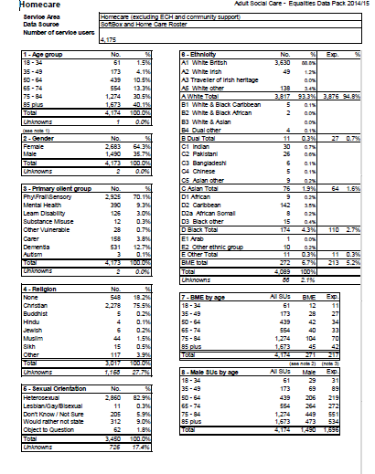
2.3 How have we involved, or will we involve, communities and groups that could be affected?
Consultation events took place throughout Bristol. Venues for the consultation were chosen because of their geographical location and for accessibility. The consultation was advertised using a variety of media channels (e.g. BCC website) and more traditional methods (e.g. posters were sent to 27 libraries and many GP surgeries) to ensure that all service users and key people were aware of what was happening.
All Equalities Groups with connections to Bristol City Council were contacted and invited to the Consultation events and offered the opportunity for a Bristol City Council employee involved in these proposals to come to meet with them. Events were organised by request and an event was set up specifically for the South Asian Community, using a paid interpreter. The table below shows all of the comments made by the South Asian Community Group and other equalities related feedback.

The Consultation results have been analysed and the result will soon be shared on the Better Home Care for Bristol Consultation page in the format of “You Said, We Did”. This information will be shared in poster format in all Bristol City Council Libraries, in all venues where events were held and an email / letter will be sent out to anybody who registered their interest in the Consultation.

Culturally appropriate food | A request was made that food prepared for South Asian service users was culturally appropriate and it was suggested that care workers could help prepare and produce curries and chapatis from scratch.
Personal Care | Service users from a South Asian Community Event also stated that it was very important to have Personal Care delivered in a culturally sensitive way
Language | Several Service users expressed a wish for their care worker to be able to speak in their preferred language.

Step 3: Who might the proposal impact?
Analysis of impacts on people with protected characteristics must be rigourous. Please demonstrate your analysis of any impacts in this section, referring to all of the equalities groups as defined in the Equality Act 2010.
3.1 Does the proposal have any potentially adverse impacts on people with protected characteristics?
Age  Not all Older service users will be able to benefit from a home care service that focuses on improving or maintaining independence as some may not be able to do this. Providers may not focus on identifying outcomes which they view more suitable for younger disabled Service Users.  The Proposal may help to bring new opportunities to both older and younger service users by commissioning Providers who are able to work creatively with Service Users. | The proposal will require all parties to consider what outcomes and individual wants to achieve and if / how they can be supported to improve or maintain their independence. It is accepted that not all service users will be able to do this and the so the service will focus on the outcomes they can achieve and that are importance to them.  All Providers will be required to demonstrate commitment to anti-discriminatory practice and policy.
Disability  Not all disabled service users will be able to benefit from a home care service that focuses on improving or maintaining independence as some may not be able to do this.  Providers may not have necessary expertise to support all disabled Service User’s.  The proposal may help to bring new opportunities to disabled service users by commissioning Providers who are able to work creatively with disabled Service Users | It is accepted that not all service users will be able to do this so the service will focus on the outcomes they can achieve and that are of importance to them.  Providers will need to demonstrate during the tender process that they do have these skills.  A secondary list of Providers to be identified to fill gaps in specialist knowledge and skills.
Ethnicity  Smaller BME Providers may not be able to compete with larger established Providers for Main Provider status.  Commissioned Providers may fail to provide carers who are able to deliver culturally aware and sensitive care for different ethnic communities.  Providers may recruit staff who are local to the service users they are serving and may come from a particular ethnic community. | A secondary list of Providers to be identified to fill gaps in specialist knowledge and skills.  If this is the case, they will be supported to identify a Secondary Provider that will be able to meet their needs.  Providers will be asked to deliver an innovative service, which may open up new opportunities for Service User’s from different ethnic communities.
Gender  Providers may attract a more equal male and female workforce if working conditions are made more attractive. This in turn may increase the number of males taking up home care employment. It is hoped that by creating Zones, the travel time of staff who are mainly women will be greatly reduced. | This would be a positive outcome and it is hoped and expected that these proposals will lead to much needed improvements in the terms and conditions of all home care staff.
Religion and belief  Through creative and innovative service provision from commissioned Providers, service user’s may experience increased opportunities to practice and share their religion. | Providers will be expected to work with people to understand their lifestyle, circumstances and beliefs, i.e. who they are, to encourage and support them to live the life they want.
Sexual orientation  The Clifton, St Werburghs and cabot areas of the city are considered locally as having long standing LGBT communities  If Providers fail to recognise the needs of the LGBT community service users may be at risk of making service inaccessible. | Essential awareness and understanding of the LGBT groups in the target population will form part of the service specification. LGBT service users will receive a service which does not discriminate and is inclusive in a non heterosexist and non-transphobic way
Carers  The focus on Providers delivering support which helps to achieve service user’s outcomes may result in improved outcomes for their carers too. | Providers will be required to be more flexible than at present and adapt to the needs of the service users and carers.

Step 4: So what?
The Equality Impact Assessment must be able to influence the proposal and decision. This section asks how your understanding of impacts on people with protected characteristics has influenced your proposal, and how the findings of your Equality Impact Assessment can be measured going forward.
4.1 How has the equality impact assessment informed or changed the proposal?
The feedback received about the importance of culturally appropriate services will be addressed in the planning and delivery of services. The importance of local recruitment and having a diverse workforce has been noted. The importance of the contractors being confident about working with people who are LGBT has been noted. The procurement process requires providers to define how they will meet diverse needs

4.2 What actions have been identified going forward?
Promote equality of opportunity – There is a need to ensure that all providers can clearly demonstrate how they will equality monitor their service users and identify any gaps in provision through tendering.

Eliminate discrimination – There is a need to ensure that not only policies are in place but that these are monitored to ensure no discrimination will take place and that there is a robust mechanism for complaining should discrimination occur.

Promote good relations – There is clearly a need to ensure that providers are versed in the diversity of possible service users especially those who may be LGB and or transgender and that the providers actively seek to promote their services to these communities. This may require Providers to demonstrate what provision they have for on-going training on Equality & Diversity issues are

Increase the weighting of the ITT equalities question and increase wordcount to enable providers to give full and frank responses

4.3 How will the impact of your proposal and actions be measured moving forward?

Service Director Sign-Off:  Alison Comley | Equalities Officer Sign Off:  Anne James – Equality and Community Cohesion Team Leader
Date:  13/11/13 | Date:  15/2/2016

