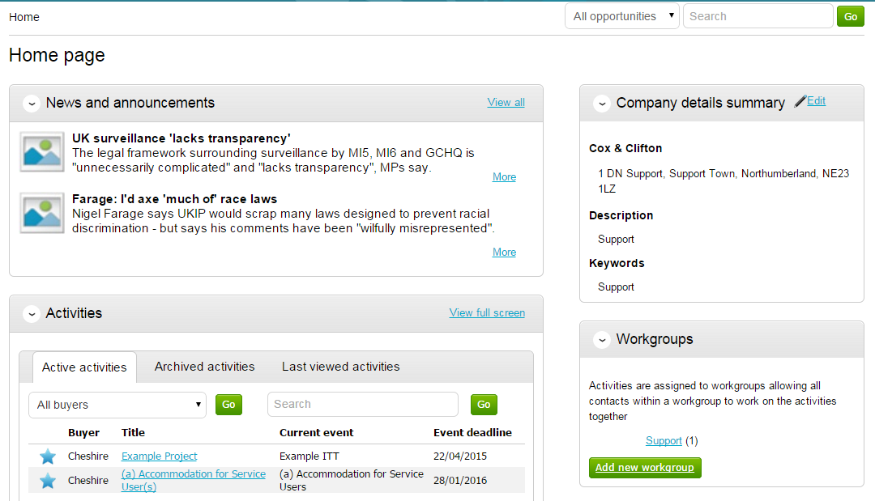

From here to view your current activities that you are working on, from the Activities section click on the title of the Activity you wish to work on.

The Activities area shows all the various tenders that you have registered with, this can be an ITT (Invitation to Tender), RFQ (Request for Quotation), a PQQ (Pre-Qualification Questionnaire) etc.

By clicking on the title in blue, further information is now shown. From this screen all aspects of this project can be dealt with; the tender can be viewed, questions can be asked and answers received, additional information can be issued and your response can be put together and sent to the contracting organisation. Each stage of the procurement process will be seen as its own section.
To view the relevant stage of the project click Open Event within the relevant stage, in this instance ‘Example ITT’.

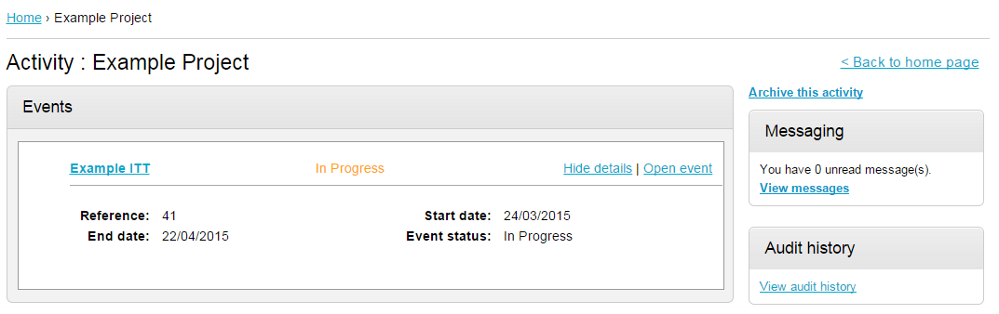

Messages

During the process all questions should be raised using the portal. The ability to ask questions/send messages is found in the Messaging section. Anything sent through this area will go to the member of staff that is working on this within the procuring organisation. Open this area by clicking on View Messages.

This will show any messages that have already been sent or received. To send a new message, click on the button.

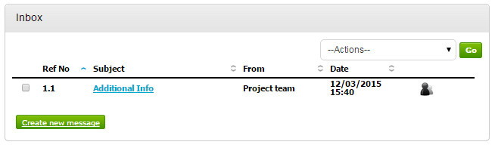

Populate the subject along with the main body of text, and once done then click on the Send button. Attachments can also be added (details of adding an attachment within the system is included later in this guide).

Click to issue the message to the procuring organiation.
The sent message is now shown in the Inbox.

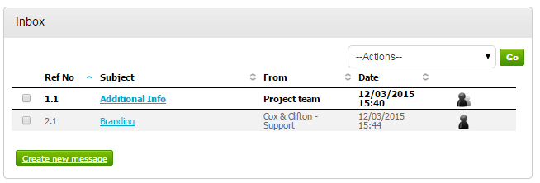

When a reply to that message is sent by the procuring organisation, you will see that the reply is linked to the original message by the numbering. All messages you send to the procuring organisation will be privately sent to them, shown by the symbol. When the procuring organisation replies they may reply privately to you alone (), or publicly (so all suppliers involved in this stage) can see the response ( ). Note: The system will NEVER show which supplier sent the original message.

