CONSULTANT BRIEF
PREPARATION OF A STRATEGIC HOUSING MARKET ASSESSMENT AND A GYPSY AND TRAVELLER ACCOMMODATION ASSESSMENT.

July 2019.

1 INTRODUCTION AND BACKGROUND.
1.1 Winchester District lies within central/southern Hampshire bordered by Basingstoke and Deane, Portsmouth, Havant, Fareham, Test Valley, Eastleigh, and East Hampshire local authorities. A number of these are influential in the way Winchester District functions and is used by its residents.

1.2 The District covers an area of 64,750 hectares with a resident population estimated to reach some 126,000 people (in 52,000 dwellings) in 2019. The District is mainly countryside interspersed with many small towns and villages. The main centre for commercial activity is the city of Winchester, with other main centres in the rural part of the District being Alresford, Bishops Waltham, Denmead, Wickham and Whiteley. Approximately 40% of the District lies within the South Downs National Park, which is a separate planning authority and has its own Local Plan.

1.3 The Council Strategy for the period 2018 – 2020 includes the overarching vision of Winchester City Council which is to combine a blend of innovation, aspiration and pragmatism when delivering local services, looking beyond the traditional ways of doing things. The City Council is committed to;

  - Making the District a premier business location
  - Developing quality housing with a balanced range of tenures
  - Protecting and enhancing our unique environment
  - Delivering services that encourage residents to lead healthy and fulfilling lives.
The outcome of our combined aims will be a district where everyone enjoys the opportunities and quality of life that comes from living in the Winchester District.

1.4 There are currently two key Development Plan Documents setting out planning policies for the District: Local Plan Part 1 (Core Strategy) and Local Plan Part 2 (Development Management and Site Allocations). The Councils’ Gypsy, Traveller and Travelling Showpersons Development Plan Document has recently been adopted and provides for the needs of Travellers up to 2031 in line with policies in Local Plan Parts 1 and 2. Work has started on a new Local Plan which will replace and roll forward these plans to 2036.

1.5 Local Plan Part 1 (LPP1) was adopted in March 2013 and sets out the strategic priorities for the District. The LPP1 development strategy sets the requirement for the overall housing growth in the District at 12,500 dwellings between 2011 and 2031. It focuses substantial growth in three strategic allocations (W of Waterlooville, N Whiteley and N Winchester) whilst setting targets for more limited growth in the market towns of about 250 dwellings. The Plan emphasises the importance of providing affordable housing and an appropriate dwelling mix. https://www.winchester.gov.uk/planning-policy/local-plan-part-1-joint-core-strategy-adopted-march-2013-local-plan-review-2006
Local Plan Part 2 (LPP2) was adopted in April 2017 and only applies to that part of the District outside SDNP. This plan provides further details and allocations from LPP1. https://www.winchester.gov.uk/planning-policy/local-plan-part-2-development-management-allocations/lpp2-adoption
1.6 In terms of the Gypsy, Traveller and Travelling Showperson DPD, this identifies sites for those that comply with the definition of travellers in the Governments statement on Travellers with a prime focus on sites for gypsies and travellers. The DPD has not been able to identify sufficient sites for Travelling Showpeople and the examining inspector makes reference to updating the needs data as part of the review of the existing local plans. Preparation of Local Plan 2036 provides the opportunity to do this, consequently preparation of an updated Gypsy and Traveller Accommodation Assessment forms part of this SHMA. https://www.winchester.gov.uk/planning-policy/traveller-dpd/gypsy-and-traveller-dpd-examination

1.7 A map of the District illustrating the neighbouring authorities, South Downs National Park Area, key settlements, roads and railways is included below. More information about the District and the Council can be found on the Council’s website www.winchester.gov.uk.

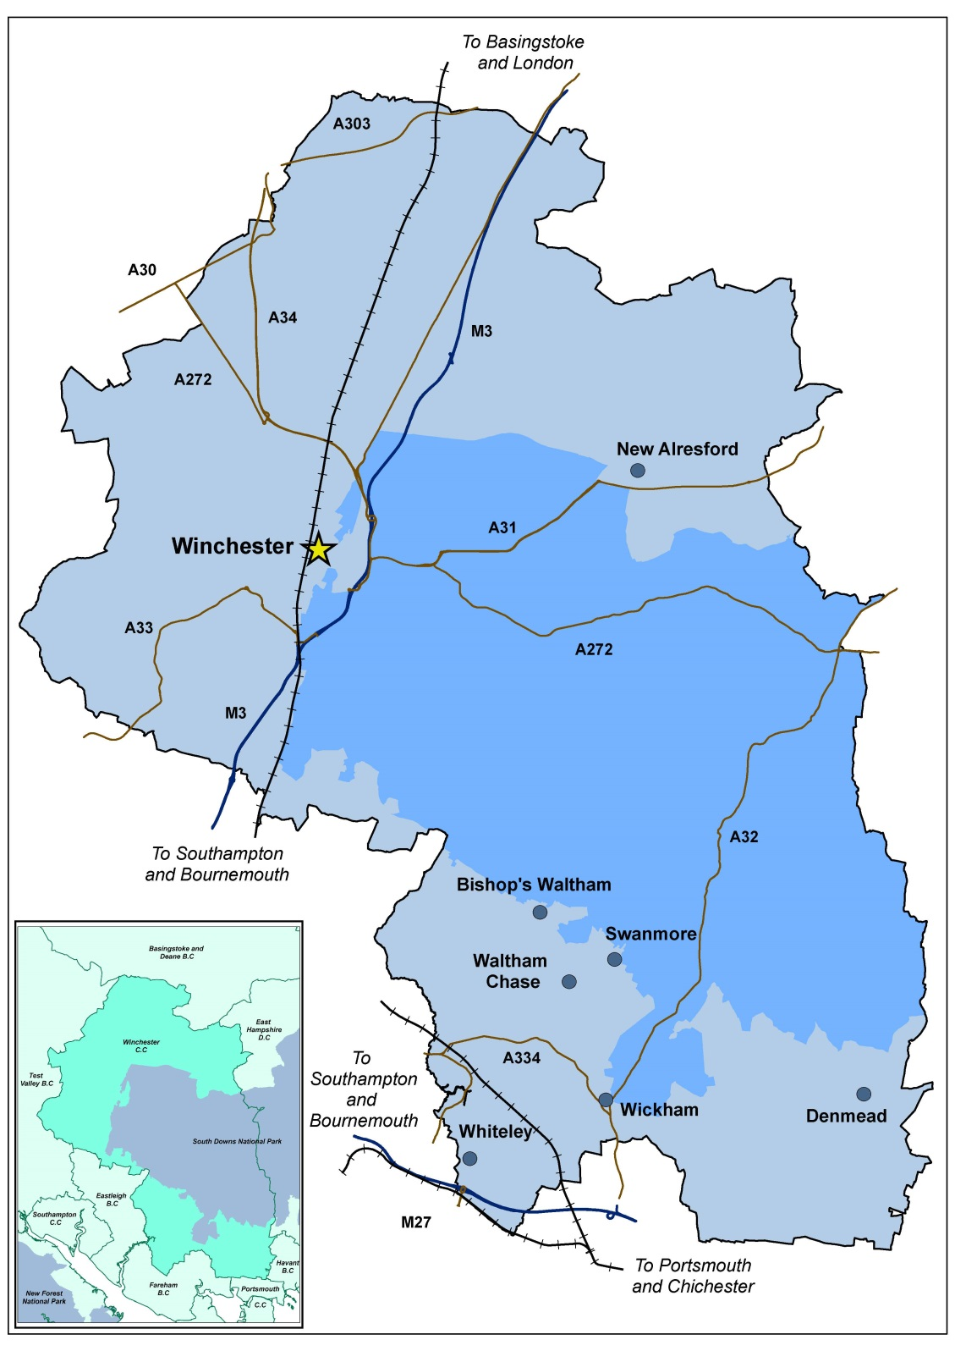
1.8 The City Council is in the process of preparing a new Local Plan up to 2036 and wishes to appoint a suitably qualified and experienced consultant to undertake a Strategic Housing Market Assessment (SHMA)/GTAA survey of that part of the District which lies outside the South Downs National Park Area.
Approximately 40% of Winchester District lies within the South Downs National Park (SDNP) which is its own planning authority and has prepared its own SHMA and GTAA to support its local plan.
1.9 The SHMA/GTAA will form part of the evidence base that will help inform the housing policies and proposals in the new Local Plan 2036. It is an assessment of future needs for market and affordable housing, the type and mix of homes required and the needs of specific groups, including travellers. The National Planning Policy Framework (NPPF) paragraph 11 requires the Council’s strategic policies to, “as a minimum, provide for objectively assessed needs for housing and other uses, as well as any needs that cannot be met within neighbouring areas” in order to be found sound.

1.10 The NPPF and updated Planning Policy Guidance (PPG) provide the framework for national policy on planning for housing, business and other development and require councils to identify the housing needs of an area. Chapter 5 (Delivering a sufficient supply of homes) says that to support the Government’s objective of significantly boosting the supply of homes, it is important that a sufficient amount and variety of land can come forward where it is needed, that the needs of groups with specific housing requirements are addressed and that land with permission is developed without unnecessary delay.

1.11 The City Council has already commissioned ICENI to produce a Future Housing Needs Study to assess the numbers of dwellings that will need to be provided over the plan period the report will be available by the end of June and should inform the work to be done in the SHMAA and GTAA. .

1.12 The NPPF (paragraph 61) has also set out new types of housing provision which need to be taken into account for the District including affordable housing, families with children, older people, students, people with disabilities, service families, travellers, people who rent their homes and people wishing to commission or build their own homes. This may not be an exclusive list and any other needs identified for groups of residents within the District should be accounted for.

1.13 In respect of students the Council is aware that this is an area of housing growth within the City which has proved to be controversial. The Council made two Article 4 Directions for the residential areas of Stanmore and Winnall which had the effect of withdrawing permitted development rights for the change of use of a dwelling house within Class C3 of the Order to a house in multiple occupation within Class C4.
As part of the SHMA the needs and likely growth of the student population within Winchester should be assessed and how the growth (assuming there will be growth) can be best accommodated with the ultimate aim of returning family houses to the market. The consultant will need to contact University of Winchester, University of Southampton and Sparsholt College.

1.14 The Council is also looking to update its information on gypsy and traveller population and sites within the district by including a Gypsy and Traveller Accommodation Assessment (GTAA) as part of the evidence base. The Council has recently adopted its Gypsy, Traveller and Travelling Show people DPD (G&T) and wishes to update its evidence base with a view to incorporating the G&T policies in the new local plan rather than in a separate DPD. The document can be viewed at http://www.winchester.gov.uk/planning-policy/traveller-dpd
Please make clear in your bid whether you have the capacity to undertake both pieces of work and whether you want to bid for one only.

1.15 The information in the SHMA is needed to ensure that the new housing policies properly address the housing needs of the District and to ensure that the policy basis of Local Plan 2036 is sound. The provision of housing is an important corporate objective for the City Council and reliable up to date information about the housing needs of its residents is needed to ensure that the housing policies are able to help to meet the need.
Other useful documents can be found at http://www.winchester.gov.uk/planning-policy/evidence-base and http://www.winchester.gov.uk/housing

2 THE PURPOSE OF THIS BRIEF.

2.1 The purpose of this brief is to set out the requirements for the assessment including;
- Its objectives;
- The timescale in which the information is needed;
- Content of the bid
- The evaluation process and criteria
- Submitting a bid.
- Conditions.
- Scoring guide.
The brief does not prescribe the methodology of the survey and consultants are invited to submit detailed proposals for providing the information required in a reliable, cost effective and efficient manner in accordance with this brief, the NPPF and Planning Policy Guidance.
3 THE OBJECTIVE OF THE SHMA and GTAA.
3.1 Using the data provided in the ICENI report “Future Housing Needs Study;
- To provide an update on people and households within the District.
- To provide an update in relation to housing stock and supply.
- Provide an update on house prices within the District.
- To advise on a proportion of the housing requirement appropriate to meet the housing needs of the South Downs National Park Area having regard to the SDNP HEDNA.
- To advise on a proportion of the housing requirement appropriate to meet the housing needs of the area covered by the Denmead Neighbourhood Plan.
- Establish the mix of different households likely to require housing in the future taking into account the categories of housing identified in the NPPF (paragraph 61) and how the overall figure needs to be sub divided to include the types of housing provision.
- To establish the need for the different identified housing types and tenures as follows;
Housing tenures:
- Market housing
- Affordable housing, including for rent, starter homes, discounted market sales housing, Entry level homes, shared ownership, shared equity and any other affordable routes to home ownership that are identified,
- Private rented sector.
- Travellers including those meeting the Planning Policy for Traveller Sites definition and other non definitional travellers, to include a GTAA to update current figures,
Housing types:
  - Families with children
  - Couples without children
  - Single people
  - Older persons accommodation including the need for Class C2 residential institutions and extra care
  - Students
  - People with disabilities
  - Service families
  - People wishing to commission or build their own homes including self and custom build both market and affordable.
  - Community Led Housing including Community Land Trust, Co housing and collaborative self and custom build.
  - Establish the size, type and tenure of housing needed for different groups identified and any other need that becomes apparent which could include but is not limited to cohousing.
  - To test the effectiveness of policy CP4 (LPP1) – Affordable Housing on Exceptions Sites to Meet Local Needs and whether it needs to be expanded upon to include entry level exceptions housing and the possibility of allocating both urban and rural exceptions sites in the new Local Plan 2036 unless this is likely to raise land values. Are there ways of incentivising land owners to bring forward their sites?
  - To test the effectiveness of policy CP2 in meeting the needs of the market for specific size of dwellings which is currently described by the numbers of bedrooms in a property. Does this have the desired effect or would the use of limitations on floor area better meet the need and relate more easily to affordable housing and nationally described space standards?
  - To test the effectiveness of the part of policy MTRA3 which allows for development proposals which have community support and does it help deliver community aspirations?
  - Generally establish where in the District particular types / tenures of housing are needed.
3.2 To break down the information into the spatial areas within the District in the following areas;
  - The whole District
  - The part of Winchester District that lies within the SDNP.
  - Denmead neighbourhood plan area.
  - Winchester City including the wards of St Barnabas, St Bartholomew, St John and All Saints, St Michael, St Luke and St Paul.
  - To assess the relevance of the Housing Market Areas (HMAs) in the light of the Standard Methodology reference to Districts and whether the definition of the Central Hampshire and Southern Hampshire HMAs needs to be updated.

3.3 An update will be required (by email / phone) between the inception meeting and the deadline for the draft report to advise on key findings and anticipated outcomes. Point of contact for update will be Jenny Nell Strategic Planning Manager. jnell@winchester.gov.uk

4 THE TIMESCALE IN WHICH THE INFORMATION IS NEEDED.
Client issues brief | 1 July 2019
Deadline for bids to be submitted to the Council. | Midday Wednesday 24th July 2019.
Selection of the preferred consultant. | Week beginning 5th August 2019.
Inception meeting. | Week beginning 12th August 2019.
Deadline for draft report. | Monday 7th October 2019.
Deadline for final report. | Monday 28th October 2019.

Please note these dates in your diary as they cannot be changed to accommodate individual bidders. The Council reserves the right to change the dates at its sole discretion. Interviews if necessary will take place at Winchester City Council’s Offices in Colebrook Street, Winchester SO23 9LJ.
5 CONTENT OF THE BID.
Please make clear in your bid whether you have the capacity to undertake both the SHMAA and the GTAA or whether you want to bid for one only making clear which piece of work you are bidding for.
Your bid should be presented electronically using no less than 11pt font size with the any supporting documents. The following details should be included. The scoring for submissions is set out in the scoring criteria table below:
- Company name, lead consultant and supporting staff qualifications and experience and time to be spent on project by different team members, and contact details;
- Brief details of 3 similar SHMAs that have been undertaken in the last 5 years including the cost and contact details for references.
- Details of any sub – contractors likely to be involved in the project.
- Proposed project plan setting out the process you will go through to complete the work and showing how you will meet the requirements set out in this brief.
- Confirmation that you can deliver to the set deadlines.
- Total cost of the work to include expenses and attendance at the Local Plan examination as needed.
6 Evaluation process and criteria.
All bids will be evaluated in the following sequence;
- Check that the bid contains confirmation that the work can be delivered to the set deadline and the assigned personnel will be available to attend the Local Plan Examination if necessary.
- Final scoring
- Decision on appointment.
The evaluation criteria are as follows:
40% on price
60% on quality.
Quality questions will be assessed against the scoring criteria set out below, using the scoring guide set out in Appendix 1.
Scoring Criteria | Score Available.
Content complies with section 3 of the brief;  • Quality and robustness of proposals to achieve Stage A  • Quality and robustness of proposals to achieve Stage B  • Any additional considerations / proposals to help achieve the aims of the Assessment | 10  10  5
Demonstrate that the organisation has the necessary experience to complete the work successfully and to the set programme;  • Experience of relevant similar work in the last 5 years,  • Clarity, structure and content of the project plan. | 10  5
Allow for sufficient suitably qualified and experienced personnel and that a suitable amount of time is allocated to the work by these individuals;  • Suitably qualified personnel assigned to the work  • Suitable amount of time is allocated to the work by these individuals. | 10  10
Price | 40
Maximum score available. | 100

The lowest priced bid will score 40 marks and each higher bid will lose 1% (0.4marks) for each 1% in price that they are higher than the lowest priced bid. The maximum reduction in marks applied will be 40 mark.
The Council reserves the right not to award the contract to any bidder.
Following the selection of the preferred bidder there will be an inception meeting at which contractual details can be finalised and any further clarification sought.
A letter of engagement will then be issued and must be accepted within 1 week in order for the contract to begin.
7 Submission of bid.
Bids should be received by midday on Wednesday 24th July 2019. Please email one electronic copy to;
Jenny Nell
Strategic Planning Manager
Winchester City Council
City Offices
Colebrook Street
Winchester
SO23 9LJ
Email: jnell@winchester.gov.uk
If there are any queries regarding the overall brief please contact:
Jenny Nell 01962 848278 or email, jnell@winchester.gov.uk
Steve Opacic 01962 848101 or email, sopacic@winchester.gov.uk
If there appears to be an error or omission in a bid the council will invite the supplier to confirm the submitted price, including errors/omissions, or amend the submitted price to correct these errors/omissions. All amendments or confirmation of bids must be confirmed in writing by the supplier.
The Council reserves the right to disregard any bid where in the opinion of the Council:
(a) there is sufficient doubt as to the Supplier’s ability to perform the contract for the submitted price; or
(b) it does not fulfil a mandatory requirement; or
(c) it contains qualifications that conflict with the Consultants Brief instructions.
Bids and supporting documents shall be in English and any contract subsequently entered into and its formation, interpretation and performance shall be subject to and in accordance with the law of England.

8 Award Process

Suppliers will be notified via email as soon as possible of any decision made by the Council during the quotation process, including notifying suppliers of the intended award.

Suppliers must not undertake work without first having received an Official Purchase Order as written notification that they have been awarded the contract and are required to start work.

As part of the notification of award process, suppliers will be provided with details of the points awarded for their submitted responses in line with the evaluation criteria above.

9 Conditions.
The Council reserves the right to withdraw from using the services of the consultant at any time during the project if it is not satisfied with the standard or quality of the work.
No part of the study should be sub-contracted to third parties without the Council’s prior consent. If consent is given sub – contractors should have the same insurance requirements as the main contractor.
The appointed consultant shall at all times be fully covered by professional indemnity insurance (£5 million professional for each and every claim and also confirm that such insurance will be maintained until the expiry of 12 years following the date of completion of the services).
The appointed consultant shall at all times be fully covered by Employers Liability (£10 million minimum indemnity limit)
The appointed consultant shall at all times be fully covered by public liability insurance (not less than £10 million for any one occurrence or series of occurrences arising out of one event, the total number of events being unlimited)
The Council will own the copyright of the final report and will have the right to copy, publish and distribute it as required (subject to the work being accredited to the consultant).
It is essential that the Consultant is satisfied that there is no conflict of interest that would undermine the value or integrity of the advice provided.
Payment of fees will be at the end of the project, subject to the Council’s satisfaction.
Any work outside the specification of the Brief, or as subsequently agreed in writing between the Council and the appointed consultants will be considered as additional work. The parties must first agree the content and cost of any such work before it is undertaken.
10 Freedom of Information
The Supplier acknowledges that suppliers are subject to the requirements of the Freedom of Information Act 2000 (‘FOIA’) and the Environmental Information Regulations 2004 and shall assist and cooperate with the Council to enable the Council to comply with its information disclosure obligations.
The Supplier acknowledges that, except for any information which is exempt from disclosure in accordance with the provisions of the FOIA, the content of this quotation is not Confidential Information. The Council shall be responsible for determining in its absolute discretion whether any of the content of this quotation is exempt from disclosure in accordance with the provisions of the FOIA.

For the purposes of the requirement set out above, “Confidential Information” means any information which ought reasonably be considered to be confidential however it is conveyed, including information that relates to the business, affairs, developments, trade secrets, know-how, personnel and suppliers of the Supplier, including IPRs, together with all information derived from the above, and any other information clearly designated as being confidential (whether or not it is marked as "confidential") or which ought reasonably to be considered to be confidential.
By submitting a quotation response the Supplier hereby gives their consent for the Council to publish this quotation in its entirety (but with any information which is exempt from disclosure having been redacted in accordance with the provisions of the FOIA).
11 Local Government Transparency Code
We are required to comply with the Local Government Transparency Code, details of which can be found on our website: https://www.winchester.gov.uk/about/access-to-data.
12 Privacy Policy
Please refer to the Council’s Privacy Policy on our website to see how the Council will use any personal data that you provide us with.

Appendix 1 Scoring guide.
The following scoring guide will be used to evaluate submissions. Each of the questions will be initially scored out of 5 and then weighted in accordance with the scores set out in the scoring criteria. For example, if a maximum of 10 points is available for a scoring element, then the score out of 5 will be multiplied by 2 and so on.
SCORE | DEFINITION | BENCHMARK
5 | Excellent | In the opinion of the evaluators, the response provides the information which :  - addresses all requirements, and  - provides excellent quality relevant supporting evidence which to some material degree provides evidence of an exemplary response and  - fully meets all WCC’s expectations including demonstrating innovative approaches to achieving outcomes in the brief.
4 | Very good | In the opinion of the evaluators, the response provides information which:  - addresses all requirements and  - provides very good quality relevant supporting evidence which to some material degree provides evidence of a very good response, and  - meets the WCC’s expectations in all material respects with no weaknesses or areas of concern.
3 | Good | In the opinion of the evaluators, the response provides:  - good quality information which addresses all requirements; but  - the supporting evidence is less than good in some material degree or is of limited relevance to the response.
2 | Marginal | In the opinion of the evaluators, the response provides information which addresses all requirements BUT the response:  - fails to provide relevant supporting evidence or  - the evidence is not relevant to the response.
1 | Poor | Fail.
0 | No submission | Fail.

As defined by the National Planning Policy Framework.

