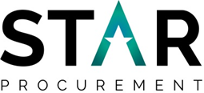
SUPPLIER ENGAGEMENT EVENT
Thursday 9th January 2020
11:30am Number One Riverside, Rochdale

STAR Procurement is hosting a Supplier Engagement Event in Rochdale to discuss the future procurement of a Dynamic Purchasing System for Home to School Transport Including SEND and Vulnerable Adults Transport.
The purpose of the event is to:
- Provide the opportunity for operators to meet with STAR
- Understand the requirements of the service
- Understand the procurement process and what changes are being implemented
- Understand how to use the chest for applications and min-competitions
The procurement is due to commence early 2020.
If your organisation is interested in attending this event then please register your interest by clicking on the link below. Once you are registered further details of the event including an agenda will be issued to you via e-mail
Booking Details:
https://www.eventbrite.co.uk/e/rochdale-supplier-engagament-event-dps-home-to-school-transport-tickets-85983295351

