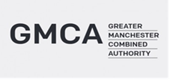
Brief for the Greater Manchester Adult Education Budget Market Engagement Event.
Date: 31st July 2018 at 13:00 – 16:00
Location:
The Sheridan Suite
371 Oldham Road, Manchester
M40 8RR
Greater Manchester Combined Authority (GMCA) wish to invite providers to a market engagement event for the provision of the Greater Manchester Adult Education Budget.
Devolution of the Adult Education Budget (AEB) formed a landmark agreement within Greater Manchester’s ground-breaking devolution deal. The Greater Manchester Combined Authority (GMCA) will assume responsibility for ensuring high quality adult education is available across the city-region from the 2019-20 academic year.

The Education & Skills Funding Agency (ESFA) has reminded providers that all AEB providers’ funding will be affected by devolution, even those in non-devolved areas. Mayoral Combined Authorities (MCAs) will be responsible for funding their residents and ESFA will be responsible for funding residents of non-devolved areas. In future, depending on providers’ geographic delivery footprint and MCAs’ commissioning decisions, providers may have a single funding relationship with a commissioning authority or multiple funding relationships covering one or more MCAs/GLA and ESFA. It is therefore important that providers understand how much of their delivery (direct and sub-contracted) is to residents of devolved areas.

When the GM AEB is transferred from the EFSA to the GMCA however we are very keen to ensure that the market is open, which is why the current PIN deals with the funding of provision currently delivered by those providers that have contracts for services with EFSA as well as EFSA grant funded providers whose primary delivery focus is not currently in GM. This will allow the GMCA to realign the AEB funding which is currently spread across a vast provider base across the country and concentrate it on a smaller provider base who will be required to deliver more targeted learning to GM residents as well as maximising the impact of the GM AEB for learners by reducing duplication of management fees and subcontracting.

Adult Education Budget
The devolved AEB must sit within a transformational education, skills and employment system within GM that delivers a step-change improvement in the basic and generic skills needed for life and work, including English, maths and digital skills. At the same time that skills system must deliver the higher level and technical skills needed to drive productivity in GM’s growth sectors. A devolved Greater Manchester AEB will form a key element in supporting this progression within the broader delivery of the skills and employment system and linking with other provision including technical education and apprenticeships/traineeships.

In particular, we want to develop with providers an approach which will deliver a system that works for everyone as set out in Greater Manchester Strategy (GMS):

- Young people equipped for life and work
- Good jobs with opportunities for people to progress and develop
A thriving and productive economy in all parts of the city-region
Contract details:
Based on GM’s indicative allocation of AEB, the value of procured activity for the 2019/20 academic year will be an estimated £25m, with the final budget expected to be confirmed by DfE early in 2019.

However, GMCA is keen to develop effective, high trust relationships with providers, delivering positive long-term impact for GM residents. This will enable providers to plan and build capacity with greater surety. We expect providers to develop a place-based curriculum offer and wrap-around support with a clear focus on learner progression.

With this in mind, GMCA’s intention is that contracts awarded from this procurement will initially last for one year (academic year 2019 to 2020), with an option to extend for a further 2 years. GMCA reserves the right to extend contracts for a second and third period of up to 12 months subject to funding availability, the provider’s delivery and performance against the contract, and skills policy (including any changes to the overall GM budget arising from the Spending Review or adjustments to the way in which GM’s allocation is calculated by central government).

We welcome all delivery models including consortia bids & other collaborative approaches to ensure that GM residents have the very best service offer that will help then into sustained employment. This marketing event is an opportunity for all interested providers to network and hear about our vision for this programme.
Agenda:
- Overview of GMS priorities
- What has the Data & Market Engagement told us so far?
- Indicative Procurement Approach and Timeline
- Roundtable Discussion
- Question and Answer Session
- Networking
To register for the event please go to the following link:
https://www.eventbrite.co.uk/e/adult-education-pre-market-engagement-event-tickets-47666679321
Please select register and then follow the instructions to successfully secure your place.
There are a limited number of places available so numbers will be restricted to 2 people per organisation. Tickets are on a 1st come, 1st served basis therefore if full capacity is reached organisations will be turned away and a further event scheduled as soon as possible
Provided in the link above are the directions to the venue and details of the public transport routes to access the venue.

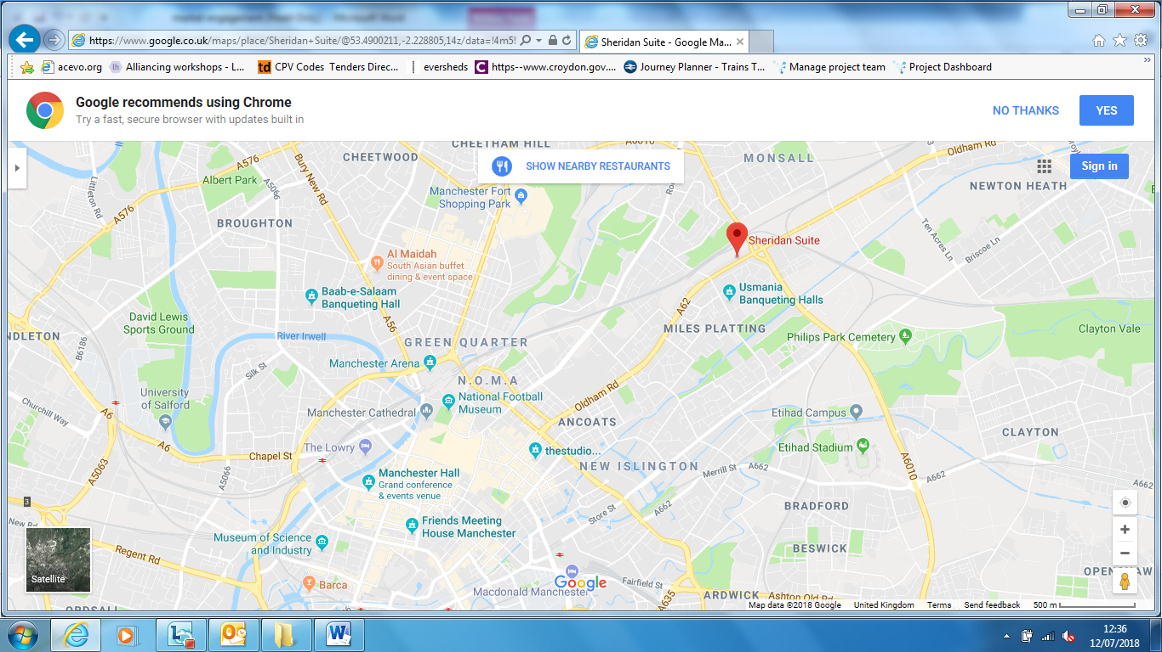

Commencing 1 August 2019
Our People, Our Place: The Greater Manchester Strategy (GMCA, October 2017)

