LONDON BOROUGH OF WALTHAM FOREST
VIABILITY REVIEW STUDY BRIEF

Project title: Viability Study - Bakers Arms
DATE: 22/01/2021

----------------------

- Introduction / Project Summary
  - Waltham Forest Council would like to invite you to quote to provide consultancy services to create a high-level viability study for three sites in Bakers Arms (Leyton Bus Depot, Leyton Leisure Lagoon and Stanley Road), Waltham Forest (please see below). The assessment should evaluate the feasibility studies carried out on the Bakers Arms and advise on commerciality/ deliverability of masterplan design options and development quantums (residential and non-residential uses) that could be delivered on the sites in order to inform our emerging Local Plan and Site Allocations Development Plan Document (DPD) and potential future supplementary planning guidance.
Sites:
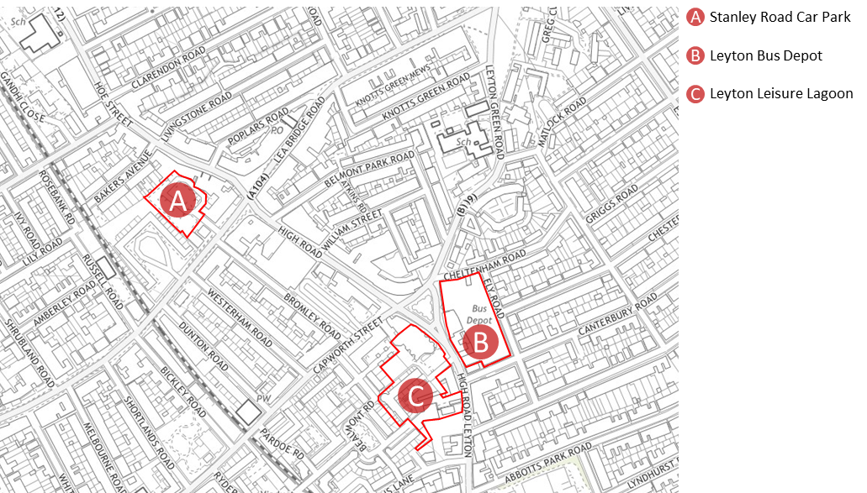

- Background & Objectives
  - Waltham Forest is in the process of preparing a new Local Plan for the borough, including a Site Allocations DPD that will identify sites for development and complement the policies in the Local Plan. In the emerging Local Plan, Bakers Arms, where Leyton Bus Depot, Leyton Leisure Lagoon and Stanley Road sites are located, is identified as a ‘Strategic Location’ - one of the primary growth locations in the borough for new homes, jobs and supporting infrastructure. The three sites were identified as a potential site allocation through the Growth Capacity Study (2018). The feasibility studies tested the assumptions made in the Waltham Forest Growth Capacity Study and demonstrated the key constraints, contextual analysis and understanding of the surrounding area, building typologies, initial sketches for high quality designs, capacity studies and efficient deliverability of the sites.
  - The key objective of this commission is to evaluate and review these feasibility studies advise on their deliverability in the context of London Plan and Local Plan policies standards.
- Key Considerations
  - Site A, Stanley Road, accommodates a car park which is used by local communities and facilities, such as Kingsway International Christian Centre, which relies on the car park during its Sunday services. In the past, they have expressed concern about the loss of car parking, so the feasibility study explored a phased approach to releasing car parking on this site. The first phase should retain half of the car parking on site, and the second should be car free (i.e. wheelchair parking only.) The site is adjacent to Grade II listed Master Baker’s Almshouses, the Bakers Arms Conservation Area and an Archaeological Priority Zone.

  - Site B, Leyton Bus Depot, accommodates the Stagecoach bus depot, including a bus garage and warehouses providing office accommodation, staff facilities and areas of external hardstanding for bus parking. The feasibility study has identified the best scenario for the site with lower shoulder heights located along the east, north and west of site, with taller tower on North West corner. Massing steps down in south west corner in response to existing two-storey house on the corner.

  - The two capacity studies examined the potential of the site, depending on whether the bus depot was relocated or retained.

  - The feasibility study has also considered the connection of this site with the Leyton Leisure Lagoon in order to provide a more integrated approach and better placemaking offers.
  - Site C, Leyton Leisure Lagoon, is currently occupied by Leyton Leisure Centre, which provides approximately 3,400m2 of facilities, including a gym, a 25m swimming pool, an aqua play pool, a health suite (with a sauna), and an associated car park. The approximate existing site area is 0.57ha, and it is positioned in the Bakers Arms District Centre. Surrounding buildings range from 2-11 storeys in height. However, the site is immediately bounded to the west and south by residential properties ranging from 4-7 storeys. The site also has very strong public transportation links – with a PTAL of 6a. The site is located within an Archaeological Priority Zone, but is outside the Conservation Area.
  - The feasibility study identified that the Leisure Centre remains on High Street, with residential development above occupying a more prominent position opposite the Green. In every scenario, the retention of TPO trees have been considered.
- Deliverables
  - Viability Study Report should include;
    - Guidance and principles on viability testing for development;
    - Residential (Market, PRS (if appropriate) and Affordable Housing), Non-residential and mixed uses values & costs;
    - Comparison of Existing Use Values and Development Land Values;
    - Financial Models in ARGUS Developer or similar format to demonstrate:
      - Scenario 1: A policy compliant development in terms of affordable housing tenure and mix
      - Scenario 2: If required, an alternative scenario to demonstrate a viable scheme that is as close to policy compliant as possible in terms of affordable housing tenure and mix; and
    - Sensitivity Analysis to demonstrate the impact of future changes in build cost, developer and landowner returns and sales/rental values. Precedents should be given for levels of developer and landowner returns that are assumed in your appraisals.
    - Recommendations (if required) to improve the commercial position by modifying/implementing a phasing strategy for the relevant site.

- Proposed Timescale for Delivery & Budget
  - The Council has been allocated a Home Building Capacity Fund from the GLA. A £7,500 has been assigned for this study and it will expect to be complete by March 2021.

- Key Information
  - Any general questions regarding the procurement process or submission of tenders can be directed to:
Antonio Mesini
Planning Policy Officer
Antonio.mesini@walthamforest.gov.uk

Sarah Parsons
Head of Place and Design
sarah.parsons@walthamforest.gov.uk

London Borough of Waltham Forest,
The Magistrates, 1 Farnan Avenue, London E17 4NX

