Schofield Street Footbridge Replacement
Expression of Interest

Rochdale Borough Council is seeking to appoint a suitably qualified contractor, preferably based within Rochdale or surroundings areas (Greater Manchester), to replace the footbridge on Schofield Street.
The footbridge crosses the East Lancs Railway (ELR, a live railway which has steam trains running on it) that has been assessed to be understrength (See photo attached).
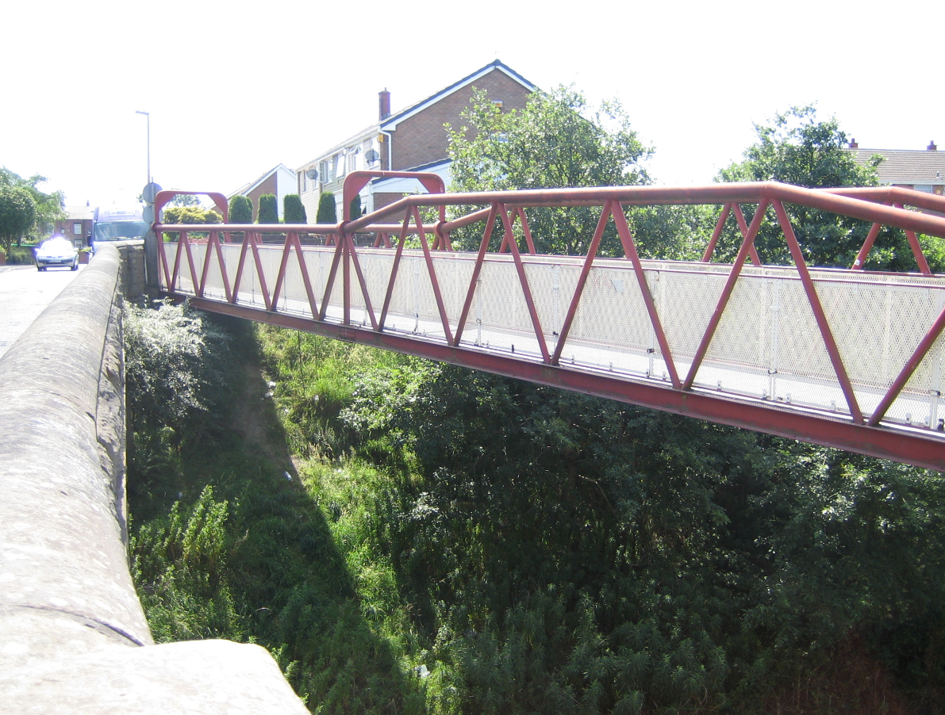
Rochdale Borough Council are proposing to remove the footbridge and replace it with a similar type bridge. The proposal is to manufacture the replacement bridge off site, bring it to site and place it onto the existing abutments. The old bridge will be removed from site and disposed.
Work Required:-
- Removal and disposal of the existing 37m span steel tubular bridge
- Design of new replacement bridge (37m span and 2.3m width).
  - Steel beam and parapet with FRP anti-slip deck
  - Additional mesh in-fill panels to the parapet to prevent debris falling onto the tracks
  - All steel to be painted to series 1900 specification with a four coat paint system
  - Bearings as required
- Manufacture of the replacement bridge off site
- Strengthening of the existing abutments as determined once the existing bridge has been removed
- Installation of the bearings
- Traffic management
- Accommodation works for crane to lift in bridge
- Transportation of the bridge to Schofield Street
- Installation of the bridge
- Any work required to repair the footway/fencing/carriageway/verges etc in close proximity to the new bridge which may be affected by the work.
The railway below the bridge is operated by ELR. Steam trains run on the line frequently during summer months and December. At other times the use is ad-hoc. ELR run a permit to work system to ensure the tracks will be clear when any work is on-going. The successful contractor will be required to liaise with ELR to ensure permits to work are provided and ELR will also require a presence on site when the work is on-going.

The company tendering must be in a position to tender these works before the end of November 2019 with the expectation that the successful contractor will be on-site by February/March 2020.
If you are interested in this opportunity can you please notify us using The Chest messaging function by Friday 18th October at 12:00 noon.
In line with Rochdale Council’s local investment initiative, if we receive enough expressions of interests from suitable contractors within Greater Manchester we will be looking to only invite these contractors to tender.
A more detailed specification will be available at invitation to tender stage, but if you have any specific questions around the project could these also be directed via the messaging function on The Chest.

