How to Submit a Response on the Portal

- Log in to Supplying the South West portal
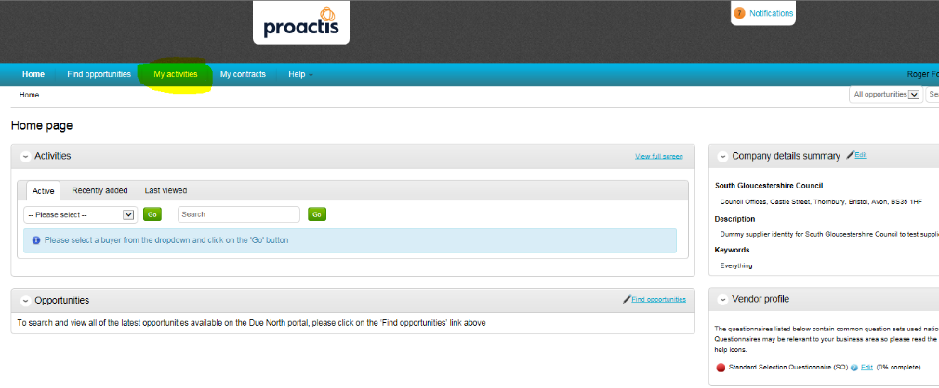
- In the top menu bar choose ‘My activities’
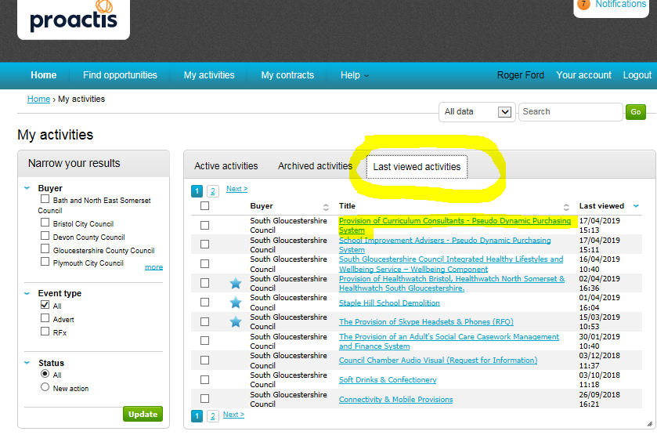
- Then click on ‘Last Viewed activities’ Hopefully the opportunity you are looking for is in this list- Please click on it

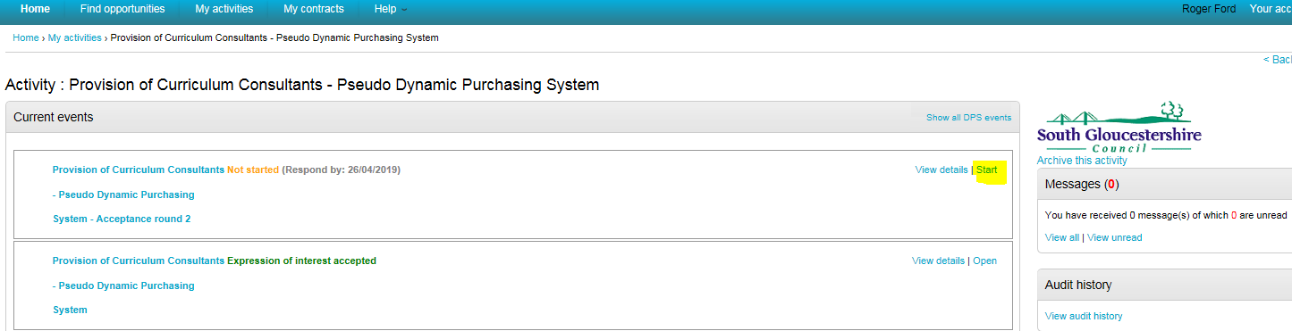
- The next page you will see is this one. Click on ‘Start’ Note: this will change to Open next time you go back to this page

- ‘Start or Open’ will take you to the page below which holds all the documents you will need to complete your tender. (see bottom of screen shot)
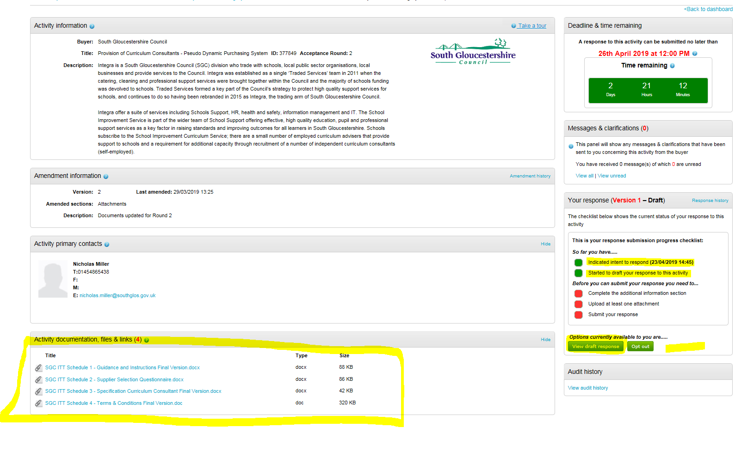
- Mine has disappeared (because I have already done it) but there will be a link asking you if you intend to respond where there is an

- click on ‘View draft responses’ (note you now have two green dots…. your responses is not ready to submit until they have all turned green)

- On this page click on ‘Edit’ and complete additional information (this will turn another red dot green for you)

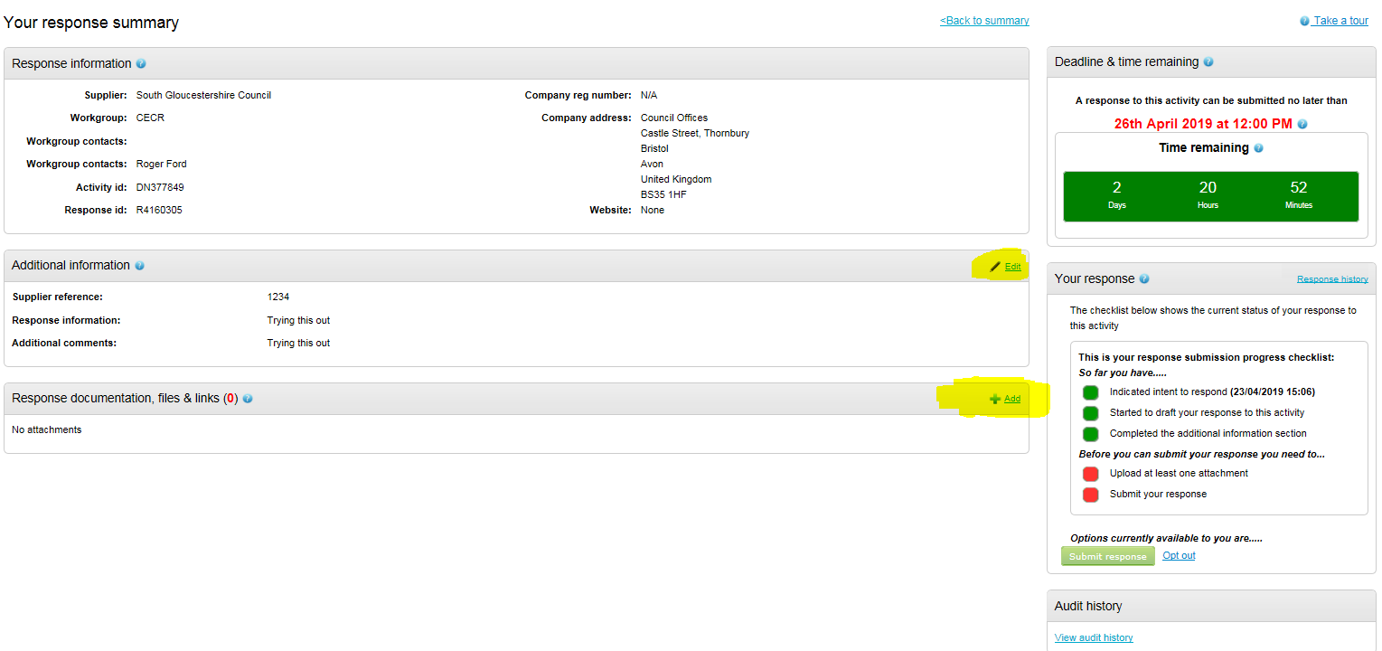
- Once you have your documents ready you can upload them to the portal by clicking on the + Add

- This is the upload screen. Start with ‘Add Files’ and once you have your documents ready, click of ‘Start upload’

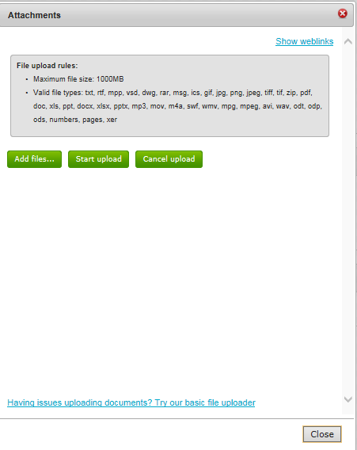

- When you happy with your submission. His the pulsing ‘Submit Response’ this will turn your final red dot green and you Submission is complete

