FOLKESTONE CLLD PROGRAMME

Brief to provide support and advice to the EU funded Folkestone Community Works programme

1. FOLKESTONE COMMUNITY WORKS PROGRAMME

  - In December 2017 Shepway District Council secured £2.49 million of European funding for a Community Led Local Development (CLLD) Programme to operate in Folkestone until 2022. The programme is called Folkestone Community Works.

  - The funding secured for the Folkestone Community Works programme is from European Structural and Investment Funds Growth programme and comprises £1.5 million from the European Regional Development Fund and £975,000 from the European Social Fund. The European funding for the programme has to be matched 50:50, with the result that some £5 million will be invested into the area and local people.

  - The aim of Folkestone Community Works is to improve the social and economic community cohesion in some of Folkestone most deprived areas by:
  - Helping residents to access jobs
  - Helping local businesses and start-ups to grow
  - Providing new job opportunities.

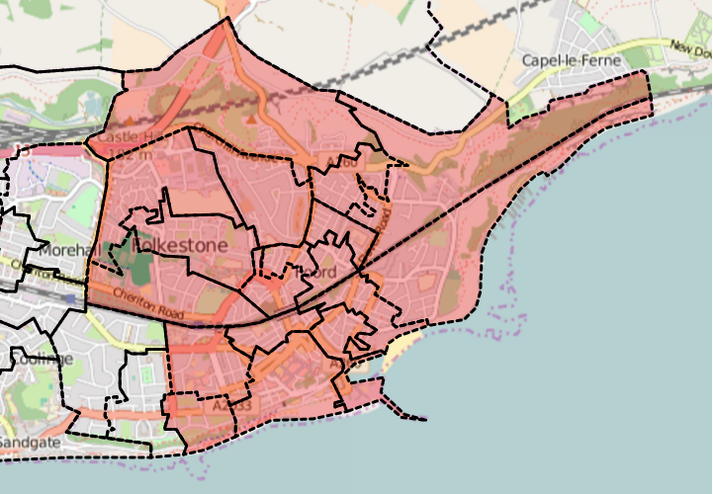
Figure 1 - Map showing the Folkestone Community Works in Folkestone

  - Funding for the Folkestone Community Works programme will be targeted on a defined area of Folkestone (Figure 1), where grants will be available for organisations and businesses to deliver the programme strategy, which was developed in 2016 as part of the programme application process.

  - Folkestone Community Works programme is structured around three objectives with eight activities:

Objective 1 – Enhancing work-readiness and well –being
Action 1.1: Work experience and job preparation for young people
Action 1.2: Getting people back into work
Action 1.3: Promoting emotional and physical well-being
Action 1.4: Promoting financial wellbeing

Objective 2 – Promoting local business and social enterprise
Action 2.5: Promotion of social enterprise
Action 2.6: Support for business start-ups
Action 2.7: DIY Space /incubation

Objective 3 – Integrated delivery mechanism for the strategy
Action 3.8: Setting up and operating the Community Hub

  - Folkestone Community Works aims to support 1,000 people including 350 unemployed, 350 economically inactive, 250 people with disabilities, 75 people from ethnic minorities and 100 people over 50+. We expect the programme will help at least 200 people to enter education or training who were not previously, 160 unemployed to find a job and 189 economically inactive people to find a job or start looking for one.

  - Folkestone Community Works also aims to support 148 new enterprises to be created, 195 existing businesses to grow, and create at least 98 new jobs as well as help 175 potential entrepreneurs to be enterprise ready. There is also scope to refurbish 400sqm of public/commercial buildings.

- PROGRAMME TIMETABLE AND FIRST PROJECT CALL

  - Programme Timetable

Programme timetable | Dates
Start date (date from which eligible expenditure will be incurred) | 26 October 2016
Financial completion date (date by which eligible costs will have been defrayed (European Social Fund – contractual completion date) | 31 December 2022
Practical completion date (date by which all outputs will be achieved. European Regional Development Fund only) | 31 December 2022
Activity end date (date by which all the activities described in the funding agreement will be completed) | 30 June 2022
Other milestones | Start date | Completion date
First call
Launch event with introduction workshop |  | February
Issue and submission Eligibility Forms |  | 2 March 2018
Issue and submission of applications | March 2018 | May 2018
Workshop 1 to support applications | April 2018 | May 2018
Workshop 2 to support applications | April 2018 | May 2018
Assessment of full project applications | June 2018
LAG Meeting – reviews applications, decision on approval | June 2018
Project team set up funding agreements | June 2018 | July 2018
Project team visit delivery organisations to ensure monitoring structure in place | June 2018 | July 2018
Delivery Organisations commence work | Aug/Sept2018
LAG Meeting– consider if further funding rounds required and implement | March 2019
LAG Meeting – Commencement of Mid-term evaluation | Sept 2019
LAG Meeting– Presentation of Mid-term evaluation with commentary to LAG. Adjustments made to delivery if required. Consider if further funding rounds required and implement | December 2019
LAG Meeting– consider if further funding rounds required and implement | March 2020
LAG Meeting – consider if further funding rounds required and implement | March 2021
Activity end date | 30 March2022
Grant recipient’s funding defrayed by | 30 June 2022
LAG Meeting – programme closure review | October 2022
Outputs/results completed by |  | 31 October 2022
Programme staff contracts end |  | 30 November 2022
Final M&A claim | 1 December 2022 | 31 December 2022

The dates of the two workshops for the first call are scheduled for:
- Workshop 1 provisionally scheduled for Thursday 19th April 10:30am to 4:00pm.
  - First session 10:30am to 1:00pm presentations on key topics for organisations wanting to access ESF and/or ERDF funding and complete the project application form such as budgets, match funding, procurement, outputs and results, monitoring and evidence and state aid.
  - Second session: 1.00pm to 4pm 1:1’s or small groups. Organisations will be asked to pre-book and identify areas they want further guidance on.

- Workshop 2: provisionally scheduled for early May 2018 either week commencing 30th April or 7th May 2018 10:30am to 4:00pm. Similar format to workshop 1.

- FOLKESTONE COMMUNITY WORKS PROGRAMME MANAGEMENT

  - Folkestone and Hythe District Council is the accountable body for the Folkestone Community Works programme. A Programme Management Team has been established within Economic Development to deliver the programme. This team comprises a Programme Manager and Programme Assistant who oversee the delivery of the Folkestone Community Works programme with support from other officers in the legal, communications, HR and finance departments.

4.2 Folkestone Community Works programme will meet its outputs and results by offering to local organisations and businesses funding through two funding streams:

- Main Projects: to be delivered by intermediary organisations who are the project applicants. The beneficiaries are residents or businesses in the Folkestone Community Works area (ESF & ERF funding)
- SME Business Grant Scheme: Businesses are the applicants and beneficiaries (ERDF funding).

  - The application process is a two stage process, stage 1 is an Eligibility Questionnaire and the stage 2 is the full application. Workshops are planned to be held to support and the applicants to ensure they understand the requirements that need to be meet and the level administration associated with EDRF and ESF funding.

  - The first round has been launched and Eligibility Questionnaire forms submitted. It is envisaged there will be a further two or three calls over the length of the Folkestone Community Works. This call for projects, which commenced on 22nd February includes two workshops to support interested organisations to complete the Application form which is due to be submitted by 20th April 2018. These workshops will make sure that potential delivery organisations are fully aware of the administrative requirements of any EU funded projects and the need to adhere to the EU rules and regulations. Information will be provided on key areas including state aid, procurement rules and regulations, eligible spend, evidencing outputs and results and record keeping.

- BRIEF SPECIFICATION

  - Folkestone and Hythe District Council is seeking consultant support to undertake its programme management responsibilities. The key deliverables required are to:

- Support the delivery of the First Call Project Application workshops and in providing training and advice to project applicants for projects through:
- prior to the workshops: ½ day preparatory training for the programme management team covering key issues when managing ESF and EDRF projects (content to be confirmed)
- presenting on key aspects of the programme in conjunction with the programme management team at the two workshops.
- providing answers to questions from the potential project applicants at the workshops
- supporting the programme management team with 1-2-1 support for project applicants as required during the project grant funding process.

- Provide training and on-going advice to the Folkestone Community Works Programme team on the relevant rules and guidance for the England 2014 to 2020 European Structural and Investment Funds in administering, delivering the programme and in submitting financial claims, maintaining evidence, etc to the managing authorities for ESF and ERDF funding

Please note: the Folkestone Community Works Programme Management Team will set-up and organise the workshops. This includes inviting and organising attendees, booking and preparing the workshop facilities in Folkestone.

If the Folkestone Local Action Group (LAG) and Folkestone and Hythe District Council consider further funding rounds are needed to meet the outputs and results for the EU funding, then further funding calls will be undertaken. If this occurs then the contract may be extended to cover future rounds in 2019-2020.

The contract will run from 1 April 2018 to 30 December 2018, with the potential for this to be extended to provide support for future project calls.

The budget for the services for April to December 2018 is up to £3,000. The total estimated contract value, if the contract is extended, is £5,000.

6. PAYMENT

6.1 Payments will be made by monthly invoicing and the tracking of time spent in. Timesheets will be required.

