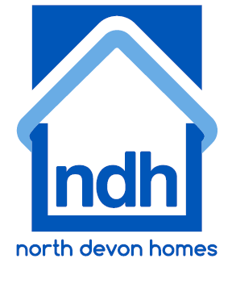

North Devon Homes
Asset Management
Expressions of Interest
Electrical Response Repairs Works
North Devon Homes (“NDH”) is a Charitable organisation formed in February 2000 to take on the management of 3,200 homes located primarily in Barnstaple, Ilfracombe and South Molton in North Devon.

NDH would like to invite expressions of interest ( EOI ) from suitably qualified contractors to provide a electrical responsive repairs service across our stock. The annual contract value is in the region of £400k and NDH issue approximately 2300 job tickets per year with approximately 350 emergency jobs and 150 out of hours call outs.

The successful contractor will be expected to work collaboratively with NDH to ensure an efficient and effective service is delivered to our customers that will be completed within our target timescales, whilst maintaining our standards for customer satisfaction. When you register an interest you will be sent the Invitation to Tender.

The initial 3 year contract will commence in June 2020 with the potential to extend for a maximum of a further 3 years subject to satisfactory performance review.
Timescales :
EOI Close : 23/12/2019
Tender Issued : 16/01/2020
Tender Returned : 20/02/2020
Contract Awarded : 26/03/2020
Contract Start : 01/06/2020

To register your interest, please go to www.advantageswtenders.co.uk where you can find the advert for this opportunity

