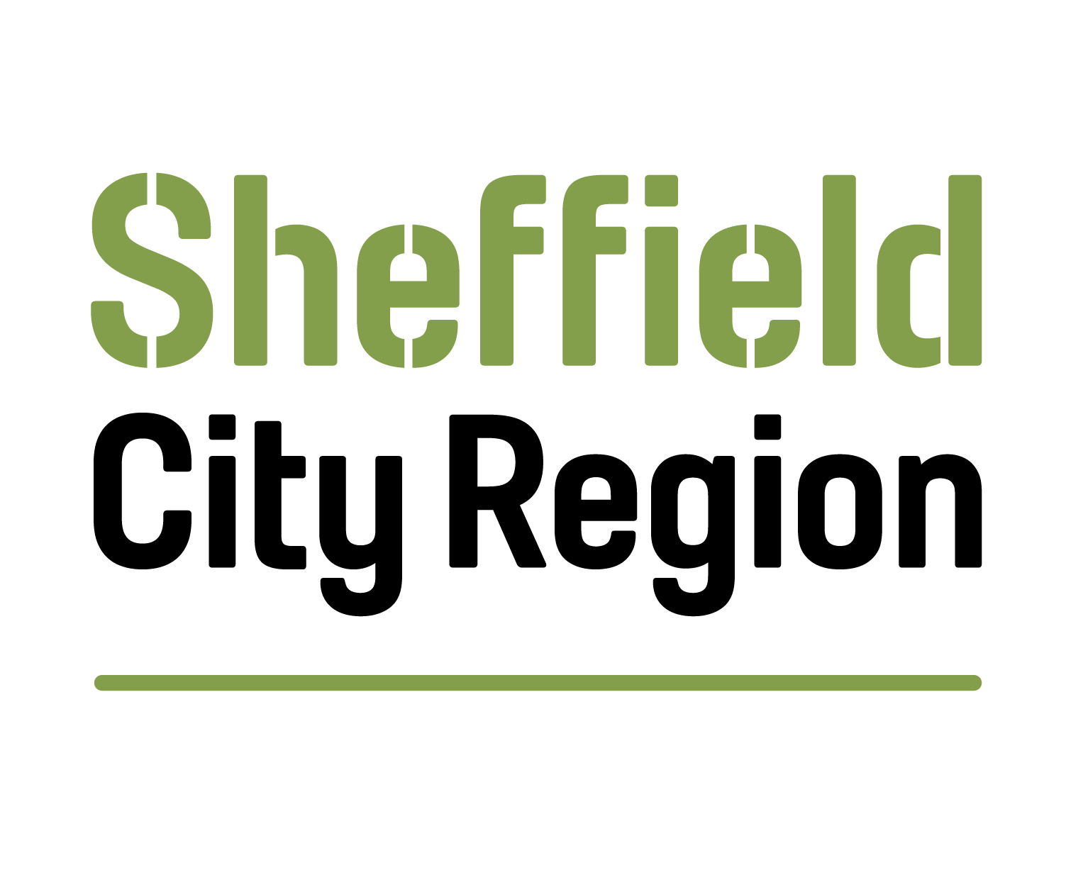

Invitation to Tender Part 3 - Specification
Title: Participatory Democracy
Reference: DN676053
Tender return deadline: 12 noon, 11 November 2021

You are invited to submit a tender for the above contract and the following documents are available on the YORtender system to enable you to submit your tender electronically.
- Invitation to Tender Part 1 –Instructions (for reference)
- Invitation to Tender Part 2 - Terms and Conditions (for reference)
- Invitation to Tender Part 3 – Specification (this document for reference)
- Invitation to Tender Part 4 – Tender Submission (to be returned)

Table of Contents

1. INTRODUCTION 3
2. AUTHORITY INFORMATION 3
3. GENERAL DESCRIPTION 3
4. VISION AND OUTCOMES 3
5. DRIVERS AND BENEFITS 3
6. STATEMENT OF REQUIREMENTS 4
7. STATUTORY REQUIREMENTS AND GUIDELINES 5
8. CLIENT DETAILS 5
9. ORDERING OF GOODS OR SERVICES 5
10. COMMUNICATIONS STRATEGY 5
11. DATA AND INFORMATION TECHNOLOGY 5
12. TRANSITION AND MOBILISATION 6
13. EXIT PLAN 6
14. EQUALITY AND DIVERSITY 7
15. EMPLOYMENT PRACTICES 7
16. C CORPORATE SOCIAL RESPONSIBILTY / SOCIAL VALUE 8
17. ENVIRONMENT AND SUSTAINABILITY 8
18. QUALITY MANAGEMENT 9
19. WORKING PRACTICES 9
20. HEALTH AND SAFETY 9
21. CONTRACT MANAGEMENT 10
22. PAYMENT 10
23. PERFORMANCE MANAGEMENT 11
24. PERFORMANCE INDICATORS 11

INTRODUCTION
  - Sheffield City Region Mayoral Combined Authority (SCR MCA) is inviting tenders from organisations with suitable experience and expertise to support the management and delivery of participatory democracy, citizens engagement and associated research.
  - It details the standards and outputs which the Supplier is required to achieve and how these will be measured.
  - It will form part of the contract with the Authority.
  - The estimated value of the contract, including any extension period(s) is £25,000
  - The Authority anticipates that the contract will start Nov/Dec 2021 and end early spring 2022.
  - SCR MCA is inviting tenders from companies with suitable experience and expertise to support the delivery of participatory democracy and citizens engagement research solutions.

AUTHORITY INFORMATION
  - This specification is published by the Sheffield City Region Mayoral Combined Authority (the Authority). Further information about the Authority can be found on our website at https://sheffieldcityregion.org.uk/

GENERAL DESCRIPTION
  - The MCA and Local Enterprise Partnership (LEP) have approved their 20-year Strategic Economic Plan (SEP), which sets out our blueprint to drive the region’s recovery from COVID and transform South Yorkshire’s economy and society for people, businesses and places. The SEP shows the way to a stronger, greener and fairer economy as the region looks to unlock its potential and create prosperity and opportunity for all. The vision at the core of our strategy is to “build an economy that works for all”.
  - Our subsequent Renewal Action Plan (RAP) sets out our road map to help South Yorkshire recover from the pandemic and put us on the path towards social and economic renewal. It will help people, employers and places recover, and put us on course to transform our region – making our economy and society stronger, greener and fairer. The plan also contributes to our longer-term goals and the transformation of our City Region – so we can build back better. The plan shows how we will help to make the economy:
  - Stronger – an economic transformation to create not just a bigger economy but a better one: higher-tech, higher skill, and higher-value
  - Greener – a green transformation to decarbonise our economy, improve our environment, and revolutionise our transport
  - Fairer – a transformation of wellbeing and inclusion, reforming our economy, raising our quality of life, reducing inequality, and widening opportunity
  - In order to deliver a more socially and economic inclusive South Yorkshire the MCA will develop an Inclusion Plan articulating a set of actions which have gained consensus of key stakeholders. To inform this, the MCA needs to develop a stronger evidence base on the specific issues of economic and social inclusion facing the region.
  - The Inclusion Plan should focus on how entrenched inequalities within South Yorkshire can be addressed, such that all people are enabled to contribute to and benefit from the prosperity generated through the implementation of the SEP. In this way, the Inclusion Plan will fully complement the SEP by ensuring that the prosperity that arises from economic growth is equitably distributed across the population, leading to greater social cohesion and improved life chances for all.
  - Under the working title of ‘Inclusion Plan’, SCR MCA is looking to adopt a set of actions which embeds inclusive practices and outcomes into decision making, activities, investments and all actions for us and our partners. We have decided to embrace participatory democracy as one means of helping us define the activities under several areas of the “Inclusion Plan” that are being taken forward:
    - Health and wellbeing
    - Social outcomes contracts (and charter)
    - Social value via progressive procurement
    - Inclusive innovation
    - Access to public services

  - We hope this commission will also help us understand how participatory democracy can become a useful tool in our engagement in the future.

BACKGROUND AIMS AND OUTCOMES
  - SCR MCA has much to gain from democratic engagement and citizen participation in identifying priorities, working through challenges and across the wider devolution agenda. Participatory democracy is key to more effective decision making that better meets the needs of local communities and builds on their strengths, knowledge and experience. It can bring disengaged citizens back into the democratic process, empower residents and help increase legitimacy. Participatory democracy supports the development of locally focused activities that are better suited to the strengths, needs and aspirations of local people, helping improve strategic design and improving outcomes.

  - There are lots of examples of effective civic and democratic engagement and other combined authorities have already put in place approaches to civic and democratic engagement. SCR MCA has fledgling elements of participatory democracy in its Governance and structures, for example around overview and scrutiny, public consultations on policy, the Youth Combined Authority, and engagement with communities through partner organisations. However, more can and should be done.

AIMS AND OUTCOMES
  - The aim of the project is to provide a direct, responsive and cost-effective channel for the voice of the South Yorkshire public to inform and develop the focus, ambition and scope of the Inclusion Plan at key milestones in the process.

  - The research has two key aims:
  - Gather citizen views and qualitative insight to guide the:
    - Identification and agreement of inclusion plan priorities.
    - Propose areas of focus and provide feedback on the emerging areas of the Inclusion Plan.
    - Help identify actions and owners within the plan.

  - Provide the basis for a co-learning journey for the SCR MCA, with recommendations on how to continue to embed participatory democracy in our work.

The work has a series of objectives including:
  - Provide feedback based on informed understanding of specific issues and of communities’ own lived experience and knowledge.
  - Engage with a cohort of our population in a meaningful way around the emerging focus for constituent parts of the Inclusion Plan.
  - Engage a series of other stakeholders to include their voice:
      - Local Politicians - updating them and ensuring their voice is heard.
      - The voluntary and community sector.
  - Produce a series of short report findings (or other outputs) which capture:
      - Key priorities and definitions of inclusion.
      - Feedback on a proposed activities and particularly the inclusion plan workstreams procurement and employer charter aspects of the inclusion plan;
      - “action oriented” interventions and activities which can be delivered by different partners; and
      - How future participatory democracy approaches can embedded within SCR MCA activities (including what type of engagement would be suitable for thematic engagement) for example; how participatory democracy approaches can be embedded and why we should (e.g. gathering insight from participants/stakeholders to how they feel this process is more or less value than other processes)
  - Get a public view on the name of the Inclusion Plan and its constituent parts.

Methodology
  - SCR MCA is looking for suppliers to propose a methodology to deliver the aims and objectives. We are open to proposals, to potentially include but not limited to citizen panels, technology-based approaches, traditional primary research methods (e.g. focus groups) etc.
  - On appointment, we expect the successful supplier to provide all software/platforms and physical facilities required to run the engagement and for the work to provide a set of more informed insights.
  - We would like suppliers to provide parameters of engagement including number of people and suggested dates and method (bearing in mind the potential options for F2F meetings).
  - We expect the supplier to undertake the majority of communications, with SCR MCA’s communication channels (e.g. email circulation lists, social media) being available. We can also provide stakeholder maps if this would be helpful.
  - We would be interested in suppliers working with voluntary and community sector in South Yorkshire to help reach citizens not usually engaged in participatory democracy approaches.
  - We would like the supplier to delineate roles for a small team of Combined Authority officers to participate, noting that activities should not take up more than 2-3 hours a week (on average).
  - We would expect that details of engagement will be shared and recorded for transparency purposes.

Working with evidence suppliers
  - The supplier should work and cross-references with the team delivering a complementary commission which is focused on an evidence review of economic and social inclusion in South Yorkshire. We anticipate that this dialogue will focus on research evidence and how this aligns to the priorities identified through the participatory democracy. This will also include testing the key messages from the evidence review with the citizens (as part of the prioritisation and definition of inclusion). See below diagram to show how the two contracts interact:
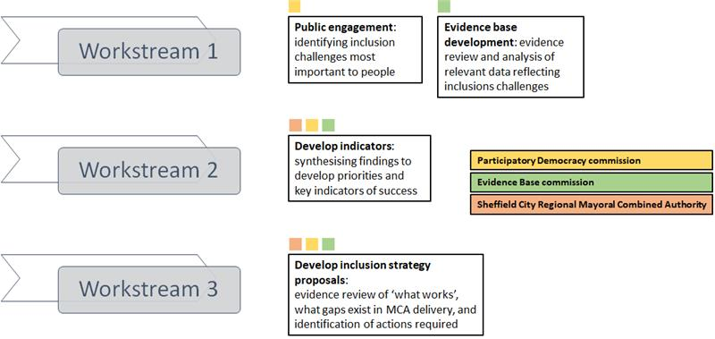

Geographic Nature
  - The focus for the work is the communities of South Yorkshire, namely Barnsley, Doncaster, Rotherham, and Sheffield.

Representative
  - The successful supplier will be responsible for engaging or “recruiting” members of the public, all of whom should be based in South Yorkshire for employment or residency. Your response to this tender should advise on size of the engagement, taking account of the demographic mix and other socio-economic conditions. We appreciate that as an engagement tool, any solution may not be fully representative of the population of South Yorkshire but are looking for a good mix of representation from different ethnic, health, socio-economic, age groups. We are also interested in reaching groups across the population that have not been engaged in SCR MCA activities or policy in the past.

Additional project stakeholders.
  - The focus should be upon engaging citizens but based on work to date, we have identified the following groups as also important to inform and get input on the project:
  - Politicians (Local leaders)
  - Voluntary and Community Sector
  - Discussions with other Combined Authorities or LEPs or local councils (e.g. Wigan) that already run participatory democracy solutions to develop knowledge and

Scope and intended use
  - SCR MCA and partners already carry out a several research projects aimed at citizens and we intend that this project will complement existing research approaches.
  - Our thinking on public engagement is still developing. We also recognise some of the potential limitations of citizen engagement, including that the solutions are unlikely to automatically enable us to easily access the most hard-to-reach communities. We would like suppliers to suggest limitations and any mitigations.

STATEMENT OF REQUIREMENTS
  - We suggest three short reports but are open to ideas to how outputs are delivered. Outputs should cover in fair detail:
  - Suggested name of document(s)
  - Identification of priorities around inclusion under the priority areas:
    - Health and wellbeing
    - Social outcomes contracts (and charter)
    - Social value via progressive procurement
    - Inclusive innovation
    - Access to public services
  - Suggestions and feedback on scope of activities within above areas
  - Identified actions and action owners related to above areas.
  - Short Recommendation Report on Participatory Democracy in MCA
  - A slide pack (or similar product), summarising the approach, methodology and highlights of the work. This should be suitable for presenting to Boards and also sharing with the general public.
  - Tenders should include a project plan and time schedule for the engagement. The plan should be accompanied by a resource profile, giving a breakdown of the resources in person days allocated to each task, for each key project team member.
  - Suppliers will be expected to present findings at each ‘stage’ of engagement with citizens at three meetings with SCR MCA leadership teams (likely one LEP board and the other with the SCR MCA Executive teams).
  - We expect the suppliers to establish weekly meeting with the SCR MCA project team.

TIMESCALES
  - Engagement timescales:
  - Identification of stakeholders – Week 1/Week 2
  - Priority Identification – 2 months
  - Provide feedback based on informed understanding of specific issues and of communities’ own lived experience and knowledge.
  - Engage with a cohort of our population in a meaningful way around a focus for the Inclusion Plan.
  - Interim report which reports on:
    - Key priorities and definitions of inclusion.
    - Feedback on a proposed activities and particularly the inclusion plan workstreams procurement and employer charter aspects of the inclusion plan;

  - Final Report on Inclusive Plan priorities and Participatory Democracy in South Yorkshire which covers:
    - Key priorities and definitions of inclusion.
    - Feedback on a proposed activities and particularly the inclusion plan workstreams procurement and employer charter aspects of the inclusion plan;
    - “action oriented” interventions and activities which can be delivered by different partners; and
    - How future participatory democracy approaches can embedded within SCR MCA activities (including what type of engagement would be suitable for thematic engagement) for example; how participatory democracy approaches can be embedded and why we should (e.g. gathering insight from participants/stakeholders to how they feel this process is more or less value than other processes)
  - Identification of actions and owners – 3 months
  - Public view on the name of the Inclusion Plan and its constituent parts.
3month after start

STATUTORY REQUIREMENTS AND GUIDELINES
  - The Supplier will ensure that all relevant consents and certification required by legislation, guidance or Good Industry Practice are obtained and maintained. Including licences for use of data, etc.

CLIENT DETAILS
  - A dedicated Project Manager within the Authority will act as first point of contract for the Supplier.
  - A project Steering Group, with a representative invited from each of the commissioning partners, will be established by the Project Manager. The Steering Group will be responsible for project delivery overall and receiving progress reports, etc.
  - The Project Manager can be contacted via email or telephone during normal officer hours.
  - The Project manager will also ensure contact details for partners are provided as required.
  - If face-to-face meetings between the Authority and Supplier are required / permitted under Covid-19 restrictions these will take place at the Authority’s offices at 11 Broad Street West, Sheffield, S1 2BQ.

ORDERING OF GOODS OR SERVICES
  - A fixed price for the entirety of the work will be agreed on selection of the preferred Supplier. It is assumed that payments will be made to the Supplier at relevant points.

  - No amendments to the required Services will be made without the Authority’s written permission, and any amendments will be subject to the schedule of rates included in the Supplier’s submission, which will form part of the contract.

COMMUNICATIONS STRATEGY
  - The Authority’s Project Manager will be the first point of contact for the Supplier.
  - The Supplier will also be expected to take part in meetings of a Project Steering Group. Working within the current restrictions imposed by Covid-19, Steering Group meetings will be held virtually via MS Teams on a monthly basis. However, a face to face steering group meetings will be sought if this becomes practical over the course of the work.
  - In between meetings of the Project Steering Group, the Supplier will need to be contactable by phone, email and MS Teams during normal officer hours and as required to ensure progress of the work.

DATA AND INFORMATION TECHNOLOGY
  - The Supplier will be required to access information from a range of sources including:

  - Access to Master Maps (under existing Local Authority licenses)
  - Agreements for data access and sharing, use of QGIS. Local Plan information, etc
  - Input and expertise from local partners (Supplier to source relevant input from partners including: Local Authority ecologists & GIS technicians, other LNP partners e.g. NE, EA, FC, Wildlife Trusts, Woodland Trust, local groups)
  - Access to data from local records centres (Supplier to source)
  - Tenderers will need to include in their submission any additional data from third parties required to deliver the Services. It will be the supplier’s responsibility to arrange access to third party data sets, and submissions should be made inclusive of any timescales or costs associated with this.

EXIT PLAN
  - The Supplier will provide all of the outputs listed at Section 6.1 to the satisfaction of the Client.
  - All data and reports will be provided to the MCA.

EMPLOYMENT PRACTICES
  - The Authority is officially recognised as a Living Wage employer by the Living Wage Foundation and we encourage our contracted suppliers to voluntarily sign up to the movement. One of the aims of the Living Wage is to help reduce levels of poverty across the UK. Payment of the Living Wage allows people to provide for themselves and for their families, improving their quality of life and expectations for the future. For businesses, paying a Living Wage can improve the quality of work carried out, create a more responsive and flexible workforce, and reduce absenteeism and staff turnover. For society, the Living Wage reduces reliance on benefits and can help reduce social and health inequalities. Lower-paid workers tend to spend money locally, which can be good for business and for the local economy. You can find more information at www.livingwage.org.uk.

CORPORATE SOCIAL RESPONSIBILTY / SOCIAL VALUE

Developing an Inclusion Plan for SCR MCA will enable the authority and its partners to improve the welfare of those economically excluded in the region.

Tenderers’ submissions will not be evaluated in relation to social value, but the Authority will welcome any proposals from tenderers that articulate how their delivery of the Service could provide additional social, economic or environmental benefits to the Sheffield City Region.

ENVIRONMENT AND SUSTAINABILITY
  - The Supplier shall in performing the service for this contract meet all Legislation, Guidance and Good Industry Practice in environmental management.

WORKING PRACTICES
  - To meet the obligations of this contract the Supplier shall ensure that Good Industry Practice is maintained.

  - A key component of this commission is for the Supplier to be proactive and willing in their approach to working with stakeholders across different organisations.

HEALTH AND SAFETY
  - The Supplier will provide and maintain Quality Plans and Health and Safety Plans in respect of this Service in accordance with the Health and Safety at Work etc. Act 1974:
  - The Supplier of this service will be required to adhere to the Health and Safety at Work Act 1974 at all times and any other relevant guidance and directives in force or subsequently issued.

CONTRACT AND PERFORMANCE MANAGEMENT
  - The Authority recognises that it is good practice to provide planned contract management for all contracts. This will assist the Authority in achieving value for money and supporting a positive working relationship with the Supplier.
  - The Project Manager for this contract will be a Senior Economic Policy Manager in the MCA’s Policy Team.
  - The contract manager for this contract will be Emma Pashley, Programme and Performance Officer in the Authority’s Programme and Performance Unit.
  - A Project Steering Group, with a representative invited from each of the commissioning partners, will be established to oversee the performance progress of the Project. This Steering Group will be responsible for ensuring the project progresses in line with the timescales agreed and ensure full engagement from all partners.
  - The project will be monitored through monthly review meetings. The supplier will submit a monthly report in advance of review meetings, detailing progress towards delivery of outputs, and an associated technical update detailing specific tasks undertaken, in progress and planned. Monthly review meetings will be held virtually and include the Supplier and the Authority’s contract manager and project manager.
  - At contract completion a closure meeting will be held, to confirm the handover of final outputs to the MCA and to review the recommendations and requirements in relation to the outputs.

PAYMENT
  - Tenderers will, as part of their submission, provide a payment schedule detailing their fee in relation to the outputs associated with this project, payment milestones in the contract will be linked to satisfactory completion of draft and final outputs. The Supplier will invoice on a monthly basis for payment milestones achieved in the preceding month.
  - The Authority will supply a purchase order number against which the Supplier can submit invoices. Payment terms are 30 days from receipt of a valid invoice.

