Contents
How to find this opportunity using the Kent Business Portal 1
How to access the SQ documents 4
How to submit an SQ response 5

How to find this opportunity using the Kent Business Portal

To find the Opportunity on the Kent Business Portal, go to www.kentbusinessportal.org.uk and click ‘Current Opportunities’ on the left hand side.
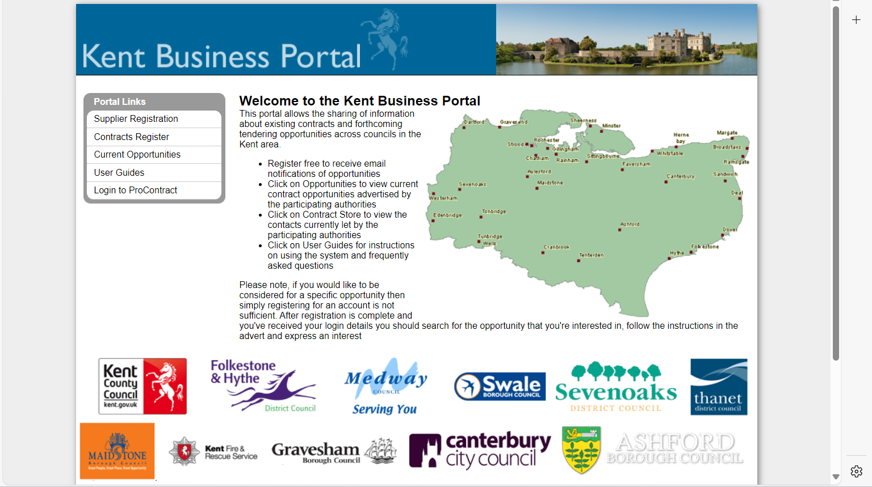

Choose ‘Kent County Council’ from the ‘Organisations’ drop down list
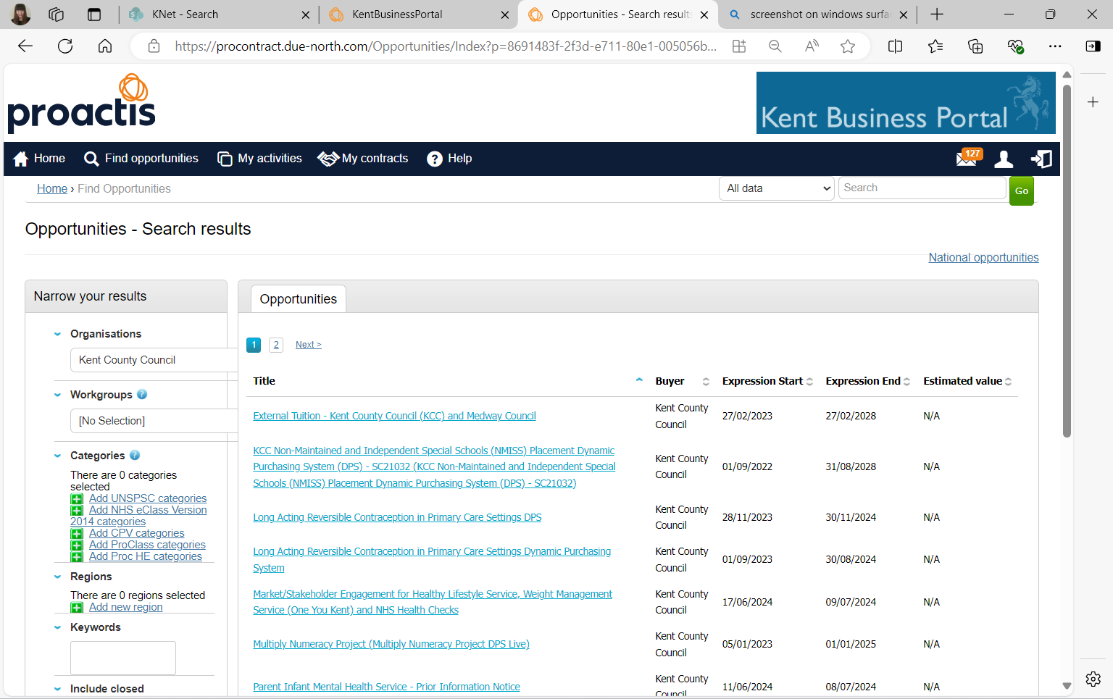
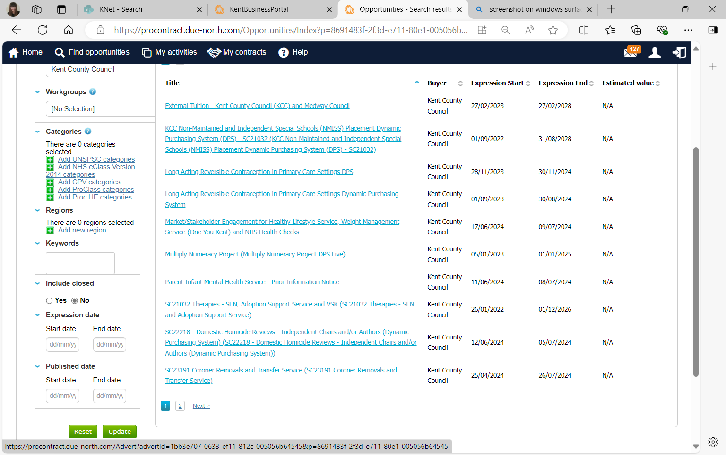
Click on the opportunity title from the list shown.

Click ‘Register Interest in this opportunity’. You may be prompted to login to your Kent Business Portal account.
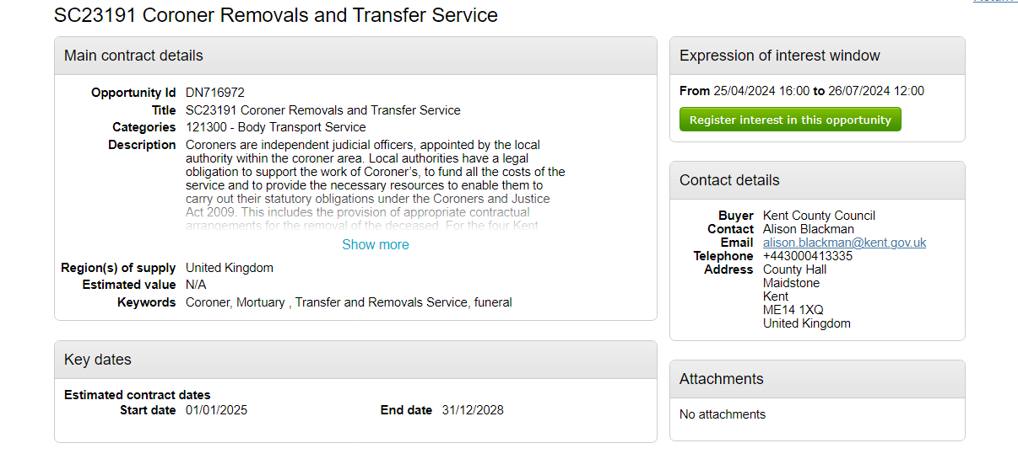

To access the SQ documents, click on the link shown. You should also receive an email including a link to the SQ documents. 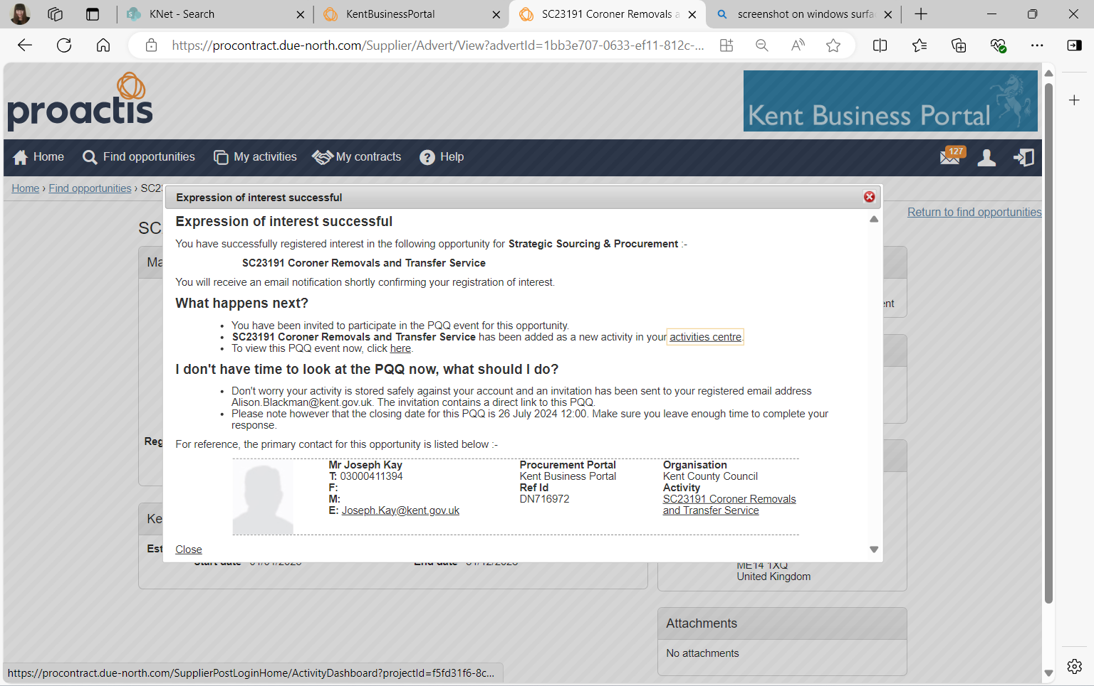

How to access the SQ documents

Click ‘Open’
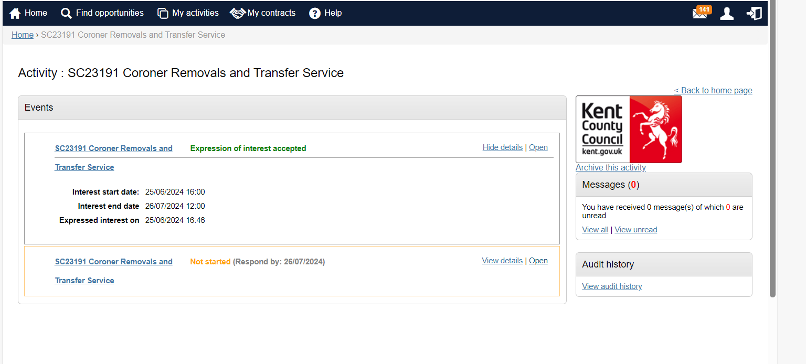
The SQ page includes a countdown to the deadline for responses on the right-hand side.
Click on ‘View All’ on the right-hand side to access any clarification messages relating to this opportunity, or submit a question about the opportunity to the Council.
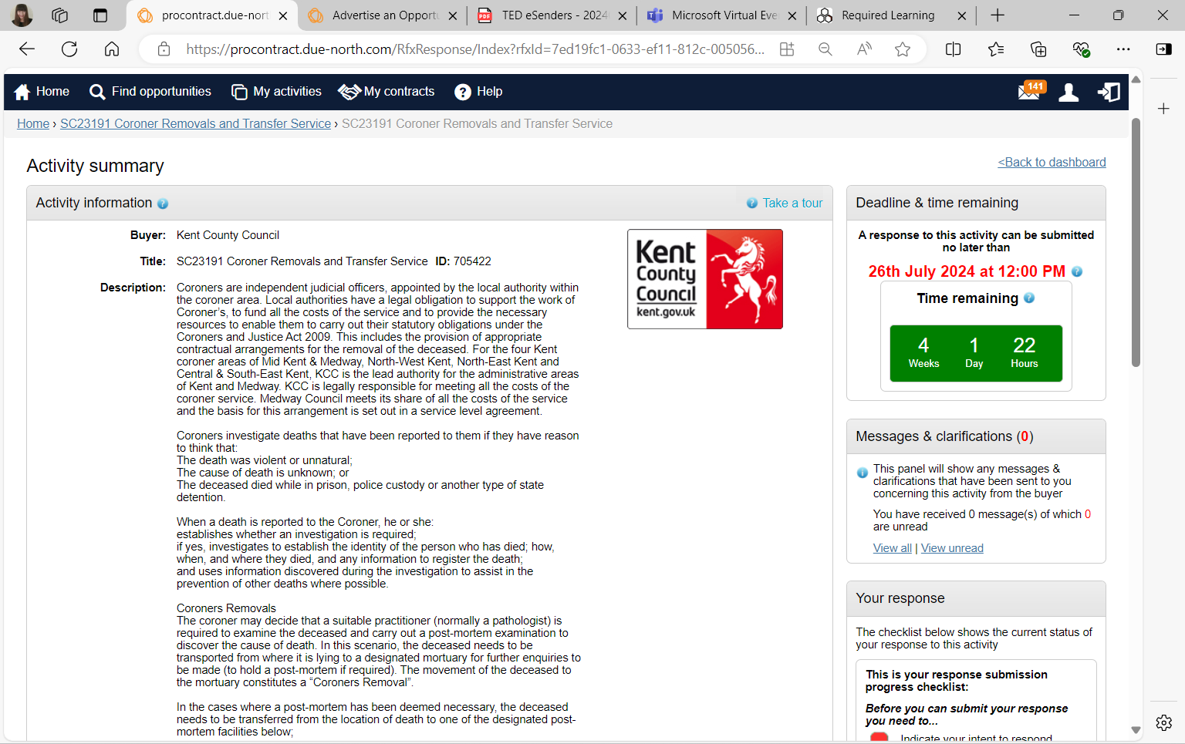

The SQ documents can be found at the bottom of the page

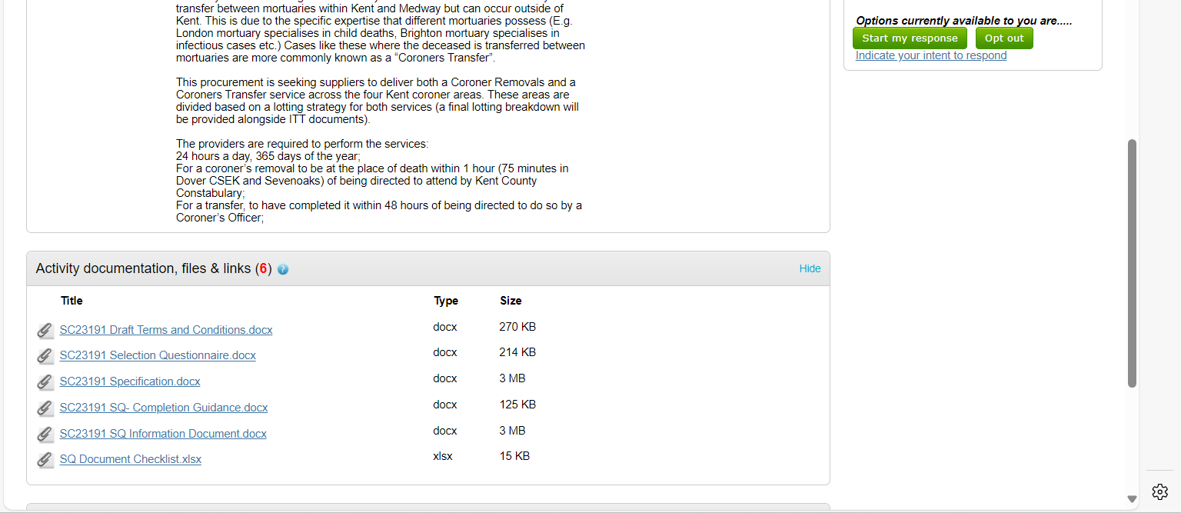

How to submit an SQ response

When you are ready to submit your response, click ‘Start my response’.

To attach your SQ response document, click ‘Add’.
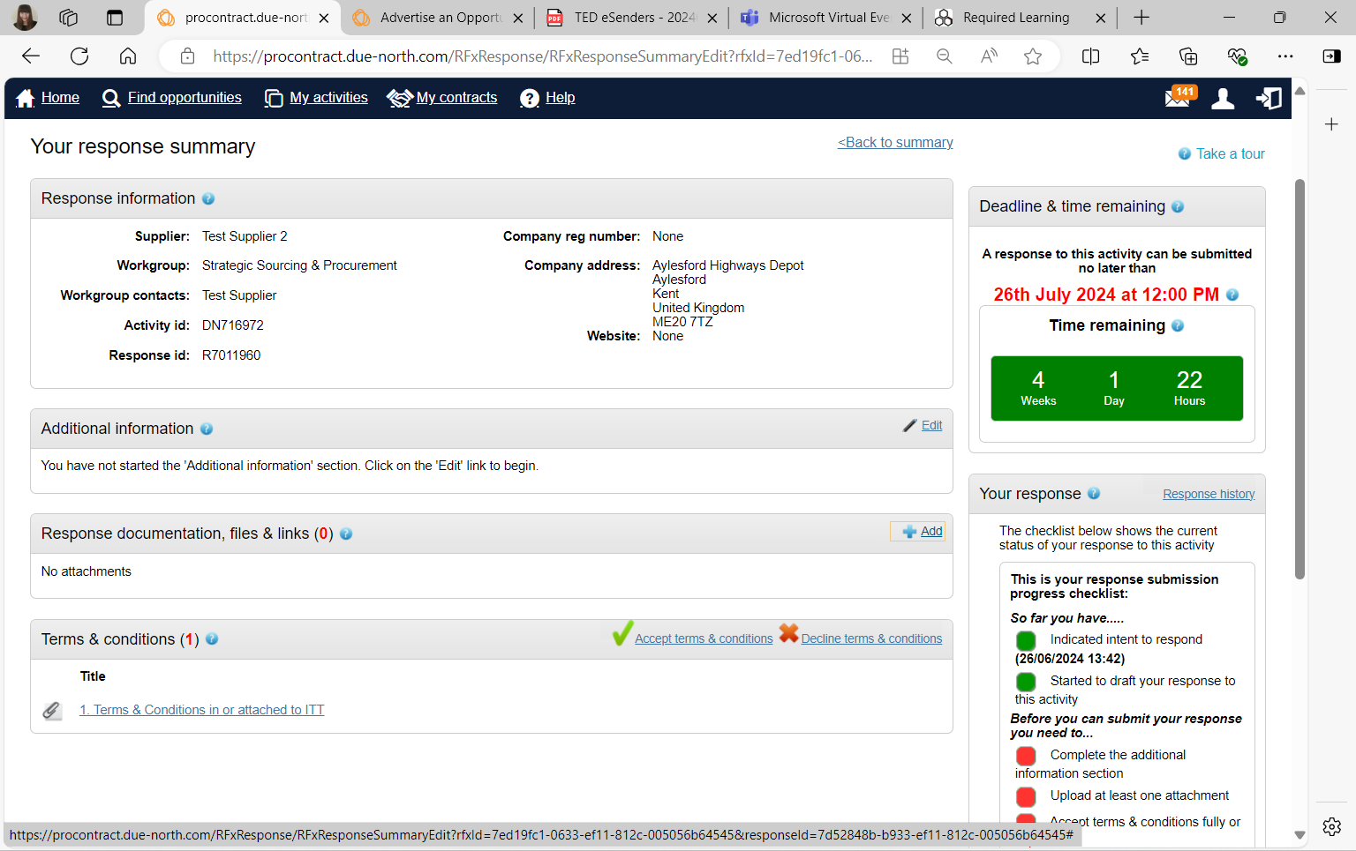
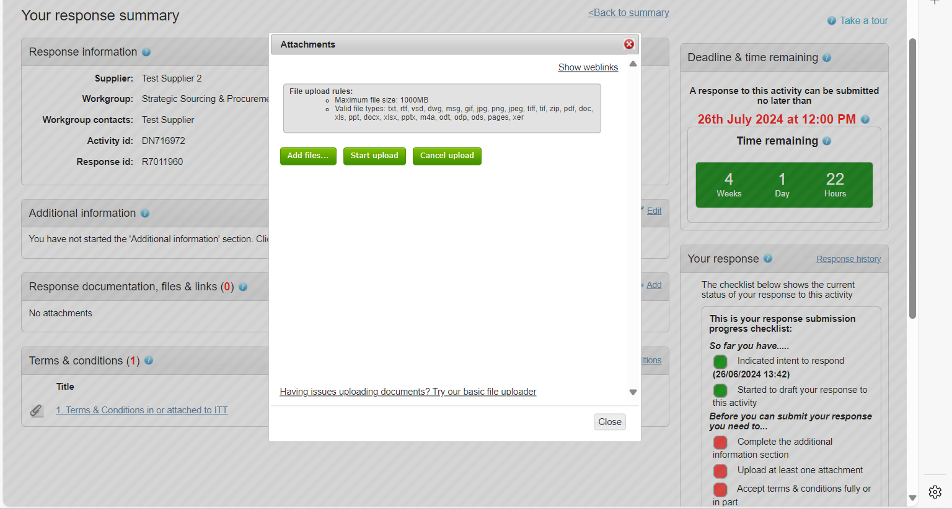
Click ‘Add Files’ and select the relevant documents from your computer. When you have selected your files, click ‘Start Upload’.

Before you submit your SQ response, you must click ‘Accept Terms and Conditions’ to indicate that you accept the Council’s proposed terms and conditions. The checklist on the right-hand side will show any required actions not completed in red. When all actions are green, the response can be submitted.
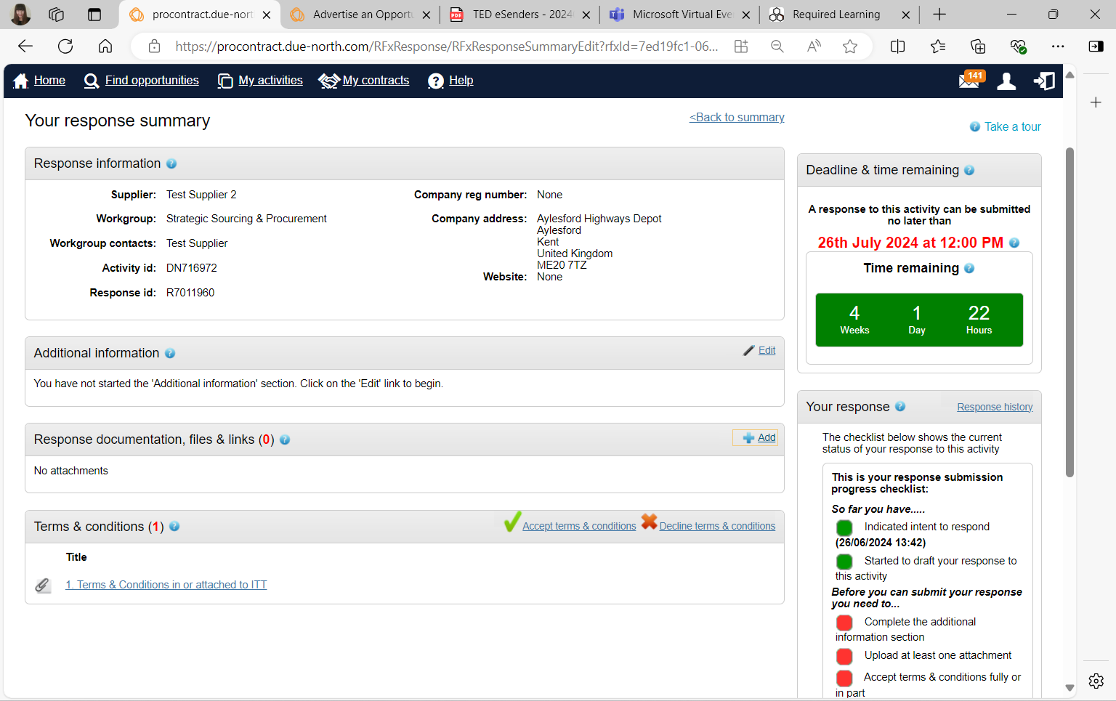
When you have successfully submitted your response, you should receive an automated email to confirm from the Kent Business Portal.

