Lake District National Park Authority

Coast to Coast National Trail access improvement work

Upland path definition/restoration & localised peat reprofiling work in the upper reaches of Wythburn

May 2023

Deadline for Submissions
Midday Friday 7 July 2023

INFORMATION AND INSTRUCTIONS TO TENDERERS

Introduction and background
As part of the establishment of Wainwright’s Coast to Coast Path as a National Trail, the Lake District National Park Authority is seeking a contractor to design and build a mixed, stone flag & aggregate path along a 400m section of bridleway in a remote location. The specific site sits in the upper reaches of Wythburn, across Mere Beck, a wet peaty bowl on Wainwright’s Coast to Coast between Greenup Edge and Far Easedale.
The surrounding landscape includes ecologically important and sensitive habitats including areas of deep peat, and the water courses are tributaries of Thirlmere Reservoir. The successful contractor will need to demonstrate suitable knowledge and experience of working in these types of sensitive locations, habitats & landscapes to ensure appropriate protection of water, soil and flora and fauna during and after the work completion.
The intention of this tender is to procure a contractor to source & supply materials, and undertake delivery of the work using suitable machines in Autumn 2023 or at the earliest opportunity after that subject to further discussion post-bid and during evaluation. The successful contractor will need to:
- Source and supply non-calcareous ex-mill floor stone flags/new sawn stone flags to the site which is a remote location at an altitude of about 450m which is totally inaccessible by road or track. The stone flags will need to be transported to the work site by helicopter.
- Use experience and appropriate techniques to source onsite aggregates for areas of the route where aggregate is the best surface treatment.
Access to the site will involve dismantling, flying by helicopter and then reassembly of a digger in remote upland terrain (and the reverse upon project completion). Fuel and other essentials will also have to be flown in & have appropriate storage facilities. The supplier must therefore ensure that the quotation supplied takes account of all the organisation and costings associated with all helicopter operations.
Access and egress to site for personnel will involve a mountainous 5km walk each way.

The Issue
The Lake District National Park was established in 1951, after Government enacted the National Parks and Access to Countryside Act in 1949. The Lake District National Park Authority (“the Authority”), established by the Environment Act 1995, has some functions and powers of a local authority, although some statutory powers are different to other local government bodies. The long term strategic vision for the Authority is that the National Park will be an inspirational example of sustainable development in action. The National Park receives approximately 19 million visitors each year.
The Highway Authorities (Westmorland and Furness Council and Cumberland Council) are ultimately responsible for all Public Rights of Way in Cumbria. Since 1997 the Lake District National Park Authority has had full delegated powers to manage aspects of rights of way network in the Lake District National Park, including maintenance, surveying and updating the legal records. This entails various duties to assert and protect the rights of the public to their use and enjoyment, prevent as far as possible their obstruction, improve access where possible and regulate their use as required. The Authority undertakes the additional responsibility of ‘protecting the landscape’, repairing eroded paths (over and above the necessary) to reduce the impact of usage on the environment and landscape.
As part of DEFRA funded establishment of Wainwright’s Coast to Coast Path as a National Trail, Natural England have specifically requested that this area of wet peaty bowl has path definition/restoration undertaken to help the site meet the requirements of National Trail Quality Standards. Authority also perceive there is an opportunity to undertake some localised peat reprofiling work at the site to improve the ecological benefits delivered by the path enhancements.
Maps of the path where work is required, plus possible helicopter & machinery pick up/drop off site for flags is provided in Appendix 1.
In order to carry out this work, we would like potential contractors to complete prices for each component of the work as set out in Supplier Pricing (4)
The precise specifications for the work package will be drawn up by the successful contractor using these prices in conjunction with, and to be agreed by, Authority / Fix the Fells representatives. The extent of the works may be varied depending on funding availability.
Rebuilding and restoring upland paths is highly specialised work, with exacting standards required if paths are to be effective and long-lasting in harsh environmental conditions. This is a sensitive location given that it sits within the catchment of Thirlmere Reservoir. Knowledgeable, highly-skilled & meticulous workers are required to deliver a project in this location.

(PQQ) – Supplier Pre Qualification Questionnaire (1)

Tenderers will need to be able to demonstrate experience, skill and competencies in all the areas outlined below. If a Tenderer is unable to demonstrate the required experience, skills and competencies in all the areas they are unable to proceed any further or submit a Tender for consideration.
Essential pre-qualifying requirements | Tick to confirm requirement is met
Experience - Proven track record of at least 3 years repairing upland fell paths, and undertaking peat restoration work
Experience - Specific experience of building mixed flag and aggregate paths using locally sourced aggregate in peaty environments
Experience - At least 3 years experience of commissioning and leading on the delivery of helicopter-based operations (stone/machinery lifts etc)
Staff - Sufficient numbers of suitably skilled, qualified/experienced & fit staff (requiring walking in mountainous environments, in inclement weather up to 5km from nearest road)
Knowledge and skill base - demonstrating compliance with best practice from both ‘Repairing Upland Path Erosion’ (Davies and Loxham) and ‘Upland Pathwork’ 3rd edition (Upland Path Advisory Group)

To discuss the opportunity and consider any challenges associated with the remote nature of the site please contact Annie Duckworth (annie.duckworth@lakedistrict.gov.uk) An accompanied site visit is essential to fully appreciate all the challenges and dynamics associated with the location of the work.

Tender Objective
This tender is for the provision of a contractor to design and build a mixed Stone Flag and Aggregate path at a site in the upper reaches of Wythburn, a wet peaty bowl on Wainwright’s Coast to Coast between Greenup Edge and Far Easedale. The project seeks to deliver a definitive line and facilitate easy access and use of the public Right of Way.
The work delivered must be of a standard in keeping with that which has been delivered in the past 15 years adhering with best practice from both ‘Repairing Upland Path Erosion’ (Davies and Loxham) and ‘Upland Pathwork’ 3rd edition (Upland Path Advisory Group). This is highly specialised work in a sensitive environment requiring a contractor with at least 3 years’ experience of similar work in similar environments. The range of activities required includes:
- Contributing to the development of an Environmental Method Statement
- Sourcing appropriate machinery and materials to be able to deliver the work
- Inspecting the job site to identify, survey and assess environmental damage caused by current useage, and propose solutions for remedy/ameliorating ongoing adverse impact, including bringing people onto a singular used route
- Producing site descriptions and designing work specifications
- Delivering specialist pathworks including drainage, waterbars, ditching, resurfacing, alignment and construction of paths (aggregate surfacing, soil inversion, aligning & defining, cut and fill, revetments, stone flags and stepping stones)
- Delivering specialist pathworks and techniques to accommodate the specific hydrology of the site (stream crossing) and ensure longevity of the interventions and useability by users of the Rights of Way network
- Landscaping (transplanting vegetation, reseeding, grading, deflection/desire lines and reprofiling peat hags)
The contractor must have significant experience of relevant logistics and safe working practices, including:
- Quantity assessments and procurement
- Construction Design and Management Regulations & associated risk assessment. Provision and safe operation & storage of relevant machinery, tools and equipment
- Team/contractor welfare & personnel supervision
- Commissioning helicopter led operations & working with helicopters, heavy loads and heavy machinery
- Public safety
- Environmental risk management

Timetable for this project
The work is due to be undertaken in Autumn 2023 (or at the earliest opportunity after that subject to further discussion post-bid and during evaluation) and are due to be fully completed by the end of April 2024.

Experience/Skills/Competencies Required
The Authority wishes to contract with a single supplier for the procurement of materials (stone flags), the transportation of materials onto site and the successful design and build of a 400m mixed flag and on-site sourced aggregate path.
This requires experience/skills/competencies across a number of areas. The successful Tenderer should meet all of the Essential Requirements listed below.
Excellence in assessment and design
- Extensive experience of assessing dynamics of upland paths and public use thereof, identifying causes of path damage/non adherence, and designing appropriate solutions
- Experience of path maintenance and incorporation of this into design and construction
- Experience of producing site descriptions and specifications for work in remote upland environments
- Experience of designing specifications that are ecologically and environmentally sensitive and take account of localised water quality, conservation priorities and biodiversity objectives
A track record of delivery
- Experience of delivering upland path restoration in protected landscapes
- Extensive experience of surfacing work on upland paths, including alignment and construction (aggregate surface, soil inversion, aligning and defining, cut and fill, revetments, stone flags and stepping stones)
- Experience of sourcing materials for Upland pathworks, including site-sourced aggregates, soil and vegetation and procuring appropriate flags.
- Experience of landscaping work including transplanting vegetation, reseeding, grading, deflection/desire lines
- Experience of procuring and managing helicopter ops to move materials/equipment onto site
- Demonstrable awareness and knowledge of hydrological, ecological and archaeological issues and experience of working in Sites of Special Scientific Interest, Special Areas of Conservation and other designated habitats and landscapes.
Effective logistics and safe working practices
- Track record of sourcing, locating and securing appropriate materials
- Access to all necessary and specialist tools and equipment
- Fundamental incorporation of risk management systems, including generic and dynamic risk assessment, Construction Design and Management Regulations, working with helicopters and working in challenging environments
- Excellent personnel supervision with regard to lone working, motivation and organisation
- Systemic protection of workers, including First Aid qualifications, including provision of relevant qualifications for this type of work in this type of work environment,
- Personal Protective Clothing and equipment for mountain work sites and relevant kit for type of work
- Embedded consideration of team welfare, through provision of appropriate shelter, vehicles and work patterns
- Extensive experience and consideration of public safety in site management
- Extensive experience of safe management and provision of appropriate machinery, including All Terrain Vehicles, tracked barrows, tracked and wheeled excavators
- Extensive experience of working with helicopters, including loading and take-off/landing site management
- Experience of appropriate in-field environmental risk management
Quality assurance
- Experience of implementing Quality Management processes, including ongoing monitoring and assessment to ensure that specifications are met.
The key competencies above will guide our scoring when assessing applications.

Submission of the tender documents
What you need to do

Your submission should include:

- Supplier (PQQ) – Supplier Pre Qualification Questionnaire (1)
- Supplier Information (2)
- Summary of relevant skills, experience and proposed delivery. Supplier Experience Table (3)
- A firm price for completion of all items listed in Supplier Pricing Table (4) (i.e. a price that is not subject to variation).
- Two references (two sheets enclosed). Supplier References (5)
- Declaration of non-collusion (sheet enclosed to be signed). See Supplier Statement (6)

Tenders must be received by Midday Friday 7th July 2023. Tender documents received late, i.e. after the specified date and time, will not be considered.

How to return the tender

The tender is to be submitted in electronic format via The CHEST online procurement system at https://www.the-chest.org.uk. The system will notify you by email to acknowledge receipt of your submission. Please note that no tender document will be deemed to have been received unless an email receipt has been sent.
Opening of tenders

Tender documents will remain unopened until after the closing date, after which time they will be opened at one time, with witnesses, by independent officers of the Authority. All tenders submitted will be verified to ensure that the information requested has been provided. Once tender documents have been opened and signed they are then passed to the originating department for evaluation.
Timetable for this project

Our timetable for this project is:

Date | Activity
Monday 22 May 2023 | Publication of Tender Documentation
Wednesday 14 June 2023 | Compulsory accompanied site visit for potential tenderers
Friday 7 July 2023 (midday) | Tenders return deadline
Week beginning 10 July 2023 | Tender evaluation and shortlisting
by Friday 14 July 2023 | Notification to successful supplier
Friday 28 July 2023 | Contract Award (after 10 working day cooling off period)
Supplier sources materials | As soon as possible after contract award
Work commences on site | Work to be completed as early as possible Autumn/Winter 2023
Contact and information

For further information or any queries regarding the content of the tender please submit questions via The CHEST messaging system.

For feedback on your submission please contact Jo Willmott (jo.willmott@lakedistrict.gov.uk).

Lake District National Park Authority

Northern Office, Old Station Yard,

Threlkeld, Keswick, Cumbria, CA12 4TT

Registered Office: Wayfaring House, Murley Moss Business Park, Oxenholme Road, Kendal, Cumbria LA9 7RL

Evaluation of tenders
Evaluation criteria
All tenders received will be considered based on the information they have submitted in their tender. The tenders will be evaluated upon the following criteria;

Criteria | Potential Score | Weighting | Max Score
- Price | 1-5 | 8 | 40
- Previous experience undertaking similar work in comparable environments | 1-5 | 5 | 25
- Proven technical ability to complete the work to the required standards of quality, safety and environmental sensitivity | 1-5 | 5 | 25
- Overall quality of the submission (detail; presentation; clarity) | 1-5 | 2 | 10
Overall score
Maximum possible score |  |  | 100
Questions on tender submissions
If tenderers have any questions they wish to ask the Authority, they must submit them to the Authority via The CHEST messaging system. Any questions received will be made anonymous and responses sent to all tenderers.
Award of tender
The Authority will decide to whom the contract shall be awarded based on the evaluation criteria outline above. The Authority does not bind itself to accept the lowest or any tender/quotation and reserves the right to accept the whole or parts of tenders/quotations. The Authority will notify acceptance of the tender to the successful tenderer as soon as is reasonably practicable.

TENDER INFORMATION
Confidentiality
The details of these documents and all associated documents are to be treated as private and confidential for use only in connection with the Tender process.
Freedom of Information
The Authority is committed to meeting its legal responsibilities under the Freedom of Information Act 2000. Accordingly all information submitted to the Authority may need to be disclosed in response to a request under the Act. If you consider that any of the information included in your tender is commercially sensitive, please identify it and explain (in broad terms) what harm may result from disclosure if a request is received, and the time period applicable to that sensitivity. You should be aware that, even where you have indicated that information is commercially sensitive, we may be required to disclose it under the Act if a request is received. Please also note that the receipt of any material marked ‘confidential’ or equivalent by the public authority should not be taken to mean that the public authority accepts any duty of confidence by virtue of that marking. If a request is received, we may also be required to disclose details of unsuccessful tenders.
Anti-Fraud and Corruption Policy
The Authority has an Anti-Fraud and Corruption Strategy which sets out the responsibilities of officers and action to be taken in cases of theft, corruption, irregularity, or when damage is suspected. The Confidential Reporting Code, (Whistle Blowing Policy), forms part of this Strategy which provides a mechanism for staff to report suspected wrong doings confidentially. In the event of such an issue, an investigation would be carried out and action taken as necessary.
Costs and expenses
The Authority will not be responsible for, or pay for, expenses or losses which may be incurred by a tenderer in the preparation of their tender. The Authority does not bind itself to accept any of the tenders as a result of the tendering process including the lowest tender.
Preparation of Tenders
For the preparation of their tender and entering into a contract with the Authority, tenderers must ensure that they have all the information required and must satisfy themselves of the correct interpretation of terminology used in these documents.
Queries on the tenders
If any points in these tender documents are considered by the tenderer as unclear, the tenderer should address their queries via The CHEST messaging system to obtain an explanation before sending their tender. Their query will be responded to via The CHEST, but it shall not be construed in a way that adds to, modifies or takes away from the meaning and intent of the contract and/or the obligations and liabilities of the contract.
Alterations
None of these documents may be altered by the tenderer. If the tenderer wishes to propose modifications to any of the documents (which they may consider would provide a better way to achieve the contracts objectives) they must provide details in a separate letter accompanying the tender response.

Prices
All prices must be net and, where applicable, carriage paid with all cash and trade discounts allowed for.
VAT
All prices and/or rates shall be exclusive of Value Added Tax.
Validity of tenders
Tenders shall be valid for a minimum of three calendar months from the closing date for receipt of tenders.
Sub-contractors
The level of sub-contracting and the processes for doing so must be pre-approved with the Coast to Coast Project Ranger to comply with the funding agreement and Public Contracts Regulations 2015.
Quality of goods / services
Tenderers must possess relevant professional qualifications and experience.
Conflict of Interest
The Authority requires all tenderers to confirm whether any actual or potential conflicts of interest that exist which may prevent them undertaking this work, and a description of measures they would adopt if a potential conflict of interest arose during or following completion of this work.
Treatment of tender
The acknowledgement of receipt of any submitted tender shall not constitute any actual or implied agreement between the Authority and the tenderer.
Debriefing
All unsuccessful bidders will be offered the opportunity to be given a debriefing. Requests for debriefing are to be made in writing.
The Authority’s use of Contract Outputs
The Authority may wish to publicly quote the Contract Outputs such as any policies, figures, training materials, risk assessments etc. Tenders are requested to confirm that the Authority may (at the Authority’s own discretion) do so without restriction.
Ownership
The intellectual property rights rest with the Authority, not the tenderer.

Tender Submission
Please also include a completed copy of the Pre-Qualifying Questionnaire (1) as part of your submission.

Supplier Information (2)

Information about you

All sections to be completed
Your organisations name
The formal name under which you/your organisation trades
Name of key contact
Contact telephone number
Contact email address
Is the organisation for whom you work registered for VAT? (Y/N)
If we were to contract with you, confirm the number of people in your organisation who are able to deliver this work

Supplier Experience Table (3) –

Summary of relevant skills, experience and proposed delivery

All sections to be completed

Previous experience

Describe your background in delivering this type of work, including specific jobs and clients.

Outline experience of relevant techniques, processes, and machinery/equipment.

Include relevant health & safety and logistical experience

Max 600 words

Qualifications/ experience of Key Personnel leading implementation of this work

Max 400 words

Ability to complete work to timescale

Max 150 words

Outline method statement

Summary of how you intend to do the work.

Max 600 words

Risk assessment & health and safety

(outline matters you would consider for risk management and how you would manage these )

Max 400 words

Approach to deployment of workers locally

Summary of how you intend to accommodate and deploy workers locally in delivering this work.

Max 400 words

Local knowledge and experience

Max 400 words

Points to high-light

Please detail anything else you would like to add in support of your submission

Max 200 words

Specific example of similar work

Add photo, etc as required

Include site name/location, nature of works, customer, date, duration, scale

NOTE:

Appendices to your tender will be accepted to illustrate key points. These may include case studies, a proposed work schedule, photographs and a diagram of the proposed team structure. We would ask you to keep these concise and relevant, clearly referencing which section each piece of information relates to.

Supplier Pricing Table (4) –

All distances below are approximate and subject to alteration as ground conditions dictate. Final price paid will be adjusted pro-rata | Total price | Additional Notes
Source, and supply to site, sufficient quantity of ex-mill floor/ new sawn stone flags* to construct a 200m linear path
Please ensure your price includes all 3 elements – procuring the stone flags, road haulage to Thirlmere and flying to site. (Assume a 5km flight with 300m ascent)
Construct a 200m stone flag path, and further 200m new sub strata reversal pathworks with associated landscaping, plus path repair work, consisting mainly of landscaping, habitat restoration and path definition. Build a safe stepping stone river crossing using on-site stone**. Eradicate 150m former walked lines to assist in them falling out of use.
(Please ensure your price takes account of the very remote and inaccessible nature of the worksite & assume the machinery necessary to undertake the work on site needs to be dismantled/re-assembled, & flown in/out of the site by helicopter)
Landscaping and associated re-profiling & habitat restoration of peat hags, 600 square metres, in the vicinity to improve the visual and environmental landscape.
Precise location & detail to be agreed post tender
Total Cost
*Absolute minimum size of the flags is 0.9m x 0.6m and minimum thickness 80mm.
The stone should be either worn/natural or treated to appear naturally riven. There should be no unworked cut/sawn edges. If the stone is cut from freshly quarried material one flat face should be treated to appear naturally riven.
The suitability of any stone intended for use must be agreed by an Authority/Fix the Fells representative prior to work commencing.
The flags are to be delivered to the site to a mutually agreed specific location post contract award (please see location map in the supporting documents for indicative location of the site and its relation to a likely heli-lift site). The flags are to be loaded on suitable lifting agents which will not collapse under the weight of stone and will be properly loaded and banded to ensure safe lifting whilst helicopter is in transit.
** A suitable stream crossing in natural materials (stone) will be required for year-round use in normal weather conditions. The precise techniques and design to be agreed before work commences.

Supplier References (5) –

Potential suppliers are required to submit details of two organisations for which fell path contracts have been completed. This is so that references may be obtained. The Authority may wish to obtain an email/telephone reference for the successful tenderer prior to the award of the contract.
Reference 1 Comments
Organisation Name |  | Please give details of a job name/reference number
Contact Name

Address

Telephone Number
E Mail address
Approx value of contract awarded (£)

Reference 2 Comments
Organisation Name |  | Please give details of a job name/reference number
Contact Name

Address

Telephone Number
E Mail address
Approx value of contract awarded (£)

PLEASE NOTE THAT ALL INFORMATION WILL BE TREATED IN THE STRICTEST CONFIDENCE AND WILL BE USED PURELY AS A MEANS OF OBTAINING REFERENCES.

Supplier Statement (6) – Declaration of Non-Collusion

To: Lake District National Park Authority

The essence of selective tendering is that the Authority shall receive bona fide competitive tenders from all firms tendering. In recognition of this principle, I/We certify that this is a bona fide tender, intended to be competitive and that I/We have not and will not (either personally or by anyone on my/our behalf):-

- Fix or adjust the amount of the tender (or the rate and prices quoted) by agreement with any other person.

- Communicate to anyone, other than the person calling for this tender, or names offered in support of queries, the amount or approximate amount or terms of the proposed tender (except other than in confidence, where essential to obtain professional advice or insurance premium quotations required for the preparation of the tender).

- Enter into any agreement or arrangement with any other person that he shall refrain from tendering or as to the amount or terms of any tenders to be submitted.

- Canvass or solicit any member, officer or other employee of the Authority in connection with the award of this or any other Authority contract or tender.

- Offer, give or agree to give any inducement or reward in respect of this or any other Authority contract or tender.

Signed (as in Tenders) duly authorised to sign | …………………………………………….. ……
For and on behalf of | ………………….. ……………………...……….
Date | …………………….……………………………..

Appendix 1 & 2

Appendix 1: Site general location & potential helicopter pick up/drop off site for flags & digger NY 316,140

Appendix 2: Intended route for the mixed Stone Flag & Aggregate path (this is indicative only)

(GR refers to midpoint) | Approx. Length (m) | Notes
Path  Upper reaches of Wythburn, Mere Beck  NY 294,104  A wet peaty bowl traversed by walkers between Greenup Edge and Far Easedale | 400m | Path definition & creation of mixed 200m stone flag / 200m sub strata reversal aggregate path, along with enduring (stone) method of stream crossing
Habitat restoration  Upper reaches of Wythburn, Mere Beck  NY 294,104  A wet peaty bowl traversed by walkers between Greenup Edge and Far Easedale | 150m of path (which will be made redundant by creation of new path)  600m Peat Hags in the vicinity | 150m path eradication work consisting mainly of landscaping & habitat restoration  Reprofiling of 600m the surrounding Peat Hags to improve visual landscape & deliver environmental benefits

Appendix 1: Site general location & potential helicopter lift/drop sites

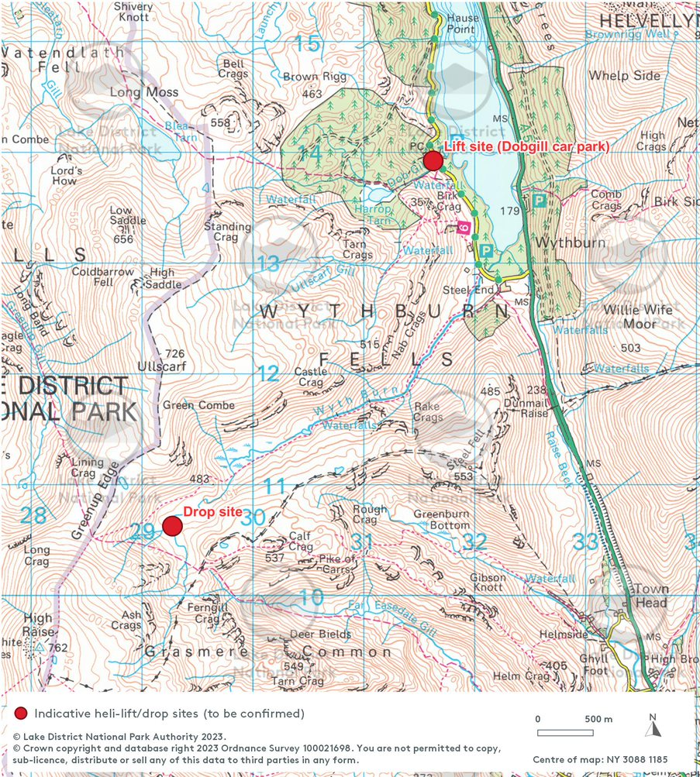

Appendix 2: Intended route for the mixed Stone Flag & Aggregate path (this is indicative only)

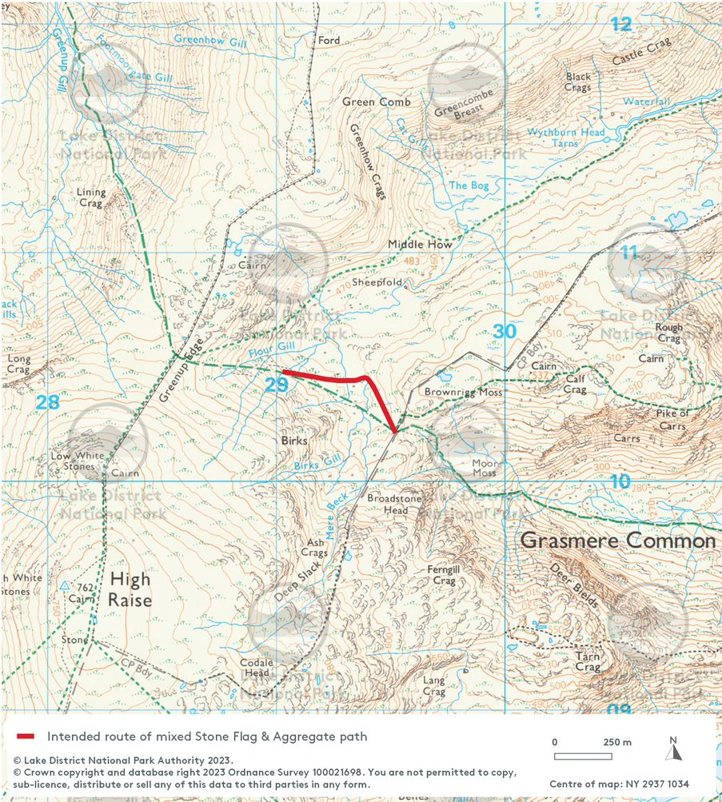

Ends

