Disability Hub Prior Information Notice (PIN)/Request for Information (RFI)

Introduction
The London Borough of Southwark wishes to engage with providers who have experience in managing, leading and coordinating a network of providers in a ‘Lead Provider’ role preferably within a social care environment.
The council is conducting this RFI in order to gain an understanding, insight and views from providers who have experience and knowledge of forming strong relationships and partnerships with a number of organisations to deliver services.
The council is seeking information from providers in order to assist the development of a procurement strategy for its Disability Hub service model with the aim of a future tender opportunity to seek an organisation who can manage its “front door” as a ‘Lead Provider’ by assisting individuals to access information, advice and support and navigate the local system linking with community opportunities and services that can support independence and wellbeing.
The council seeks in the future to contract with an organisation who can both:
- Fulfil the duties of a lead provider to provide and / or subcontract and manage all aspects of Information and Advice to Southwark residents
- Signpost residents to a network of providers who can provide services to support independence and wellbeing

The service should:
- Align with the council’s strength-based approach i.e. approaches that focus on an individual’s strengths (including personal strengths and social and community networks) and not on their deficits
- Support the council’s early intervention model i.e. delivering timely low level support or activities that enable disabled people and their carers to develop/ maintain their wellbeing and independence and avoid crises, thereby reducing, delaying or preventing the need for more intensive support
- Deliver against the components identified in the Southwark Disability & Carers Hub Model see Illustration 2
Request for Information
Please could you complete and return the enclosed questionnaire by 3pm, Thursday 7th July 2022. This is for information gathering purposes only. Once you have completed enclosed questionnaire at Appendix A of this document, please submit your responses via the messaging facility, within project DN616227 of the e-procurement portal (Pro-Contract). Please note that all communication must come through the messaging facility, including any queries related to this request for information.

Please note this is NOT the commencement of a procurement procedure, nor does this PIN and questionnaire constitute a call for competition to procure any services for the council, and the council is not bound to accept any proposals offered. The council is not liable for any costs, fees or expenses incurred by any party participating in the soft market testing/request for information exercise. Any procurement of any services by the Council in the future, will be carried out strictly in accordance with the provisions of the Public Contracts Regulations 2015.
Completed questionnaires must be submitted using the Pro-Contract e-tendering Portal messaging facility. This will require you to register your company at https://procontract.due-north.com. If you experience any technical difficulties, please contact the Pro-Contract supplier support desk via email servicedesk@proactisservicedesk.com or Tel 01937 545070
Responses to the questionnaire will be treated confidentially.

Southwark Council would like to thank you in advance for your participation.

Service Description

This service aims to offer disabled residents, and their carers, of all ages:

- A new way to connect with community groups and local activities
- Access to information, advice and support that enables them to overcome barriers/ challenges and live fulfilled and active lives
- Support to develop and maintain independence and resilience, preventing needs from escalating through advocacy and self-advocacy

The service, to be delivered by a ‘Lead Provider’, will promote and facilitate the connections and support needed to avoid crises and reduce, delay or prevent need for more intensive services. The service will comprise two key elements,

- Information and Advice (IAG) and
- Group Based Activities and Community Inclusion (see Illustration 1. Lead Provider Functions)

Illustration 1. Lead Provider Functions

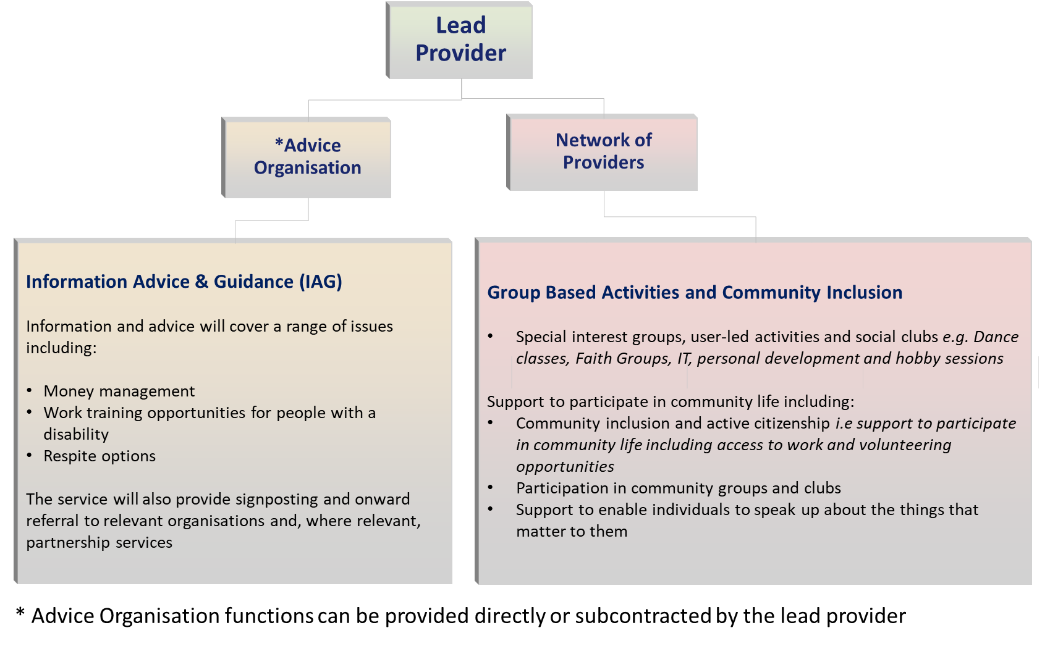
- Information and advice

Information and advice will be offered to the following groups:

- Residents with a disability of all ages, living in Southwark, including those with Autistic Spectrum Disorder (ASD), Learning, Physical or Sensory disabilities.
- Carers of all ages, caring for someone with a disability in Southwark.

Information and advice will cover a range of issues from money management to work and training opportunities for people with a disability, through to respite options. The service will also provide signposting and onward referral to relevant organisations and, where relevant, partnership services. For example, it is envisaged that this service will work closely with the Southwark Mental Health Wellbeing service for people with mental health needs, and act as a referral source where individuals with mental ill health present at this service.

- Group based activities and community inclusion

Group based activities will be delivered and / or facilitated by the service, empowering the following groups to develop and run activities appropriate to their specific needs and to determine preferred outcomes:

- User-led groups (including those established for people with ASD, learning, physical and sensory disabilities)
- Carer groups

The service must provide a comprehensive range of community-led and co-produced activities i.e. special interest groups, peer support and self-advocacy.

Appendix A – Information Gathering Questionnaire
All information supplied will be treated as strictly private and confidential and will not be divulged to any other parties other than those directly involved in the project.
Part A - Organisation Information
1 Name of Organisation:

2 Contact Name:

3 Telephone No:

4 E-mail Address:

5 Nature of Business and services provided :

6 Please indicate, if applicable, any subsidiary companies run by your organisation:

7 If part of a group, please indicate brief details of the ultimate holding company:

Part B – Questionnaire
No. | Question | Provider Responses
1) | Do you have experience in forming partnerships/alliances/relationships with other organisations and managing a network of service providers in order to fulfil a common goal?
2) | If you have answered ‘Yes’ to question 1), please describe the form of the relationship/partnership you have managed and the contract structure used?
3) | In regards to the proposed contract model (see illustration 2), would you be interested in bidding for this type of contract opportunity?  If ‘Yes’, please state the reasons why?  If ‘No’, please state the reasons why?
4) | From your experience what do you foresee as being the most effective contracting arrangement to providing the service in the following Service Model diagram (see illustration 2) that provides Information and Advice and links residents with community opportunities and services across Southwark?

Illustration 2. Southwark Disability & Carers Hub Model
* Advice Organisation functions can be provided directly or subcontracted by the lead provider
