Call Reference: DN314629

Met Office tendering on behalf of BEIS.
Expressions of Interest title: Vertical Structure of Weather over Southeast Asia
To register your interest, see notes at the end of this page. Registering interest requires no proposal detail at this stage and carries no obligation to bid. Please note that this EOI is open to UK researchers only.

Estimated value: up to £300k

Key Dates

Estimated Publish of Call:  (Start of bidding period). | Mid-February 2018  A notification email will be sent to parties who have formally registered their interest by way of clicking on the ‘Register Interest’ button displayed below the opportunity on the ProContract portal
Estimated Bidding Period: | 6 weeks
Estimated Award of Call: | March/April 2018
Background
The Met Office anticipates holding a call for research proposals in January 2018. In preparation for the call, the Met Office is inviting expressions of interest from UK researchers.

The Weather and Climate Science for Service Partnership for Southeast Asia (WCSSP Southeast Asia), supported by the UK Government’s Newton Fund, is a research programme that will support the development of capability to underpin services to provide better advice of high impact weather and climate events and, therefore, will support climate and weather resilient economic development and social welfare.

Summary of WCSSP Southeast Asia aims
This project aims to develop underpinning capability in modeling at the global, regional and local scale, and advance the understanding of high-impact weather events in order to support services to improve advice and mitigate the impacts of extreme weather and climate events.

Specific aims include; improving the understanding of the impact of large scale atmospheric processes on the weather and climate of Southeast Asia, assessment and improvement of Unified Model performance at both convective and non-convective scales, improving the understanding of the local impact of tropical weather systems and improving the interpretation of global and convective scale forecasts.

For further information please visit the programme website -
http://www.metoffice.gov.uk/research/collaboration/newton
Submissions will be sought on ‘Vertical Structure of Weather over Southeast Asia’:
Rationale:
The weather of Southeast Asia is dominated by convective activity which is strongly influenced by both local and large scale processes. The vertical structure of the atmosphere in the region has had little previous attention and there has been no systematic evaluation of model processes in the vertical, particularly with reference to their thermodynamic profiles and relevance to convection initiation. An accurate representation of the vertical structure of the atmosphere and its horizontal variability is likely to be key for models to accurately predict high impact weather in the region.

Required activity:
The project will work on the nature of weather events in the region with a key focus on vertical processes and structures as captured in global and convection permitting (CP) models. The overall aim is to identify model processes that play a key role in weather representation and work towards improving these in both parameterised and CP models. Specific examples of this may include:
- In-depth focus on model representation (including the vertical structure) of one or more local phenomena such as cold surges, Borneo Vortex, sea breezes, Tropical Cyclones, Sumatra squalls and other relevant processes that are associated with High Impact Weather (HIW) events
- Convection initiation and its representation in models
- Forensic examination of thermodynamic profiles in models to identify the key processes in global and CP models which are least well represented
- Model assessment against available observations such as radiosondes and interaction with the ongoing Years of Maritime Continent as appropriate
- Using sensitivity studies to examine the impact of model configuration on vertical structure over a convectively active tropical maritime region
Anticipated outputs or results:
Outputs could include:
- New information about the vertical structure of the atmosphere and its horizontal variability over Southeast Asia, as represented by models, reanalysis and in observations
- Improved understanding of the role of land-sea contrasts, cold pools etc… on convection and other HIW events.
- Detailed evaluation of the vertical structures in models and observations along with sensitivity studies to model physics changes.
- Improved understanding of optimal configurations for CP models in the region (e.g. grid-lengths; numerics; mixing)
- Specific recommendations for parameterization developments in global and CP models
Background on the Newton Fund
The Newton Fund builds scientific and innovation partnerships with partner countries to support their economic development and social welfare, and to develop their research and innovation capacity for long-term sustainable growth. It has a total UK Government investment of £735 million up until 2021, with matched resources from the partner countries.
The Newton Fund is managed by the UK Department for Business, Energy and Industrial Strategy (BEIS), and delivered through UK Delivery Partners, which include the Research Councils, the UK Academies, the British Council, Innovate UK and the Met Office. The Newton Fund is part of the UK’s official development assistance (ODA) and therefore requires that the UK funding is awarded in a manner that fits with ODA guidelines.
For further information visit the Newton Fund website (www.newtonfund.ac.uk) and follow via Twitter: @NewtonFund.

Background on the WCSSP Programme
The Met Office is administering the Newton Fund through the Weather and Climate Science for Service Partnership Programme (WCSSP Programme), comprising projects to develop partnerships harnessing UK scientific expertise to build the basis for strengthening the resilience of vulnerable communities to weather and climate variability. WCSSP Southeast Asia is a project in the WCSSP Programme.
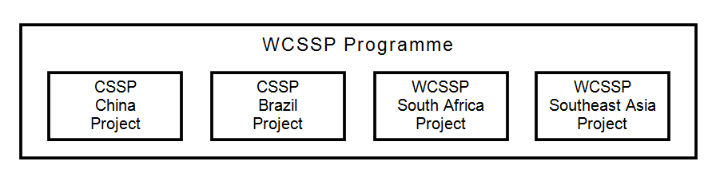
Eligibility
The following criteria must be met by the organisation submitting a bid against Newton funded Calls in order to be eligible to apply or be awarded funds against this Call:

- Demonstrate in the Bid, how it contributes to the Newton Fund aim to develop science and innovation partnerships.
- How ODA compliance is demonstrated.
- Must be a UK operating and registered organisation.
- Consortium bids are eligible; a lead partner must be nominated for payment and agreement purposes and must be a UK operating and registered organisation. Details of all consortium members must be provided
- Funding can only be used to fund new activity for the costs incurred.
- There must be an In Country economic and societal benefit to which must be demonstrated.
- The activity must last the full duration of the Grant Award Term specified
- There must be a willingness to work with Authority and other organisations and individuals associated with the Programme.
- Be willing to work with other funding authorities to ensure delivery costs represent the most efficient use of resources to deliver the overall Programme over the Grant Award Term.
- Bidders are not expected to have In Country Partners to respond to this call. The bilateral partnership nature of the Newton Fund means that effort by in-country researchers is supported by our existing In Country partners as standard.

How to Apply:

The above Expression of Interest is advertised on the Met Office ProContract e-Tendering portal called ProContract. To access and register your interest you will need to log onto the ProContract portal via this link: tenders.metoffice.gov.uk You may need to search for the Call reference DN281275.

You will need to register your company (if you have not already done so) and register your interest against the opportunity before you are able to access the tender documents.

If you require guidance or ‘how to’ instructions – see the supplier manuals on the right hand side of the supplier home page.

Online Discussions between Bidders and the Met Office:

There is a Discussions function on ProContract which shall be used to provide all further information regarding this opportunity including any changes to time scales, scope or clarifications. This function must be used by bidders to submit all clarification questions.

