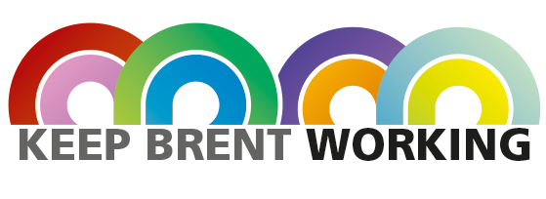
LONDON BOROUGH OF BRENT
KEEP BRENT WORKING

TECH CAMPS & AWARDS 2021
Does your organisation deliver services to local government?
Does your organisation care about workforce diversity and inclusion?
Is your organisation obliged to deliver social value, within your service delivery?

The London Borough of Brent invites you to play an active role in ‘Brent Tech Camps & Awards 2021’!
This ground-breaking new skills training programme identifies and trains Brent residents through a series of employer-led training camps, designed to inspire and up-skill residents, challenging them to develop a start-up business ideas on the subject of the Green Economy.
Over twelve months - kicking-off with a high profile B2B Skills Summit webinar - the programme aims to support companies in finding and employing highly skilled and motivated local residents.
Residents work in teams on a set project, developing employability skills, with mentorship from supporting employers, as they work towards a recognised Employability Award. An end of programme Pitching Competition, showcases personal and professional achievements - identifying the stand-out team, and best Greentech business idea!
Supported by Cllr Stephens, Lead Member for Education, Business, Employment & Skills, the programme directly supports Brent Council’s ‘Keep Brent Working’ campaign to support post-Covid economic recovery - ensuring organisations have access to the latest training resources and opportunities to assist their ‘re-start’.
The London of Brent invites you to support the programme:
(1) Mentoring Residents
Could you, or your team, spare a few hours to support Brent residents? You would be mentoring residents (remotely), helping them develop their business idea, while sharing insights into your own career and the good work of your organisation.

(2) Judging Residents
The programme resolves in a high-profile Pitching Competition, with local and national media. Would a representative from your Senior Management, be prepared to judge the business ideas, and help select the stand out team, and best business idea - alongside Cllr Stevens and other business leaders?
Keep Brent Working, Skills Summit
We invite you to join a B2B Skills Summit launch event on 11th February 11am-12:30pm https://www.eventbrite.co.uk/e/keep-brent-working-skills-summit-tickets-135973589667
Next Steps
To explore how the programme can align with your own commercial ambitions and social value obligations, please contact Career Camp Managing Director, Edward Baker: ed@CareerCamp.org.uk

