Expression of Interest

Project Client: North West Leicestershire District Council
Project Name: Queens Street Development

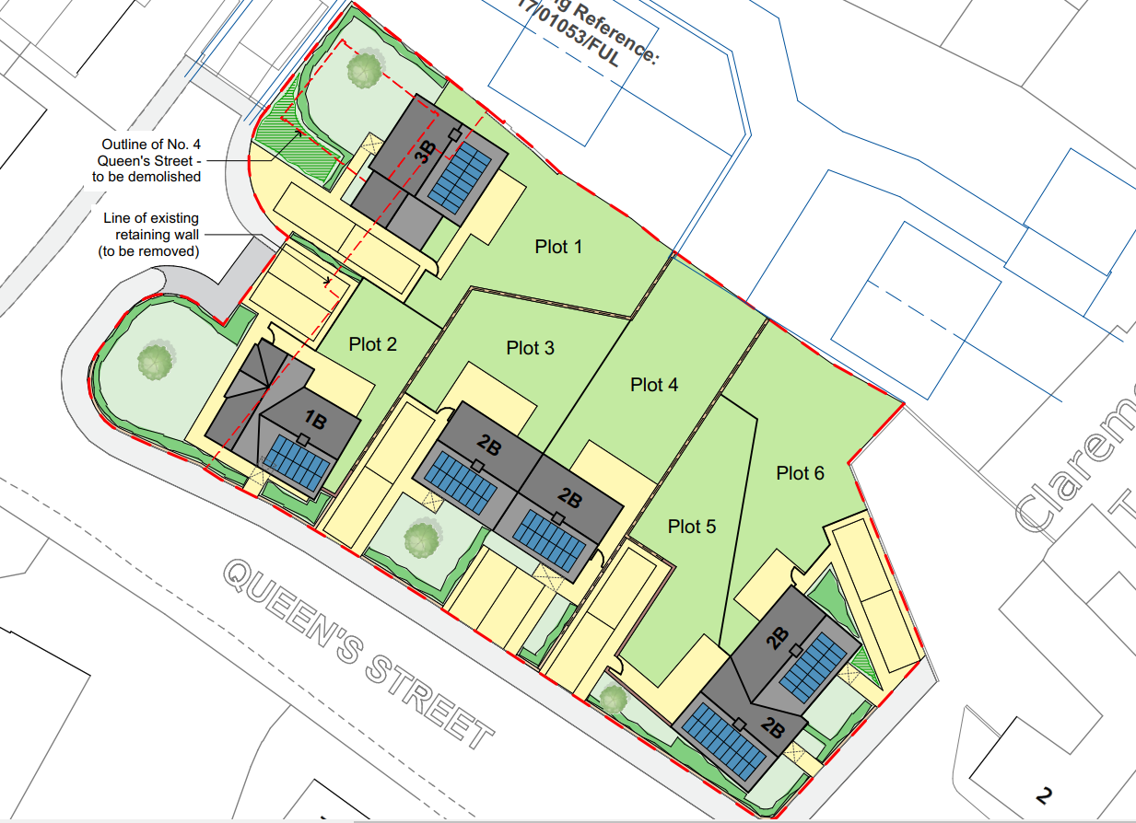

Date Issued: 10/06/2024
Return Date: 24/06/2024

Introduction:
North West Leicestershire District Council is seeking a contractor to construct 6 residential properties along with associated external works and services to include associated car parking, landscaping, and retaining walls.

Accommodation Schedule:

Plot No | Type | Mix | GIFA (m²) | Tenure
1 | Detached House | 3b5p | 94.5 | Affordable Housing
2 | Bungalow | 1b2p | 51.37 | Affordable Housing
3 | Semi-Detached House | 2b4p | 74.7 | Affordable Housing
4 | Semi-Detached House | 2b4p | 74.7 | Affordable Housing
5 | Semi-Detached House | 2b4p | 76.9 | Affordable Housing
6 | Semi-Detached House | 2b4p | 75.28 | Affordable Housing

Site Location Details:

The proposed development site is located off Queens Street, Measham. The site was occupied by the Queensway House building of 16 sheltered housing flats. The site comprises open brownfield land with a retaining wall and parking to the west side. The location of the former no4 Queens Street (now demolished) has a retaining wall to its west side also. The site is bound by existing residential buildings on all its boundaries with a retaining wall to the north side beside the new development.

Project Team:

Client Representative: Michael Fowell
Employers Agent: Greenwood Projects
Clerk of Works:
Principal Designer:
Architect:
M & E Consultant:
Transport Consultant:
Drainage Engineer:
Ecologist:

Procurement Approach:

North West Leicestershire District Council are seeking to procure a construction company who has a proven record of accomplishment and can deliver a scheme of this size and complexity. If we have an elevated level of interest, North West Leicestershire District Council may apply capability criteria questions as a sifting brief to determine the most capable applicants, who would be invited to participate in the ITT.

Indicative Timetable:

Activity | Date
EOI Issued (2-week response) | Tuesday 9th July 2024
EOI Due | Tuesday 23rd July 2024 at 12:00 (noon)
Sifting Brief (if required) | 2 weeks
ITT Issued | August 2024*
Tender Return (8 weeks) | September 2024*
Assessment | October 2024*
Contractor Selection | October 2024*
Start on Site | November 2024*
* = indicative timings
Submission of Expression of Interest:

Members must respond to this EOI via the ProContract eProcurement Portal by noon on Tuesday 23rd July 2024.

Queries in relation to EOI:

Any queries or additional information required in relation to this EOI should be raised via the ProContract eProcurement Portal on or before noon on Thursday 18th July 2024.

Award of Tender:

Tenders will be assessed on both price and quality criteria on the following basis: -
Price - 60% weighting
Quality - 40% weighting

