Appendix 1
Specification for General Repair and Maintenance
Services

Contents

Specification Appendix 1

Data Processing Agreement Annex A

Additional Appendices See below
(See additional documents)

WDH Health and Safety Policy Appendix A
WDH Customer Care Policy Appendix B
Safeguarding Children and Vulnerable Adults Guidance Appendix C
Complaints and Compensation Policy Appendix D
Working at Heights Policy Appendix E
Construction (Design and Management) Regulations Appendix F
2015 (CDM 2015) Policy

Appendix 1

The work to be carried out within this contract is to provide an effective, responsive and preventative day-to-day maintenance and repairs service.

This duty will include the repair and maintenance of any building fabric, any component or fitting that is attached to the fabric, any service conduit / pipe, mechanical appliance (excluding gas and electrical works), and external works including aspects of open space infrastructure to ensure that properties remain safe, secure, operable and provide a suitable environment for occupiers and visitors.

Length of Agreement

The contract will be let for up to 36 months, commencing 1 July 2024 until 30 June 2027 (subject to satisfactory performance) with the option of a further two periods of 12 months, (reviewable annually, subject to satisfactory performance and benchmarking) until 30 June 2029. There is no minimum or maximum value of works associated with this contract.

Scope of Requirements

Introduction

This tender is to carry out repairs and maintenance work to properties throughout the Wakefield District and Surrounding area.

WDH is looking for a minimum of two contractors within each LOT who can work across the whole of the Wakefield district and surrounding area. All Lots will include an element of emergency work and any contractor must have provision to attend to emergencies as outlined in this document.

The internal repairs work will require contractors to carry out joinery, plumbing plastering, bricklaying, mould and flooring repairs to tenanted properties.

PLEASE NOTE: Gas and electrical repairs to tenanted properties are excluded from this tender.

The external repairs work lot will require contractors to carry out roofing, and guttering repairs to tenanted properties.

The work to be carried out within this contract is to provide an effective, responsive and preventative day to day maintenance and repairs service. This duty will include the repair and maintenance of any building fabric, any component or fitting that is attached to the fabric, any service conduit/pipe, mechanical appliance (excluding gas and electrical works), and external works including aspects of open space infrastructure to ensure that properties remain safe, secure, operable and provide a suitable environment for occupiers and visitors.

The work will be split up into the following LOT’s

LOT 1 – General Repairs and Maintenance
LOT 2 – Roofing Repairs and Maintenance

LOT 1 –General Repair and Maintenance

This will include Joinery, Plastering, Plumbing, Flooring, Groundwork, Fencing, Bricklaying and mould prevention in the areas as identified in the map below.

WDH is looking for a minimum of two contractors who can work across the whole of the Wakefield district and surrounding area.

LOT 2 – Roofing Repair and Maintenance

This will include roofing repairs as identified in the map below. Typical examples of repairs include:

- Repair a leaking roof.
- Repair a leaking gutter.

The primary function of this LOT is to repair existing roofs until WDH invest in full component replacements which is not covered by this contract. i.e. a full roof replacement is not covered.

Please Note: If the successful tenderer deems the roof beyond economical repair then they must provide a summary report which will then progress to WDH Planned Team.

WDH is looking for a minimum of two contractors who can work across the whole of the Wakefield district and surrounding area.

Wakefield District

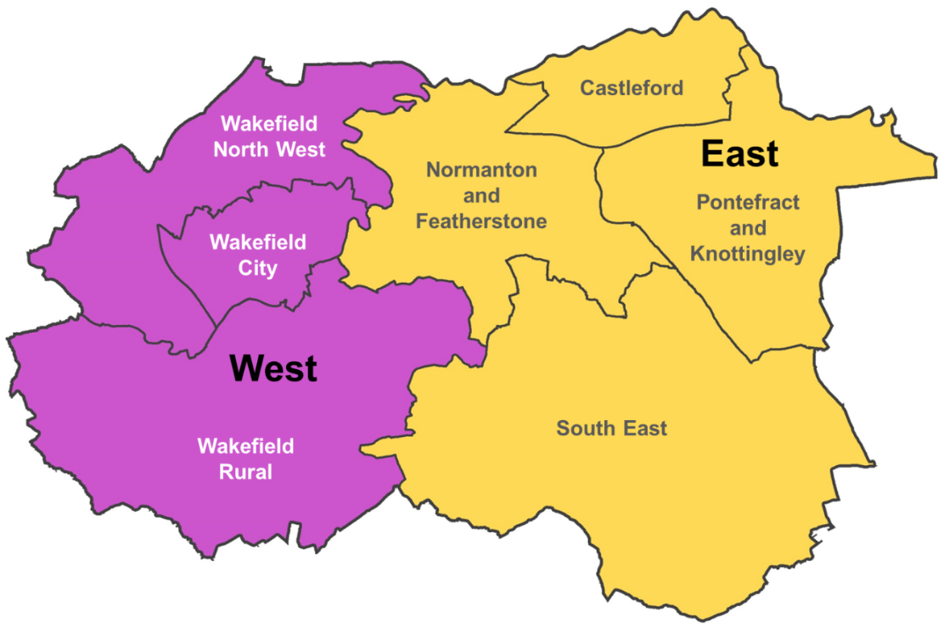

Surrounding Area

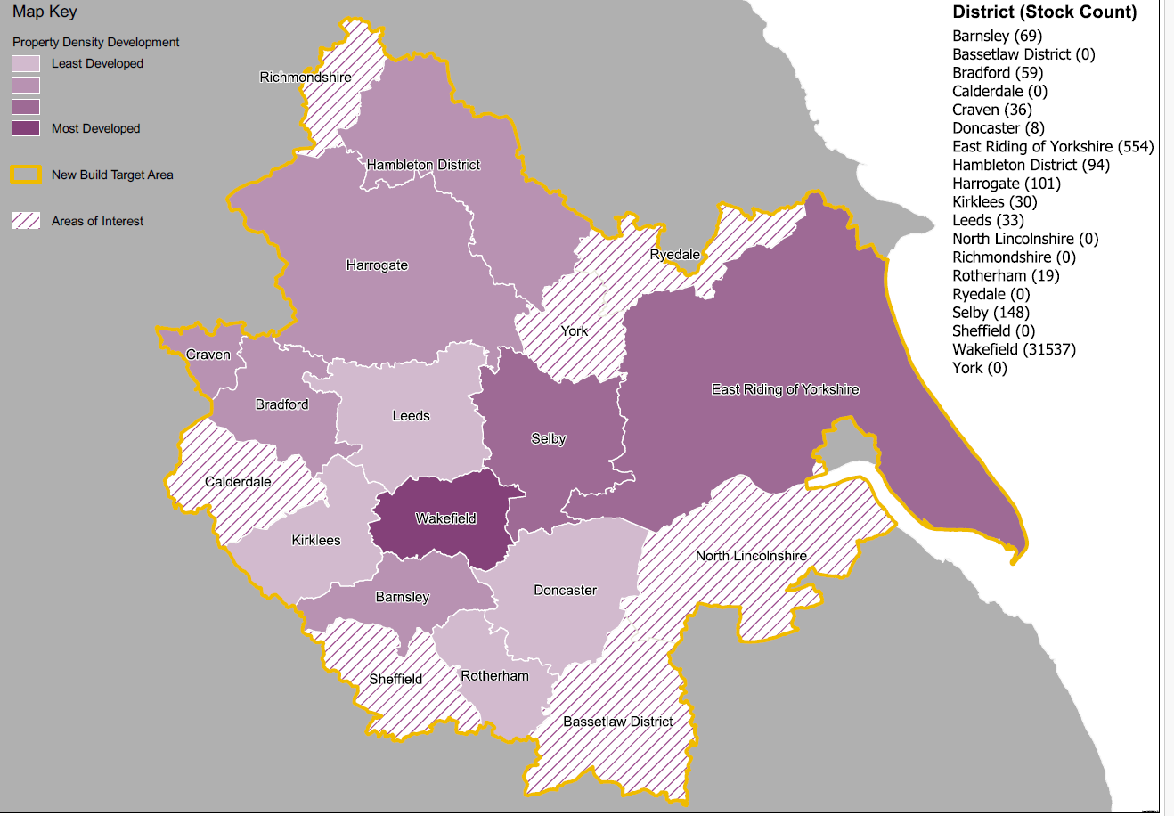

Lot Bid

Supplier Name :

Tender Reference :

Our intention is to bid for the following lots:

Lot Bid

Lot 1: General Repair and Maintenance | Yes/No
Lot 2: Roofing Repair and Maintenance | Yes/No

If bidding for more than one LOT, suppliers must provide supplementary information where necessary, detailing any variance in price within Appendix 3 Schedule of Rates.

For this purchasing requirement WDH requires a minimum of two contractors to undertake General Repair and Maintenance services and two contractors to undertake Roofing Repair and Maintenance services across the Wakefield District and surrounding areas. It is envisaged that if a Contractor ranks 1 or 2 in both LOTS’s based on the Evaluation and Award Criteria, they will be selected and awarded Repair and Maintenance services in both LOTS.

The work in each LOT will be split on a 50:50 basis for suppliers Rank 1 and Rank 2 in line with the Evaluation and Award process and performance by achieving relevant KPI’s. If performance is not maintained and KPI’s are not met then WDH reserves the right to reduce the percentage split until performance is achieved.

WDH reserves the right to itself to decide which Contractor(s) will be nominated to provide the necessary services across particular geographical regions, subject to WDH requirements and the Evaluation and Award process.

Estimated Volume of Jobs per Annum

Area and Trade | Estimated Volume of Jobs per annum
LOT 1 - General Repair and Maintenance  Joinery  Plumbing  Plastering  Bricklaying and Pointing  Flooring  Groundworks  Fencing  Mould work | 11  12  955  185  35  22  32  300
LOT 2 – Roofing Repair and Maintenance  Roofing Repairs  Guttering | 1247  606

Please note: The volumes have been used for estimation purposes and no minimum or maximum value of works can be associated with this contract and the volumes are only to be used as guidance.

General Scope

Wakefield and District Housing Limited (WDH) invites tenders for General Repair and Maintenance Services including, but not limited to, Joinery, Roofing, Plumbing, Plastering, Bricklaying, Fencing, Groundworks and all associated remedial works at various properties across the Wakefield District across the Wakefield District.

Please Note: This will be a supply and fit contract. WDH on occasions may offer free issue materials (encompassing these contract arrangements) to the Contractor deemed appropriate by WDH.

The work shall comprise of a Planned Repair and Maintenance service as described within Appendix 1A General Building Specification 2022.

Regulations and Standards

All works undertaken shall comply with the appropriate Regulations, British Standards and Codes of Practice and shall be in accordance with the manufacturer’s instructions.

Response Times

All General Repair and Maintenance services will be carried out Inside normal working hours (see Labour section below).

Planned General Works.

The successful tenderer will be required to undertake works comprising of general refurbishments and planned repairs to WDH properties across all trades types to tenanted properties as described within Appendix 1B General Building Specification 2022.

Construction (Design and Management) Regulations 2015 (CDM 2015) Policy

The Successful Tenderer must adhere to CDM Regulations 2015. The policy sets out the responsibilities and duties of managers, or their delegated officers, and provides a summary of the Construction (Design and Management) Regulations 2015 (CDM 2015) located within Appendix F

Lead Time

WDH may require a professional service to all properties. The successful tenderer(s) will be working closely with WDH tenants, and it is important to reduce as much disruption as possible.

To meet these timescales the following lead times must be met and will be cross referenced against Management Information (MI) and Key Performance Indicators (KPI’s).

Description | Lead Time
Priority 1 | 2 hours
Priority 2  Priority 3  Priority 4 | 24 hours  5 working days.  28 working days

Warranties and Guarantees

The period for review of works / warranty period is 12 months. The guarantee, which will be provided by the successful tenderer without cost to WDH and shall cover all costs inclusive of transport, labour materials and parts to allow all systems to become fully operational and safe. Rectification of poor workmanship will be deemed as the Successful Tenderers responsibility. WDH will not accept any responsibility for any material costs incurred by the Contractor(s) due to poor workmanship. Rectification must be completed with seven days of notifications from WDH.

All materials used must be used in accordance with the manufacturer’s recommendations in line with the method statements and working practices agreed with WDH as illustrated within Appendix 1B General Building Specification 2022.

WDH on occasions may offer free issue materials (encompassing these contract arrangements) to the Contractor deemed appropriate by WDH.

The work will be subject to inspection by WDH throughout the contract period. Rectification of poor workmanship will be deemed as the Contractor’s responsibility. WDH will not accept any responsibility for any material costs incurred by the Contractor due to poor workmanship.

The work areas will be kept tidy at all times and be left in a satisfactory condition.

Technical Specification

The work to be carried out within this contract is to provide an effective, responsive and preventative day to day maintenance and repairs service. This duty will include the repair and maintenance of any building fabric, any component or fitting that is attached to the fabric, any service conduit/pipe, mechanical appliance (excluding gas and electrical works), and external works including aspects of open space infrastructure to ensure that properties remain safe, secure, operable and provide a suitable environment for occupiers and visitors.

WDH requires the successful tenderer(s) to be able to provide all of the following trades. This will include joinery, plumbing, plastering, flooring, bricklaying, groundwork, roofing, guttering and fencing.

Customer Care

WDH puts tenants ‘at the heart of everything we do’. Consequently, suppliers must ensure that, when delivering services to WDH, their personnel conduct themselves in a polite, professional, and courteous manner at all times. In addition, the supplier’s personnel are required to be sensitive to people’s lifestyles, religious beliefs, and ethnic origins.

Work areas must be kept as tidy as possible during works and must be left in a clean and tidy state at the end of each working day and upon completion of works.

It is not permissible for suppliers to dispose of trade and other waste in domestic refuse containers (e.g.: wheelie bins) at our tenanted properties. All waste must be disposed of to comply with current Environmental legislation.

WDH has a ‘no radio’ policy whilst working at, within or around the homes of our tenants. Suppliers are required to comply with this ‘no radio’ policy and ensure that their personnel deliver works in a considerate manner to minimise disruption and disturbance to WDH tenants and the public.

The supplier’s personnel are not permitted to use gas supplies, electricity supplies, water supplies or toilet facilities in any WDH properties – either tenanted or untenanted – unless they have obtained prior written agreement from WDH.

All the supplier’s personnel must carry a WDH ID visitors’ badge, which shall be supplied by WDH and must always be visible. All badges must be returned on completion of the work, inform WDH immediately if any badges are lost or stolen.

The successful tenderer will be working closely to WDH tenants and should present a professional attitude at all times. The successful tenderer must comply with the Customer Care Policy located in Appendix B and Safeguarding Children and Vulnerable Adults Guidance in Appendix C. Any issues arising where this has been transgressed will form part of the contract review process. The successful contractor(s) must comply with the Contractor Minimum Standards Charter located in Annex B. Where appropriate, action could result in the successful tenderer being charged for the customer complaint compensation WDH has to pay and / or loss of work from the allocated programme

The Supplier shall ensure that all individuals engaged in regulated activity are subject to a valid enhanced disclosure check for regulated activity undertaken through the Disclosure and Barring Service.
The Successful Tender must monitor the level and validity of the checks for each member of Supplier Personnel. The Successful Tenderer must not employ or use the services of any person who is barred from, or whose previous conduct or records indicate that he or she would not be suitable to carry out regulated activity or who may otherwise present a risk to Service Users.

Site Attendance

The successful tenderer will:

- contact the relevant tenant to agree a convenient appointment
- contact the tenant on the day of the job with an estimated time of arrival prior to attending site;
- Arrive at the appointed time
- In the event of not being able to meet the pre-arranged appointment, the tenant should be contacted to explain/apologise for the cause of the delay and if required, agree a new mutually convenient appointment.

- Risk assess the repair to be completed. Where the repair cannot be completed safely this must be triaged to WDH’s management team.
- wear a uniform and carry identification at all times including overshoes when going in a tenanted properties.
- comply with the WDH Customer Care Policy, a copy of which can be found at Appendix B of the document;
- following completion of works the engineer will inform the relevant tenant the work has been completed and work must be signed off from the tenant.

Whilst on site the supplier’s personnel are expected to take all reasonable precautions to protect the fabric of WDH properties and tenants belongings.

Continuity of Service

WDH require the Successful Tenderer to maintain the continuity of service to WDH within the agreed response times even when adverse situation arise, including, but not limited to the following situations

- Adverse weather.
- Human Resource issues such as Holidays.
- ICT outages/failures.

Access to Dwellings

The successful tenderer must make a suitable appointment with the WDH tenant during agreed response times as located above.

On the day of the job the successful tender must contact the WDH tenant to make sure access is available and work can progress.

When arriving at the property the successful tender must provide photographic identification to the tenant including overshoes when accessing the property.

Once works have been completed, the successful tender must explain the work completed and any preventative measure taken to resolve.

Photographic Evidence

The successful tenderer must supply before and after photos of all works completed to ensure invoices can be processed within the relevant timescales. These photos must be supplied to WDH alongside the invoices.

Failure to do so, could result in non-payment until evidence is provided.

Labour

The successful tenderer must provide WDH with a process/responsibility process map of how their day to day repair and maintenance service will work to meet our performance criteria, detailing all key contacts, contact phone numbers, email addresses, hours of operation and so on.

WDH’s typical office working hours will be between 8 am to 5:pm Monday to Friday.

Contact with WDH outside these times and at weekends will be through our 24 hours a day, every day, OneCALL service on 0345 8 507 507.

Emergency Repair / Emergency Call Out

The successful tenderer must provide WDH with a process / responsibility process map of how their emergency response service will work based on 24 hours a day, every day cover to meet our performance criteria, detailing all key contacts, contact phone numbers, email addresses, hours of operation, and so on.

When issued with a job category of “emergency repair” the successful tenderer must respond immediately to meet the contract performance for this category of repair. Ideally, the tenant should be contacted to ensure that they are in their property to gain access and for the successful tenderer to give safety advice according to the situation to ensure tenant safety prior to attending site.

In an emergency the WDH person to whom contact is made shall be provided and have access to the authority to directly instruct operatives to carry out work and to give instructions relating to the priority of each individual callout and to make decisions within an emergency situation. Also at all times throughout the contract period, during normal working hours, a senior employee of the successful tenderer shall be available to answer urgent contact from WDH.

First Time Visit Repairs

For all works referred to in this contract a first time visit repair must be completed whenever possible, first time visit repairs will be monitored to meet the contract performance criteria.

Failure To Complete and Unsatisfactory Work

If the successful tenderer fails to complete the work in accordance with the performance criteria or any part there of or to remove or make good any defective or unsatisfactory work, when ordered to do so, WDH may take the work from the successful tenderer and arrange for completion of the work by others and make good the work complained of, and to charge the successful tenderer with all additional costs incurred. WDH may also retain any monies due to the Contractor at any time the amount of such costs.

Technical Support

The successful tenderer must also include within his tender to have at his disposal a technical library consisting of but not limited to manufacturer's instructions, British Standards Codes of Practice, applicable Regulations or EEC equivalent. The successful tenderer must also include to be prepared to add to this library information to reflect WDH’s appliance population and to liaise with manufacturers both verbal and written and by joint site visit to overcome complex problems and technical issues.

The successful tenderer must also allow for full technical resources to support his workforce. The successful tenderer should be aware that it is not WDH’s responsibility to resolve technical problems.

The successful tenderer shall also include for the successful tenderer to issue a verbatim extract to his operatives of the whole technical specification, including mandatory requirements, extent of liability and WDH’s specific servicing requirement to ensure there is no misunderstanding as to the standard required.

Value of Parts and Materials Approval – Repair Jobs

The successful tenderer has authorisation to purchase parts and materials to the total sum of £250 excluding VAT per order without authorisation from the appointed WDH contract manager. All parts used must be detailed on the supplier invoice against the job number for validation purposes.

Authorisation must be given by the appointed WDH contract manager for parts and materials exceeding a single or total value greater than £250 prior to purchase.

This price is subject to change however the scope of this framework is to repair what’s there and leave a functional wind and watertight property. It is not to replace full component's.

All parts must be replaced on a like for like basis.

WDH reserve the right to open book costing that allows visibility (if required) of material costs of the successful tenderer as well as the option to provide Free Issue materials.

Ordering of the Works

The successful tenderer shall provide facilities, for the receiving of responsive repair orders from WDH by phone, our WDH OneCALL centre as well as by email. The successful tenderers facility must be operational and manned 24 hours a day, every day.

In answer to the request from WDH for the successful tenderer to attend for a responsive repair or any other works within this Contract it is the successful tenderers responsibility to arrange appointments with the tenant and to obtain information to enable the works to be carried out at the appointed time.

WDH will not accept any liabilities, in connection with the information received by the contractor from the tenant regarding the nature of the work reported or any access arrangements.

Daily Work Completions

The successful tenderer shall provide WDH with a weekly work completion spreadsheet for the previous week the spreadsheet will be automated capturing all the contractors ‘work in progress’ and shall be fully completed and be emailed to repairs@wdh.co.uk

Stock Availability

The successful tenderer shall ensure that before the Works commence, that they have sufficient stocks of materials and parts to fulfil the obligations of the job issued and complete a first time fix repair.

The successful tenderer shall provide details of their supply chain arrangements and typical buying rates.

However if it occurs, that the successful tenderer cannot obtain parts and or materials at the time they are required, the successful tenderer shall inform the tenant and WDH when the parts and or materials will be available and include to arrange a further appointment for such parts and or materials to be fitted to enable the appliances and or systems to become operational.

WDH on occasions may offer free issue materials (encompassing these contract arrangements) to the successful tenderer deemed appropriate by WDH.

WDH on occasions may offer free issue materials (encompassing these contract arrangements) to the successful tenderer deemed appropriate by WDH.

Tenant Contact

The Successful tenderer is required to make contact with the tenant prior to a site visit to arrange a convenient day and time. The contractor must endeavour to fully comply with the contract performance criteria as detailed in this contract and as such all attempts to contact tenants should be recorded on a date, time, method of contact and contact established by basis.

No Access

Where there is no prior contact from the contractor with the tenant and an abortive visit / no access is recorded there will be no recharge to WDH under this contract unless the successful tenderer can evidence prior contact.

Hard to access properties will be discussed at contract review meetings and agreement of next steps. When contact to WDH tenants has been made, and an appointment made and the successful tenderers cannot gain access to the property, WDH will pay a no access cost of £40 but photographic evidence of the property/door must be submitted.

Sub-Contracting Work

The successful tenderer is to provide details of any sub contracting company to be used under this contract for discussion and agreement prior to their use. Any additions or amendments to this list of companies originally detailed must be agreed with WDH prior to using on this contract.

Sub-contractors may only be used on written agreement from WDH and under the following conditions:

- Prior notification of intent to Sub-Contract work, and name of Sub-Contractor.

- Agree to full compliance of this contract and specification.

Please note: if standards quoted within this (or associated documents) have been superseded or recommended to be superseded WDH expect the services to be carried out to this legislation.

Contractor Skills and Training

It is a requirement that any contractors working on WDH has the necessary skills and training deemed by WDH and located within Appendix 13. This includes but not limited to;

- Copies of CSCS Cards
- Enhanced DBS Check
- Face Fit Tests
- Asbestos Awarness
- Records of PAT testing, plant, tool and equipment / maintenance records.
- Noise Safety Awareness
- Abrasive Wheels Training
- Manual Handling Training
- Needlestick Awareness
- Hand Arm Vibration Training
- Gas Safety Awareness (Regulation 8).
- Working at Heights
- Fall Protection/Arrest Systems training
- Safeguarding Awareness Training

Please provide within your tender response, a skills matrix for your organisation on the above training requirements as located within Appendix 13

Please provide within your tender response within Appendix 4 how you will accommodate this and any additional value-added services you can provide.

Construction Skills Certification Scheme (CSCS)

The successful tenderer(s) will be responsible to only let CSCS registered employees work on the contract. It is also important to update WDH with relevant documents as employees change.

Asbestos

WDH will undertake asbestos surveys of all properties and provide the successful tenderer with details. However the contractor should provide evidence of training provided to its employees around asbestos awareness for such occasions where they may come across or disturb asbestos containing materials.

Compliance with Regulations

All works undertaken must be in full compliance with the following Regulations:

- Health & Safety at Work Act 1974.
- CDM Regulations 2015
- The Work at Height Regulations 2005.
- The Management of Health & Safety at Work Regulations 1999.
- The Electricity at Work Regulations 1989.
- Gas safe installation and use regulations ( Regulation 8 )
- Noise at Work Regulations 2008
- COSHH Regulations 2002
- RIDDOR 2013
- Control of Asbestos at Work Regulations 2012
- The Control of Vibration at Work Regulations 2005.
- Construction (Design and Management) Regulations 2007.
- Manual Handling Operations Regulations 1992
- Health and Safety (First Aid) Regulations 1981
- Personal Protective Equipment at Work Regulations 1992 (as amended)
- Provision and Use of Work Equipment Regulations 1998
- The Waste Management Licensing Regulations 1994

Note:

If any standards quoted within this (or associated documents) have been amended, superseded or recommended to be superseded WDH expect the services to be carried out to this legislation.

Waste Management

WDH has strategic objectives concerning Corporate Social Responsibility. We pro-actively seek environmentally responsible disposal solutions for all our waste streams and we are very close to achieving 100% landfill avoidance.

Successful suppliers will be required to assist WDH by contributing towards these objectives in terms of how they dispose of any waste.

The successful tenderer(s) must be in possession of a waste carriers licence issued by the environment agency to work on this contract and provided as part of Appendix 4.

Working at Heights

Where the required services involve working at height, they must be delivered in compliance with the Work at Height Regulations 2005 (and any subsequent revisions).

When working on ladders the successful tenderer(s) personnel must, in the first instance and prior to commencement of any works, risk assess and determine that ladders are the most suitable piece of equipment for the work to be undertaken, always keeping in mind the principal of short duration and three points of contact with the ladder. If ladders are identified as the most suitable means of working at height, then the successful tenderer (s) must:

- ensure a suitable device for ‘footing’ the ladder is used
- ensure a suitable ladder ‘standoff’ device is used (where necessary)
- ensure that the ladder is suitably tied into the property to which works are being undertaken
- ensure that any personnel using the ladder are equipped with and use a suitable safety / fall arrest harness
- ensure that the ladder is regularly inspected by a competent person and records are available.

All safety/fall arrest harnesses must comply with BS EN 365:2004 Personal protective equipment against falls from a height. Users of such safety/fall arrest harnesses must be trained and certified to use the equipment and proof of this training must be provided to WDH both at the commencement of the contract and thereafter upon each and every instance when the training/certification is renewed.

Please note, where a safety/fall arrest harness does not meet the required WDH specification then WDH is able to supply the contractor with an appropriately compliant harness at the supplier’s cost. Furthermore, where the harness user’s training/ certification does not meet WDH’s required standard then WDH is able to provide the appropriate training/certification to the harness user at the supplier’s cost

All works undertaken must be in full compliance with WDH’s Working at Heights policy (see Appendix E).

Compliance with RIDDOR

All works undertaken must be in full compliance with the Reporting of Injuries, Diseases and Dangerous Occurrences Regulations 2013, RIDDOR. Where an occurrence / incident is reportable under RIDDOR then the appointed WDH contract manager within this contract must be notified immediately, if not contactable then the Escalation Procedure within this contract must be followed immediately.

Protection of the Site and Works

During this contract and throughout the execution of the ordered works, the successful tenderer(s) shall include for the protection of all fixtures and fittings in the property at no additional cost to WDH. In the case of occupied dwellings, the successful tenderer(s) must protect the occupiers' belongings from damage, either by covering with dust sheets or by removal of such belongings from the working area and great care must be taken to ensure that only minimal disturbance is caused to the occupants, especially in respect of dust and noise.

The successful tenderer(s) shall take particular care of gardens, trees, shrubs, paths, kerbs, verges, and so on and shall make good and reinstate any damage or disturbance caused by the ordered works, without cost to this contract.

The successful tenderer(s) must also include for all surplus materials and debris arising out of the ordered works to be removed from the site or dwelling on cessation of each day's work and the area of the work shall be left in a clean and tidy condition. The removal of waste needs to be undertaken in accordance with appropriate regulations and legislation governing the transfer and disposal of waste.

Prevent Trespass

The successful tenderer(s) workforce is not allowed to trespass upon properties adjoining those in respect of where the work is to be carried out. If the execution of work requires that the operative must enter upon adjoining property, the necessary permission must be first obtained by the successful tenderer(s) by the appointed WDH Contract Owner

The successful tenderer(s) shall indemnify WDH against any claim or action for damages on account of any trespass or other misconduct of its employees. Operatives will be allowed only into such parts of the site and buildings as may be necessary to execute the works.

Warranties and Guarantees

In the case of repairs made under the contract, these should include a defect liability period of 12 months from date of completion – completion being determined from the date that WDH (Client) sign-off the work as being complete.

The defect liability period should include parts and labour required to rectify any of the defects.

All defect liability period issues should be classed as ‘priority’ and attended within four hours. In any such criteria that this cannot be met then the successful tenderer(s) should notify WDH in writing. In the event of the anticipated fixing period exceeding five working days, a site meeting review will be undertaken to determine the optimum solution.

Identification

The successful tenderer(s) shall provide all his employees and volunteers that are to work on the contract with identification cards stating that they are bona-fide employees and or volunteers of the said successful tenderer(s). The cards must have a photo of the employee, the successful tenderer(s) name and telephone number, the operatives name and an expiration date based on the date for the end of the contract.

Confidentiality

The Supplier must maintain the highest levels of confidentiality regarding any personal information that is supplied to them about WDH’s residents, including any other information they acquire whilst working at their home. Suppliers must not discuss with the resident WDH’s business, other residents, other properties, previous workmanship or other Service Providers. Any enquiry regarding WDH’s business should be redirected to the appropriate WDH contact.

The Supplier shall not during the term of this Contract, or at any time after its expiry or termination, for any reason (except in the normal course of its duties under this Contract), disclose to any person or otherwise make use of any information of which it has or may in the course of its appointment under this Contract become aware of, nor shall disclose to any person whatsoever anything contained in this Contract (except in the normal course of its duties under this Contract), without the prior written authority of WDH, save only where the Supplier is required by any regulatory body or statute or by Court Order so to do.

The Supplier will be required to ensure all WDH material and documents are secure and confidential. At times the Supplier will be made aware that they are to be in possession of highly sensitive documents. These documents (such as Accounts, budgets and so on) require being kept secure and absolutely confidential. Failure to do so could lead to the instant termination of the Contract without any break clause being enforced by WDH.

On termination of this Contract and on satisfactory completion of the Exit Management Plan (or where reasonably so required by WDH prior to such completion) or prior to the beginning of any Liquidation proceedings the Supplier shall procure that:

- all Documentation including equipment;
- all Group data;
- all IPRs owned or licensed by WDH as well as any other Group Supplier IPR or Supplier data that has been provided to the Supplier through WDH and used in the provision of the Services to which the Supplier has, during the continuance of this Contract and whilst providing the Services, had access to;
- any and all copies of the same in the Supplier’s control or which the Supplier has passed to any third party; and
- any Group owned copyrights and / or materials should all be delivered to WDH forthwith should any of the stated events occur.

Dress code

Suppliers are required to wear an appropriate form of clothing, which is clean and tidy, and where necessary, to wear the required safety clothing. Employees should have identification on them at all times and should show this to WDH employees and customers prior to entering any property.

The Supplier’s employees shall also be issued with the necessary safety equipment to ensure that he can carry out his functions in accordance with the recommendations of the Health and Safety at Work Act and The Supplier’s Working Policy Document(s). The Supplier will comply with any reasonable requests for additional Personal Protective Equipment (PPE) to be used.

Before starting work in a WDH property the Supplier must:

- park vehicles responsibly (observing any local restrictions, ensuring that access for neighbouring residents / businesses is not compromised and or inconvenienced);
- where appropriate ensure that they have met with the WDH Representative to be inducted onto the site;
- explain how long the work will take and which areas will be affected;
- ask if materials and tools can be left in a particular place, checking they will not cause inconvenience to the customer;
- explain to the customer (WDH representative / tenant) the nature of the work that is to be carried out and how this may affect occupants; and
- check that this agrees with the work the customer expects to be done. If there is a difference, contact the relevant WDH contact for advice.

Conduct whilst in a WDH property:

- Disruption - assessors must ensure there is minimum disruption to the resident and employees.
- Offer to cover shoes when entering premises and or ensure that floor coverings are protected as required
- Health and Safety - the site must be kept safe at all times. Fire exits, lifts, staircases, corridors and doorways must be kept clear and not blocked by the Supplier’s tools or materials
- Do not take personal property into a resident’s home.
- Assessors must ensure that they are never left alone with minors (where minors are present, and no parent or guardian is available, the Supplier shall inform WDH immediately of the issue, and remove assessors from site.
- Assessors must not seek to obtain private work from WDH residents.
- Protection of property - assessors must treat the homes of residents / WDH property with respect and ensure that suitable protection is arranged for the resident's property and that delicate or valuable items are removed from the work area.
- Damage to property - any damage to property resulting from negligence of assessors must be compensated for by the Supplier.
- Utility services - electric and gas supplies may only be used with WDH’s / the resident's permission
- Do not consume alcohol or take drugs (other than prescription medicines which do not impede the safe operation of the task) under any circumstances while in the employ of WDH.
- Where occupiers to the premises will be absent whilst service is being carried out the Supplier shall ensure that the property is kept safe and secure at all times. Supplier’s employees should liaise with site security where present.
- Circulation routes (and access and egress points) for vehicles and/or pedestrians and employees must be kept free from obstructions and this must be maintained at all times.
- Tools must not be left unsecured or in such position as to present a hazard to persons at any time during the contract.
- Access into WDH buildings and offices must be kept secure at all times throughout the contract. Access gates / doors must be kept closed when not in use and must be attended when being used.
- The Supplier is responsible for moving and subsequently replacing any fittings, fixtures, furnishings, floor coverings to enable the services to be carried out.

Contract Management

Contract Review

The successful tenderer will be required to attend regular contract review meetings with WDH in order to discuss contract performance and make sure performance criteria are being achieved and to discuss and resolve any issues arising. It is envisaged that such contract reviews will be conducted monthly although more frequent meetings with WDH operational employees responsible for the day to day running of the contract may be required from time to time.

Any ongoing management information (MI) requirements of WDH should be supplied free of charge (FOC) in the format and time intervals required. Management Information will consist of but not restricted to:

- No of General Repair and Maintenance Services Undertaken within each trade.
- First Time Fix information and Percentages.
- Status of Property Completions
- Issue with Material Deliveries.
- Outstanding Technical Issues.
- Any efficiency gains or reduction in the carbon footprint.
- Customer Satisfaction
- Records of any Health and Safety Issues
- Changes to qualification matrix

Contract Pricing

Prices must be held firm for at least 12 months from commencement of the contract.

The contract price should include:
- All costs involved with delivering the services outlined in Appendix 1;
- Any costs of preparation of any reports (including amendments to draft reports) and management information required, including those to fulfil KPI reporting;
- Any contract management costs including liaison with WDH personnel and residents;
- Costs of attendance at relevant meetings; and
- Any other disbursements ordinarily required to deliver the service/s outlined.

Please complete the Pricing Schedule section (Appendix 3).

Contract Pricing Review

An annual review of prices will be allowed (if required) only on the anniversary of the commencement of the contract. If variations to the rates charged are required, these should be by mutual agreement and not exceed the prevailing rate of deflation / inflation based on the ‘agreed index’, other than if a ‘benchmarking realignment’ is made to maintain value for money. Prices may reduce as well as increase. The appropriate Consumer Prices Index (CPI) (of the UK Office for National Statistics) will be the ‘agreed index’ used unless an alternative index is mutually agreed by both parties.

Invoicing

Application for payments will be submitted by the supplier for the works designated to an individual supplier required under the programme and a 100% check/ inspection will be undertaken by WDH.

WDH will at this point provide the supplier with a purchase order number. Upon completion of the work, and subject to the works being of satisfactory quality, WDH will approve/amend and agree the invoice which will then be processed to WDH Exchequer Services

The supplier shall invoice WDH, referring to the purchase order on the invoice which they will send to the Team Leader inbox which is tlrepairs@wdh.co.uk

WDH shall pay the suppliers invoice within 30 days from the date of receipt of the invoice which should correspond with the date sent to WDH.

Added Value Services

The basic requirements are outlined within this document regarding the service WDH requires, however potential Service Providers may be able and are encouraged to provide services which add value to this contract.

Innovative Solutions

WDH are continually looking to improve the quality-of-service delivery to our residents, not only through service reliability and feedback, but also through performance measurement and innovation.

Whilst the basic needs, required by WDH, are outlined within this document, tenderers are encouraged to provide innovative solutions. In such instances proposals should be submitted as part of your tender submission. If a cost would arise then it should be entered as a separate entry and any additional documents cross-referenced in the Price Schedule of Appendix 3.

Management Information (MI)

The successful tenderer’s performance will be monitored throughout the duration of the contract against a series of Key Performance Indicators (KPIs) for which the successful tenderer will provide appropriate management information (MI) required by WDH.

WDH and the successful tenderer will agree the MI appropriate to the ongoing successful management and service delivery as soon as possible in the tender process. However, where agreement cannot be reached, those provided by WDH shall prevail.

Appropriate WDH employees will utilise this performance data to manage the contract and co-ordinate appropriate action plans with the successful tenderer to provide the residents with the required service levels and value for money.

It is envisaged that the MI will be based around (but not limited to) the following areas and that WDH and the Successful Tenderer will agree the MI appropriate to the ongoing successful management and service delivery as part of the mobilisation of the contract:

Critical Management Information;

- No of General Repair and Maintenance Services Undertaken within each trade.
- First Time Fix
- Status of Property Completions
- Issue with Free Issue Materials Deliveries.
- Outstanding Technical Issues.
- Any efficiency gains or reduction in the carbon footprint.
- Customer Satisfaction
- Records of any Health and Safety Issues

Key Performance Indicators (KPIs)

The successful tenderer performance will be monitored throughout the duration of the contract against a series of Key Performance Indicators (KPIs) for which the Successful Tenderer will provide appropriate management information (MI) required by WDH.

Appropriate WDH employees will utilise this performance data to manage the contract and co-ordinate appropriate action plans with the successful tenderer to provide the residents with the required service levels and value for money.

WDH and The successful tenderer(s) will agree the KPI’s appropriate to the ongoing successful management and service delivery as soon as possible in the tender process. However, where agreement cannot be reached, those provided by WDH shall prevail.

Appropriate WDH employees will utilise this performance data to manage the contract and co-ordinate appropriate action plans with the successful tenderer(s) to provide the residents with the required service levels and value for money.

It is envisaged that the KPIs will be based around (but not limited to) the following areas and that WDH and the successful tenderer(s) will agree the KPIs appropriate to the ongoing successful management and service delivery as part of the mobilisation of the contract:

Critical KPI’s and minimum service levels

- Time to respond to Priority 1, when notification has been given by WDH: 2 hours: 100%
- Measure the time taken from communication sent by WDH to confirmation from contractor is on site and the job has started.
- Total number of priority 1 responses inside 2 hours / total number of priority 1 jobs x 100%.

- Time to respond to Priority 2, when notification has been given by WDH: 24 hours: 100%
- Measure the time taken from communication sent by WDH to confirmation from contractor is on site and the job has started.
- Total number of priority 2 responses inside 24 hours / total number of priority 2 jobs x 100%.

- Time to respond to Priority 3, when notification has been given by WDH: 5 Working Days: 100%
- Measure the time taken from communication sent by WDH to confirmation from contractor is on site and the job has started.
- Total number of priority 3 responses inside 5 working days / total number of priority 3 jobs x 100%.

- Time to respond to Priority 4, when notification has been given by WDH: 28 working days: 100%
- Measure the time taken from communication sent by WDH to confirmation from contractor is on site and the job has started.
- Total number of priority 4 responses inside 28 working days / total number of priority 4 jobs x 100%.

- Materials used on projects: Must be as specified or an equal approved which has been signed off by WDH prior to pricing and carrying out any works; 100%
- Measure from the product specification document issued prior to commencement of works / product specification installed on site.

- Health and Safety Regulations
- Measure the compliance with Health and Safety Regulations
- No Health and Safety Regulation Breaches

- Quality Control Checks on Properties: 10% of job completed each month: 100%
- Measure the quality performance of the contractor by completing a minimum 10% of quality control audit on completed properties;
- Total number of quality control audits completed / Total number of jobs within the month x 100%

- Quality Control Performance on completed Properties: No return visits: 97%
- Measure the quality performance of the contractor by completing a minimum 10% of quality control audit on completed properties with no return visits required.
- 100 – (Total number of return visits / total number of quality control checks completed)

Service Credits

The performance management criteria outlined is intended to ensure the contractor maintains the standard of performance at the contracted levels and should they fall below these, the means to restore the agreed standard of performance.

Performance management will be as follows:
- Service credit will be applicable once performance falls below the minimum service level and where service credits are due these shall be payable to WDH by means of a credit on the next monthly invoice.

- contractor performance against service levels will be calculated and reported through the management information the Successful Tenderer will provide.

- Service levels will be reported, managed and calculated monthly unless otherwise advised by WDH

- Where service levels fall below the minimum service level, the Successful Tenderer will provide to WDH monthly: the service credits; the calculated cash amount; and the credit; as well as an appropriate rectification plan.

- The cash credit will be calculated monthly as follows;

For each instance of non performance against turnaround time the contractor shall pay WDH a sum of damages equivalent to one week’s ‘Average Weekly Target Rent plus weekly management costs identified by an open book costing exercise. Excluding Service Charges’ or part thereof, at WDH’s discretion where loss has been identified.

For each instance of non-performance against quality the contractor will be liable to either, at WDH’s discretion, undertake all necessary remedial work at his own expense or to pay WDH a sum of damages equivalent to the cost of WDH procuring such remedial work from a third party. In addition the contractor shall pay WDH a sum of damages equivalent to one week’s ‘Average Weekly Target Rent Excluding Service Charges’ or part thereof, at WDH’s discretion where loss has been identified.

The cash credit should not exceed more than 10% of the invoice value of the calendar month in question.

Health and Safety and Insurance

The successful tenderer(s) will be required to deliver services in compliance with the WDH Health and Safety Policy (Appendix A).

Suitable arrangements should be made for the necessary insurance required, as detailed below

- Employers Liability – minimum of £10,000,000.
- Public Liability – minimum of £5,000,000.
- Product Liability – minimum of £5,000,000.
- Professional Indemnity – minimum of £1,000,000.

Verification of Tender Information

WDH reserve the right to undertake appropriate verification work deemed necessary to verify claims made within tender returns. This may include, but not be limited to: site visits; technical assessments; checks with, or by third parties; and requests for additional information or requirements.

Furthermore, the right is reserved that, where deemed necessary and appropriate by WDH that this may be undertaken with the “first ranked” or “preferred tenderer” in order to verify the winning bid.

If as a result the bid is excluded or the bid marks reduced so that the second bidder becomes the winning bidder, then that bid will be verified in the same manner and so on.

Data Security and Information Security

The Successful Tenderer will be required to complete a full GDPR disclosure.

The security of our WDH Tenants and employees’ data is of paramount importance to us. The successful supplier will hold confidential personal data about our employees. Any data provided to the successful supplier must be kept confidential and dealt with in accordance with the relevant legislation and in line with WDH Data Protection Policy and completed within Annex A Data Processing Agreement.

