Accessing opportunities on PROACTIS/NEPO PORTAL
Allowing organisations to locate documentation which MUST be downloaded and fully completed to enable organisations to resubmit into the opportunity by the deadline stated.
For Help contact the Portal Helpdesk using the Help button for contact information or frequently asked questions.
- Select ‘Register an interest in this opportunity’ once selected screen 2 should appear.
(if you have already done this and did not access the documents immediately go straight to paragraph 4).
- Select ‘To view this DPS event now, click ‘here’ once selected screen 3 should appear.
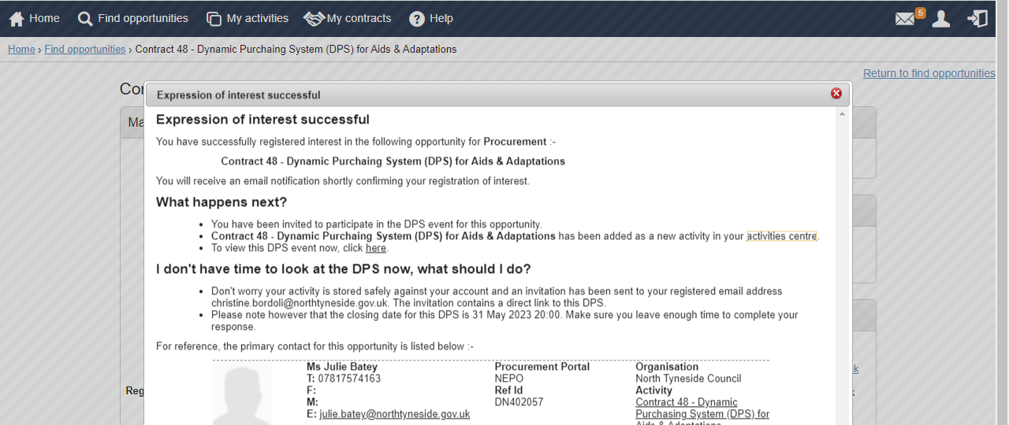
- Scroll to the bottom of the screen to view all documentation and download to complete.
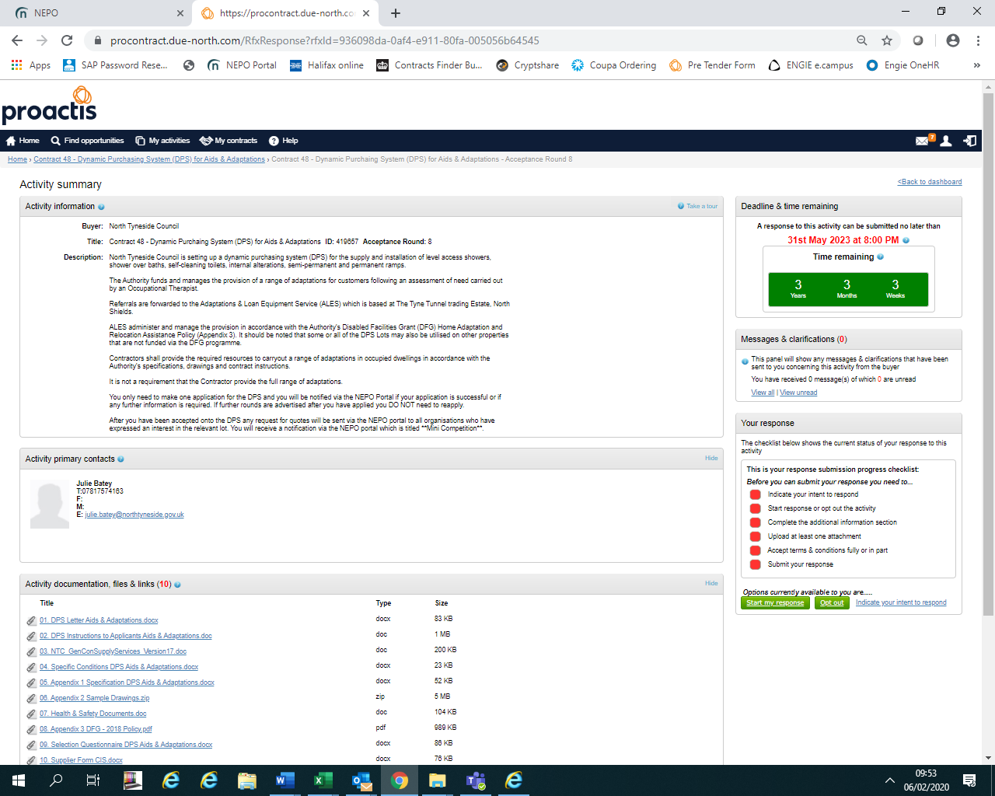
- ALTERNATIVELY:-
If you log out after registering an interest/expressing an interest and do not select the option identified in paragraph 2, you can re-enter the portal and from the home page go to the opportunity using ‘My Activities’.
- Screen 5a, using ‘Narrow your results’, filter to the Buyer, then select ‘Update’ and there is an option to reduce the list further either by searching using a word with the title and select ‘Go’, e.g. DPS which will reduce the list to ones only containing that word, alternatively, check page by page. . Screen 5b shows the list of your current activities, you can select the one you wish to view; anything underlined in blue is a link to another page in the Portal.
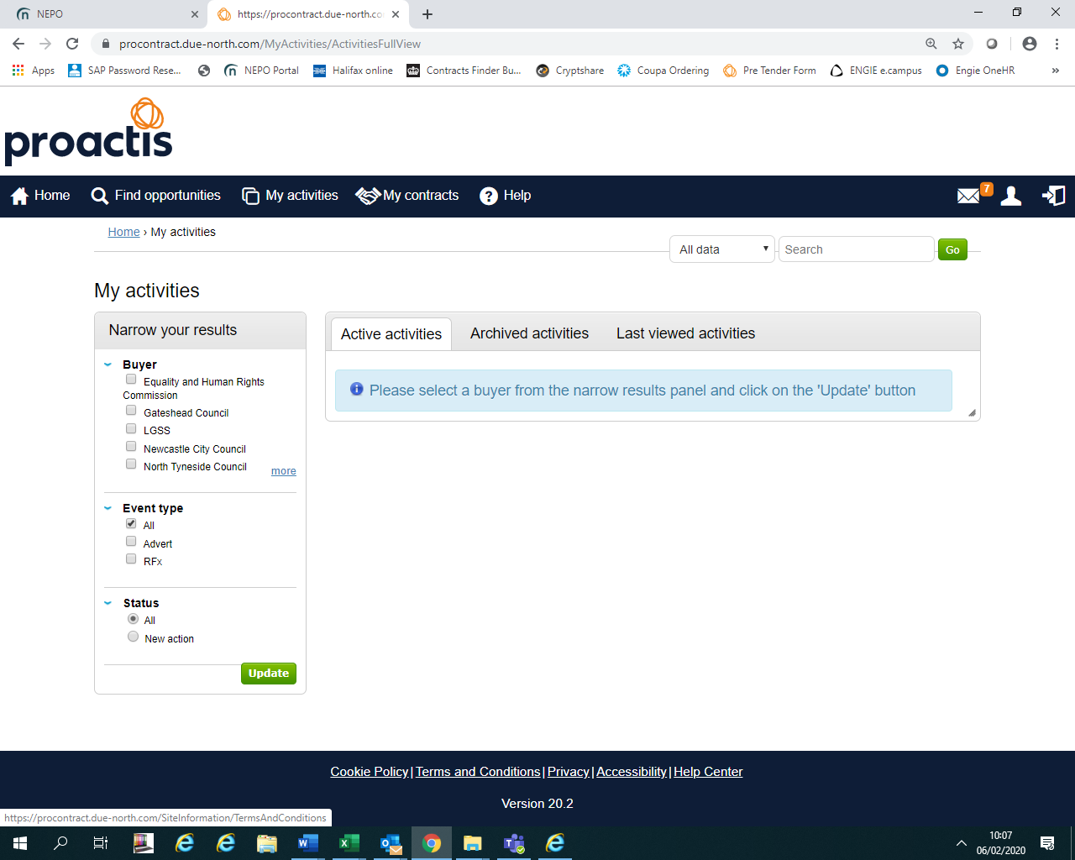
a
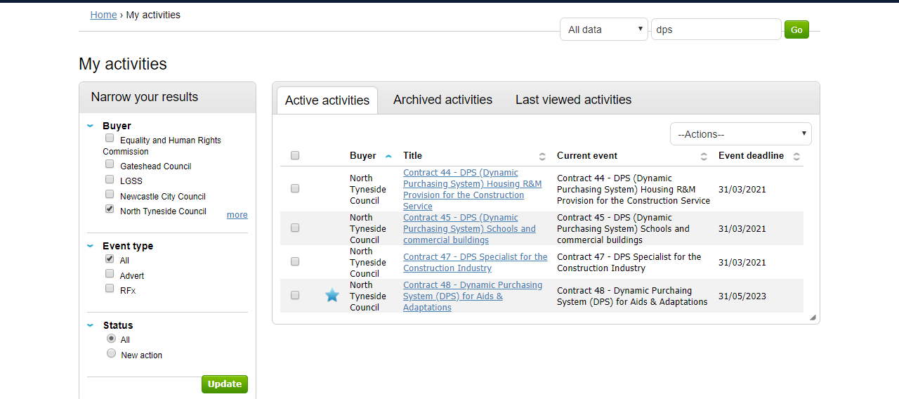
b

- Once you have selected the link to the opportunity, the following screen should open, select ‘open’.
- The opportunity should open in the next screen, showing the date for the deadline of submissions with a deadline clock, all the documents for fully completing and returning via the Portal are listed at the bottom of the screen.
NOTE – FOR DPS Frameworks:-
The sooner you apply the sooner you could be accepted and receive requests for services/works required.
Rounds are closed when the Authority receives an application, another Round opens automatically, you DO NO NEED TO RE-APPLY in another Round unless we specifically ask you to due to an issue with your application.

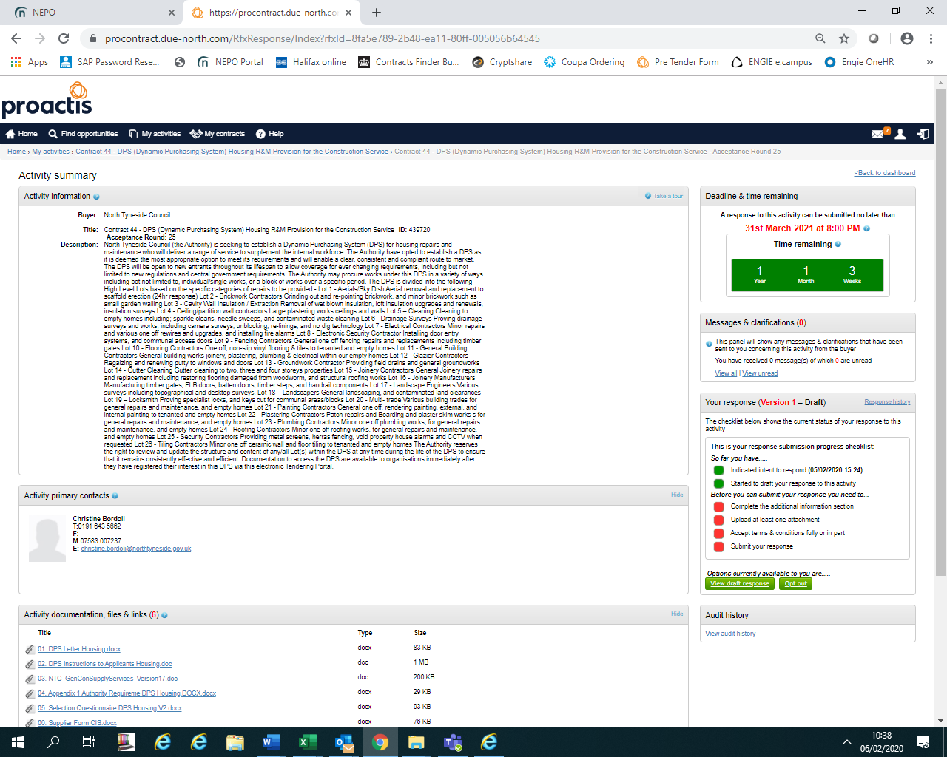

ALL OPPORTUNITIES :-

Ensure you read ALL the documentation including the Instructions.
Ensure you upload ALL the required documents FULLY COMPLETED including any supporting documents, BEFORE THE DEADLINE to avoid missing out.

