Lake District National Park Authority

Invitation to Tender (ITT) for:

Refurbishment of Public Toilet facilities

at

Brockhole on Windermere, LA23 1LJ

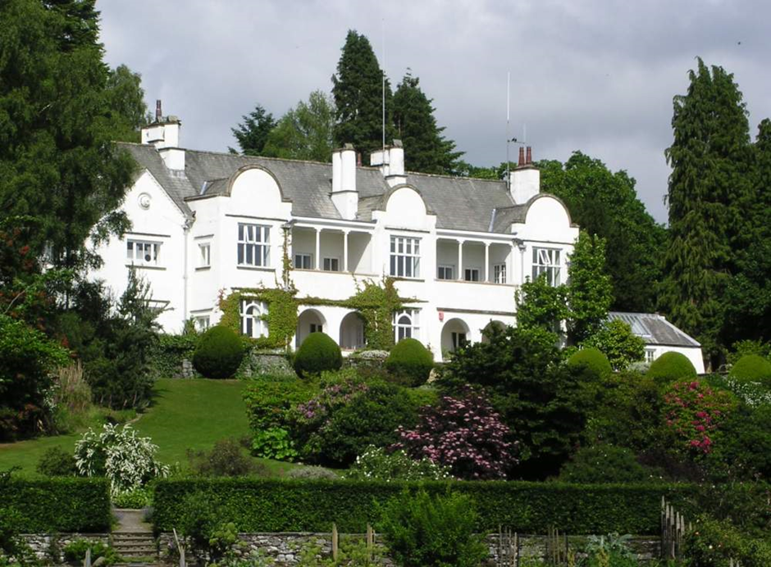

Date: 20 November 2020

Deadline for Submissions: 12:00 18 December 2020

Introduction and background

Brockhole is located in Cumbria beside the A591 between Windermere and Ambleside. National Grid Reference, NY 3894 0100. Latitude 54.401, Longitude -2.942. www.brockhole.co.uk. The main house was built in 1898 as a family residence and privately owned until the 1940s. It was purchased by the Lake District National Park Authority (LDNPA) in 1969 and has been operated as the National Park Visitor Centre since then. The house has a significant Arts and Crafts heritage, and the formal landscaped gardens are registered. Brockhole’s 30 acres of grounds are open to the public and extend down to the shore of Windermere lake.

Today, Brockhole is a busy visitor attraction with in the region of 300,000 visitors a year. Brockhole house includes a café, restaurant, exhibition, shop and soft-play area. Brockhole also offers conference facilities and caters for private wedding parties. The main public toilets on the ground floor in Brockhole house are used by all of these customers are are now in need of complete refurbishment.

The grounds include formal gardens and offer an extensive range of adventure activities including water sports, mini golf, archery and high rope courses. There are take-away catering outlets and public toilets within the grounds. The whole site is open all year round, though in January/February 2021 will not open to the public every day of the week.

The Issue

The main public toilets on the ground floor in Brockhole house include a disabled toilet, ladies toilets (5 WC) and gents toilets (2 WC, 4 Urinals). All of these toilets are in need of complete refurbishment. Brockhole’s customers will expect them to be fitted out to a much higher standard than at present, to provide a suitable quality of facilities to meet both our requirements and our customer expectations.

The toilets will provide for a wide cross section of visitors, including;
- Customers of the Gaddum Restaurant – which offers a high quality dining experience
- Customers of the Café – which is popular with a broad range of visitors from all over the world including families with children
- Visitors to the Indoor Soft Play area – parents with young children and babies
- Business customers to the conference facilities
- Wedding parties and other private functions
- Cultural Tourists visiting the exhibition and shop, and seeking out the Arts and Crafts heritage of the Lake District

The refurbished toilets must also be designed to withstand the wear and tear resulting from approximately 200,000 visits per year. In addition they must be easy to service and maintain, hygienic and easy to keep clean, and robustly designed to withstand high levels of usage.

The toilets will need to be completely stripped back and re-fit to your new design, fixtures and fittings whilst preserving essentially the same room layouts as at present. There is an existing feed of hot and cold tap water to each toilet facility, and it is not expected to be necessary to relocate any existing wastewater drainage outlets. We anticipate that three existing Dyson hand dryers will be retained.

You must be able to complete the refurbishment by 12 March 2021.

Below is a brief summary of the work to refurbish the Ladies, Gents and Disabled toilets,

Agree the final design, materials and finishes with LDNPA client

Deal with any requirement for Building Regulations compliance etc.

Remove and retain items to be re-used such as three Dyson Airblade hand dryers

Strip out. Remove and dispose of all other fixtures and fittings, ceiling tiles, wall tiles, flooring and exposed pipework.

Prepare walls, floor and all surfaces

Supply and install tiling using large-format tiles to all walls

Supply and fit replacement radiators, flooring, toilet cubicles

Supply and fit replacement WC’s, cisterns, urinals and cistern boxing

Supply and fit Doc M Pack and baby changing facilities in disabled toilet.

Supply and fit replacement vanity units, basins, taps, mirrors and lighting

Supply and fit replacement ceiling panels and emergency lighting

Re-fit three hand dryers. Supply and fit additional dryer.

Redecoration of lobby areas including supply and fit of new door push panels, handles, finger guards, signs etc.

Completion, sign-off and hand-over to LDNPA by 12 March 2021.

We have a budget of £50k to £70k for this project.

Our full specification for the refurbishment is given in Annex 1.

We expect that works on site will take place between mid-January and early March 2021. Note that during this period, Brockhole will be open most days including at weekends. Consideration will need to be given to how you will manage the refurbishment project to allow visitors to continue to safely enjoy the site.

Tender Objective

We are seeking an experienced contractor to

re-design the ladies, gents and disabled public toilets, proposing suitably quality fixtures and fittings that meet our requirements and our customers’ expectations,

provide a project manager to oversee the project and to be the interface with the Brockhole team, communicating and consulting with them throughout as required,

deliver the strip-out and re-fit (tiling, joinery, plumbing, electrical, painting and decorating etc) of the refurbished toilets,

complete, sign-off and hand over the finished project to the Brockhole team by the 12 March 2021, including any necessary Building Regulations certificate.

The contractor will be expected to submit a detailed price breakdown listing costs of project management, labour, and of proposed fixtures and fittings. See Annex 2.

The final tender price given on the Form of Tender (annex 3) should include the supply of all materials, disposal costs and contractor preliminaries such as welfare and any storage for equipment and materials. All prices must be exclusive of VAT.

Following this procurement exercise, a JCT Minor Works Contract, DB2016, shall be used as the contractual basis for the refurbishment work ( https://www.jctltd.co.uk/category/minor-works-building ).

Our budget for this project is in the region of £50k to £70k. We are seeking to work closely with the supplier to get the highest quality outcome within budget that meets our requirements.

The chosen supplier will be expected to attend pre-start meetings before commencing any work on site, to sign the agreed contract, to agree all preliminaries including Health & Safety and other practical details, the Construction Phase Plan, sites for welfare facilities and areas to be used for deliveries, storage, and loading/unloading.

Pre-start meetings with the Brockhole team will important to agreeing the final choices of materials, paints, fixtures and fittings, paints and finishes.

Tender Specification

The following information is included in this Invitation to Tender pack:

Invitation To Tender – This Invitation to Tender Document

Annex 1 – Detailed Refurbishment Specification including plans

Annex 2 – Template for detailed cost breakdown (to be completed by supplier)

Annex 3 – Form of Tender (to be completed by supplier)

Annex 4 – Declaration of Non-Collusion (to be completed by supplier)

Annex 5 – References (to be completed by supplier)

A site visit is considered essential to fully appreciate the opportunity and understand the site. Due to coronavirus restrictions the site is currently closed to the public, but appointments for accompanied site visits can be arranged on the following nine dates:

Monday 30 November to Friday 4 December 2020
Monday 7 December to Thursday 10 December 2020

Site visits will need to be at pre-arranged times, and face masks worn be worn at all times. We request that visits are arranged before 10am or after 4pm.

All requests for a site visit should be made by sending a message via the procurement portal.

Essential Experience/Skills/Competencies Required

Tenderers wishing to bid be able to complete the refurbishment by 12 March 2021. As part of their submission, tenderers must also provide,

Brief CVs showing the experience/skills/qualifications of the main personnel to be employed on this refurbishment project

A brief CV of the project manager who will oversee the refurbishment.

An overview of two similar projects completed within the last 4 years.

Contact details for two references for similar projects you have completed. If you have previously worked for the Lake District National Park Authority we must be included as one of your two referees. See Annex 5.

Details of your accounts and evidence in relation to financial viability of your business.

Before commencing a formal tender evaluation, the above documents provided by tenderers to demonstrate suitable experience / skills / competencies will be checked to ensure compliance. At this stage, any non-compliant tenders will be rejected by the Authority.

Payment Terms

The successful tenderer will be paid in line with the agreed contractual terms defined during contract negotiation.

Submission of the tender documents
What you need to do

Your submission must include:

- All of the information requested in the previous section, Essential Experience/Skills/ Competencies Required. See above

- Contact details for two references for similar projects you have completed. If you have previously worked for the Lake District National Park Authority we must be included as one of your two referees. See Annex 5.

- A detailed cost breakdown using Annex 2 of this Invitation to Tender pack as a template

- An overview of your design and approach to the refurbishment to meet our/our customers’ requirements and to complete the work by 12 March 2021 to a high quality. Any general observations you may have on the project can also be included here. See Annex 2

- A proposed schedule of works. See Annex 2

- Your fee proposal on a signed copy of the Form of Tender, see Annex 3, based on your recommended design as identified in Annex 2.

- A signed copy of the Declaration of non-collusion, see Annex 4.

Tenders must be received by 12:00 noon on 18 December 2020. Tender documents received late, i.e. after the specified date and time, will not be considered.

How to return the tender
The tender document(s) must be submitted in electronic format via The Chest procurement portal, https://procontract.due-north.com,

Please note that no tender document(s) will be deemed to have been received unless they are uploaded to The Chest before the tender deadline. In case of query relating to tender submission please contact Martin Lord (contact details shown below).

Opening of tenders

Tender documents will remain unopened until after the closing date, after which time they will be opened at one time, with witnesses, by independent officers of the Authority. All tenders submitted will be verified to ensure that the information requested has been provided. Once tender documents have been opened and signed they are then passed to the originating department for evaluation.

Timetable for this tender

Our timetable for this tender is:

Date | Activity
12 November 2020 | Publication of Tender Documentation
w/c 30 November 2020  (Monday - Friday)  and  w/c 7 December 2020  (Monday - Thursday) | Accompanied Site Visits (by arrangement)  Site visits can be made on the following dates:  Monday 30 Nov to Friday 4 December  Monday 7 December to Thursday 10 December  We request that visits are before 10am or after 4pm  All requests for a visit should be made by sending a message via the procurement portal.
12:00 noon 18 December 2020 | Tenders return deadline
21-23 December 2020 | Tender evaluation and shortlisting
23 December 2020 | Notification to successful supplier
w/c 11 January 2021 | Contract Award (after 10 working day cooling off period)
w/c 18 January 2021 | Commencement of work on site
12 March 2021 | Completion of work on site and handover to LDNPA
Contact and information
All questions during the tender period (20 November to 18 December) must be raised via The Chest. Answers will be supplied, with the information made available to all parties.

For feedback on your submission please contact Martin Lord; martin.lord@lakedistrict.gov.uk.

Lake District National Park Authority, Murley Moss Business Park, Oxenholme Road, Kendal, Cumbria. LA9 7RL

Evaluation of tenders
Evaluation criteria

All tenders received will be considered based on the information they have submitted in their tender. The tenders will be evaluated upon the following criteria;

Evaluation Criteria | Potential Score
Price  - Your fee proposal on the Form of Tender. Annex 3  - Priced schedule of works for the project  - Costed alternative options for materials, fixtures and fittings. Annex 2 | 40
Quality  - Overall quality of the tender response in meeting the needs of the LDNPA (detail; clarity)  - Suitability of the proposed design overview and approach to meet the needs of the LDNPA. Annex 2  - Quality of the proposed materials, fixtures and fittings to meet LDNPA requirements and Customer expectations (suitability for our customer base, for children / adults, for cleaning). Annex 2  - Management of project to allow visitors to continue to safely enjoy the site. Annex 2 | 40
Understanding of and ability to meet the criteria outlined in the bid document including  - Sufficient detail in your submission to allow us to independently validate your proposed solution. Annex 2  - Experience/Skills/Competencies of key personnel  - Evidence of prior experience delivering similar projects  - References. Annex 5 | 20
Maximum Possible Score | 100

Questions on tender submissions

If tenderers have any questions they wish to ask the Authority, they must be submitted via The CHEST procurement portal. Any questions received will be made anonymous and responses sent to all tenderers.
Award of tender

The Authority will decide to whom the contract shall be awarded based on the evaluation criteria outline above. The Authority does not bind itself to accept the lowest or any tender/quotation and reserves the right to accept the whole or parts of tenders/quotations. The Authority will notify acceptance of the tender to the successful tenderer as soon as is reasonably practicable.

TENDER INFORMATION
Confidentiality

The details of these documents and all associated documents are to be treated as private and confidential for use only in connection with the Tender process.
Freedom of Information

The Authority is committed to meeting its legal responsibilities under the Freedom of Information Act 2000. Accordingly all information submitted to the Authority may need to be disclosed in response to a request under the Act. If you consider that any of the information included in your tender is commercially sensitive, please identify it and explain (in broad terms) what harm may result from disclosure if a request is received, and the time period applicable to that sensitivity. You should be aware that, even where you have indicated that information is commercially sensitive, we may be required to disclose it under the Act if a request is received. Please also note that the receipt of any material marked ‘confidential’ or equivalent by the public authority should not be taken to mean that the public authority accepts any duty of confidence by virtue of that marking. If a request is received, we may also be required to disclose details of unsuccessful tenders.
Anti-Fraud and Corruption Policy

The Authority has an Anti-Fraud and Corruption Strategy which sets out the responsibilities of officers and action to be taken in cases of theft, corruption, irregularity, or when damage is suspected. The Confidential Reporting Code, (Whistle Blowing Policy), forms part of this Strategy which provides a mechanism for staff to report suspected wrong doings confidentially. In the event of such an issue, an investigation would be carried out and action taken as necessary.
Costs and expenses

The Authority will not be responsible for, or pay for, expenses or losses which may be incurred by a tenderer in the preparation of their tender. The Authority does not bind itself to accept any of the tenders as a result of the tendering process including the lowest tender.
Preparation of Tenders

For the preparation of their tender and entering into a contract with the Authority, tenderers must ensure that they have all the information required and must satisfy them of the correct interpretation of terminology used in these documents.
Alterations

None of these documents may be altered by the tenderer. If the tenderer wishes to propose modifications to any of the documents (which they may consider would provide a better way to achieve the contracts objectives) they must provide details in a separate letter accompanying the tender response.

Prices

All prices must be net and, where applicable, carriage paid with all cash and trade discounts allowed for.
VAT

All prices and/or rates quoted must be exclusive of VAT.
Validity of tenders

Tenders shall be valid for a minimum of three calendar months from the closing date for receipt of tenders.
Sub-contractors

The names and addresses of any sub-contractors the tenderer proposes to employ must be provided with the tender.
Quality of goods / services

Tenderers must possess relevant professional qualifications and experience.
Conflict of Interest

The Authority requires all tenderers to confirm whether any actual or potential conflicts of interest that exist which may prevent them undertaking this work, and a description of measures they would adopt if a potential conflict of interest arose during or following completion of this work.
Treatment of tender

The acknowledgement of receipt of any submitted tender shall not constitute any actual or implied agreement between the Authority and the tenderer.
Debriefing

All unsuccessful bidders will be offered the opportunity to be given a debriefing. Requests for debriefing are to be made in writing.
The Authority’s use of Contract Outputs

The Authority may wish to publicly quote the Contract Outputs such as any policies, figures, training materials, risk assessments etc. Tenders are requested to confirm that the Authority may (at the Authority’s own discretion) do so without restriction.
Ownership

The intellectual property rights rests with the Authority, not the tenderer.

