QUOTATION REQUEST
Gosport Borough Council invite quotes for the supply and delivery of sports pitch maintenance materials as detailed below for delivery between 5th April and 14th April 2021.
General considerations
The supplier must agree to Gosport Borough Council terms and conditions.
The materials examples listed are given as guideline to the nature of the materials required and the nature of the environment in which the materials are to be used.
Requirements
All products must conform to relevant BS:EN standards and be appropriate for the location of use indicated on the table below.
Quantities are stated either as values to apply products to or volume to be delivered.
USE | MATERIAL | APPLICATION AREA | APPLICATION  NUMBER | DELIVERED QUANTITY
BOWLS & CRICKET | Nematodes to control chafer grubs | 12,000 m² | 1
STADIUM FOOTBALL | Spring/Summer Fertiliser – 12-4-8 | 8300 m² | 4
STADIUM FOOTBALL | Biostuimulants and micronutrients – organic turf stimulant and seaweed based micronutrient fertiliser. | 8300 m²
ALL SPORTS | Herbicide – selective | 20,000 m² | 1
ALL SPORTS | Fungicide for the control of Fusarium, Dollar Spot, Red Thread, Anthracnose and Rust. | 20,000 m² | 1
BOWLS | Sterile fine turf topdressing |  |  | 20 x 25 kg bags
BOWLS & CRICKET | Grass seed – Ultrafine dwarf Ryegrass Blend |  |  | 3 x 20 kg bags
BOWLS | Spring/Summer Fertiliser – 14-0-7 |  |  | 160 x 20L
BOWLS & CRICKET | Turf conditioner Seaweed extract | 12,000 m² | 3
BOWLS & CRICKET | Turf Suplement – Trace elements | 12,000 m² | 1
BOWLS | Wetting Agent with seaweed | 8,000 m² | 1
CRICKET | Top Dressing - Surrey Loam |  |  | 50 x 25 kg
CRICKET | Spring/Summer Fertiliser –12-0-9 |  |  | 4 x 20 kg

Delivery
All materials are to be delivered to Grange Farm, Little Woodham Lane, Gosport, PO13 8AB shown on plan of area below.
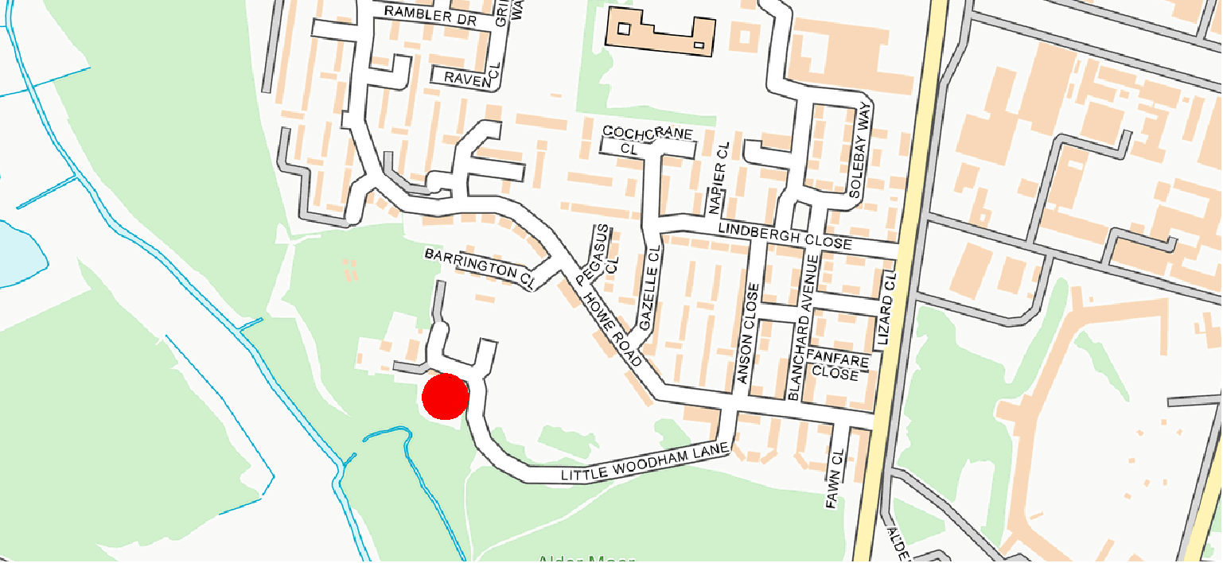

QUOTATION PROCESS
Please return quotes through the South East Business Portal, also known as Proactis, this must be your full and final price.
Quotes are to be returned by 15th February 2021.
Evaluation
These works will be awarded on best value price, provided the quotation covers all of the required considerations detailed above.

