INTRODUCTION AND WEBINAR LINK

The Greater South East Net Zero Hub (GSENZH) is funded by the Department of Energy Security & Net Zero (DESNZ) as part of government policy to deliver clean growth. The purpose of the GSENZH is to support the development of low carbon energy projects in the region, bringing forward business cases that can attract investment in energy infrastructure.

GSENZH is one of five Local Net Zero Hubs operational in England. The GSENZH covers eleven Local Enterprise Partnership areas (LEPs) in the Greater South East region. These LEPs provide the strategic direction and governance for the GSENZH. The GSENZH works through the LEPs and their partner organisations to engage with a wide range of organisations. The Accountable Body for the GSENZH is the Cambridgeshire & Peterborough Combined Authority (CPCA).

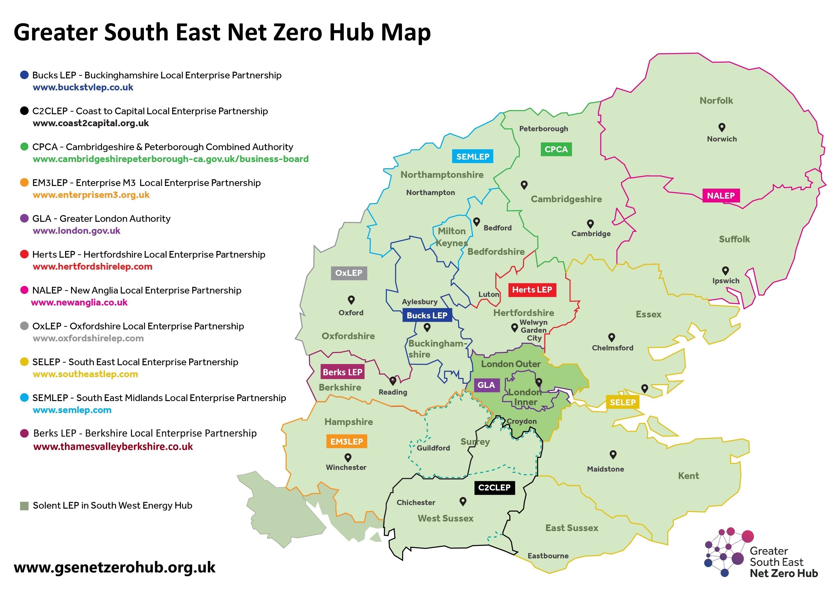

The Clean Growth Strategy commits the Government to upgrade as many homes as possible to Energy Performance Certificate (EPC) Band C by 2035, where practical, cost-effective and affordable, and for all fuel poor households, and as many rented homes as possible, to reach the same standard by 2030. Just under half (44%) of social rented homes, approximately 1.8 million, have an EPC rating below C.

The GSENZH sets out to improve low energy performance homes in England by installing eligible measures. The primary purpose of the GSENZH is to raise the energy efficiency rating of low income and low EPC rated (D, E, F or G rated) households, to deliver the following outcomes:

- Deliver cost-effective carbon savings to carbon budgets and progress towards the UK’s target for net zero by 2050.
- Deploy low carbon heating, supporting the transition away from fossil fuel-based heating and supporting supply chain growth of the clean heating sector.
- Support clean growth and ensure homes are thermally comfortable, efficient, with a reduced impact on the environment and well-adapted to climate change.
- Support economic resilience and a green recovery in response to the economic impacts of Covid-19.
- Deliver better quality, safer, greener homes in levelling-up and rural areas.

The GSENZH are looking to procure retrofit services against the following themes: Turnkeys, Managing Agents, Inspection services, Installers, Retrofit assessments/coordination and Design, and Energy Efficient Products/ancillary items, covering a range of schemes. This will be a new DPS, in addition to the current Installer DPS.

A Market Engagement Webinar has been planned to enable an efficient consultation with relevant suppliers and installers to gain an insight into your expressions and assess your appetite to tender for works across existing and upcoming government-funded, multi-measure retrofit programme's.

The purpose of the Webinar is to provide you with an overview of the following:
- The government-led retrofit schemes being delivered by the GSENZH in the region
- The proposed delivery route (multi-category Dynamic Purchasing System)
- The benefits of applying to become an approved supplier on this new DPS
- The technical requirements, standards and expectations of suppliers of the new DPS
- Timelines and the Procurement approach

The Webinar aims to provide comprehensive details of this exciting New Procurement venture, opening up more opportunities for suppliers working across the UK.

This event will be hosted online via teams, featuring presentation from the Hub’s Procurement experts. Attendees will be given the opportunity to ask questions and also have access to a detailed questionnaire.

Details of the event:
Date: 27th February 2024
Time: 11am

Webinar Link:
Microsoft Teams meeting
Join on your computer, mobile app or room device
Click here to join the meeting
Meeting ID: 354 821 236 734
Passcode: 9XQd5J
Download Teams | Join on the web
Join with a video conferencing device
teams@vc.macegroup.com
Video Conference ID: 125 735 304 9

