EOI
Tameside Metropolitan Borough Council
EXPRESSION OF INTEREST FOR:
Construction works (Heritage sector) for the Grade 2 Star Listed building- Ashton old Baths Annex for the following;
Internal works, repairs, restoration and alterations of the Ashton Old Baths- Phase 2 Annex for the change of use from a storage and distribution ( Use class B8) to office accommodation ( B1), Coffee shop ( A3) and a new internal data centre by Sudlows (Sui generis) with supporting sub-station (by others) and generator compound externally with a fence enclosure, External lighting scheme to the Ashton old Baths building, Signage to the new Ashton old Baths entrance external area and retractable canopies with a heating solution to the upper terrace decks of the existing phase 1 office pods.

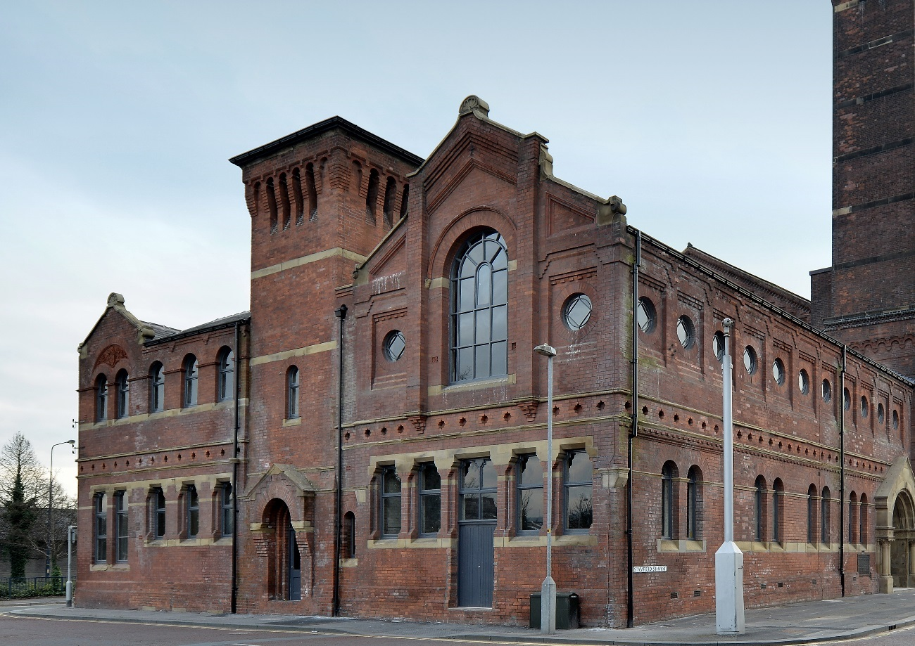

CONTRACT REF:
SPECIFICATION
Specification for a Contract for the Provision of: Construction Build Services
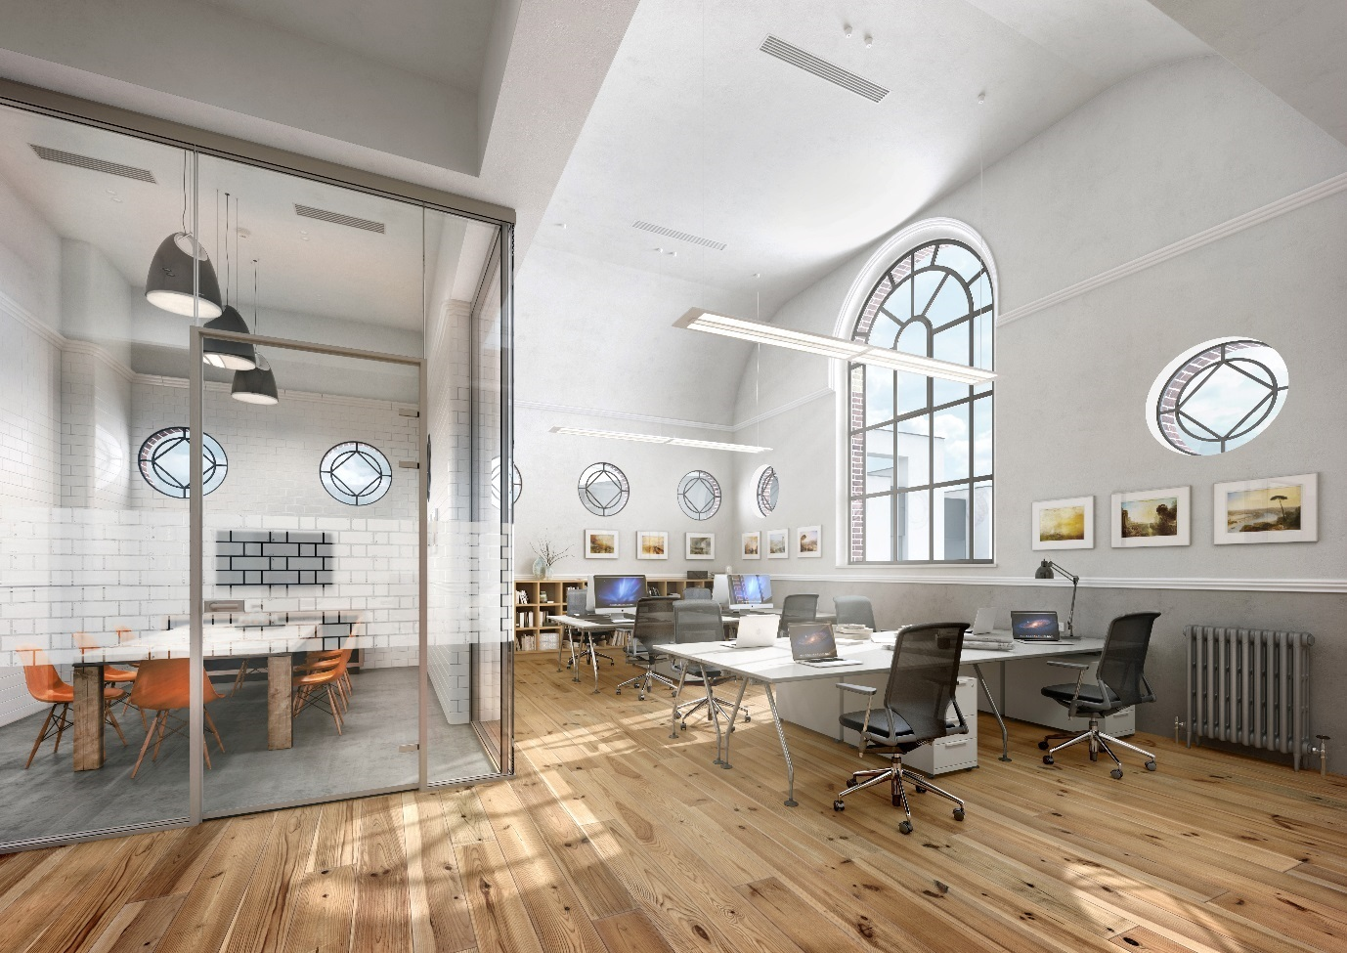Proposed CGI for one of the first-floor office and meeting rooms to the Annex where the past meets the present.

Ashton old Baths where the present meets the past!
The past is to be enhanced and persevered as Ashton old Baths was built in the 1870s for Tameside Metropolitan Borough Council and designed by architects Paull and Robinson in the Italianate Romanesque Style, it became the beating heart of a thriving Community.

The present is for MCAU Architects to convert the original baths into new offices and a Data centre using new materials such as glass, drylined walls and feature innovative lighting so it becomes the new beating heart again and regenerates this area for Tameside Metropolitan Borough Council.

GENERAL DESCRIPTION OF THE SERVICES REQUIRED
Tameside Metropolitan Borough Council is now in a position to commission appropriate construction build works services at the earliest opportunity in order to commence the timely implementation of the Ashton old Baths Annex project with new Data centre and offices.
The Council is therefore seeking Expressions of interest only at this stage from an appropriate construction company. The next tender stage after the EOI will be accessed on the contractors Heritage and restoration experience of previous similar types of projects.
The purpose of this brief is to set out to prospective tenderers the Council requirements. This will lead to the commissioning of a suitably qualified and experienced firm to provide the construction build services for the construction stage of this project, i.e. to develop the technical design to a construction level, preparation of production information and bills of quantities, copy writing, construction, management of operations on site during the installation and maintenance period, to formal final completion of the works. The construction contract will be a traditional JCT contract of works and the information level available before a start on site will be up to RIBA Stage 4.
A comprehensive design package including works up to RIBA stage 3 and in some cases beyond has already been prepared under the lead design co-ordination of MCAU Architects with a comprehensive design team already assembled. RIBA stage 4 is already underway by this design team and will be available for issue in the middle of July 2019 for the Tender stage.
The successful firm will work with the Council (Client) and this existing MCAU Design team of consultants - to take these existing design proposals (which are to RIBA stage 4) to deliver the full manufacture and fit-out of the above works including the implementation of any specialist disciplines required. The Data centre is supplied and installed by Sudlows, who will be a sub-contractor to the main contractor.
The firm will assemble an appropriately skilled and experienced team to carry out the work required for the project’s delivery. The contractor must provide assurances and warranties for all deliverables, including compliance with standards of health and safety, durability for an anticipated construction works life and the assurance of quality standards as evidenced by ISO 9001 accreditation.
The appointed firm will be expected to work closely with the client’s design services company MCAU who will have day-to-day responsibility for the management of the consultants under the JCT traditional contract. The firm will need to work with the Architectural Design Team of MCAU, Oxford Innovations, TMBCs team, and other Council staff and advisors to ensure that the project is delivered to the agreed budget and programme, meeting project objectives and satisfying the requirements of the client and Design Team.
It is anticipated that the successful firm will be appointed in early Oct 2019 and will be required for the duration of the delivery/construction period, which currently is anticipated to end (practical completion of works) in March 2020 for the Data centre and August 2020 for the rest of the main works.

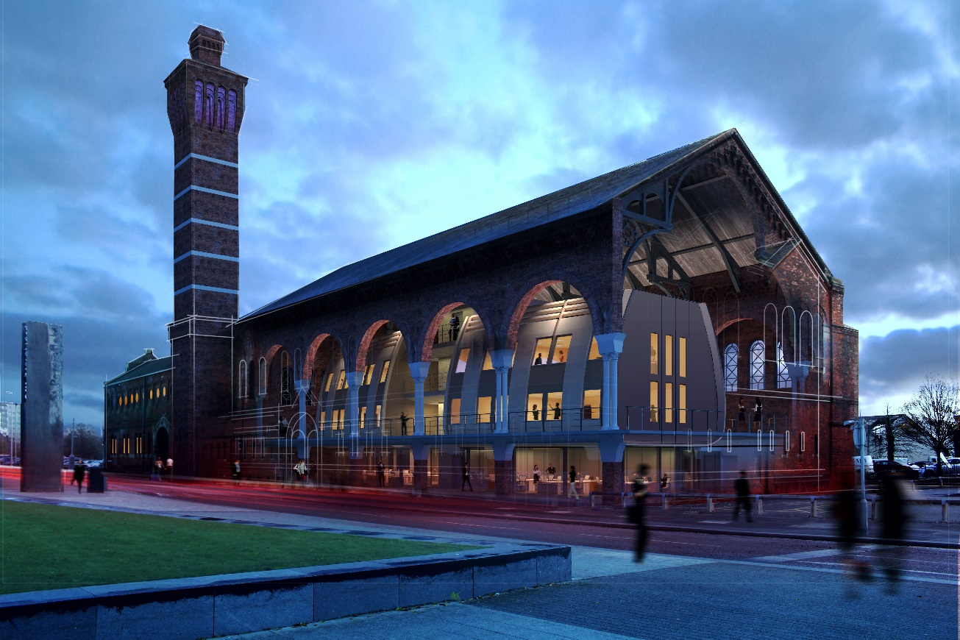
CGI image of the existing Phase 1 Ashton old Baths on the right with the Proposed Phase 2 Annex internal works to the left of tower at the back of the image.

THE CLIENT

Tameside Metropolitan Borough Council seek to obtain Expressions only at this stage from a suitable construction firm.
The current Ashton old Baths is managed by Oxford Innovations. It is intended that the new Annex works will be managed by Oxford Innovations as both buildings are interconnected and part of the same use.
Project design support will be provided through MCAU who have been appointed as the design lead services for RIBA Stages 4 through to 6.
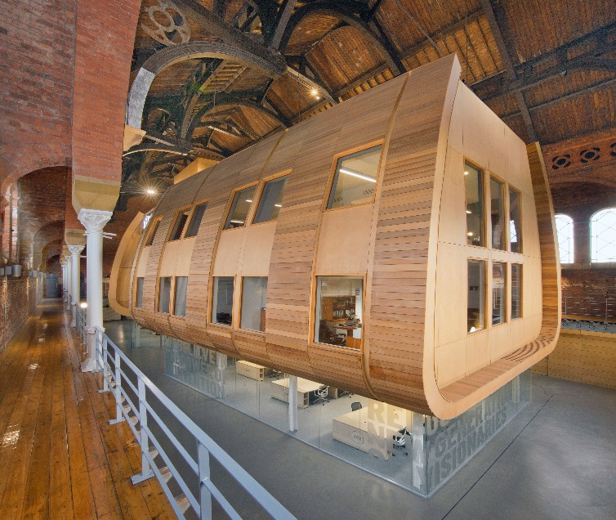
Existing office pods installed next door as part of the first Phase completed in 2017.

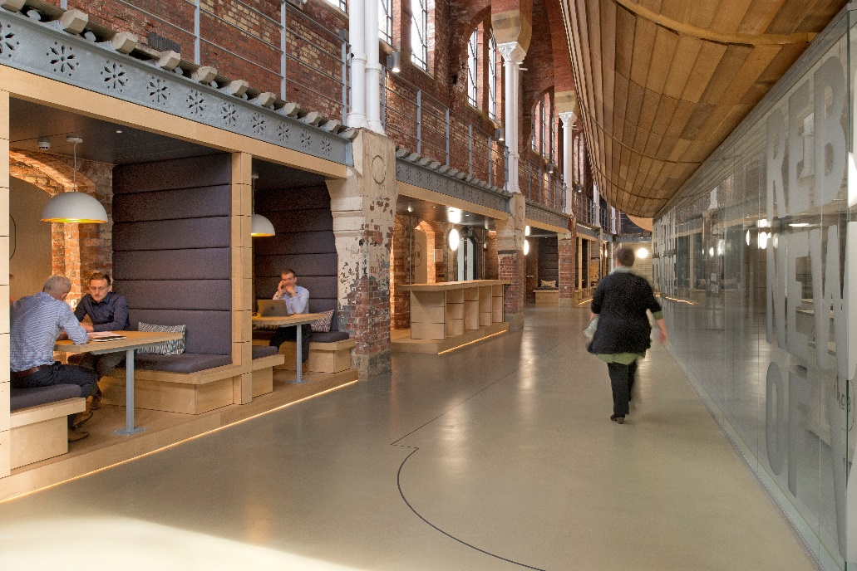
Existing ground floor breakout area installed as part of the first phase completed in 2017.

PROJECT INFORMATION

THE ASHTON OLD BATHS ANNEX – GRADE ii star listed building.

The new vision for this former swimming baths is the bring the building back to use as a creative, digital and media hub. The project has been spilt up into two phases with the first phase 1 completed in 2017. This Phase 2 will involve the restoration and fit out of the adjacent annex. Early in the design process. The external fabric of the whole building has been completely restored and refurbished to protect its internals for the next generations.

The vision is for the Construction works (Heritage sector) for the Grade 2 Star Listed building- Ashton old Baths Annex to deliver Internal works, repairs, restoration and alterations of the Ashton Old Baths- Phase 2 Annex for the change of use from a storage and distribution ( Use class B8) to office accommodation ( B1), Coffee shop ( A3) and a new internal data centre by Sudlows (Sui generis) with supporting sub-station and generator compound externally with a fence enclosure. Full planning and Listed Building Consent were obtained last year by the client team.

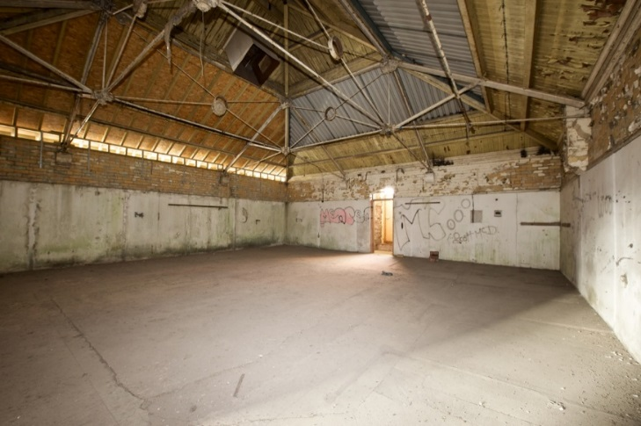
Existing First floor room (F18) in the Annex to convert into offices.
Existing first floor plan of the Annex.

Existing ground floor plan of the Annex.

A Full design team has been appointed this includes the following;
Tameside Metropolitan Borough Council- client
Star Procurement Services- Procurement services
MCAU Architects are the lead design services designers and Architects under this appointment the key consultants are as follows;
Appleyard and Trew - contract administrators, cost consultants and CDM
Crooks Walker Consulting – Mechanical and Electrical up to Tender, then client role afterwards.
Renaissance Engineers – Civils and Structures.
WSP -Fire
Align Building control – Building regulations approval.
Then as a subcontractor to the main contractor, the sub-contractor ‘Sudlows’ are to provide the Data centre works.

THE architectural Historical RESTORATION PROJECT– GRADE ii star listed building.

This important Grade II* (star) listed building has lain redundant since its closure in the 1970s and has been a long-term item on the Buildings at Risk Register since it began. On the 28 March 2014 we had received an extremely supportive letter of endorsement from Julian Holder Historic Areas Advisor and Buildings Inspector - English Heritage for our proposed overall works for the building.
Brief Heritage summary of the works to the
Grade 2 star - Phase 2- Annex part of the
Ashton Old Baths (Hugh Mason House)

Our overall proposals will ensure the retention of a unique part of the heritage of the area, whilst the restoration and increased use of the building will also continue to build on the success of the completed Phase 1 works, acting as a catalyst for Town Centre Investment, improving the immediate surrounding environment and having a positive impact on neighbouring sites and the street scene.
The works proposed to the internal listed building fabric are identified in various documents and drawings submitted with this application. Broadly speaking these works involves the sensitive heritage repair, reinstatement and restoration of original built fabric internally to help partly restore it to its former glory in parts. Where materials have deteriorated beyond repair, replacement materials to match the existing will be used and rein-stated as part of the sympathetic refurbishment allowing the continued maintenance of the building and securing its long-term future; ensuring the retention of its architectural style and features; minimising impact on the building’s historic fabric; and having a beneficial impact on the essential character of the building.
We are addressing the much-needed longer-term conservation and re-use of this eastern side/Annex part of the baths, that reflects the imaginative proposals and delivery for the completed Phase 1. We are doing this with a sympathetic discrete new office and data centre use that is compatible with the significance of the building to secure the long-term future of this second part of the building. Any new minimal interventions into the existing fabric of the building will be detailed in a new contemporary way so as not to harm the buildings internal fabric.
The configuration of the new office workspaces and data centre will not really affect the historic fabric of the building in general, as we are generally in principle respecting the historical room layouts from its use as baths with individual rooms such as private women’s swimming baths, Turkish baths and changing/dressing rooms. These existing room layouts demonstrate a morphological internal plan sequence of the spaces, that is reflected in the current internal fabric of the building’s layers. We are intending to respect the areas of high and considerable significance identified in the Heritage statement relating to those parts or elements of the building deemed to be of particularly special interest. We understand that these components are fundamental to the understanding of the architectural design concept moving forward, and play a major role in reflecting their evidential, historic, aesthetic or communal values. An example of these are the existing lobby entrance, tiled women’s baths room, reinstatement of the roof lights and refurbishment of the cast iron roof structure to the first floor, coved first floor ceilings, glazed tile walls and internal plan arrangement.
Whilst the current aesthetic value of the interior has been reduced due to the loss of fabric and fixtures and fittings, the exceptional form, expression and spatial qualities of the rooms enable the understanding and interpretation of this building, which we are aiming to maintain. The retention of the plan form, to the eastern annexe reflects the former uses of this side of the building. This dramatic contrast to the large open former pool hall, and the difference in spatial quality, is still understood and appreciated as reflecting the separate functions of these two areas within the building and is of special interest in reflecting the history of the building and its former uses.
The important aims of the project are as follows;
- Create amazing office space in the existing spaces.
- The sensitive heritage repair, reinstatement and restoration of original built fabric internally with sympathetic refurbishment first and foremost followed then by the new contemporary interventions of glass, new materials and animated spaces.
- Create a new Data centre with supporting compound for TMBC.
- Offer a personal, friendly, interactive and engaging environment.
- Prolong and re-define the life of the building with this new architectural order and use.
- Provide an innovate environment that is part of the overall Innovation ideas for TMBC.
- Support the work of TMBC.
- Attract and work with innovate collaborative companies.
- Share knowledge and skills
- Provide a coffee shop area, meeting rooms and communal area that becomes a focus point
- Be a landmark for the town centre
- Work cooperatively as part of a heritage network in Ashton.
- Build on the success of the Ashton old Baths first Phase with office Pods.
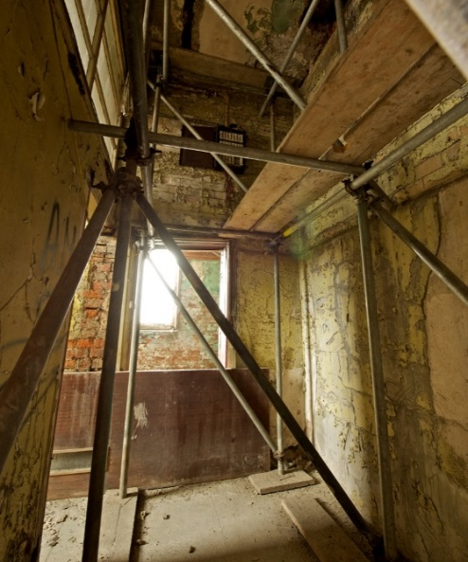
Existing ground floor corridor with proposed WCs to the left and a proposed office in the room beyond.

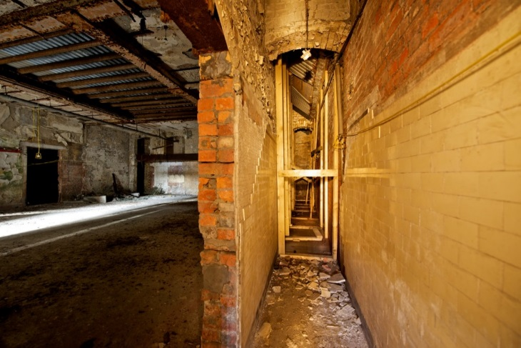
Existing view into the proposed Data room on the Ground floor supplied and installed by Sudlows under the main contractor.

OVERALL PROJECT FUNDING
The budget for the transformation of the scheme is £2.8M, however the final figure will be confirmed at ITT stage.

overall PROJECT delivery PROGRAMME to completion
A current outline timetable for the delivery / construction stage of the project is provided below.
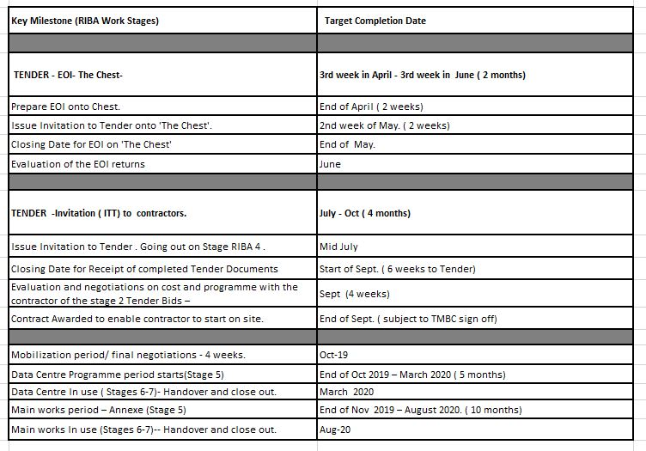

Project SPECIFICATION
The appointed firm will be required to provide an appropriately skilled team to work with the Design Team, which is under the umbrella of MCAU, Council Staff and Oxford Innovations to deliver the required scheme on site.
A comprehensive design package including works up to RIBA stage 3 and in some cases beyond has already been prepared under the lead design co-ordination of MCAU Architects with a comprehensive design team already assembled. It is not intended for all this information to be released as part of this EIO process as RIBA stage 4 is already underway by this design team and this will be available for issue at the start of August 2019 for those that are successful and reach the next Tender stage. The services of a contractor will be required to adopt the developed design and implement the scheme in full in the delivery phase.

The scope includes:

- Familiarisation with all work carried out thus far, including interpretation of the design plans
- A minimum of monthly meetings with the client team to report progress
- Formative evaluation of RIBA 4 designs
- The technical specification and design of proposals to construction status to enable your sub-contractors to carry out the works, including the inclusion of the specification of materials and construction methods required for the production with achieving the design vision.
- The production and implementation of all elements within the design scheme as shown on the attached plans;

The appointed contractor construction team will also be required to:

- Work collaboratively with a range of partners including the Council, Design Team and Oxford Innovations to help realise the vision for the future for this Annex.
- Ensure that the refurbished Annex is a welcoming, safe, accessible to all parties.
- Actively promote and enable opportunities for community participation and involvement in the restoration, management, operation and use of the former Annex.

(Example Precedent image only) of the Proposed Profilit glassed cladding wall to the corridor of the Data centre in the Annex.

At this stage, we are seeking expressions of interest only as part of this pre-tender period.
Your expression of interest should be sent via the Chest portal before the EOI closing date.
Please note that neither the Council nor their advisers will be liable for any costs incurred by third parties either through the preparation of their expressions of interest. All costs must be at the individual’s risk.
Any queries in respect of the Expressions of Interest should be directed via The Chest.
The project team intend to hold a “Market Engagement Bidders Day” at 11:00 on 29 May 2019, where bidders can attend the site, tour the building and get an overview of the works required. The procurement team will provide information relating to the procurement process and explain how the new social value portal works. If interested please contact Mr Paul Stevens from MCAU at 0161 974 7203 to arrange an appointment.
Address: Stamford St W, Ashton-under-Lyne OL6 7TW

APPENDIX – LIST OF DELIVERABLES-REFER TO THE PLANS and sections.

Refer to the internal plans for the list of rooms that show the proposed room uses and required deliverables within the Annex ground and first floors. Works also includes the following;

Sudlows Data centre and supporting Data centre generator compound externally with a fence enclosure that surrounds the sub-station as well.

External lighting scheme to the Ashton old Baths building.

Signage to the new Ashton old Baths entrance external area.

Retractable canopies and heating solution to the upper terrace decks of the existing phase 1 office pods.

APPENDIX – proposed Annex layouts

------end of doc.---

