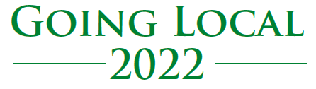

An opportunity to ‘Meet the Local Buyer’

Thursday 21st July 2022

Main Hall, Bicton College, East Budleigh, Budleigh Salterton, Devon EX9 7BH

The Devon and Cornwall Procurement Partnership is a collaborative group representing public sector organisations across the regions of Devon and Cornwall.
The event is free of charge to attend and will provide organisations with the opportunity to:
- Meet and get advice from a wide range of public sector procurement specialists from the regions of Cornwall and Devon
- Attend seminars given by expert speakers from across a range of sectors and disciplines
- Learn how to access opportunities to bid for public sector contracts
- Understand how to use the Supplying the Southwest procurement portal
- Network with other local organisations.

To register attending the Going Local event email the below details to
goinglocal-mailbox@devon.gov.uk

Full Name:
Company Name:
Brief description of the type of services/ goods you provide below.

