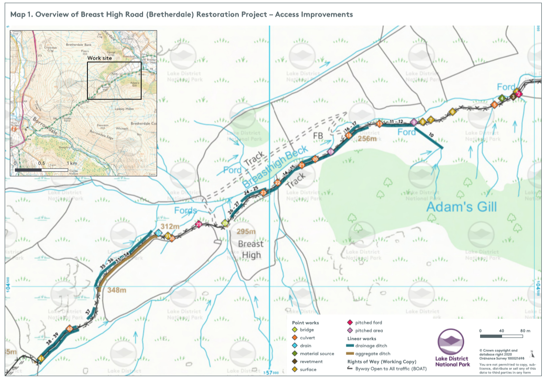

Breast High Road Bretherdale Restoration Project - Route Specification

Map Ref | Current feature/  condition | Access Improvement | Material/  Size req. | Image
1 | Track washed away due to culvert overflowing | Use material gained from 4 to fill in section of track. | 3m x 4m area | 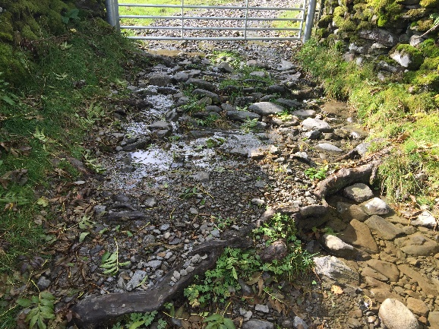
2 | Culvert not large enough and washing away road | Install pitched wath. Increase drain under the wall, installing a bigger top stone over the culvert then rebuilding the wall – using the new culvert stone as the wall foundation | 5m x 4m pitched area: Est 20t stone | 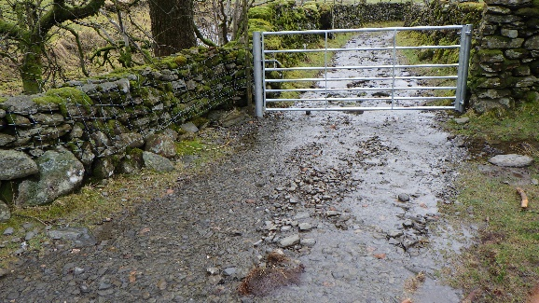  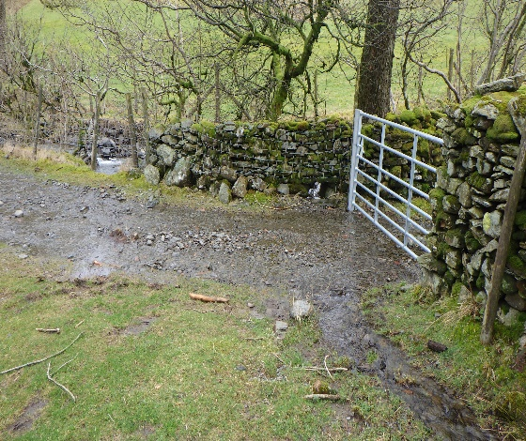
3 | Side of track falling away | Revetment up side of track | 2m | 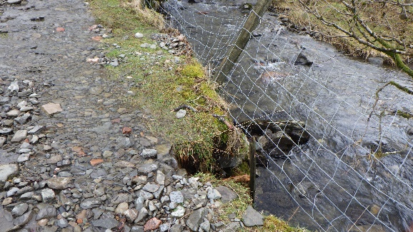
4 | Source of material for infilling track at 1. | Source of material |  | 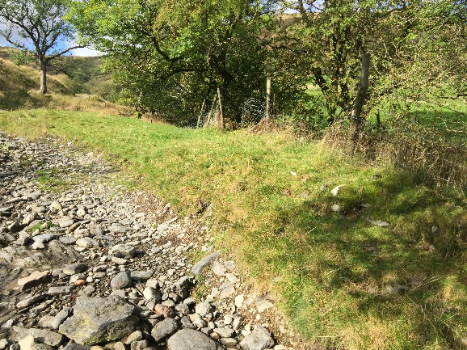
5 | Broken culvert not working | Replace with 60cm culvert | 60cm culvert pipe. | 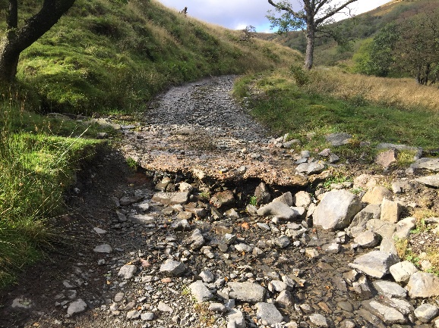  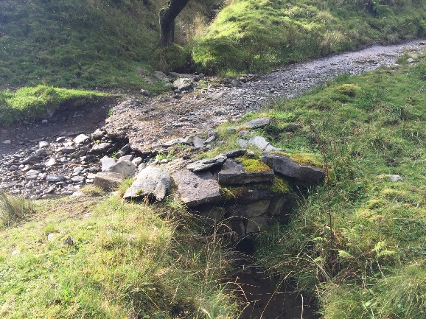
6 | Water washing across road | Reinstate aggregate wath |  | 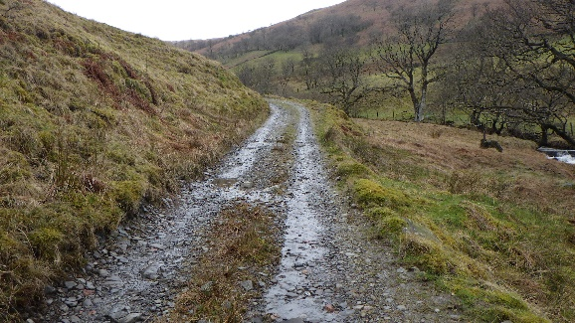
7 | Small wath | Maintain small wath |  | 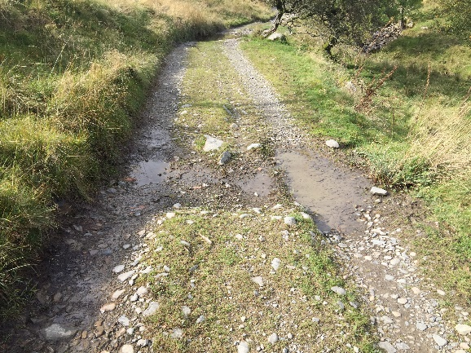
8 | Small wath | Maintain small wath |  | 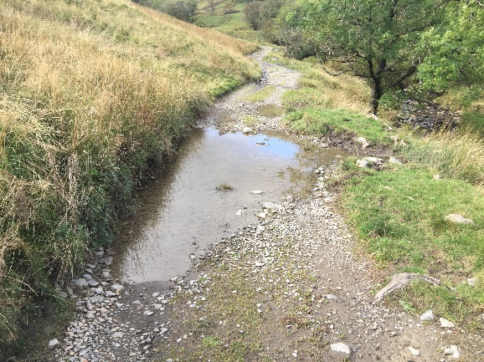
9 | Water washing across road | Install pitched ford to enable water to flow over route without washing away | 3mX4m Pitching.  Est. 12 tonne stone | 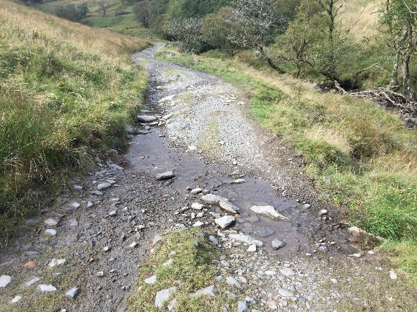
10 | Drainage ditch blocked | Reinstate drainage ditch | 40m | 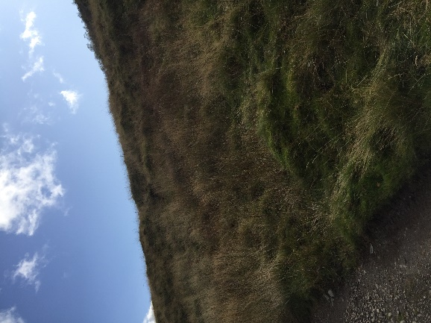
11-12 | Drainage ditch on either side of route | Install 65 m side drains on both sides | 130m. Use any material gained on track to increase surface. | 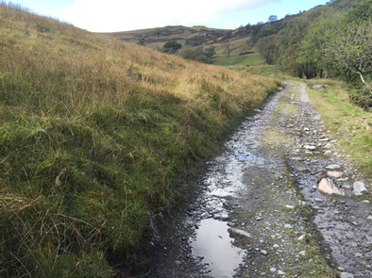
13 | 30cm Culvert - ok | Maintain existing culvert - ensure clear |  | 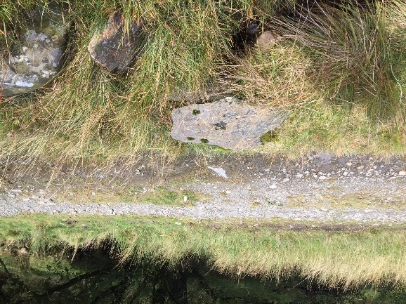
14-15 | drainage ditch on south side - not functioning/blocked or non-existent | Reinstate/install drainage ditch | 235m. Use any material gained on track to increase surface | 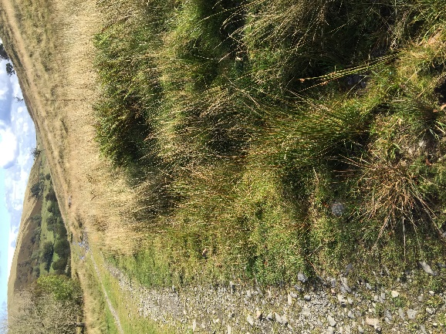
16-17 | Existing drainage ditch into beck | Reinstate/install drainage ditch into beck | 25m. Use any material gained on track to increase surface | 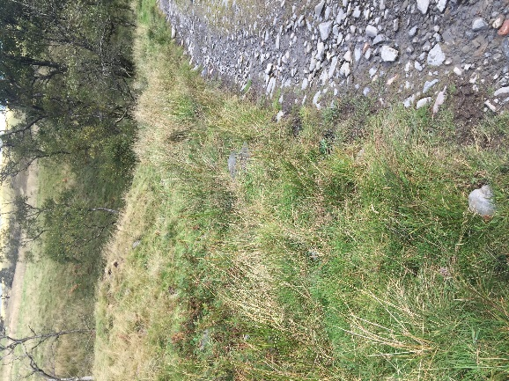
18 | Existing broken culvert | Replace with 30cm culvert | 30cm culvert pipe | 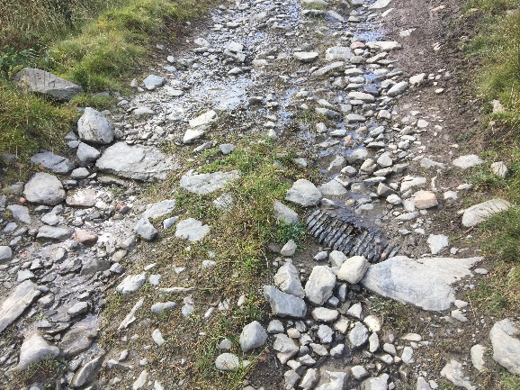
19 | Path washed away by water | Install pitched wath | 3m x 4m wide pitched wath | 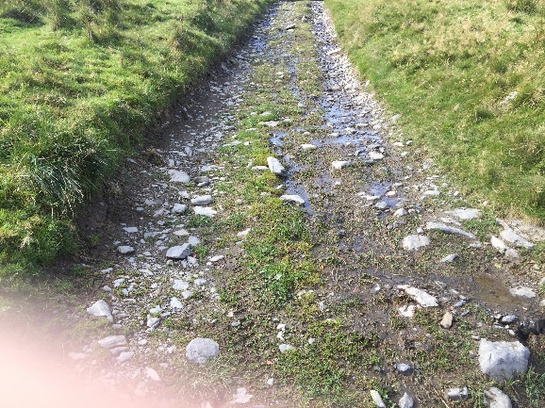
20 | Existing 30cm culvert ok | Maintain existing culvert - ensure clear |  | 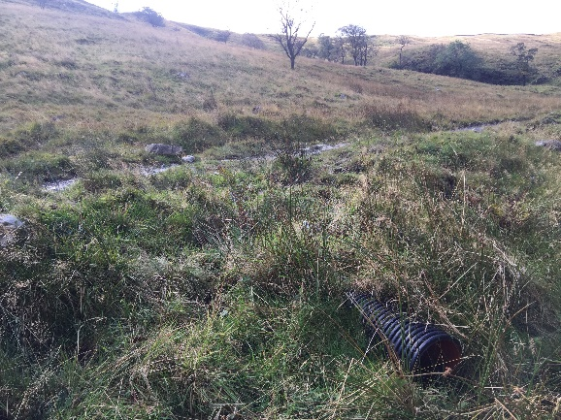
21 | Existing 30cm culvert ok | Maintain existing culvert - ensure clear |  | 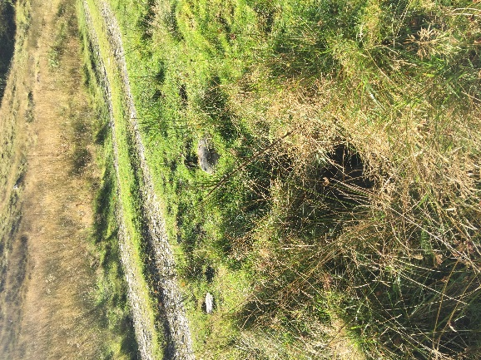
22 | Existing 90cm culvert drain with broken concrete over | Replace with a 4m x 4m bridge.  Reprofile upstream bank to provide materials to infill track.  Clear downstream drain. | Design and build 4m x 4m steel and plaswood bridge. | 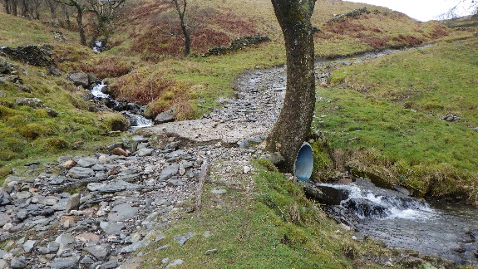  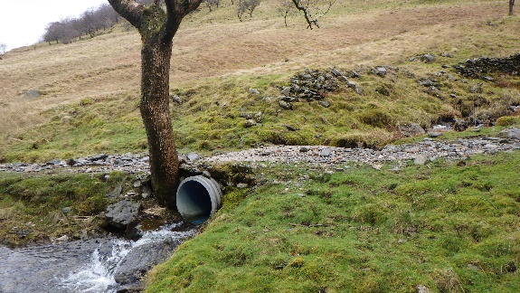  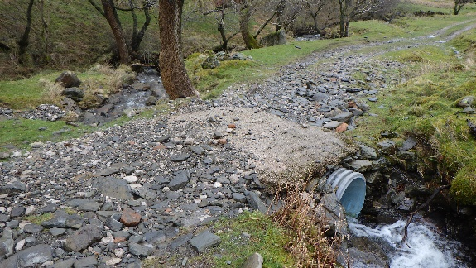  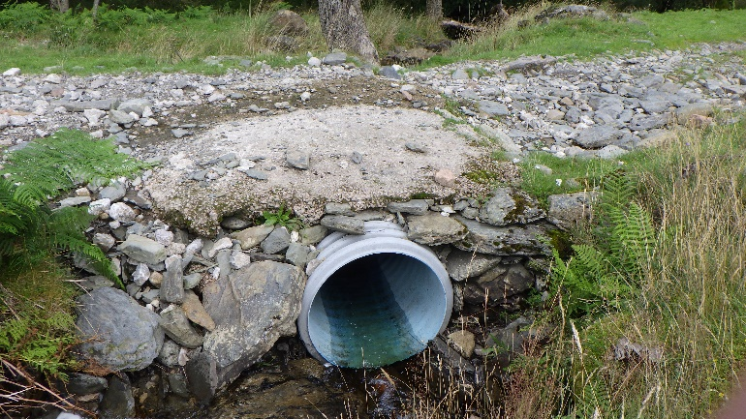
23 | Broken culvert not working | Reinstall new 30cm culvert – 2 lengths. | 2 x 30cm culvert pipes | 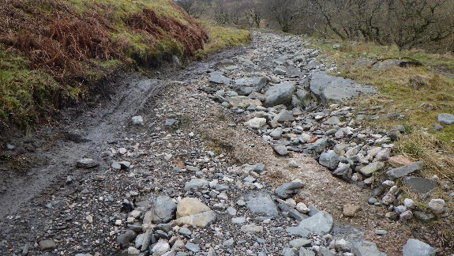
24-25 | existing broken/blocked drainage ditch | Reinstate drainage ditch | 30m Use any material gained on track | 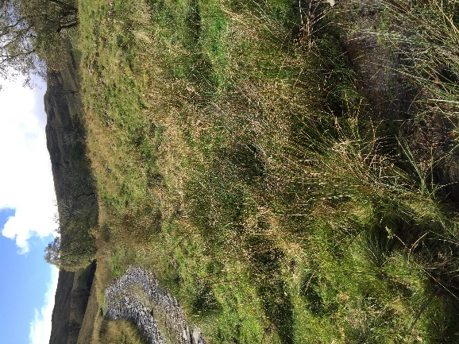
26-27 | Side drain to beck | Reinstate drainage ditch  Move track to right hand side of gully. Form a drain on left hand side of track. | 50m  Use any material gained on track | 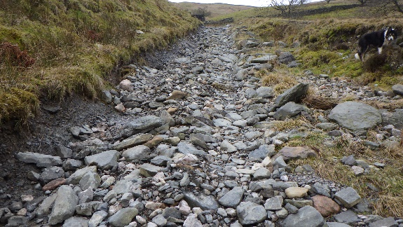
28 | Broken culvert with concrete over | Replace with 6mx3m bridge.  Lower beck on upper side to avoid overflow downstream | 6mx3m steel bridge  Design and build steel and plaswood bridge | 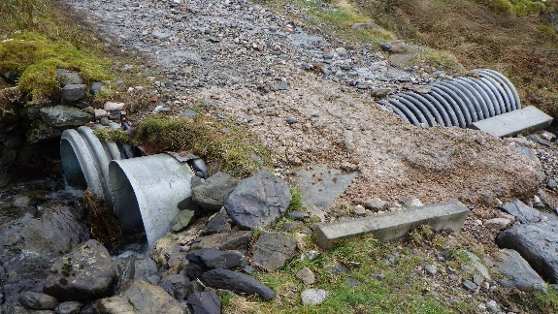  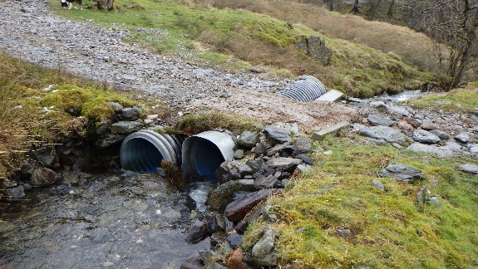  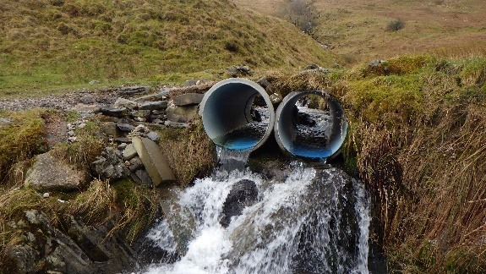  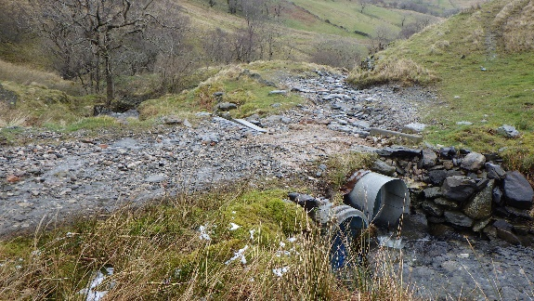
29 | Concrete culvert broken | Replace concrete with a pitched ford | 4mx3m pitching.  Est 12t stone req. | 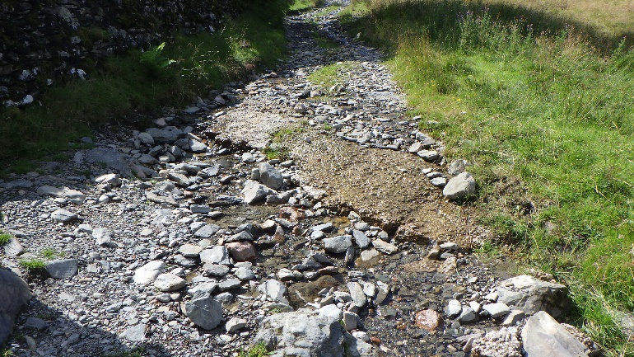
30 | Broken culvert with concrete over | Replace culvert with 60cmx6m pipe in 2 lengths. | 60cm x 6m pipe in 2 lengths | 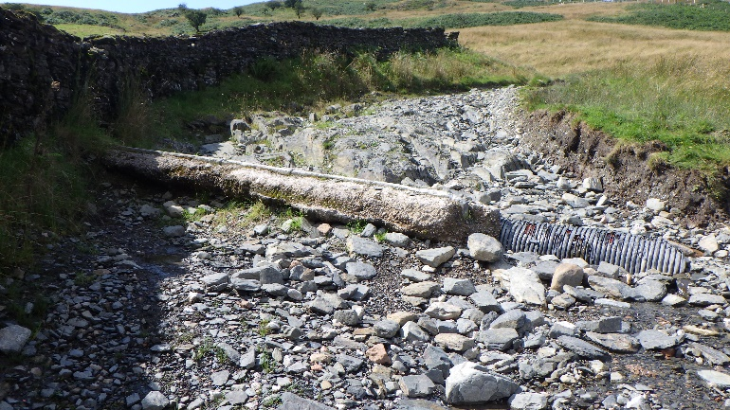
31 | Users widening road | Narrow road to 3m. Subsoil surface. Use boulders to narrow and restrict access to surrounding area. | Boulders req. | 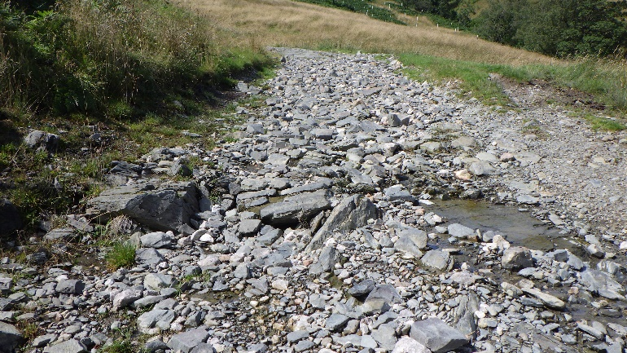
32 | Naturally occurring drainage feature | Utilise drainage feature to encourage water off the route |  | 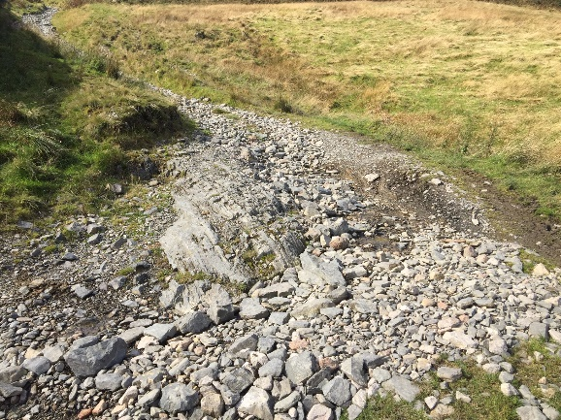
33-34 | Water running on track | Aggregate ditch alongside track. 1m wide | 150m | 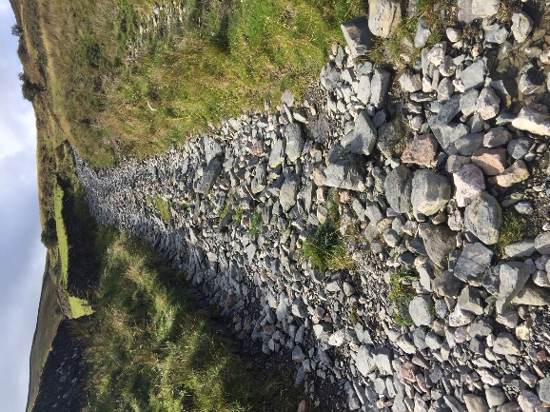
35-36 | Side drain | Reinstate/install side drain | 150m | 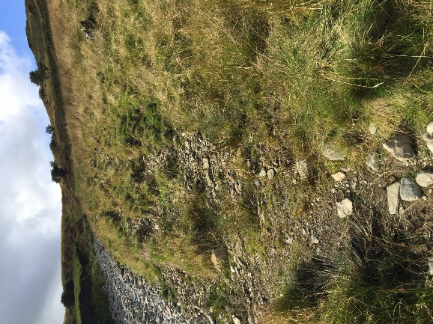
37 | Side drain blocked | Deepen side drain | 20m | 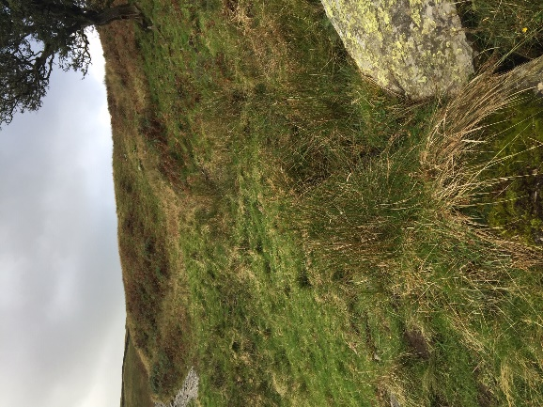
38-39 | Side drains on both sides blocked | Deepen and clear side drains on both sides. Use material to infill track. | 100m x 2 | 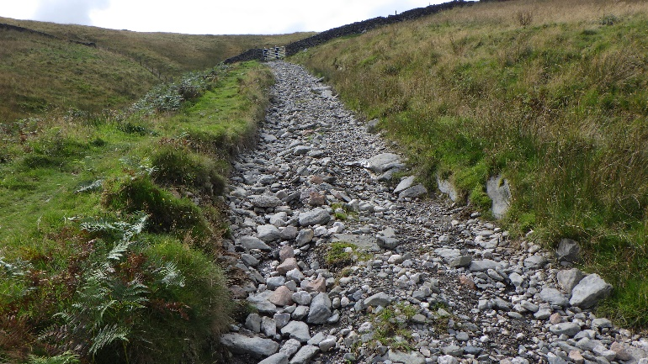
40 | Culvert blocked/broken | Replace 45cm culvert and remove some of the bank to reprofile route | 45cm | 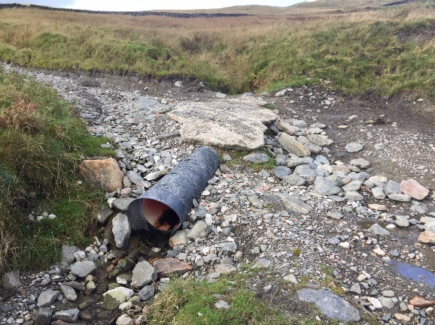
41 | Cross Camber drain not working | Reinstate |  | 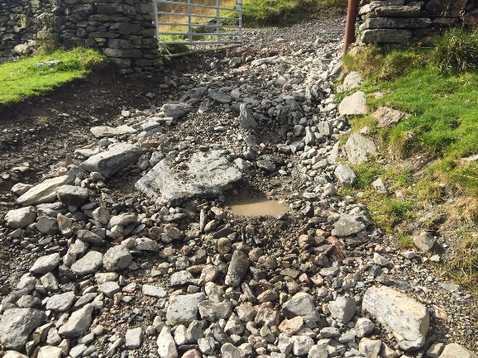

We will also require subsoiling and surfacing of 600 metres (x 3 metre width) of track within the Bretherdale section. See below for map.
We have identified potential sources of substrate which could also be used during the subsoiling process – subject to agreement with the site supervisor and landowner.
The subsoiling will require a 6inch (15cm) capping of aggregate material in addition to the subsoiling.

