Pre-Construction Information

for works at Green Court, Green Lane
Folkestone, Kent CT 19 6QS
Date: June 2019

1 PROJECT TEAM AND NATURE OF PROJECT...............................................................4
2 EXISTING ENVIRONMENT 8
3 CLIENT CONSIDERATIONS AND MANAGEMENT REQUIREMENTS 14
4 SIGNIFICANT RESIDUAL HAZARDS 16
5 HEALTH and SAFETY FILE 19

Appendices

Annex A: Health and Safety File Brief

Introduction

A Client must provide pre-construction information, as soon as is practicable, to every designer and contractor appointed or being considered for appointment, to the project.
Pre-construction information provides the health and safety information needed by:

- designers and contractors who are bidding for work on the project, or who have already been appointed to enable them to carry out their duties;

- principal designers and principal contractors in planning, managing, monitoring and co-ordinating the work of the project. Pre-construction information provides a basis for the preparation of the construction phase plan. Some material may also be relevant to the preparation of the health and safety file (see Appendix B).

Pre-construction information is defined as information about the project that is already in the Client’s possession or which is reasonably obtainable by, or on behalf of the Client. The information must:-

- be relevant to the particular project;

- have an appropriate level of detail; and

- be proportionate to the risks involved.

Pre-construction information should be gathered and added to as the design process progresses and reflect new information about the health and safety risks and how they should be managed. Preliminary information gathered at the start of the project is unlikely to be sufficient.

When pre-construction information is complete, it must include proportionate information about:-

- the project, such as the Client brief and key dates of the construction phase;

- the planning and management of the project such as the resources and time being allocated to each stage of the project and the arrangements to ensure there is co-operation between duty holders and the work is co-ordinated;

- the health and safety hazards of the site, including design and construction hazards and how they will be addressed;

- any relevant information in an existing health and safety file.

The information should be in a convenient form and be clear, concise and easily understandable to help other duty holders involved in the project to carry out their duties.
 | PROJECT TEAM AND NATURE OF PROJECT
 | Client: | East Kent Housing  Garrity House  Miners Way  Aylesham  Kent, CT3 3BF  Contact: Antony Mckean  Tel No: 07538 660382  E-mail: antony.mckean@eastkenthousing.org.uk
 | Contract Administrator: | East Kent Housing  Garrity House  Miners Way  Aylesham  Kent, CT3 3BF  Contact: Antony Mckean  Tel No: 07538 660382  E-mail: antony.mckean@eastkenthousing.org.uk
 | Principal Designer: | East Kent Housing  Garrity House  Miners Way  Aylesham  Kent, CT3 3BF  Contact: Antony Mckean  Tel No: 07538 660382  E-mail: antony.mckean@eastkenthousing.org.uk
 | Designers: | na
 | M&E Engineer: | na
 | Principal Contractor: | To be advised (Tender stage)  Contact:  Tel No:  E-mail:
 | Project Milestones: | Start |  | Finish
 |  | TBC |  | TBC
 | Pre-Construction Period:
 |  | TBC |  | TBC
 | Construction Period:
 |  | TBC Weeks
 | Project Duration:
1.7 | Address of the Project: | GREEN COURT  Green Lane, Folkestone,  Kent CT19 6QS
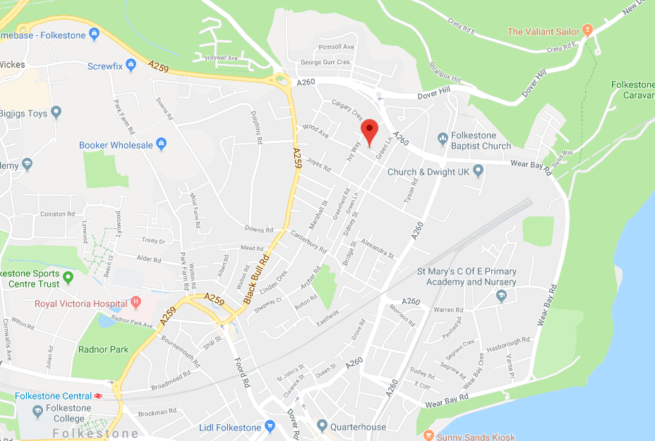
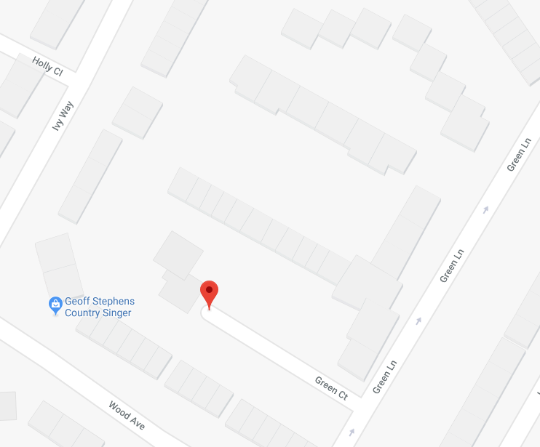
 | 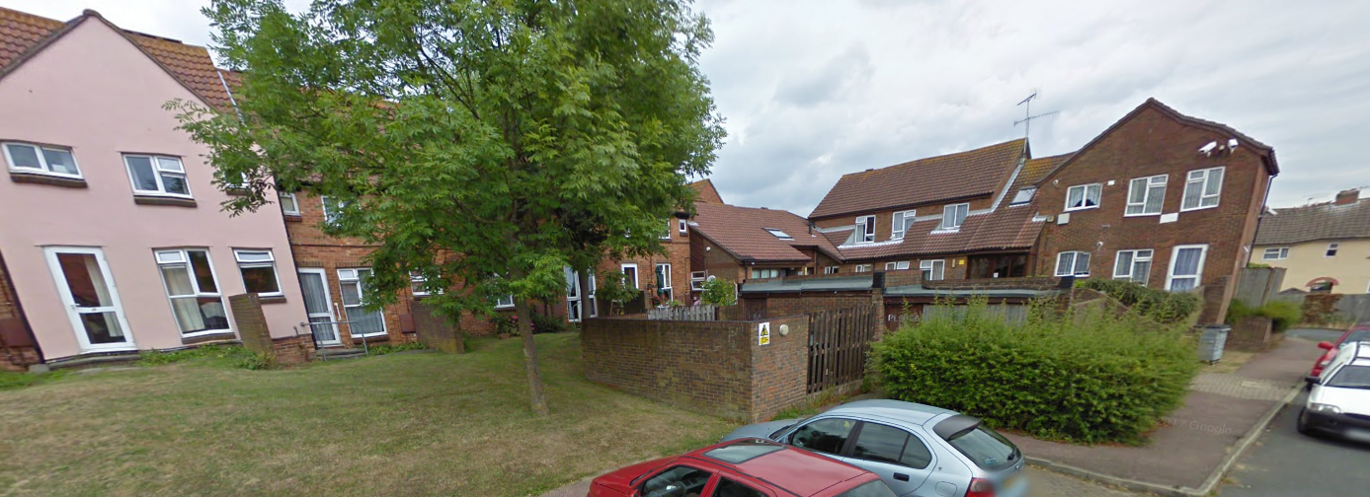
 | The Scope
The scope of these works is to supply Green Court, Folkestone a completely new Radio Linked Fire alarm system.

To fully remove the existing wired smoke detection system and the older redundant Domestic smoke detection.

The works are to be carried out across the whole site and there are no exclusions. The new communal fire alarm will be installed completely to Block A, B and C as these have a full evacuation fire strategy. Block D’s communal areas will also be connected to the main communal fire alarm.

There are also 9 individual bungalows and 4 flats in Block D that will have new D1 LD1 smoke detection fitted.

The new communal fire alarm will have its own dedicated auto dialler monitored by a control centre. The individual dwellings will be connected to the site warden call monitoring centre.

Completely repair and make good all damage caused by the installation of the new fire alarms.

Completely repair and make good all damage caused by the removal of the existing fire alarm system and domestic detection.
 | Planning Permission
 | It is understood Planning Permission is not required for the scope of works.
 | Nature of Construction Works
 | The nature of works is refurbishment.
 | End Users
 | On completion of the works the properties will be for sheltered residential use.

EXISTING ENVIRONMENT

Safety Hazards

Surrounding Land Uses and Related Restrictions

The site is situated in a predominantly residential area.

There are various public amenities present within the surrounding roads and the Principal Contractor must be aware of the close proximity of members of the public/children and take all reasonable precautions to prevent unauthorised access onto site.

The Principal Contractor should carry out these works with due care and consideration and ensure all necessary protective measures are in place.

Services

It is understood the site is served by the following Services:-

Electricity
Mains Gas
Sewers
Water
BT, TV and Cable
Others
Please note, this list isn’t exhaustive

The Principal Contractor is responsible for making himself aware of the locations of existing services prior to works commencing on site. The accuracy of this information cannot be guaranteed and the Principal Contractor shall provide a Site Specific Method Statement demonstrating how he will avoid any damage to “live” services during the works in accordance with the recommendations of HS (G) 47 “Avoiding Damage from Underground Services”.

The Principal Contractor must protect all existing services. For any drainage works, the Principal Contractor should carry out a survey using tracing equipment to determine and mark the location of any underground or exposed services before carrying out any works.

Existing Structures

The existing structure:
2 storey residential flats of standard construction.

Boundaries, Access and Egress

Site access and egress is via surrounding access paths. A small compound may be allowed in certain areas, subject to permissions.

Other Restrictions

The Client has stipulated that working hours are to be from 08.00 hours - 17.00 hours Monday to Friday, there shall be no working on the weekends or public holidays unless by prior agreement with the Client & Contract Administrator.
There is restricted parking in the area.
Contractors must ensure that vehicles are parked legally and do not restrict access to the public or the emergency services

Health Hazards

Asbestos

R&D Survey will be carried out by the principal contractor before commencing on site. Any identified ACMs should be dealt with according to the recommendations of the survey and “The Control of Asbestos Regulations 2012” prior to any construction works commencing.

All licensed ACMs removal works should be undertaken by licensed asbestos contractors and in full accordance with “The Control of Asbestos Regulations 2012”. All works with ACMs should be undertaken in full accordance with current HSE guidance and best practice.

Any works (including surveying works) that require mobile or fixed scaffolding to be utilised in the vicinity of identified or suspected ACMs must use an asbestos licensed scaffolding company.

All site operatives must be able to demonstrate suitable asbestos awareness training proportionate to their job roles as required by the “The Control of Asbestos Regulations 2012”.

Should any suspected or unidentified ACMs be discovered or disturbed during construction, then the Principal Contractor should cease works immediately and contact the Client/Client’s representative and the Principal Designer. He should ensure the area is suitably sealed to prevent further contamination and suitable signage should be put in place warning as to the presence of asbestos.

Weils Disease

There is existing drainage on site and as such there may be a risk of Leptospirosis (Weils Disease), Hepatitis B.

Ornithosis

The Contractor is to be aware that during the opening up of roof spaces that the risk of Ornithosis, a microbiological hazard due to the presence of pigeons, may be present. Respiratory protection may be required to protect against infection from inhaling dusty, dried faeces containing zoonoses.

Exposure to UV radiation (from the sun)

Where there is the potential risk of exposure to the sun, operatives are to comply with following HSE guidance - The sun protection six-point code and ‘keep your top on’ health risks from working in the sun.

Lead

The exposure of operatives to lead should be prevented. This may occur during blast, removal and burning of old paint from windows and doors. Where applicable, reference should be made to the Control of Lead at Work Regulations 2002.

Silica Dust

Where the works involve the cutting of bricks, paving slabs, kerb stones or other concrete products, there is the potential for generating silica dust, which can lead to respiratory illness’ including silicosis. Silica dust generated by works needs to be adequately controlled by ‘wet’ systems or LEV/vacuum systems, PPE should be a last resort.

Hazard associated from Previous Site Use

There are no known hazards from previous site use that have been brought to the attention of the Principal Designer/Adviser to Principal Designer for inclusion within this Information Pack.

Sharps/Needle Stick Injuries

Any workers involved in clearance works within the building should be made aware of the possibility of drugs paraphernalia, including used syringes, which pose a high risk of needle stick injuries with the associated risk of Hepatitis B and C infection, therefore, appropriate precautions must be taken, these can include a walk round and look at areas, prior to site clearance.

Common places to find drugs paraphernalia are in fluorescent light fittings, false ceilings (one tile lifted up and items ‘thrown’ into ceiling space) in and behind toilet cisterns and behind ventilation grills. It has also been known to be found where squatters are evicted and stair rails are ‘booby trapped’ with syringes taped underneath.

Litter pickers/grippers are a preferred option over puncture resistant gloves as they avoid the hands coming into contact with sharps. Bins rather than bags will better contain sharps, which will need to be disposed of in a safe manner.

Mould/Spores

In significant amounts of mould were found to be present in the ceiling and wall coatings, these moulds often contain Cladosporium and Aspergillus. These moulds are known to cause respiratory problems in humans, including allergy, asthma and infections. Demolition or alterations to the building fabric/ventilation systems can release spores into the atmosphere. When these coatings are stripped out, dust suppression and suitable respiratory protective equipment must be used to prevent respiratory problems.

Record Information

The following record information will be provided by the client:

- Asbestos Management Surveys (Type-2) for communal areas. R&D Surveys must be carried out by the principal contractor before commencing on site and provide the reports to client, Contract Administrator & principal designer.

CLIENT CONSIDERATIONS AND MANAGEMENT REQUIREMENTS

General Requirements

Prior to construction works commencing, the Client will require the Principal Contractor on this project to establish suitable arrangements to achieve the following:-

Adequate welfare facilities on site.

The Principal Contractor will be responsible for providing all the welfare facilities required by current health and safety legislation, including but not limited to:

- First-aid cover.
- Sanitary conveniences.
- Washing facilities.
- Drinking water.
- Accommodation for clothing.
- Facilities for changing clothing.
- Facilities for rest.

Provide and manifest adequate security on site preventing unauthorised entry.

The Principal Contractor must review the following details:

- The Principal Contractor will be responsible for security of the works and materials on site.
- The Principal Contractors operatives will wear ID photo cards throughout the contract period and sign in and out in order that a record is kept of all operatives and visitors to site during the project.
- The type of entrance into the pavement for scaffold access, a procedure and drawing on the standard expected is available, this standard includes for a lockable wooden hoarding around the access point.

Promote co-operation and co-ordination amongst project team members.

Promote the implementation of the “General Principles of Prevention” during design and construction.

Effectively plan and manage Health and Safety on this project.

Provide all relevant information for inclusion within the Health and Safety File.

Client Specific Requirements

The Principal Contractor is to refer to the Contract Documents for any Client Specific Requirements placed on the Principal Contractor during the Construction Phase. In any case, the Principal Contractor should ensure due consideration is given to neighbouring residents who will remain in occupation during the works.

Communication

Good, timely communication is essential for co-operation and co-ordination of activities on this project. Drawings should be used to highlight hazards or unusual work sequences, if required.

Induction training and toolbox talks help to ensure workers understand the risks and precautions, and are a good opportunity to inform workers of site rules or any special risks relating to the project.

Site induction, training and information are vital to securing health and safety on site. The Principal Contractor has to ensure, so far as is reasonably practicable, that every worker has:

- A suitable induction.
- Any further information and training needed for the particular work they will be carrying out.
- Communication between residents, operatives and site management.

Security

Where applicable, the entrance gates to the site must be secure, kept locked at all times when not in use and of the same height as the hoarding.

The Principal Contractor shall review the effectiveness of the site perimeter, including arrangements for maintaining the perimeter, particularly where there is evidence that persons can breach the fencing.

The perimeter of the site shall be lit at night (as applicable), should suitable illumination not already be present.

The site is to be kept secure and will be locked outside normal working hours. Access to and egress from the site is to be strictly controlled at all other times.

Where the public are at risk from falling materials, all walkways, footpaths and entrances etc., shall be provided with overhead protection such as pedestrian tunnels, crash decks, fans etc., including lighting as appropriate.

The Principal Contractor is to also provide appropriate information on the site rules, hazards and special precautions. Informative, mandatory and warning signs should be clearly displayed outside and within the site.

Visitors must not be allowed to walk around the site unaccompanied, unless they are familiar with the site and the risks they may be exposed to. The Principal Contractor is to provide personal protective equipment for visitors where applicable.

SIGNIFICANT RESIDUAL HAZARDS

Design Hazards

In accordance with the CDM 2015 Regulations, Designers are required to provide the Client, Principal Contractor, Principal Designer and other members of the project with satisfactory design information in respect of a project and this should be an ongoing process to assist the project team discharge their obligations under the Regulations.

The Principal Contractor should ensure adequate risk control measures are established to address significant hazards within the design.

Construction Hazards

The Principal Contractor should ensure adequate risk control measures are established to address the following hazards identified by the project team with respect to the Construction Phase of the project.

Site Fire Safety and Management

The Principal Contractor should demonstrate in his Construction Phase Plan how he will comply with the requirements of the Regulatory Reform Fire Safety Order 2005. This will include the production of a suitable and sufficient site fire risk assessment for the initial stages of the work.

The Principal Contractor should ensure the site and all construction works meet the standards specified in the health and safety guidance document HSG168 "Fire Safety in Construction" and "Fire Prevention on Construction Sites" the joint code of practice on the prevention from fire on construction sites and buildings undergoing renovation.

Site Fire Safety Plan should include the following arrangements (where applicable).

  - A site fire safety plan (including diagram) including communications and means of escape.

  - Fire brigade access arrangements and procedures for calling the fire brigade.

  - Fire drills, fire points and the site assembly point.

  - Storage in flammables and any waste storage area.

  - Permit arrangements, such as for hot works.

  - Security arrangements to minimise the risk of arson.

  - Location of smoking areas, where necessary.

Where the project involves timber frame construction, the Principal Contractor must ensure that the recommendations contained in "Fire Safety on Timber Frame Construction Sites" issued by the UK Timber Frame Association are given due consideration.

Asbestos

R&D Survey will be carried out by the principal contractor in working areas and if discovered any asbestos shall be removed accordingly by an approved contractor before commencing on site. If during the course of the works the Principal Contractor discovers or suspects any asbestos materials on site, he shall immediately notify the Client/Principal Designer and cease working on the affected areas.

Working in Occupied Properties

The Principal Contractor must be aware when working in occupied properties of the likelihood of tenants/residents who may be elderly, violent, disabled - mentally or physically etc., and all precautions must be taken to protect operatives and visitors during the works.
The Client can provide a list of vulnerable residents on request.

The Principal Contractor must ensure the working area is sufficiently secured with adequate barriers and signage to prevent tenants/visitors from gaining access into the working area.

All emergency access routes, i.e. doorways, stairways, corridors and communal areas etc., must be kept clear at all times and not obstructed with operatives materials/vehicles at any time.

Working at Height

Where there is a residual risk of persons/materials falling from working at height, risk control measures should be implemented in accordance with the Working at Height Regulations 2005.

Where reasonably practicable, the Principal Contractor must take adequate steps to:-

- Manage working at height.

- Prevent a fall from height.

- Control and manage the consequence of any remaining fall risks.

Excavations

The Principal Contractor is to ensure that all excavations are adequately secured with barriers, signage etc., and measures are in place to prevent operatives, vehicles and members of the public, from falling in and the sides collapsing.

Site transport Arrangements or Vehicle Movement Restrictions

The Principal Contractor must assess the best traffic management route that will not put pedestrians and others at risk to site activities due to area being largely residential, especially when working on or adjacent to the public highway. The Principal Contractor must provide adequate signage, lighting and barriers.

Restrictions on Deliveries or Waste Collection or Storage

The delivery of plant and equipment must be considered. The management of the traffic for all deliveries and waste from the site is to be covered within a risk assessment and method statements.

A suitable time for these should be discussed, as the area will be busy due to local schools and residents within close proximity.

The Principal Contractor will need to prepare a detailed site layout drawing showing perimeter fencing, access provisions, location of stores and storage areas, and welfare facilities, for inclusion in his Construction Phase Health and Safety Plan.

Site Transport Arrangements or Vehicle Movement Restrictions

Barriers, means of separation or permits-to-work are required to keep all sub-contractor construction workers away from hazards created by others and other people away from hazards created by the construction work.

The Principal Contractor will also be expected to manage and record the following as required:-

- Traffic management plan as part of H&S Plan prepared, implemented, updated and enforced;

- Pedestrians are separated from movements e.g. at site entrance/exit and during plant slewing and loading;

- Reversing minimised and controlled e.g. by one-way systems and the use of trained banksmen;

- Safety and warning devices e.g. ROPs, seat belts, mirrors, CCTV, radar and reversing alarm etc;

- Maintenance systems for checking brakes, steering, lights etc., and all safety/warning devices;

- CTA Training card or equivalent held by drivers or operators and a verification system in place;

- High visibility clothing provided to and worn by all persons as risk.

The Principal Contractor shall take all precautions necessary to eliminate, as far as possible, the danger to the public arising from the transportation of materials to and from the site. This shall include, for the duration of the works, efficient watching during the entry and exit of all vehicles and efficient warning of the movement of such vehicles to members of the public on the public highway and to persons within the site as necessary. Alternative pedestrian routes (as applicable), should be clearly signposted ensuring segregation of the operatives and public from the site and moving vehicles/plant.

The Principal Contractor is to ensure that no vehicle access routes are blocked or left inaccessible due to the contractor’s vehicles etc., being left unattended within such access ways.

The Principal Contractor’s procedures for delivery and removal of material, plant and equipment are to be managed to limit the inconvenience to the local residents.

The Principal Contractor should provide facilities to ensure vehicles and plant leave the site free from mud, i.e. wheel washing routines to be incorporated to ensure no mud or debris is left on the public highway and take all other precautions necessary to maintain and keep public and private roads free from mud, debris etc., arising from the works throughout the duration of the contract.

Control of Dust and Noise

Due to the site being situated within a predominantly residential area, noisy works must only take place during the hours agreed with Client & Contract Administrator.

The Principal Contractor is to also take reasonable steps to prevent the spread of dust throughout the construction phase.

Construction

- Site set up, welfare provision and site security.

- Segregation of construction from the occupied existing residential properties.

- Noise, dust and vibration generated by construction (see above).

- Falls from Height (see above).

- The movement of construction vehicles - pedestrians, children etc.

- Working with existing live services and hazards associated i.e. electrocution, explosion etc.

HOSPITAL

In case of emergency, the nearest hospital is :

Royal Victoria hospital

The map below shows location
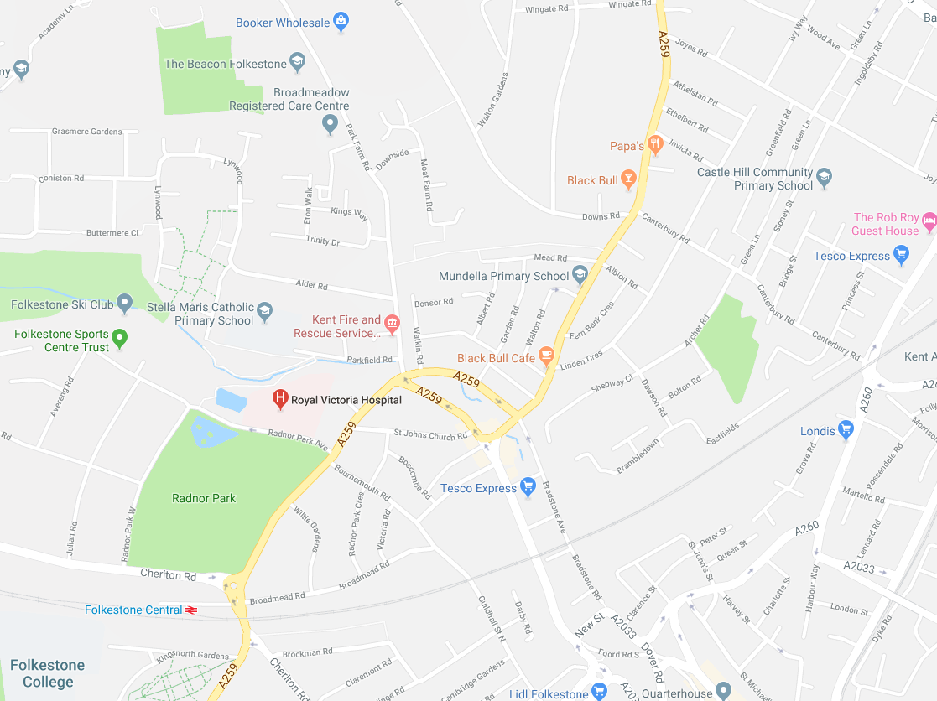

The Construction Phase Health and Safety Plan

The Principal Contractor’s Initial Construction Phase Plan in response to this document shall include the following:-

- Description of the project.

- Proposals for planning, managing (including site rules) and monitoring construction works without risk to health or safety in compliance with CDM 2015. Due consideration should be given to Part 4 (duties relating to health and safety on construction sites) of the Regulations.

- Arrangements for controlling significant site risks such as safety and health risks with the designs, surrounding environment, the site, during the construction phase, materials to be used and work sequences to include site specific Method Statements and Risk Assessments.

- The layout and format of the Health and Safety File and the arrangements for collection and gathering of information and the subsequent storage of the information.

HEALTH AND SAFETY FILE

The Principal Designer is required to liaise with the Client, Principal Contractor, Designers and other project team members to prepare the Health and Safety File in respect of this project.

The Principal Contractor, in accordance with Regulation 12(7) shall liaise with Contractors on the project to collate and issue to the Principal Designer relevant information required to complete the Health and Safety File.

Requirements for the Health and Safety File have been detailed in Appendix A - Health and Safety File Brief.

Annex A:

HEALTH AND SAFETY FILE BRIEF

GUIDANCE NOTES - HEALTH AND SAFETY FILE INFORMATION

Specification for the Health & Safety File

One hard copy and one electronic copy of the Health and Safety File are required.

All documentation must be clear, clean and legible; folders should be well presented with enough space so that pages can be turned without damage. The following are NOT acceptable:

- Faxes or copies of faxes
- Documents copied so often that text “breaks up”
- Background shading, black edging or colouration from photocopies
- Hand-written material
- Use of sales literature is to be avoided as far as possible, where a manufacturer’s literature, model or parts sheet is used, the relevant parts are to be underlined and/or highlighted. Details of the company’s QA systems, history or certifications have little relevance to the Health and Safety File.

Layout of Health & Safety File for This Project:

- Index

- Principal Designer’s information - To be provided by the Principal Designer

- Description of the project

A brief description of the works, this may be taken from the original scope of works, however, it must include details of any changes or additions to the original scope so that the description accurately reflects the project ‘as built’.

In addition to the description the file should contain details of the design concepts behind various elements of the structure. A useful checklist might include the following broad headings:

  - Cladding/infills

  - Structural frame/load bearing walls

  - Curtain walling, window systems etc

  - Roof structures/covering

  - Mechanical services’ design concept, e.g. whether natural ventilation or air-conditioning

  - Electrical services’ design concept, e.g. whether all electric lighting is on one circuit or on a floor-by-floor basis.

- Parties involved in the project, including name, addresses & contact details, i.e.:
- Client
- Contract Administrator
- Quantity Surveyor
- Principal Designer
- Principal Contractor
- Statutory Authorities
- Other contractors

- Schedule of materials used on the project

These can be combined

- List of suppliers

- General details of the construction methods and finishes schedule

The file should identify any specific sequence which was used in the erection of the building and which might need to be reversed during any alterations or demolition. This is a particular reference with regard to prefabricated buildings or structural elements, such as portal frames, that are inherently unstable in isolation during erection and have specific temporary propping requirements. Another example may be detailing the sequence in which external cladding panels were assembled, which would indicate how they might therefore be most safely disassembled.

For the materials used, this would particularly refer to any substances, which were potentially hazardous, such as flammable finishes or various types of insulating materials. These may be identified on the drawings or as a separate piece of documentation.

- Description of equipment/facilities installed

The file needs to set out the various elements within the building, which are provided for maintenance and have health and safety implications for those using them, for example:

- Facilities for roof access
- Window cleaning cradles
- Remote window opening gear
- Permanent fixings for fastening ladders, eyebolts etc.

- Description of the maintenance procedures for the structure

The file needs to outline health and safety issues with regard to the overall structure and its finishes. This might include procedures for:

- External decoration
- Gutter clearing
- AOV System

These procedures should include details of required frequency of cleaning, types of cleaning materials to be used and those to be avoided etc.

- Mechanical and Electrical O&M Manuals

Although the HSE advise that this information is not included within the Health and Safety File, it is at the request of the Client that this information is provided.

Manuals are required with regard to any specialist plant or equipment, including maintenance schedules with appropriate references for re-ordering replacements and central heating installations etc. These would include general mechanical and electrical items, such as lifts and air conditioning units. The manuals would obviously need to be extensive as is necessary in order to adequately maintain specialist plant or equipment.

- Hazard data sheets for materials used & details of any residual hazards.

Details of any hazardous materials used (for example lead paints; pesticides; special coatings which should not be burnt off), safety data sheets should only be included for materials, which pose a hazard in their final state, once the building is complete.

Details of residual hazards which remain and how they have been dealt with (for example surveys or other information concerning asbestos; contaminated ground which has been capped rather than fully remediated; water bearing strata; buried services; any special access requirements etc).

- Certificates

Although the HSE advise that this information is not included within the Health and Safety File, it is at the request of the Client that this information is provided. Certificates applicable to the project, including those that certify plant & equipment as having been installed in a safe state.

- Electrical installation
- Asbestos/Hazardous waste remediation & Clearance certificates
- Fire alarm
- Sprinkler systems
- Firas and Full Fire Doors Certs
- Practical completion
- Building control
- Fensa registration for the installation
Supplier’s and contractors QA/trade accreditation certificates are NOT to be included.

- Details of any utilities known, incoming positions etc

Information on services should be included within the file; these could be incorporated into the ‘as built’ drawings. A useful checklist would include:-

      - Mains distribution, e.g.

- Location, size and termination of gas, electric mains
- Location, size and termination of water main, waste water drains/sewers
- Location, size and termination of telecommunications

      - Emergency back-up facilities, e.g. standby generators, UPS systems

      - Security alarms

      - Fire fighting systems e.g.

- Sprinkler systems
- Drencher systems
- Fire shutters etc

- Any record or ‘as built’ drawings:

- Architect
- Structural Engineer
- Mechanical Engineer
- Electrical Engineer
- Windows/Roof lights

The drawings should be the final ‘as built’ or ‘as installed’ version, i.e. as amended from the originals through the construction process. These will represent the final structure as it actually exists and not just as it was conceived, ‘Preliminary issue’, ‘For planning’ or ‘Construction issue’ drawings are NOT acceptable. The drawings should indicate:

      - The position of incoming services and distribution (any or all of which may be concealed).

      - The location and details of various building materials used etc.

The drawings are able to convey a lot of information and are likely to cross-refer to the information on hazards under the various headings above.

- Tenant’s Manual (if applicable)

