PROCUREMENT OF THE CONTRACTOR/DEVELOPER TO WORK WITH THE CPCA/PCC/HE PARTNER TO BUILD THE NEW UNIVERSITY OF PETERBOROUGH

SUPPLIER ENGAGEMENT EVENT

DATE: Tuesday 3rd March 2020
TIME: 9.30 am to 12.30 pm
VENUE: IMET, Alconbury Enterprise Campus, PE28 4WA

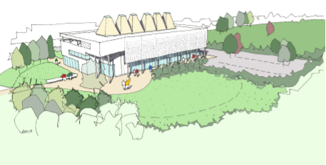

It is a long, established ambition for the City of Peterborough to have its own University. It is envisaged that the project will create a new high-quality space for Peterborough and establish a strong identity for the University in the city, transforming an under-utilised concrete Wirrina car park off Bishops Road, Peterborough on the Embankment, into a welcoming ecological green space creating a well-defined learning environment which will be fully accessible to all.

It is proposed the New University of Peterborough buildings will be welcoming, contemporary, distinctive and sustainable.

The building locations have been cited to be visible from the City and to passers-by whilst protecting the view of Peterborough Cathedral, along with ensuring sustainable accessibility for pedestrians, cyclists and public transport users. The Phase 1 building will be approached by an extension of the existing foot and cycle paths from the City, enabling access to the main building via Arrival Square. The Phase 1 building will offer open, flexible, innovative spaces for teaching and learning as well as limited office space, created around digitalisation and technologies. The initial building is spread over three floors which optimises natural daylight throughout the building which is conducive to positive wellbeing and effective learning.

It is intended to procure a single contractor/ developer who will initially work with the CPCA to build the Phase one building, and, subject to a satisfactory outcome, has the ability to partner with the CPCA & PCC, the HE Partner and other stakeholders to deliver the entirety of the project over the next 10 years. The Phase 1 build will be a £20M build and it is our ambition that the further phases namely; Phase 2 will be a £20M build and Phase 3 will be a £80M build.

Although the current workstreams do not include accommodation or social spaces such as cafeterias, a library and other socially focused buildings; it is anticipated that in the coming years that these will be required and as part of this, there would be an opportunity for a suitable developer (investment partnership) to invest in the project as a commercial venture – both with regards to maintaining the university building and open spaces for a financial return from up to 10,000 students by 2030, but also with regards to funding and achieving an economic return on the additional student facilities.

The project is currently concluding its procurement process to identify the HE Partner with the aim to have appointed them by the end of March 2020.

At this point in the process it is intended that the procurement to identify a Contractor/ Developer Partner will commence in April 2020. It is anticipated that the successful organisation will be identified through a Competitive Procedure to enable negotiation around the holistic requirements of the project; with the initial Phase utilising a pre-construction agreement to enable an efficient selection process and then with each subsequent phase being negotiated and appointed under their own Design and Build Contracts, using the rates agreed during the initial process for Profit and Overheads.

However, through this market engagement event we are seeking input from potential partners as to what would make this project commercially and reputationally appealing

