OFFICIAL

Making homes happen

Property (National)
Further Competition Invitation to Tender Stage 1 (Under OJEU)

Tattenhoe Park Phase 7, Milton Keynes – Marketing and Disposal via DPS

ProContract ref: DN615335
Date: 31st May 2022

Instructions
Your response must be submitted via the e-tendering portal (ProContract).

All requests for further information in respect of this Further Competition must be sent using ProContract. No approach of any kind should be made to any other person within, or associated with, Homes England.

Suppliers should specify in their clarification questions if they wish the clarification to be considered as confidential between themselves and Homes England. Homes England will consider any such request and will either respond on a confidential basis or give the Supplier the right to withdraw the clarification question. If the Supplier does not elect to withdraw the question and Homes England considers any clarification question to be of material significance, both the question and the response will be communicated, in a suitably anonymous form, to all prospective Suppliers who have responded.
All responses received and any communication from Suppliers will be treated in confidence but will be subject to the above.

Please note all communications during the tender period will be via the ProContract website all bidders that have registered their interest for the Procurement will receive a direct email notification from ProContract on any updates via the suppliers registered email address. It is the Suppliers responsibility to check the ProContract website for any updates to the Procurement process. No claim on the grounds of lack of knowledge of the above-mentioned item will be entertained.

Please refer to ProContract for the Tender Deadline. See also below.

Introduction
The purpose of this Invitation to Tender is to award the contract for the marketing and disposal of residential land at Phase 7 of Tattenhoe Park, Milton Keynes via Dynamic Purchasing System (DPS), to one developer by Agreement for Lease and the Homes England Standard Building Lease. We ask you to respond to the questions detailed in the Evaluation Criteria section below using the Response Form at Annex A and to submit a Resource/Pricing schedule.

Background

Phase 7 of Tattenhoe Park represents the next phase of development at Homes England’s Tattenhoe Park scheme,
approximately 4 miles to the south west of Central Milton Keynes.

Homes England and its predecessors have procured primary infrastructure for Tattenhoe Park and secured outline planning permission for the scheme, and Homes England is now progressing delivery of the development on an ongoing, phased basis.

The outline consent (ref 17/00918/OUT), was a renewal of outline planning consent (ref 06/00856/MKPCO), for an extended period of eight years, granted on 17 August 2017, for the residential development of up to 1,310 dwellings (part now delivered), as well as a new primary school, community facilities and other uses. There is a 30% affordable housing requirement (5% shared ownership, 25% social rent). Reserved matters approval is required for each phase.
Current/previous phases are as follows:

2

- Phase 1 – Barratt David Wilson: 154 homes delivered, development complete.
- Phase 2 - Crest Nicholson: 112 homes, started on site in March 2021.
- Phase 3 – Countryside Properties: 318 homes where development commenced in Spring 2021.
- Phase 4 – Bellway: 160 homes, started on site May 2022.
- Phase 4a – Lodge Park: 30 units due to start in FY 22/23.
Please see below for a red line site plan:

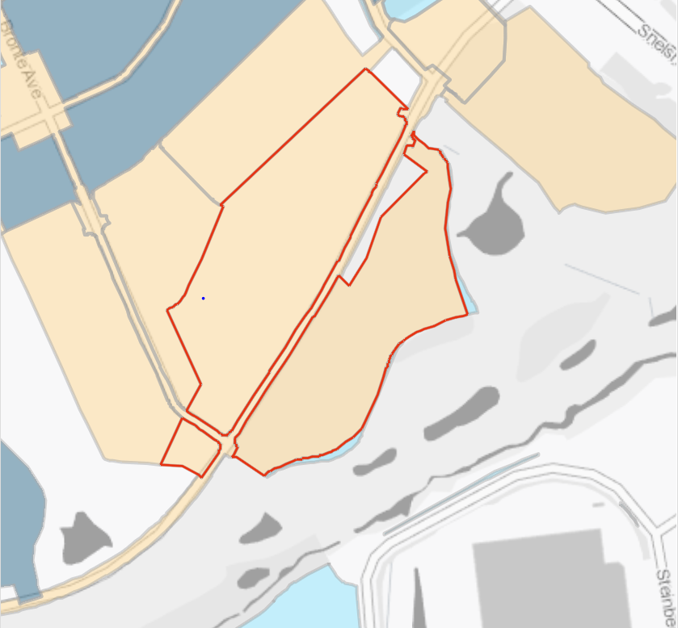

The plan below provides a general indication of the extent of each phase and their relationship to each other:

3

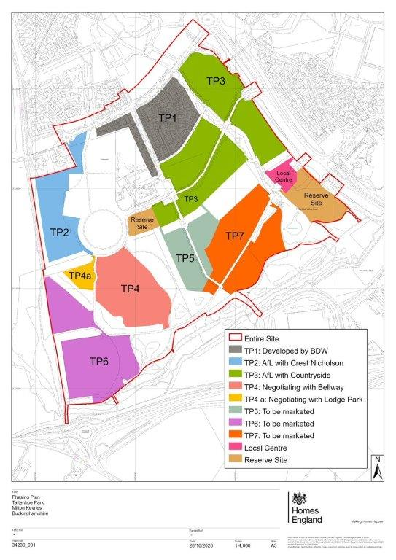

General site constraints and considerations
The Phase 7 site represents the next phase of development. The site extends to circa 11.01 acres (4.4592 ha) and has outline planning permission for circa 180 homes. It is currently expected to commence marketing of the site in Summer 2022, with the aim of securing a preferred developer, and exchanging conditional contracts, by 31st March 2023.
The preferred developer will be responsible for delivering part of the site-wide drainage solution for Tattenhoe Park; it is anticipated that this will include some off-site works, on land owned by Homes England.

Progress to Date
As indicated above, Homes England has secured outline planning permission for the entire Tattenhoe Park development, including Phase 7, and has procured much of the required site-wide infrastructure.

Much of the required relevant due diligence was originally undertaken on a site-wide basis, and a commission has been undertaken to appoint a consultant to review this information and identify any gaps or items which need to be updated.
4

Pinsent Masons will be appointed as the agency’s legal advisors.

The technical information to be issued (but not limited to) to developers for the TP7 opportunity is likely to include the following:

- Archaeology
- Arboricultural note
- As-built Survey Note Review (Drainage Survey)
- BNG Assessment
- Constraints Plan
- Construction Access Plan
- Construction Environmental Management Plan
- Drainage Information
- Ecology Surveys
- Engineering Drawings
- Environmental Impact Assessment
- Existing Utilities Plan
- Flood Risk Assessment
- Framework Residential Travel Plan
- Geotechnical Advice
- Geo-envrionmental Factual and Interpretive Report
- Habitat Survey
- Highways Responsibilities Plan
- Land Registry documentation and Title Report
- Overview of existing foul and surface water drainage
- Road Core Site Investigation Factual and Interpretive Report
- Summary of Ecological Data & Development Commitment
- Topographical Survey
- Transport Assessment
- Underground Utilities Survey

An indicative timescale for the developer selection process for TP7 is set out below:

- September 2022 – G3 Paper (Disposal Strategy) Approved (25/09/22), Expressions of Interest sought from DPS
- October2022 – Sifting Brief Issued (depending on number of EoIs received)
- October 2022 - Sifting Brief responses evaluated; ITT issued to shortlisted bidders
- November 2022 – Bids received; tenders evaluated
- December 2022 – G4 Paper (Approval to Dispose) prepared/approved
- February 2023 – Heads of Terms Issued
- March 2023 – Agreement for Lease/draft Building Lease exchanged

A key requirement is to select a development partner, and exchange conditional contracts by 31 March 2023.

5

Objectives
In selecting a development partner, Homes England wishes to invite Expressions of Interest from the DPS, short list a number of appropriate bidders, and then invite detailed bids from them using Homes England standard evaluation templates with a focus on the understanding of site constraints, design (Building For a Healthy Life (BFHL)), pace of delivery (with contractually agreed programme milestones) and the use of Modern Methods of Construction (MMC). A scoring split of 60/40 (price/quality) is likely to be used, although this is yet to be confirmed (subject to internal approval).

Developer submissions in response to the ITT will be assessed against price and non-price criteria as stated above such as quality of design, experience and proposals in respect of pace and use of MMC. The offer achieving the highest combined score across both price and non-price elements will be considered as the winning bid and recommended for approval as Homes England’s preferred developer. The price component will be assessed with the highest land price (NPV) offered being awarded the highest price score with all other bids adjusted proportionally. The detailed tender pack will comprise a comprehensive marketing pack giving details of Homes England’s existing knowledge of the land, relevant planning and constraints information, bid options and submission requirements. A draft sale agreement and heads of terms will also be included in the tender pack.

The shortlisted bidders will then be invited to respond to this brief. Detailed bids will include:

- A master plan for the site
- A phasing and delivery plan;
- Details of the design (including Building for Life compliance) and local sustainability standards to be achieved;
- Evidence of the proposed MMC for the site;
- A planning strategy including appropriate housing mix;
- Financial offer

We will endeavour by this method, to appoint a partner who will optimise land value payments and also housing delivery rates, including affordable homes and use of MMC.

Please note that as set out in the Property Framework Scope of Services (Section 2 – Land and Property Agency Services), the administration in relation to the above work will be the responsibility of the Marketing and Disposal Consultant. This will include use of Pro-Contract eg to issue documents and respond to queries.

6

Key Deliverables
It is envisaged that the appointed consultant will support Homes England in undertaking soft market testing of developer appetite of the site, via targeted approaches to DPS members. As part of this commission Homes England will require the appointed agent to:

Stage 1 - Sifting Brief

- Identify a lead contact and maintain this throughout the commission;
- Advise on the extent and scope of the Tender Pack required supporting the marketing of the site.
- Agree upfront a robust programme for the development partner selection process including the key stages and outputs.
- Preparation of the Sifting Brief and support to Homes England in assessing the responses.

Stage 2 - Tender Pack (ITT) Preparation, Marketing, Evaluation and Selection, Homes England Board Approval

- Preparation of the Tender Pack for issue to bidders at the Invitation to Tender (ITT) stage.
- Produce a shortlisting document and support in shortlisting bidders based upon their Sifting Brief responses.
- Manage the bidding process and respond to queries from potential developers throughout the Sifting Brief and ITT stages utilizing the Homes England Pro-Contract system.
- Develop in collaboration with Homes England the scoring criteria and support/advise Homes England in assessing returned bids, including producing a detailed analysis of the financial returns. Developer interviews will also be led and minuted by the appointed agent.
- Ensure robust sign off processes for assessment, moderation and client approvals for audit purposes.
- Liaison with bidders during the marketing stage, managing requests for site visits, preparation of responses to queries and provision of any supplemental information as may be required.
- Carry out evaluation of ITT submissions and assist in shortlisting bidders to support Homes England in the selection process.
- Undertake a number of clarifications to help bidders submit fully compliant tenders.
- Preparation of a report detailing the marketing process and making a recommendation to Homes England as to the preferred development partner and where appropriate, an under bidder.
- Support drafting of the internal G4 board paper to secure formal Homes England’s approval to the selection of the preferred development partners.

Stage 3 – Pre-sale Valuation, Preferred Partner negotiations up to Contract Stage

  - Generate Heads of Terms and provide negotiation support to Homes England in concluding a development agreement with the selected development partners.

7

  - Liaise and work in partnership with the appointed solicitors.
  - Provide all necessary pre-sale and franking valuations.
  - Provision of negotiation support to Homes England in concluding a Building Lease with the selected development partners.
  - Liaison with Homes England’s legal and technical consultants as necessary in concluding the Development Agreement with the selected development partner.
  - Advice on any post tender price adjustments sought during the negotiation of the Development Agreement.
  - Prior to exchange of contracts the property consultant will confirm that the approved terms are appropriately reflected in the legal agreement. It will also confirm that the original Franking Valuation advice remains unchanged and that the final form of agreement as prepared by Homes England’s legal team is in accordance with the Board Approval and previous supporting property advice.

Stage 4 Post Contract Monitoring and Homes England support including Reserved Matters Application

  - Ongoing liaison with the selected development partner and monitoring of the partner’s development proposals to ensure they are in line with the agreed strategy.
  - Support to Homes England in considering requests from the selected development partner for approval to draft planning application/s.

General

  - Regular client review meetings when required but with meetings via a combination of Teams meetings and in -person meetings at the consultants’ South East/London office or at a Homes England South East office. It is expected that the consultant will make their office space available for potential tender interviews should this be deemed necessary.
  - Provide information, as requested by Homes England, in order to prepare papers and reports.
  - Liaison and partnership working with the appointed legal and technical consultants.

In responding to this brief the consultant must demonstrate their capacity to provide the services required in accordance with the programme. They must also demonstrate relevant expertise and experience of work on major Homes England land disposals through DPS (or formerly DPP3), including assessment of bids and subsequent successful contract negotiations with major house builders and/or housing associations.

Please also tell us the structure of your project team and indicate who will be the day to day contact for the commission.

Homes England is the client for this commission and will pay the agent under normal panel arrangements. The primary contact at Homes England will be a Senior Development Manager and project team. The consultant may be required to liaise with other Homes England staff, legal and technical consultants and developers direct to secure additional site-specific information where necessary.

This commission is being offered to a number of members of Homes England National Property Panel in accordance with the usual tendering requirements. The appointment will be made following an evaluation of the bids against price and quality criteria as outlined in the section below.

Bids to be returned via Pro Contract by midday on Friday 8th July 2022.

Bids will be assessed and appointment of the successful bidder is anticipated to take place by mid-July. Homes England reserve the right to conduct interviews with shortlisted parties, if considered necessary, to seek further clarification.

Dates for a briefing meeting will be confirmed following appointment.

8

TENDER RESPONSE & SCORING

Your response should be set out on the pro-forma at Appendix A and returned via Pro Contract by noon on Friday 8th July 2022.

Bids should comply with the following requirements:

- Proposals should be comprehensive and include all of the elements required under ‘Project Brief - Deliverables’
above;
- The submission should be no longer than 10 A4 pages at font size 12. CVs can be included as appendices as can a resources and fee schedule.
- Fee structure – the scope of works should be priced on a fixed fee basis only.
- Tenders should be submitted exclusive of VAT.
- Your response must be submitted via the e-tendering portal (Pro-Contract).
- All requests for further information in respect of this Competition must be sent using the e-tendering portal (Pro-Contract). No approach of any other kind should be made to any other person within, or associated with, Homes England.
- Suppliers should specify in their clarification questions if they wish the clarification to be considered as confidential between themselves and Homes England. Homes England will consider any such request and will either respond on a confidential basis or give the Supplier the right to withdraw the clarification question. If the Supplier does not elect to withdraw the question and Homes England considers any clarification question to be of material significance, both the question and the response will be communicated, in a suitably anonymous form, to all prospective Suppliers who have responded.
- All responses received and any communication from the property panel members will be treated in confidence but will be subject to the above. It is the panel member’s responsibility to check the Pro-Contract website for any updates to the Procurement process. No claim on the grounds of lack of knowledge of the above-mentioned items will be entertained.

9

EVALUATION CRITERIA
Quality will account 50% of the Overall Score. The following scoring methodology will apply:
5 – Excellent Satisfies the requirement and demonstrates exceptional understanding and evidence in their ability/proposed methodology to deliver a solution for the required supplies/services. Response identifies factors that will offer potential added value, with evidence to support the response.
4 – Good Satisfies the requirement with minor additional benefits. Above average demonstration by the Supplier of the understanding and evidence in their ability/proposed methodology to deliver a solution for the required supplies/services. Response identifies factors that will offer potential added value, with evidence to support the response.
3 – Acceptable Satisfies the requirement. Demonstration by the Supplier of the understanding and evidence in their ability/proposed methodology to deliver a solution for the required supplies/services.
2 - Minor Reservations Some minor reservations of the Supplier’s understanding and proposed methodology, with limited evidence to support the response.
1 – Major Reservations/Non-compliant Major reservations of the Supplier’s understanding and proposed methodology, with little or no evidence to
support the response.
0 - Unacceptable/Non-compliant Does not meet the requirement. Does not comply and/or insufficient information provided to demonstrate that the Supplier has the understanding or suitable methodology, with little or no evidence to support the response.
PLEASE NOTE IF YOUR RESPONSE SCORES 0 OR 1 FOR ANY ONE QUESTION YOUR OVERALL SUBMISSION WILL BE DEEMED AS A FAIL.
Number | Criteria | Demonstrated by | Weighting
1 | Proposal  Provide a full property agency service for the marketing and disposal of residential land at Phase 7, Tattenhoe Park, Milton Keynes via Dynamic Purchasing System (DPS), to one developer by Agreement for Lease and the Homes England Standard Building Lease. Maximum page limit = 4, font size 12 | Statement outlining method and approach explaining how the commission will be undertaken.  Schedule of services to be delivered.  Information on other Supplier input that may be required. Identification of other information that may be required. Where relevant identification of areas of innovation.  Where appropriate identify the potential impact of external influences and stakeholders.  Other commentary on the brief. | 15%

10

 |  | Supported by relevant examples where applicable.
2 | Relevant Experience  Provide recent relevant examples of the successful disposal of residential development sites.  Maximum page limit = 4, font size 12 | Provide relevant examples of successful and proactive disposal of residential development sites of a similar nature.  In particular provide specific examples of successfully supporting Homes England in the marketing of sites to DPS (or DPP3), providing a similar range of services.  Examples of local market knowledge/experience.  Link to the Proposed Staff and Resources (below) clearly explaining how the proposed team members have been involved in the examples of Relevant Experience. | 20%
3 | Proposed Staff & Resources  Please set out clearly the team members involved, their role/relevant experience and the Homes England lead and day to day point of contact.  Maximum page limit = 2 (excluding CVs), font size 12 | Who will undertake the commission?  Who will manage the team and be the primary point of contact for Homes England?  Identify key members of staff, their relevant experience and allocation to the required services.  How much time will they devote to it?  Resourcing information provided in Resource and Pricing Schedule. Supported by CVs for key members of staff | 10%
4 | Programme/Timescales  An initial brief programme with clear milestones and a commentary on associated risks and mitigation measures.  Maximum page limit = 2, font size 12 | When will the commission be complete? When will key milestones be complete?  What is the programme for the required services? Are any programme dates we have given achievable?  An initial Risk Register highlighting the main areas of risk and potential mitigation measures. | 5%

11

Price will account for 50% of the Overall Score. The lowest price will gain the maximum marks with other prices expressed as a proportion of the best score using the maths explained in the worked example below.
The contract will be awarded on the basis of the overall most economically advantageous tender submitted to Homes England.
Criteria | Demonstrated by | Weighting
Price | Completed Resource and Pricing Schedule | 50%

Worked Example
How your scoring will be used to give a weighted score

Bidder | Question | Score out of 5 | Weighting | Weighting Multiplier | Weighted Score | Total Weighted Score
Supplier A | 1 | 3 | 20% | 4 | 12 | 30
 | 2 | 4 | 10% | 2 | 8
 | 3 | 3 | 10% | 2 | 6
 | 4 | 2 | 10% | 2 | 4
Supplier B | 1 | 5 | 20% | 4 | 20 | 42
 | 2 | 4 | 10% | 23 | 8
 | 3 | 4 | 10% | 2 | 8
 | 4 | 3 | 10% | 2 | 6
Supplier C | 1 | 2 | 20% | 4 | 8 | n/a (fail)*
 | 2 | 1 | 10% | 4 | n/a
 | 3 | 2 | 10% | 2 | 4
12

 | 4 | 2 | 10% | 2 | 4
* in the example above Supplier C’s pricing will not be scored

Worked example of how your price will be used to calculate a score

Bidder | Form of Tender price | Lowest price/Supplier’s price (as %) | Price Score (out of 50)
Supplier A | 350 | 350/350 = 100% | 100%*50 = 50
Supplier B | 700 | 350/700 = 50% | 50%*50 = 25
Supplier C | 250 | n/a | n/a
Worked example of Overall Score and Ranking

Bidder | Total Quality Score | Price Score | Total Score | Ranked Position
Supplier A | 30 | 50 | 80 | 1
Supplier B | 42 | 25 | 67 | 2
Supplier C | n/a | n/a | n/a | n/a

13

Ownership of Outputs
All data produced as a result of this commission will remain in the ownership of Homes England once the commission is finished.

Follow on Work
It may prove necessary to re-engage the appointed consultant to undertake additional work, if required.

Termination
Should performance during the period of this appointment prove unsatisfactory the Homes England will exercise its right to give notice to terminate the arrangement without giving reasons with immediate effect. If the services are no longer required, for whatever reason, then Homes England reserves the right to terminate the appointment and pay for services completed at that point.

Confidentiality
All information supplied by Homes England in connection with this Invitation To Tender shall be treated as confidential by prospective tenderers and shall not be revealed at any time to any person (including any Organisation) except for the purposes of the preparation and submission of this tender or the performance of any contract entered into by the Homes England pursuant to any such tender.
Homes England requires a clear understanding that there are no conflicts of interest in representing Homes England on this project. If there is any likelihood of potential conflicts of interest then this needs to be disclosed, and the steps to mitigate or eliminate the conflict should be explained.

TRANSPARENCY
This procurement and award is subject to the transparency arrangements being adopted by the UK Government. These arrangements include the publication of tender documentation issued and the contract between Homes England and supplier

14

ANNEX A - RESPONSE FORM
To enable Homes England to evaluate your tender, we require Suppliers to respond to the questions below whilst making reference to the evaluation section above.
Please refer to the evaluation section for page limits for each question. Any text beyond this will be ignored and will not be evaluated.

1. Proposal
2. Proposed Staff
3. Management arrangements
4. Programme/Timescales

15

16

OFFICIAL

enquiries@homesengland.gov.uk 0300 1234 500
gov.uk/homes-england

17

