Supplier Guidance

Responding to an Invitation to Tender
or Pre-Qualification Questionnaire
Introduction

This guide will take you through the steps required to submit a response to a KCC invitation to tender or pre-qualification questionnaire via The Kent Business Portal.
Further guidance can be found within the Help Centre section located under the Help section of the navigation bar once you’re logged in.

Registering your Interest in an Opportunity

- On the front page, go to Current Opportunities:
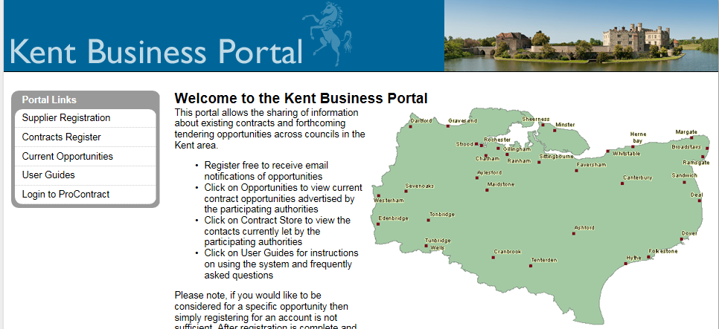

- All opportunities currently available are shown. To narrow the results to those for a specific organisation, category, region, keyword or date, use the search options on the left of the screen, then click Update:
- Once the relevant opportunity has been located, click into the Title:
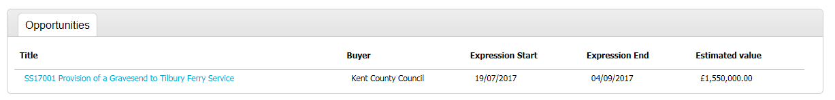

- Details of the opportunity are shown. To register interest, click Login and register interest in the opportunity:
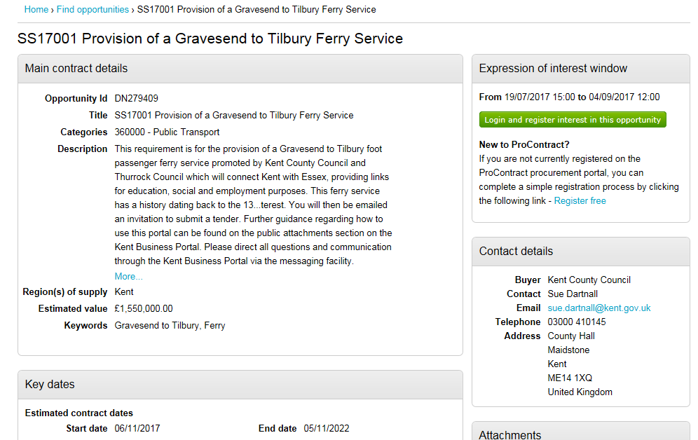

- Enter your username and password, then click Continue:
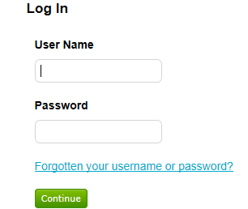

- Once logged in, click Register interest in this opportunity:
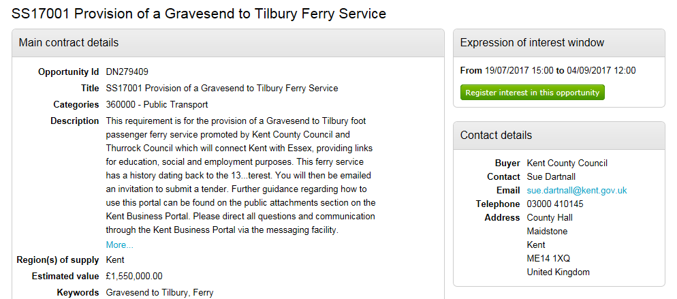

Locating Documentation Relating to an Opportunity

- Confirmation will be given once the expression of interest has been successfully registered.
- To view in Invitation To Tender information immediately, click the link to the ITT event:
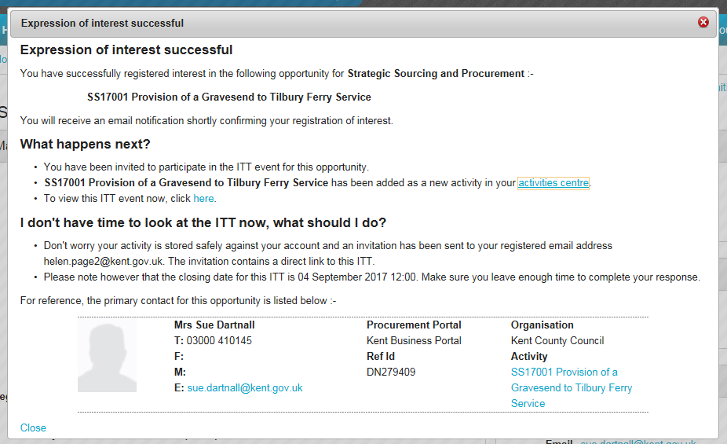

- Alternatively, you will also receive an email with a link to the relevant opportunity. This can be used to access the ITT information at a later date, by clicking into the link and logging in to the system: 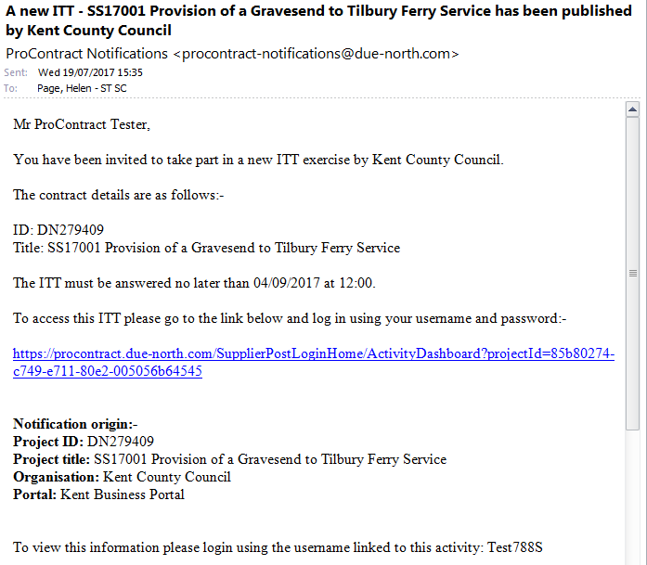

- The link will take you to a screen showing the Events relevant to the opportunity.
- The Events screen confirms expression of interest accepted.
- To view further ITT information, click Start on the ITT event: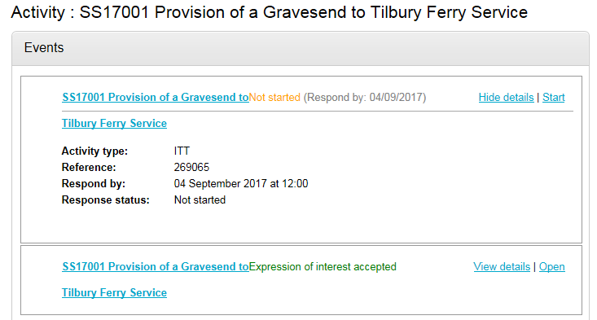

- The below screen shows the Main details of the opportunity.
- A Time remaining box shows how long is left until the submission deadline.
- A Messages box shows whether any additional messages relating to the opportunity have been received. The Messages function works in a similar way to email.
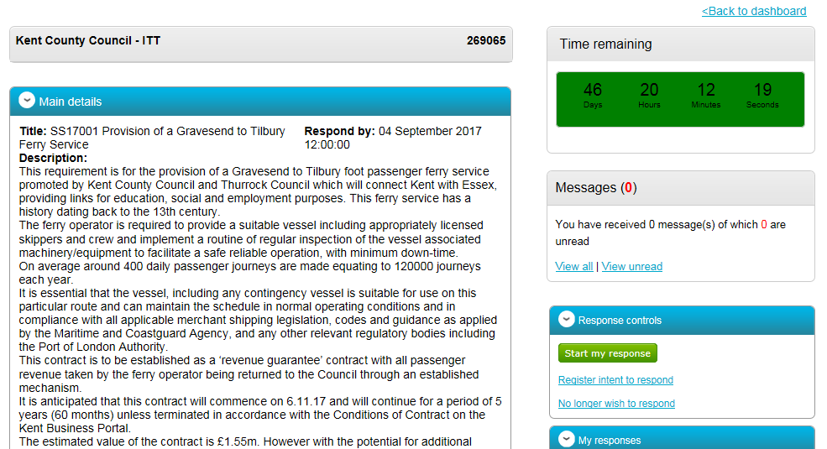

- Further down the ITT screen can be seen a list of Attachments which should be viewed before responding to the opportunity.
- Terms & conditions which should be read before responding to the opportunity are also shown.
- For each attachment and terms and conditions document, open by clicking into its name.
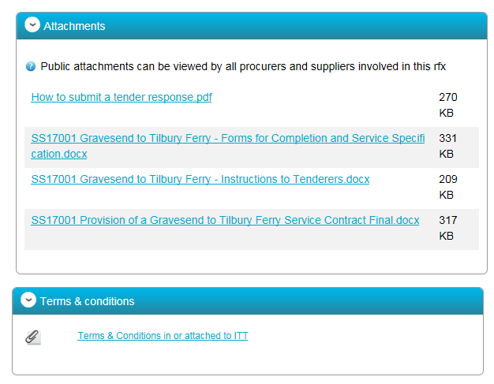

Submitting your Response

- To respond to the opportunity, click Start my response on the right hand side of the screen:
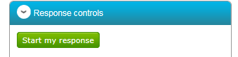

- Read the guidance and click Continue:
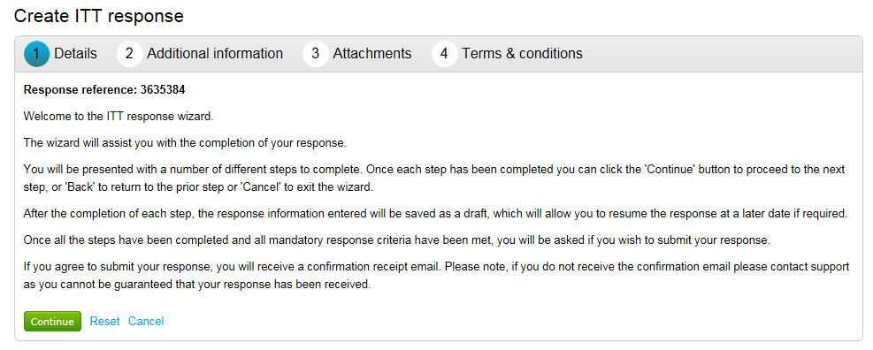

- Complete your reference, response information, and additional comments if required (these fields are optional if the main response is to be via evaluation questions and attachments), then click Continue:
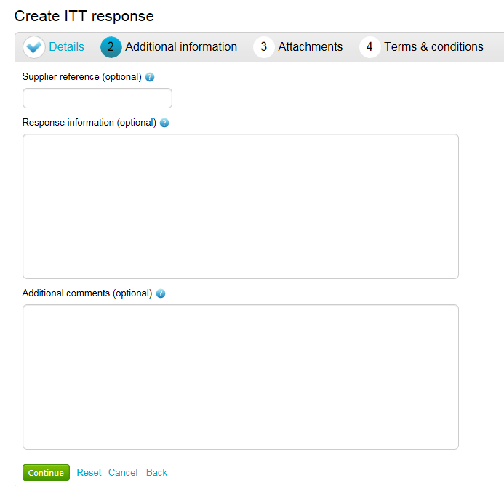

- Some opportunities may require you to complete evaluation questions at this stage. If so, click Edit response to see the questions:
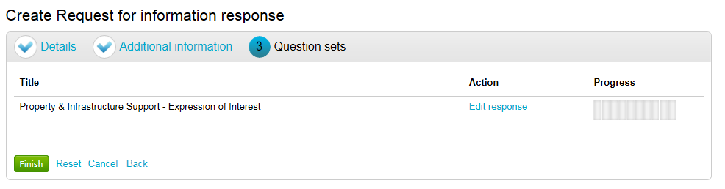

- For each question, click into Answer question to complete your response:
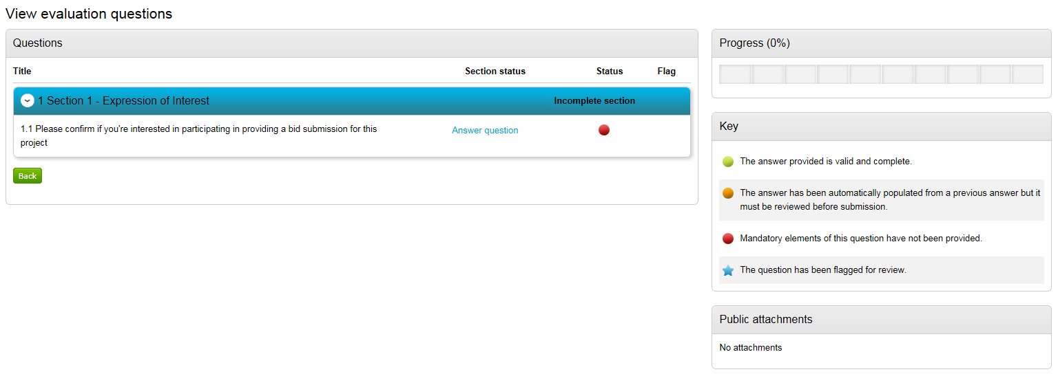

- Answer the question (this may require selecting an option, or adding free-type text, depending on the nature of the question).
- If the evaluation has multiple questions, click Save and next to complete the next question.
- Once all questions have been completed, click Save and close:
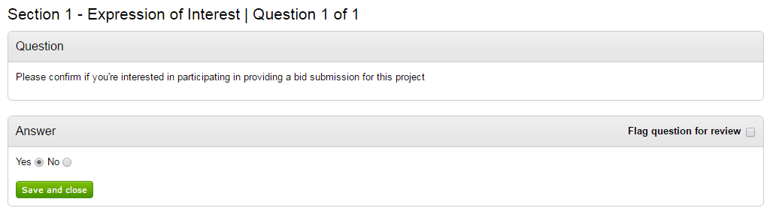

- Once the Complete section shows as green, and the Progress bar shows 100% and has turned green, click Back (or Continue, depending on how the ITT has been set up) to navigate back to the main response page:
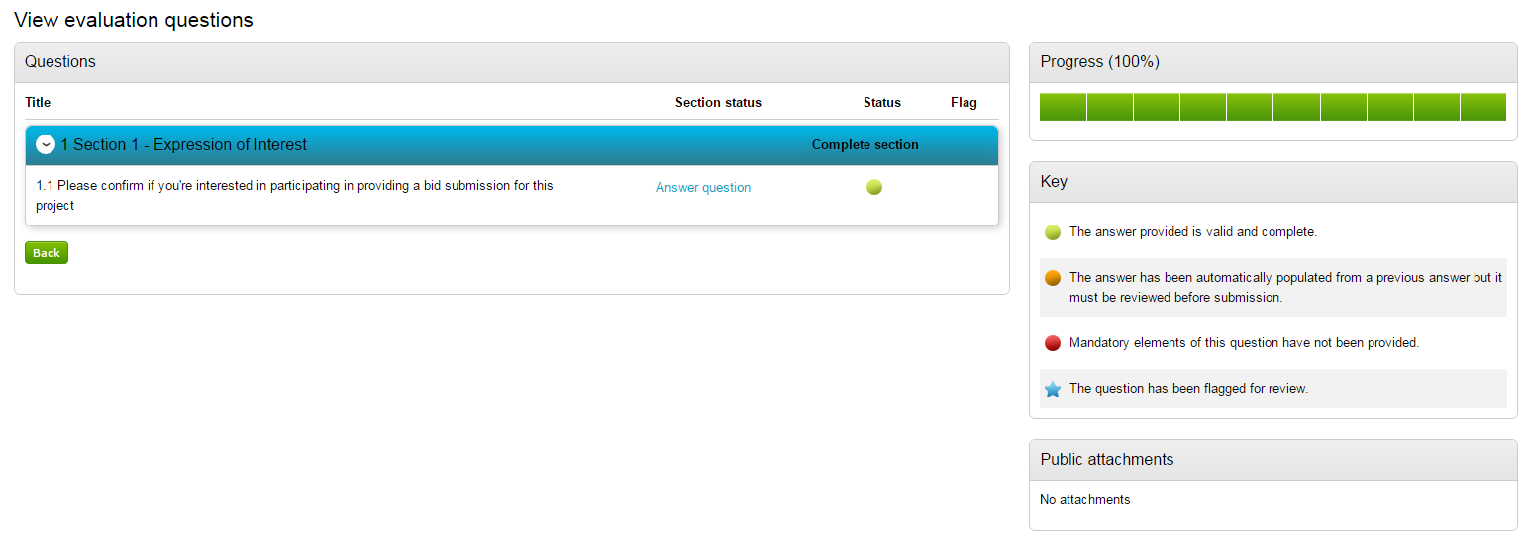

- Once evaluation questions have been completed, you will be able to continue with the remainder of the response.
- If an attachment is required, click Add attachment:
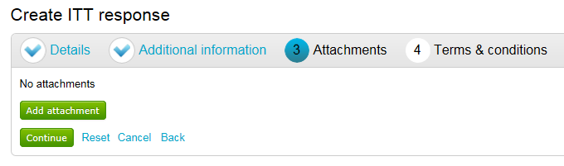

- Click Add files to locate and select files from your computer, then click Start upload to add the files to your response:
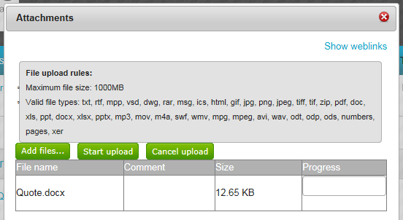

- Once all relevant attachments have been added, click Continue:
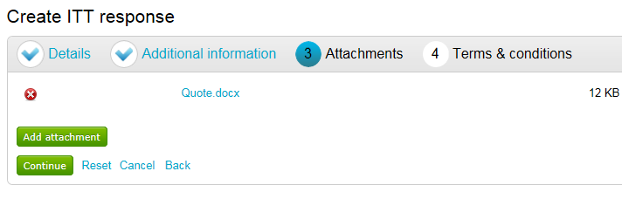

- Read the Terms & Conditions.
- Select Accept, then click Finish to navigate back to the main response page:
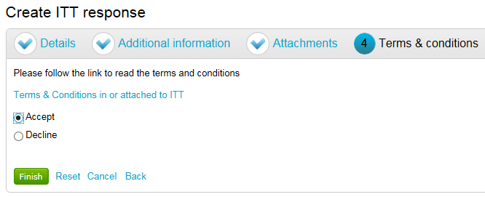

- Once the relevant sections have been completed, all items under the Submission checklist will turn green. This indicates that your response can now be submitted.
- To submit your response, click Submit response:
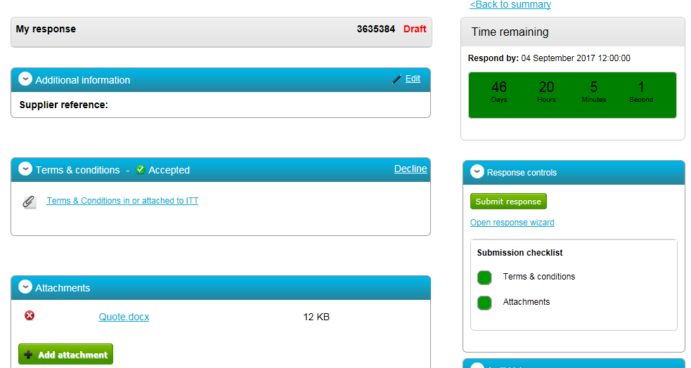

- You will be asked if you are sure you want to submit the response. Click Submit response to confirm.
- You MUST ensure this part of the process is completed. Answering evaluation questions and uploading attachments do not in themselves constitute a submitted response.
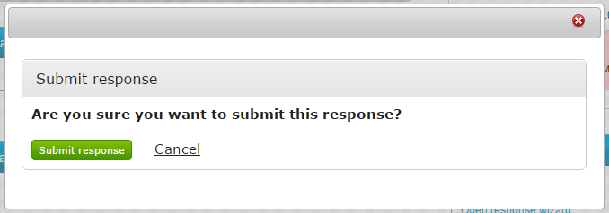

- A green box containing the word Submitted will now appear beneath the Time remaining box. This is confirmation that your response has been submitted. The system will also generate an email to confirm that the submission has been received by the system.
- Should you wish to make any amendments to your response, you can do this at any time prior to the submission deadline by using the links within the Response controls box. If you do this, please remember to ensure your amended response is submitted successfully.

