Market Engagement Questionnaire
SC22154 - Ultra-Rapid Electric Vehicle Charging Hubs
Kent County Council (the Council) is the largest county council in England, covering an area of 3,500 square kilometres. It has an annual expenditure of over GBP 900,000,000 on goods and services and a population of 1,300,000. The Council provides a wide range of personal and strategic services on behalf of its residents, operating in partnership with 12 district councils and 305 parish and town councils. The Council is responsible for maintaining over 8,700 km of carriageways and 6,300 km of footways across the County.
In line with Government plans to decarbonise transport and end the sale of petrol and diesel cars by 2030, Kent County Council is preparing the network for zero emission vehicles and in doing so supporting the ambition to reach net zero by 2050.
The Ultra-Rapid Hubs project aims to implement ultra-rapid charging infrastructure in the format of ‘hubs’ across Kent, providing up-to-date high speed charging technology to facilitate longer journeys and reduce ‘range anxiety’ among EV users.
The Council are looking to partner with a supplier to deliver these ultra-rapid hubs on KCC-owned land, with several commercial models in consideration ranging from lease arrangements to profit/revenue share. Each location may present an opportunity for different configurations of chargers and facilities; however, the minimum expectation is that 150kwh speed charging bays will be provided to support large numbers of vehicle uses per week. It is desirable that at least 6 ultra-rapid chargers are provided at each location with additional speeds and options made available where suitable. Load balancing, longer duration chargers, welfare facilities and amenities are some of the options that should be considered.
This Market Engagement Questionnaire is designed to gather information relating to this tender, which will be used to inform The Council’s strategy for commissioning these services. Your responses will help us understand your level of experience with ultra-rapid charging, your ideas for hub design and your cost estimates for this type of scheme.
Please complete and return via the Message function on the Kent Business Portal no later than 12:00pm on 22 June 2022. Earlier responses would be welcomed and meetings with suppliers will be setup on an ad-hoc basis. Meetings will be held throughout June and July. Please rest assured that any information shared with us will be treated in the strictest confidence.

SECTION A: SUPPLIER DETAILS
Supplier Name:
Company Registration Number:
Website:
Supplier Contact Details in relation to this questionnaire.
Contact Name and Position:
Contact Email Address:
Contact Telephone Number:

- Describe a recent ultra-rapid EV charging project you have been involved with, and your role.
Please answer here

- Below are a range of hypothetical sites that demonstrate the type of land KCC is considering for ultra-rapid charging hubs. What would your proposal be for each of these sites and why? Please support with images of site design where possible. Consider the following:
- Type of technology
- Number of chargers
- Speed of chargers
- Solar/ renewable energy usage and generation
- Battery storage / solutions to overcome constrained network capacity
- Giving back to the grid
- On-site facilities e.g., toilet, café, lighting, CCTV etc.
- User-friendly and innovative site design/ layout.
- Estimated overall cost for each site (broken down into high level components where possible)

Please answer here

- How would you propose we extract maximum value out of these sites in the long term? (For example, building capacity for the site to be an energy asset.)

Please answer here

- Estimated timeline up to an ultra-rapid hub completion. (Please highlight which elements are assumptions vs based on past experience/ current knowledge)

Please answer here

- What do you perceive to be the main challenges when bringing a site forward for development?
Please answer here

- Describe your approach to ensuring you have up-to-date technology throughout the life of the contract (i.e., refreshing old equipment, and upgrading to meet changing standards)
Please answer here
- How would you factor in any financial contributions we could make to the project? (i.e., If KCC can bring in grant funding to contribute to the project, will this enable higher returns to KCC in a profit/revenue share arrangement?)

Please answer here

- Which commercial model would you recommend and why? In terms of ownership, profit sharing etc.

Please answer here

- What would you deem a suitable contract length and why?

Please answer here

- How do you calculate cost to the end user?

Please answer here

- How will you make charger use and payment as easy as possible for the end user? (E.g., non-phone contactless payments)

Please answer here

- What technological innovations could you bring forward within these hubs? (E.g., solar PV, battery storage, innovative renewable energy generation.)

Please answer here

- If you have any further comments or insight, please share them below:

Please answer here

Site 1:

Details:

- Size: 0.61 acres
- Brownfield
- 45,000 motor vehicle movements per day
- Direct access to an A road
- No existing chargers in 3 miles radius
- EV density = 49.75
- On-site toilets
- 0.6 miles to a village, 4.3 miles to a town
- 3.1 miles to substation (33/6.6KV)
- 166m dig to a 6.6 network

Satellite images:

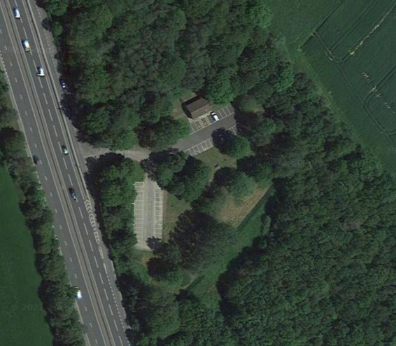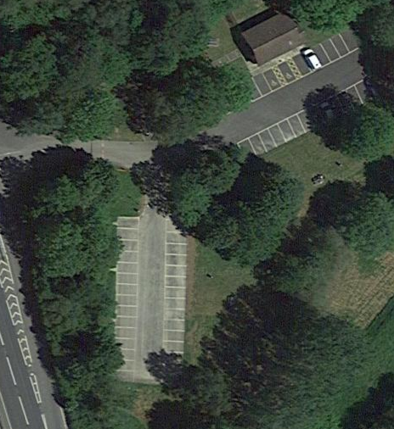

Site 2:

Details:
- Size: 0.71 acres
- Brownfield
- 20,800 motor vehicle movements per day
- Direct access to roundabout
- 15 miles from A road
- 1.7 miles from existing chargers (1x 43kW 2x50kW) and 2.6 miles from a 7kwh charger.
- EV density = 24.6
- 2.5 miles to a town
- 3.1 miles to substation (33/11KV)
- 0.9 miles to a Solar Farm (0.6MW)

Satellite images:

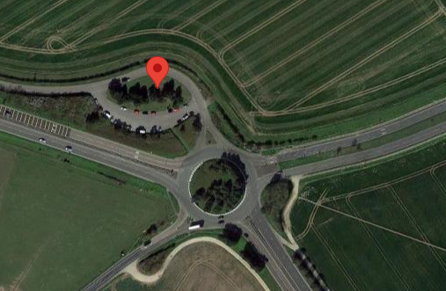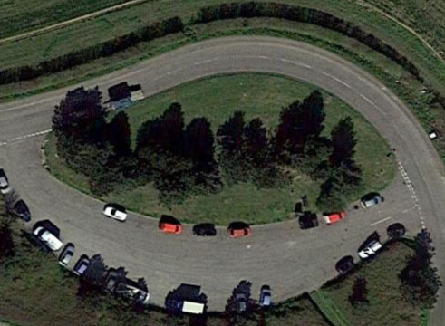

Site 3:

Details:
- Size: 0.7 acres
- Greenfield
- 32,900 motor vehicle movements per day
- Next to roundabout but access needs to be created
- 17 miles to A2
- 2.7 miles to nearest chargers (2x7kW), 3 miles 2x7kW, 3.1 miles 1x7kW, 3.1 miles 2x50kW and 1x22kW, and 3.4 miles 4x50kW.
- EV density = 26.3
- 3.35 miles to a town
- 1.6 miles to grid (33KV)
- 670 metres from 6.2 MW Solar Farm

Satellite images:

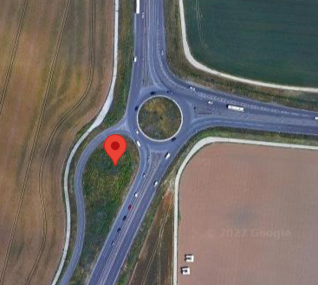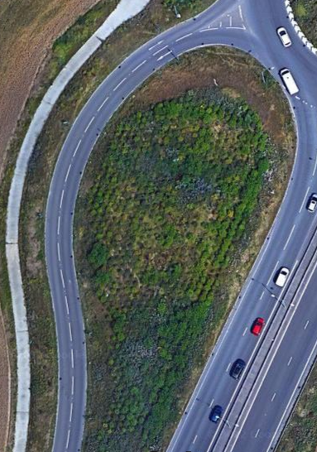

Site 4:

Details:
- Size: 0.72 acres
- Greenfield - dense vegetation on site
- 29,000 motor vehicle movements per day (nearest roundabout), 100,000+ through adjacent Motorway intersection.
- Current access to roundabout is a bus lane
- 2 miles to nearest chargers (2x50kW and 1x22kW), 2.1 miles to 2x50kW and 1x22kW, 2.8 miles to 2x22kW, 4.3 miles to 2x7kW, 4.5 miles to 2x7kW, and 3.8 miles to 4x50kW and 2x22kW .
- EV density = 56.73
- <3miles to a town
- 25 food and retail outlets within 3 miles
- 2.24 miles to grid (33/6.6KV)
- 4 miles to Solar Farm (4.7MW) and 3 miles to another Solar Farm (4.5MW)

Satellite images:

