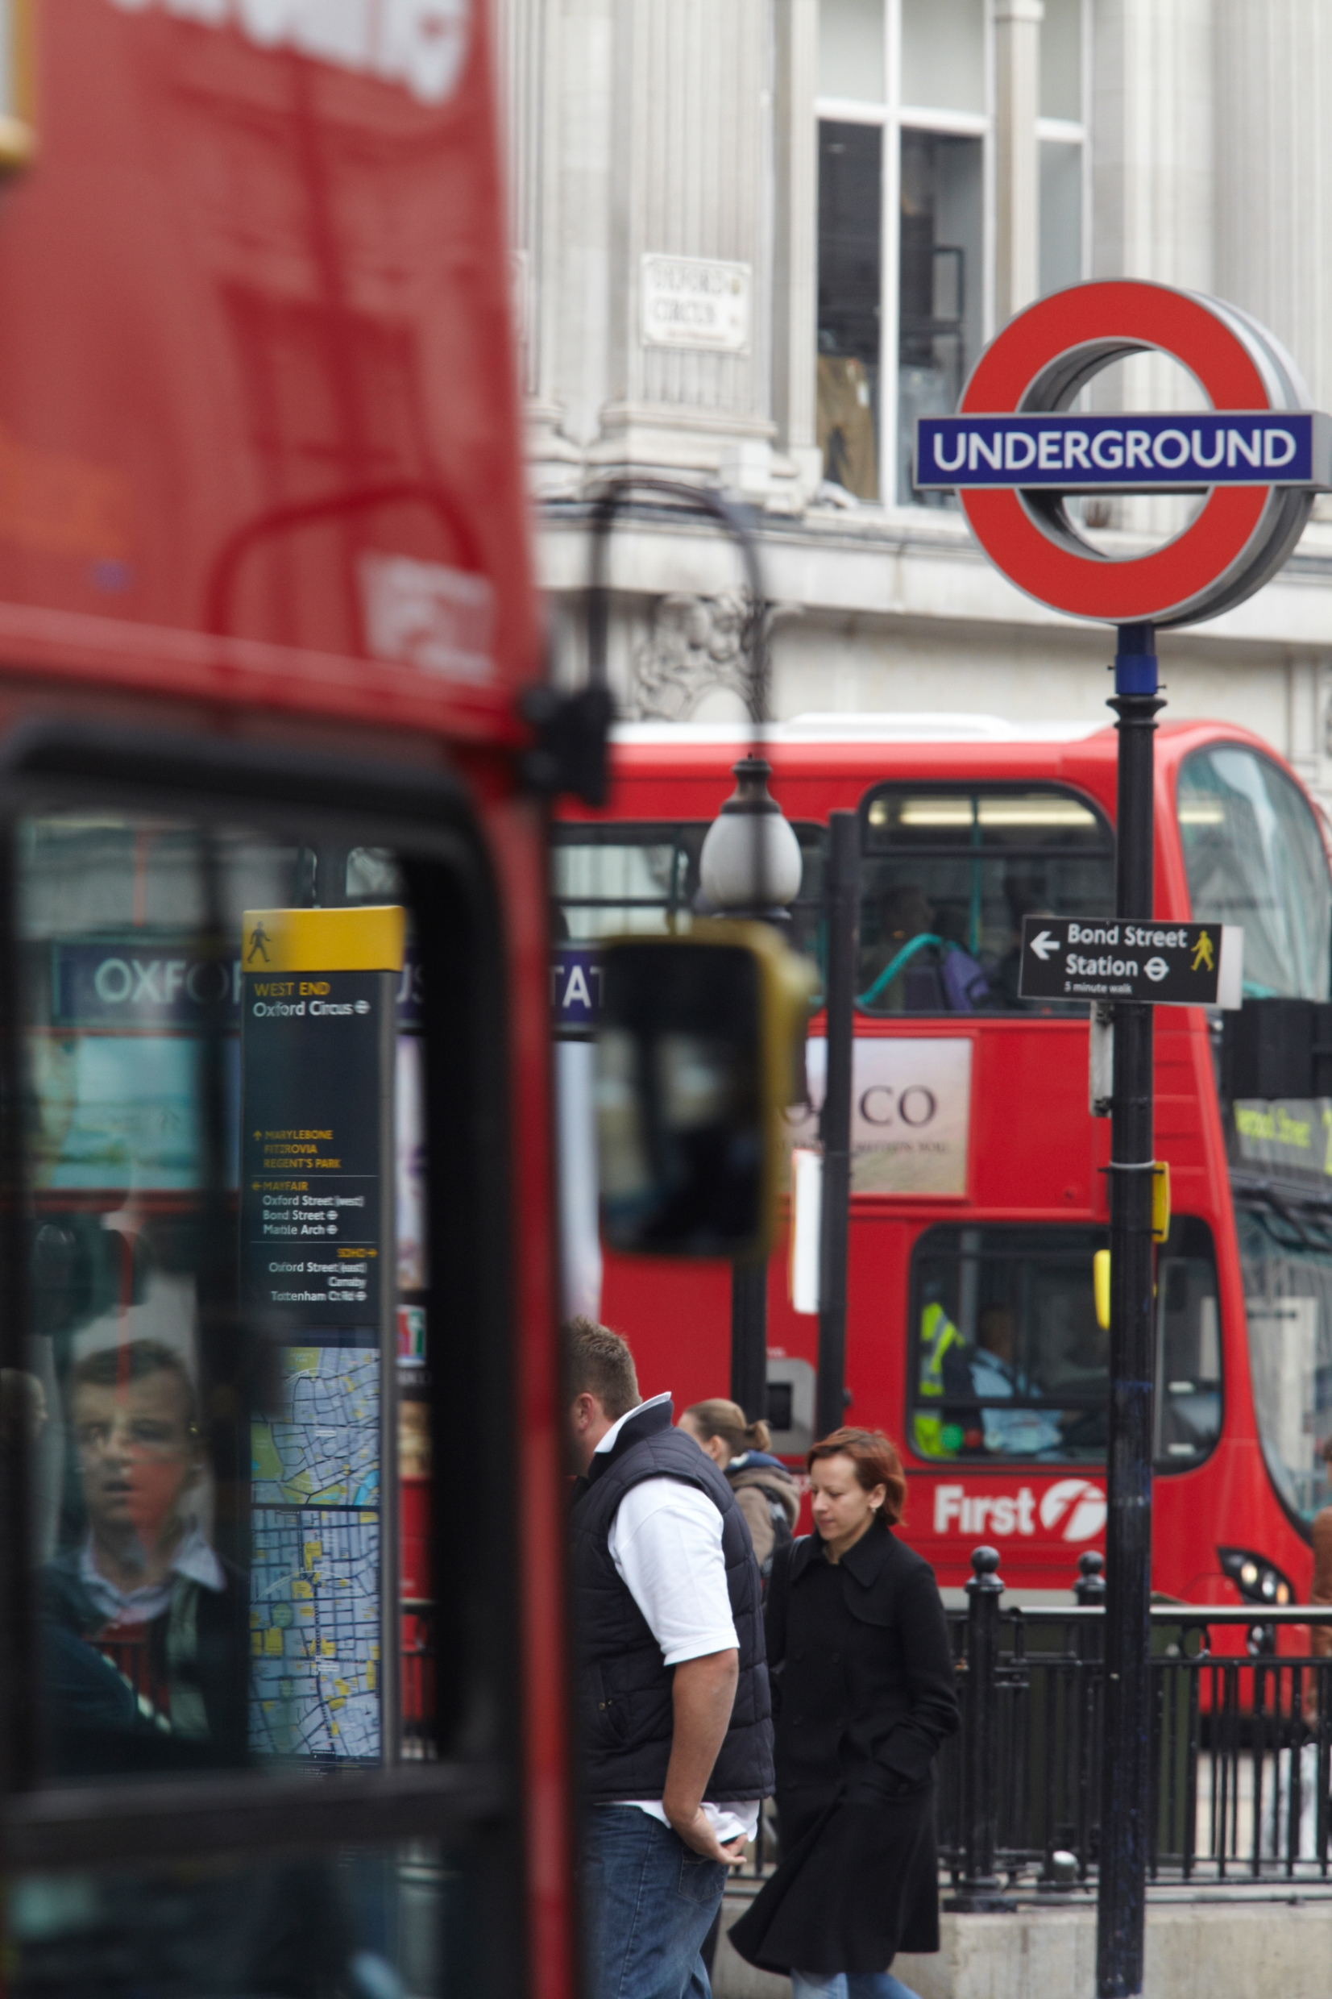
Market Sounding Questionnaire
TfL/23814 - Manufacture and Supply of Anti-Roll Bars for the S7 Programme Lift
- Introduction
This Market Sounding Questionnaire (MSQ) is issued by Transport for London (TfL) and seeks to obtain market feedback in relation to the manufacture and Supply of Anti-Roll Bars for the S7 Programme Lift. The primary focus of this questionnaire is to better understand the capacity and capability supply chain, potential delivery models, as well the supply chains perceived risks and opportunities.

TfL is currently planning to undertake an above threshold procurement for the manufacture and supply of Anti roll bars for the S7 Fleet of trains (293 units). The S7 programme lift is due to start in July 2023 and finish in May 2026.

Transport for London is part of the Greater London Authority family led by Mayor of London. We are the integrated transport authority responsible for delivering the Mayor’s aims for transport.
TfL runs most of London’s public transport services, including the London Underground, London Buses, the Docklands Light Railway, London Overground, TfL Rail, London Trams, London River Services, London Dial-a-Ride, Victoria Coach Station, Santander Cycles and the Emirates Air Line.
- Feedback Request
Feedback is requested in relation to the proposal described within this document. Your feedback is important as it will allow views from the market to inform the development and finalisation of the procurement strategy.
TfL would greatly appreciate your feedback in the form of a response to the questionnaire within this MSQ pack. Please submit your responses via TfL’s e-procurement portal ProContract.
All responses will be treated confidentially. Following analysis, a high-level summary report will be issued to participants of the market engagement giving an overview of the general themes and findings, but no participant will be mentioned by name in the report.
This exercise does not form part of any formal procurement process. All responses will be carefully considered but will not bind TfL to any particular approach to the procurement, nor will responses be treated as conveying any promise or commitment on the part of the respondent.
For your feedback to be taken into account, your completed MSQ must be received by 12 Noon on Friday 26th August 2022.

- Proposals for Consideration and Feedback
Introduction
Transport for London (TfL) are currently in the process of obtaining components in preparation for the start of the first S-Stock S7 Overhaul Programme Lift. There are currently 132 S7 trains currently in service with LUL, each train has 7 cars and entered service on the District, Circle and Hammersmith and City Lines between 2012 and 2014. The Overhaul Programme Lift is due to commence in July 2023 with the aim to be completed by May 2026.
TfL require a quantity of 293 Anti-roll bars for the S7 trains to facilitate their replacement on an on-condition basis. The purpose of this MSQ and the subsequent tender exercise is to seek the appointment of a Supplier to deliver the Anti-roll bars in regular intervals over the duration of the overhaul (from January 2024 to March 2026).
The deadline to respond to this MSQ is 12 Noon on Friday 26th August 2022. All responses and additional information must be sent via the ProContract e-tendering portal ( https://procontract.due-north.com ). If you wish to submit any clarification questions, please do so via the messaging function on ProContract by 12:00 pm Friday 19th August 2022.
The feedback that we receive will be reviewed, analysed and will be taken into account in finalising the procurement documentation for the scheme. Responses will be treated confidentially and will not be shared externally.
Following the submission of your MSQ responses TfL may undertake 1-2-1 sessions with Suppliers to further understand their responses and gain further market feedback.
Suppliers are asked to review the following appended drawings when completing this MSQ.
Table 1 – TfL Drawings
Drawing Number | Short Description
214290 | Anti-Roll Bar Sub-Assembly
214291 | Anti-Roll Bar
214292 | Anti-Roll Bar Arm
Scope and nature of the procurement
The scope of work includes the manufacture and supply of Anti-roll bars. This includes but is not limited to:
- All materials, labour required to produce the components
- All testing Supplier testing including pre and post assembly TfL First Article of acceptance to assure TfL that the components meet the material and design requirements noted in Appendix 1

Table 2 – Indicative Procurement Programme
Activity | Date
Market Sounding Questionnaire
Issue PIN and Market Sounding Questionnaire | 22nd July 2022
Market Sounding Questionnaire Deadline | 12 Noon, 26th August 2022
Standard Selection Questionnaire (SSQ)
Issue OJEU and SSQ (30 days) | Late October 2022
SSQ returns | Early December 2022
Evaluation and notification of results | Late December 2022 / Early January 2023
Invitation to Tender (ITT)
Issue ITT (30 Days) | January 2023
Tender Returns & Evaluation (including BAFO if required) | March 2023
Contract Award | Early June 2023
Contract Commencement | Early June 2023
First delivery of Anti Roll bars | January 2024

- Questionnaire
As part of this market sounding exercise, TfL wishes to seek your views on the extent of your capability, capacity, and interest in tendering for the S7 Anti-Roll bar procurement.
TfL would appreciate your feedback in the form of a response to the following questionnaire, with the specific questions to be answered in the blank tables/boxes provided. Should you consider a particular question is not applicable to your organisation, please state “not applicable” in the tables/boxes provided.
Please limit answers to no more than 500 words.

TfL/23814 - Manufacture and Supply of Anti-Roll Bars for the S7 Programme Lift Market Sounding Questionnaire
Please complete:
Organisation Name
Company Registration Number
Key Contact Name
Email Address
Telephone Number
Interest and capability
Q1 – Is your Organisation interested in tendering for the TfL S7 Stock Anti-Roll bar procurement ?
If you are not interested please explain your reasons below (e.g. complexity of manufacture, tooling costs, unable to meet the material specifications etc.).

Q2 - from the information provided within this MSQ are there any critical factors that would deter or prevent you from bidding for this piece of work? (for example: delivery timescales, supply issues etc)

Q3 - Please review the drawings listed within MSQ Appendix 1 before completing this section.
The anti-roll bar on the S-Stock is a safety critical component with precise tolerances and manufacturing requirements, as such TfL cannot accept any material or manufacturing deviation from the designs that have been supplied. | Capability  (Y/N) | Supplier Comments
  - Is your Organisation able to manufacture and supply the Anti-roll bars as detailed by TfL in the drawings listed in Appendix 1 to the required quality and material specification?
  - Can your Organisation manufacture and supply the roll bars within the delivery timescales outlined within this MSQ?
  - What is the anticipated Lead time to produce the Anti-Roll Bars?
With a presumptive delivery date of January 2024 do you believe that is achievable following the anticipated contract commencement date in table 2?
  - Does your organisation currently have the tooling in place to undertake the manufacture of the Anti-Roll Bars?
  - What type of in-service warranty would your organisation typically provide for the Anti-Roll Bar?
  - Do you have the required tooling in place to produce the Anti-Roll Bar or will you be proposing to develop it ?

Q4 – Has or is your organisation manufactured Train Anti-Roll bars? If yes please provide examples. If no, do you believe that your organisation has the capability to produce the Anti-Roll bars as detailed in Appendix 1?
Information that would be of interest includes, but is not limited to:
- Prior/Current experience of producing Anti-Roll bars or similar manufactured items.
- Experience of working with materials similar or identical to those required by TfL.
- What were the key risks, opportunities and main lessons learnt?
- What timescales were involved?

Q5 – Please briefly outline your supply chain including the manufacturing of the Roll Bars, place of proposed manufacture and the sourcing of the Raw Materials
Information that would be of interest includes, but is not limited to:
- If you are providing equipment/parts, please provide what proportion of your supplies would come from the UK, Europe or Rest of the World?
- If any of your supply chain would be impacted by the current conflict in Ukraine
- What mitigations that you have in place against the costs of materials/energy/labour
- Do you anticipate that there will be any issues with the continuity of supply of the raw materials for this requirement ?

Q6 - TfL would like to gauge how the market would prefer to deliver the services/elements/works, please indicate whether you would self-deliver and if not the percentage you would be likely to subcontract.
List all options in a table with columns for self-delivery & subcontract percentage
Element/services/disciplines | Entirely Self-Delivered  Yes/No | Will you be subcontracting?  Yes/No | If yes please list the % split between work carried out by yourself and the works subcontracted
Option 1 (Element/services/disciplines)
Option 2
Option 3
Option 4
Option 5

Q7 - Please comment on the proposed procurement programme described in section 3 - is this programme realistic? Yes / No. If No then please explain why and what TfL could do to deliver this requirement on time.
Q8 - Based on the information provided within this document, would you anticipate responding to this requirement as a single entity or form a partnership? Please also state why this is your preferred approach.

Q9 – Can you propose any innovation regarding reducing costs in the manufacturing process of the anti-roll bar ?
Q10 – Can you propose any innovation with reference to reducing the estimated production lead time of the Anti-Roll Bar ?
Q11 – How quickly could you mobilise to produce the Anti-roll bars following the award of contract ? (This would include the time to develop the required tooling if needed)
Q12 – What do you estimate to the most appropriate economic batch quantity of anti-roll bars to generate the most appropriate cost benefit ?
Q13 – Rising inflation in the UK and the rest of the world is currently a key risk for all projects. How would you go about managing fixing your costs for the contract term ?

Constraints (inc Risks), Interfaces and Opportunities
Q14 - What does your organisation consider to be the top risks (up to 3 in order of criticality) to the successful delivery of this contract? What mitigating action do you think can be taken by TfL and/or suppliers?
Rank | Risk and description (up to 3) | Mitigation | Who is best placed to manage this Risk (TfL or Supplier.? etc)
1
2
3

Q15 - What does your organisation consider to be the top opportunities (up to 3 in order of criticality) to the successful delivery of this contract? Please provide the following details.
Rank | Opportunity and description (up to 3) | Who is best placed to manage this Risk (TfL or Supplier.. etc)
1
2
3

Q16 - What other elements not included in the lists above you think TfL might be interested in/should consider for the procurement?

Q17 - From your experience, and review of this document, what technology and innovation can you recommend to TfL to enable further cost saving and improvement of processes?
Other
Q18 - Would you be prepared to follow up this market engagement questionnaire with further engagement activity, for example through a 1-2-1 engagement session? Yes/No?

Q19 - Do you have any other comments regarding the proposals set out in this market engagement questionnaire?

We would like to thank you for taking the time to respond to this questionnaire –
TfL Commercial

- End of Document -

