1. INSTRUCTIONS FOR Quotation
Introduction
Barrow Borough Council is seeking to appoint a suitably qualified organisation experienced in managing marketing and promotional activities specific to those which acknowledge the financial input from funders. In this instance the funders are the European Regional Development Fund and the Cumbria Local Economic partnership
Low Carbon Barrow is a programme of funded activities which seeks to reduce CO2 emissions in the boundaries of Barrow Borough Council.
Activities include the retrofit of Solar Panels to Housing and buildings, installation of Electric Vehicle Charge Points, transferring Council Vehicles to Electric and refurbishing facilities on Piel Island
The contract will run from 1st August 2022 to 1st February 2023
The sole aim of this contract will be to work with Barrow Borough Council to meet the acknowledgement requirements of our funders
Submission Date
Final submissions by 5pm on 8th July . Barrow Borough Council will then undertake an assessment to select the organisation whose submission most appropriately matches the desired outcomes listed in this brief, in terms of programme deliverability, methodology, experience and price.
Queries and clarifications
The final date for any queries and clarifications is noon 8th^{th} July 2022
Clarification Meetings
The organisations with the highest scores following submission may be invited to a clarification meeting between 11th and 18th July 2022
We reserve the right to ask queries prior to the clarification meeting .
Award
We aim to inform the successful supplier of our intent to award by 21st July 2022
2. BACKGROUND
Barrow in Furness Council has a challenging commitment to reach net zero. It has run Citizen Juries on Climate Change and is delivering against Low Carbon Barrow
Low Carbon Barrow is a £2m programme of investment across Barrow-in-Furness to reduce carbon emissions through demonstration projects across the ‘whole place’. The investments include energy efficiency projects in public housing and public buildings, electric vehicle charging infrastructure in key locations, a small grants programme aimed at high profile community buildings and business, a strategic ‘Zero Carbon Piel’ programme at Piel Island and a series of public and stakeholder engagement workshops. The Programme seeks to stimulate investment in low carbon technologies, much of which would drive local labour markets and local supplier markets as the demonstration projects increase demand.
Low Carbon Barrow is part funded through ERDF and CLEP. Both funders require acknowledgement in terms of logos and other publicity requirements.
3. THE SERVICE REQUIRED
Delivery of funders acknowledgement materials. For all quotable services initial design artwork will be supplied.
Materials to include
- Complete management of the delivery of livery for 3 Electric vehicles and 1 Electric Van. Initial design to be provided. This is a full service and must minimise downtime of vehicles. Vehicles will be located Town Hall Barrow in Furness. Lifespan of 4 years
- Production of funders acknowledgement to 18 outdoor Electric Vehicle Charge Points. Options can include
- Full wrap (full service to application on Charge Points required)
- Individual stickers (service to end with delivery to Town Hall Barrow in Furness
- Temporary banners with ability to securely tie 0.5m by1.5m number 2
- Acknowledgement plaques suitable for indoors and outdoors lifespan of 5 years minimum 30cmx 30cm, maximum 50cmx 50cm and variables in between acceptable
- ADDITIONAL SERVICE Interpretation Boards for Piel Island full service including design works
For all the above we are seeking sustainable and environmentally friendly substrates, however we do appreciate the need for some permanence particularly in adverse weather conditions.
Pricing requirements:
- Pricing for materials 1-4 as above. At this stage Electric Vehicles are not delivered however make and model are provided in Supporting Information
- Initial Design work is to be provided therefore pricing to reflect the use of such, production of proof, management and delivery of full service on all 1-4 materials above
- EXEMPLAR pricing for ADDITIONAL SERVICE 5 as above. This will not be used for scoring purposes however we are considering 2-3 Interpretation Boards for Piel Island and would like examples and pricing of previous works (no specification is provided)
4. SUPPORTING INFORMATION
EV Cars and Vehicles (WHITE)
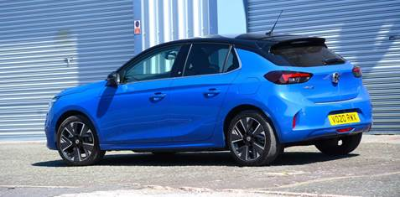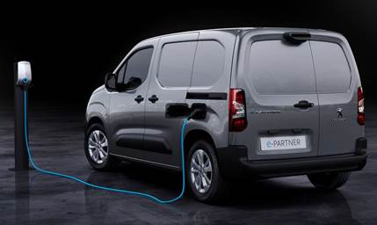
Charge Points
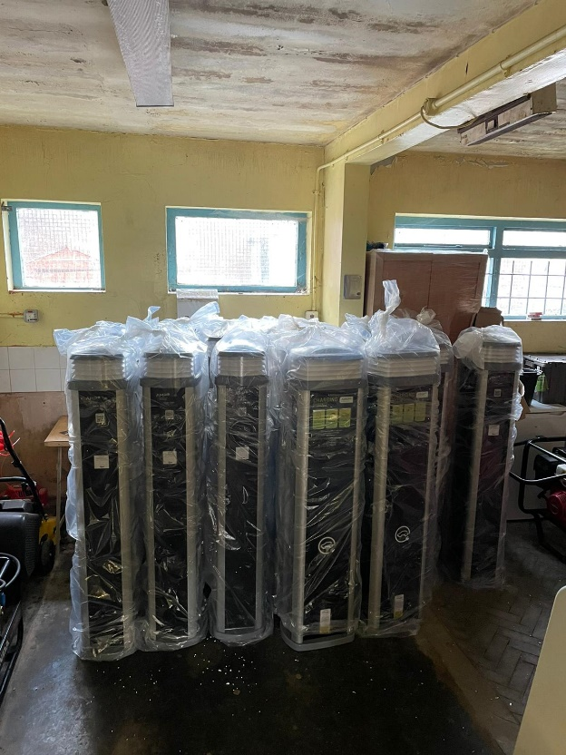
Funders requirements
ESIF Branding and Publicity Requirements v6 (publishing.service.gov.uk)
5. SUBMISSION
The following information is required for submissions:
A. Experience and ability to meet tight deadlines
A brief synopsis of experience no more than 2 sides of A4 with specific examples to evidence the ability to work to and meet tight deadlines
B. Approach
A brief synopsis of no more than a further side of A4 detailing approaches to ensure deadlines are met and inconvenience to Barrow Borough Council is minimised
C. Price
Quotations against the following
- Complete management of the delivery of livery for 3 Electric vehicles and 1 Electric Van. Initial design to be provided. This is a full service and must minimise downtime of vehicles. Vehicles will be located Town Hall Barrow in Furness. Lifespan of 4 years
- Production of funders acknowledgement to 18 outdoor Electric Vehicle Charge Points. Full wrap (full service to application on Charge Points required) lifespan 5 years
- Production of funders acknowledgement to 18 outdoor Electric Vehicle Charge Points. Individual stickers (service to end with delivery to Town Hall Barrow in Furness) minimum 15cm x 15cm maximum 30cmx30cm and any variable in between number 50 lifespan 2yrs
- Temporary banners with ability to securely tie 0.5m by1.5m number 2 lifespan 1 yr
- Acknowledgement plaques suitable for indoors and outdoors lifespan of 5 years minimum 30cmx 30cm, maximum 50cmx 50cm and variables in between acceptable
6 ADDITIONAL SERVICE Examples of Interpretation Boards and exemplar pricing (no more than 3 options) this will not be used in scoring
D. Duration
The contract will run from 29th July July 2022 to 1st February 2023 no extensions will be given and submissions will be reviewed on the ability to meet deadlines as described in A. Experience and ability to meet tight deadlines
E. Completion of Standard Questionnaire
Suppliers may be asked to complete a Standard Questionnaire which is common to Public Sector procurements. Copy attached and please note that should a supplier fail to successfully complete when requested this will result in work not being contracted
6. EVALUATION OF SUBMISSION
Barrow Borough Council will undertake to select the organisation whose submission most appropriately matches the desired outcomes listed in the brief, in terms of price, experience and approach.

Barrow Borough Council reserves the right to cancel the quotation process at any point. Barrow Borough Council is not liable for any costs resulting from any cancellation of this process nor for any other costs incurred by those quoting for this contract.

