Contract Opportunities

Contract Opportunities are posted by buying organisations to notify you of their up and coming contracts and to give suppliers a chance to express their interest in the opportunity and to receive the relevant documents.

The opportunities area will also show a list of suggested opportunities, based on the Categories and Regions selected in your profile.

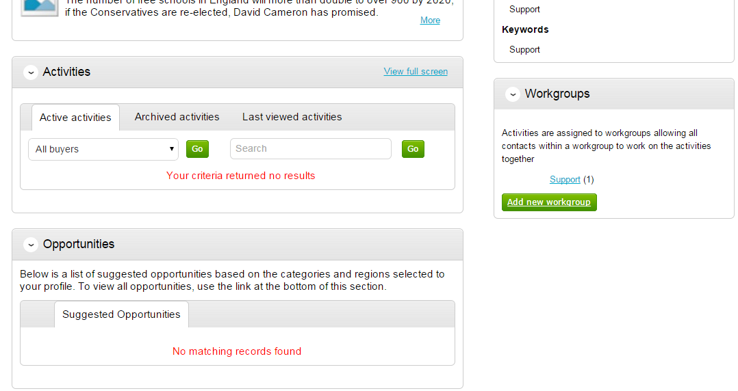

Searching Opportunities

To search for new opportunities from the supplier home page click on Find Opportunities located across the top of the page.

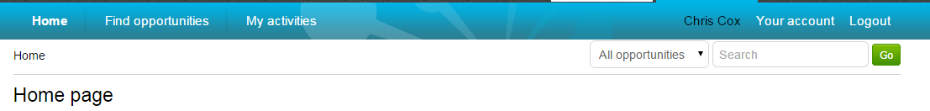

This will then open the Opportunities screen which includes a full list of all current opportunities. You can specify search criteria to narrow your results in the left hand panel, or just do a key word search (on Title, Buyer or All Data) within the Search area in the top right of the page.

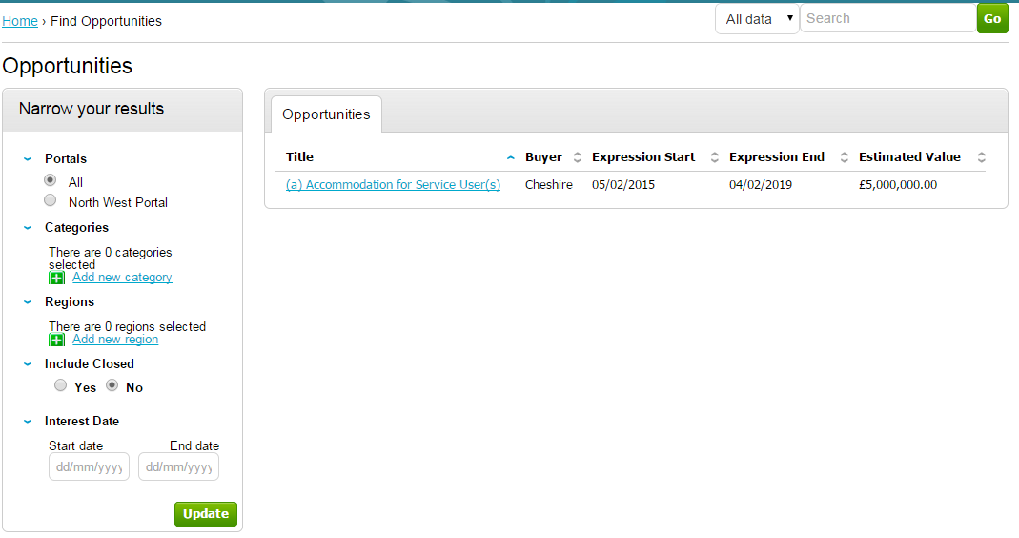

Narrow your results on:

Portals: This setting allows the Portal you are searching on to be chosen.

Categories: This field allows you to choose the category classification to which the opportunities you wish to search for are associated. To select a category, click on the Add new category and search for the relevant entry.

Regions: This field allows you to choose the region to which the opportunities you wish to search for are associated. To select a region, click on the Add new region and search for the relevant entry.

Include Closed: This defaults to No which will show only opportunities that you can currently express your interest in - so the expression of interest window is open. To view all current opportunities, and also all past and future opportunities that are on the portal but have closed, mark Yes.

Interest Date: Refine your results based on the Expression of Interest date.

Once the search has been set up in the desired way then click on Update and the opportunity results in the middle of the page will refresh.

To view the further details of the opportunity, click the corresponding title.

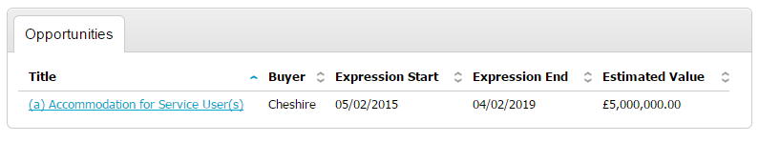

The opportunity details will look as shown, with all the relevant opportunity/contract details.

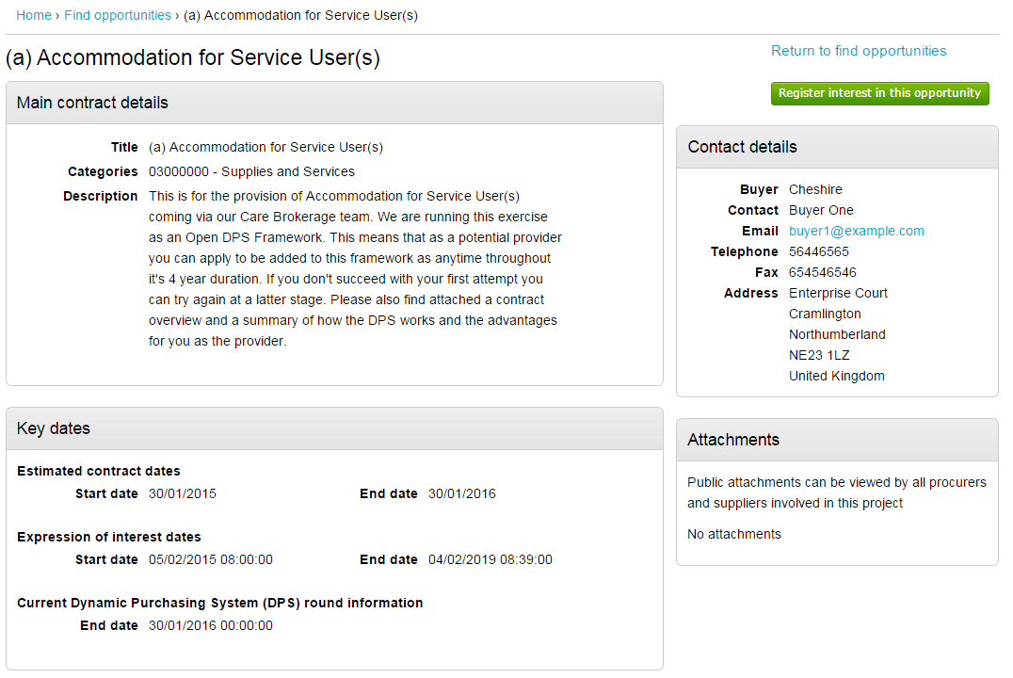

Main Contract Details

This shows key details of the contract including the title, categories and description.

Key Dates
This section shows the estimated contract dates, the expression of interest dates and any other important information (i.e. Current DPS Round end date, for example.) The expression of interest dates determine the options that will be available regarding the opportunity, as the date must fall within these two dates in order to express an interest.

Contact Details
This shows details of the Buyer and Main Contact.

Attachments
Any attachments or links relevant will appear in the bottom right, where they can be viewed/downloaded by clicking on the title.

In the top right there are 2 options – either register an interest in the opportunity, or return to the find opportunities page.

Registering Interest in an Opportunity

To register interest in a particular opportunity you must be registered on the portal.

This process is covered in detail in the section Registering

Once registered, you will have a username and password to access the portal. This allows you to register interest in any opportunities that are advertised on the portal.

Once you are logged in, you can find the relevant opportunity using the process in the section Contract Opportunities.

If after viewing the information regarding the opportunity you decide that you are no longer interested in registering an interest then click the Return to find opportunities button. If you do decide you would like to express your interest then click on Register interest in this opportunity.

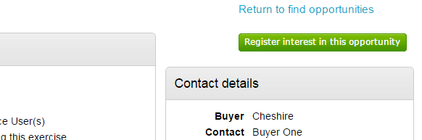

The same area will now show confirmation of the registered Expression of Interest. Click Return to find opportunities to start a New Search.
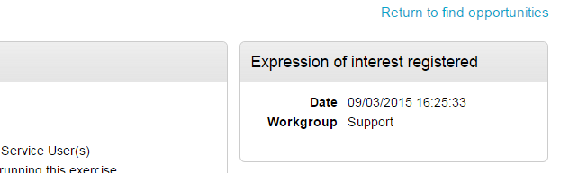

Viewing the Details/Documents

Login to the system and then it will take you to your homepage.

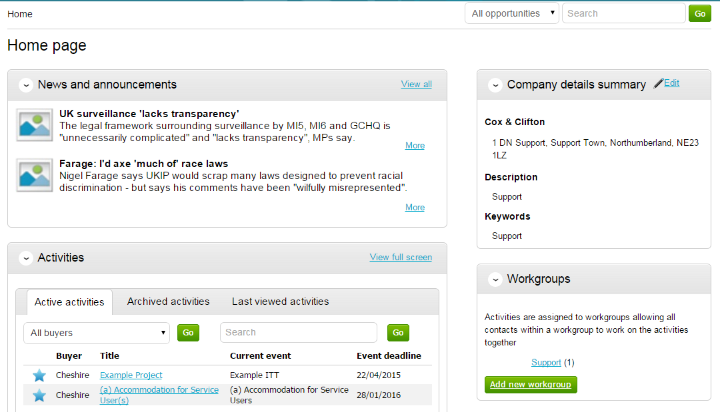

From here to view your current activities that you are working on, from the Activities section click on the title of the Activity you wish to work on.
The Activities area shows all the various tenders that you have registered with, this can be an ITT (Invitation to Tender), RFQ (Request for Quotation), a PQQ (Pre-Qualification Questionnaire) etc.

Note: The process is the same in the system for all types of tender opportunity, PQQ, ITT and RFQ’s, etc. however, in this case the ITT has been chosen to look through, and ITT will be referred to at various points. If you are completing a PQQ or Quotation (using attachments) then the screens will remain the same, it is only the terminology that will change. Online responses to online evaluations are covered in a separate guide/help section.
As you can see above, the Buyer, Title of the project, current event and event deadline is shown. In this case it shows a symbol to reflect it is new and it has not yet been viewed or worked upon yet.

By clicking on the title in blue, further information is now shown. From this screen all aspects of this project can be dealt with; the tender can be viewed, questions can be asked and answers received, additional information can be issued and your response can be put together and sent to the contracting organisation. Each stage of the procurement process will be seen as its own section.
To view the relevant stage of the project click Open Event within the relevant stage, in this instance ‘Example ITT’.

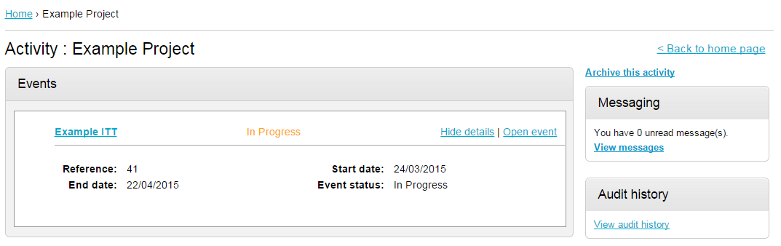

This will open the tender screen. This is broken up into different sections; Main details, Public attachments, Terms & Conditions, Item breakdown and Messaging. Note: There is also a countdown timer in the top right indicating the time left until the submission deadline.

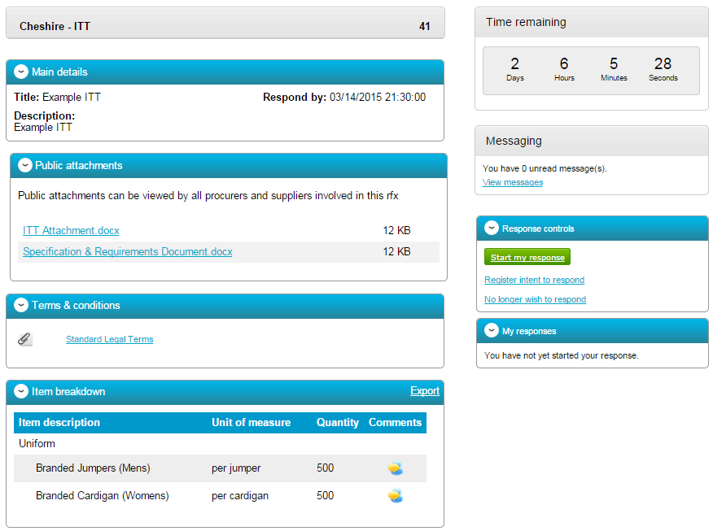

The different sections are explained below;

Main details

This section shows the title, description and date and time the completed tender must be returned by.

Public attachments

This section shows the attachments that have been published by the organisation. To download click on the title of the attachment.
Note: There may be no attachments here, however in the majority of cases there will be. Where there are documents, they should be downloaded and saved to your own network or desktop before working on them.

Item Breakdown

This section is the item breakdown for the tender used for pricing, if one has been created by the organisation.

Note: This is an optional section and there may not be one included with an exercise.

This shows the description of the group/line item, the unit the item is measured in, the quantity of these units required and any additional comments regarding the line item (shown by hovering over the icon.) An example of one is shown below.

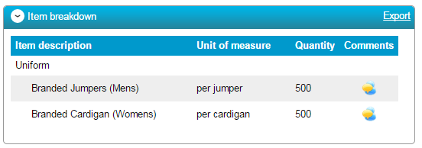
This can also be exported if required, by clicking Export.

Terms and Conditions

The Terms and conditions section shows the terms that have been used with this tender. To view them click on the Terms & Conditions title, shown in blue. There will be at least one set of terms here and there can be more depending what the procuring organisation have set up.

Messages

During the process all questions should be raised using the portal. The ability to ask questions/send messages is found in the Messaging section. Anything sent through this area will go to the member of staff that is working on this within the procuring organisation. Open this area by clicking on View Messages.

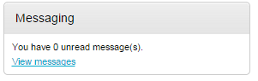
This will show any messages that have already been sent or received. To send a new message, click on the button.

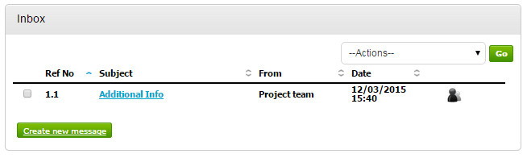
Populate the subject along with the main body of text, and once done then click on the Send button. Attachments can also be added (details of adding an attachment within the system is included later in this guide).

Click to issue the message to the procuring organiation.

The sent message is now shown in the Inbox.
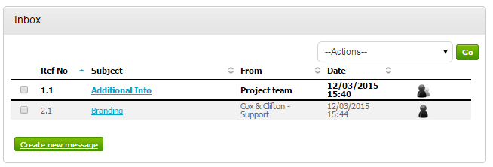

When a reply to that message is sent by the procuring organisation, you will see that the reply is linked to the original message by the numbering. All messages you send to the procuring organisation will be privately sent to them, shown by the symbol. When the procuring organisation replies they may reply privately to you alone (), or publicly (so all suppliers involved in this stage) can see the response ( ). Note: The system will NEVER show which supplier sent the original message.
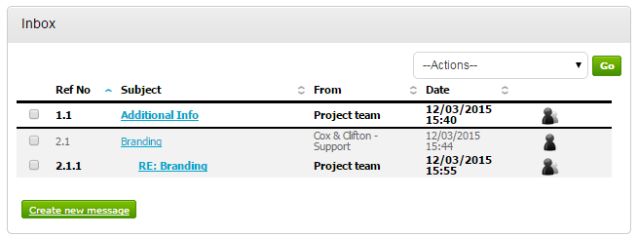

Completing the Response (using attachments)

To begin the response, from the tender summary screen, click Start my response.

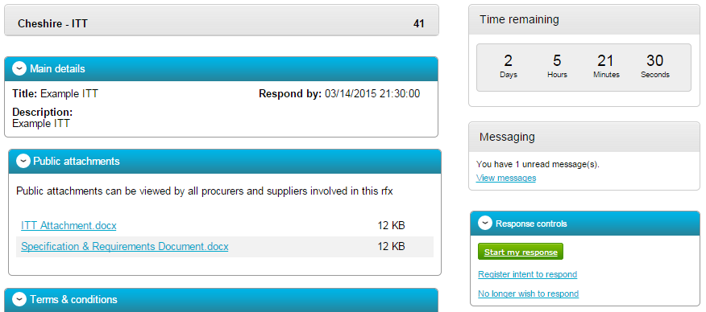

The Response Wizard

This will open up the response wizard that will take you through each stage of the tender response to make sure it is completed successfully. Stage 1 will always contain a welcome message which should be read carefully.

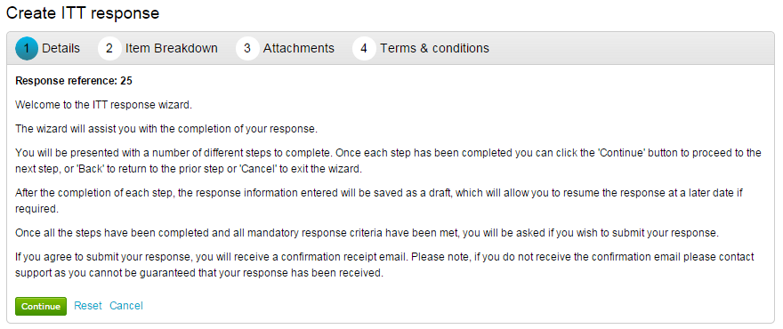
From the options section at the bottom of the page click Continue to move onto the next page or click Cancel to leave the wizard.

Submitting The Tender Response

When all information is added you can submit the response by clicking Submit response. You will be required to reconfirm this by clicking Submit response for a second time.

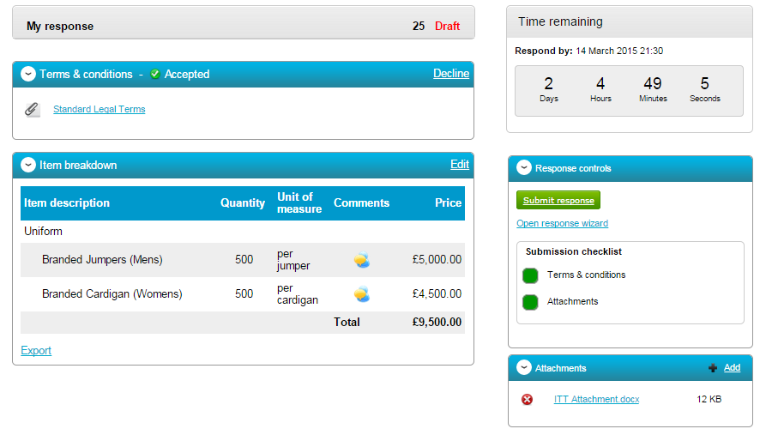

If the Submit resonse button is greyed out, the Submission checklist can be used to pick out why (anything with a red box will need revisiting.)

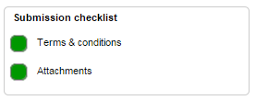

Editing Tender Response and Re-Submission

An important feature that is available after the tender response has been submitted is the ability as a Supplier to edit this response before the submission time and date has passed.

All the procuring organisation will see, is the version number of the response, but no previous submissions, providing they are all returned on time (further information on this later).

To edit a response from the tender summary screen, click Create new version.

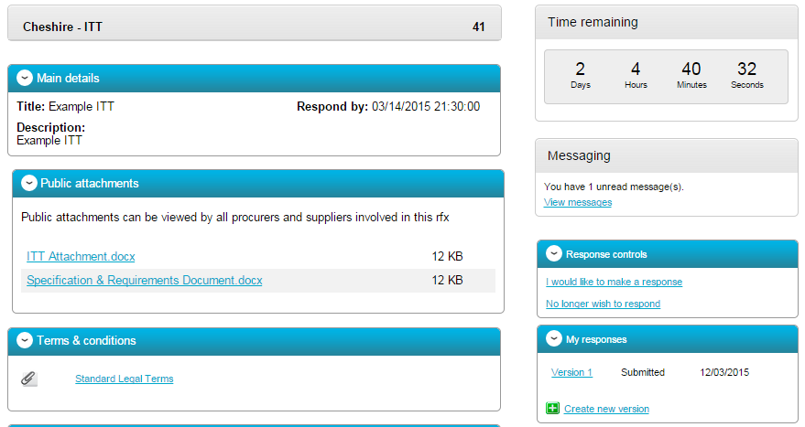

When this is clicked it will create a draft Version 2.

Each area can then be amended, either by editing the relevant section or clicking Open response wizard, and then submitted using the process oulined above.

