'Torch-Free' Zones

Warrington Museum
Bold Street, WARRINGTON
WA1 1DR, England

Project Reference: B194051/1

Patrick Walton
Area Technical Manager
07841 500354
p.walton@bauder.co.uk

At the time of the survey the roof area(s) were reviewed for the principles of 'Safe2Torch'.
The application of torch-on materials to or in the vicinity of combustible deck materials does not conform to the recommendations of BS8217:2005, clause 7.3.2.1, paragraph 3, or the advice given in the ‘Safe2Torch’ document produced by the National Federation of Roofing Contractors. When encountering an area which contains combustible material a minimum 900mm deep zone of the flat area around the material and any detail flashing to the material itself there is a requirement for 'Torch-Free' detailing. In these instances an appropriate alternative Bauder self-adhesive membrane should be used as described in: 'Torch-Free' & 'Safe to Torch' zones - ALTERNATIVE MEMBRANES AND APPLICATION. The 'Safe to Torch' zone detailing and method of application will be described in the Additional Items section and the 'Torch-Free' & 'Safe to Torch' zones section of the Bauder specification and further shown in the Bauder 'Torch-Free' & Bauder Bituminous detail drawings. It is recommended that anyone preparing a specification should follow the ‘Safe2Torch’ guidance to avoid the use of a direct torch-on application in these areas. This report should be read in conjunction with the Bauder Specification.
Bauder has identified the following as 'Torch-Free' zones:
Roof 1, Roof 2, Roof 3, Roof 4, Roof 5, Roof 6
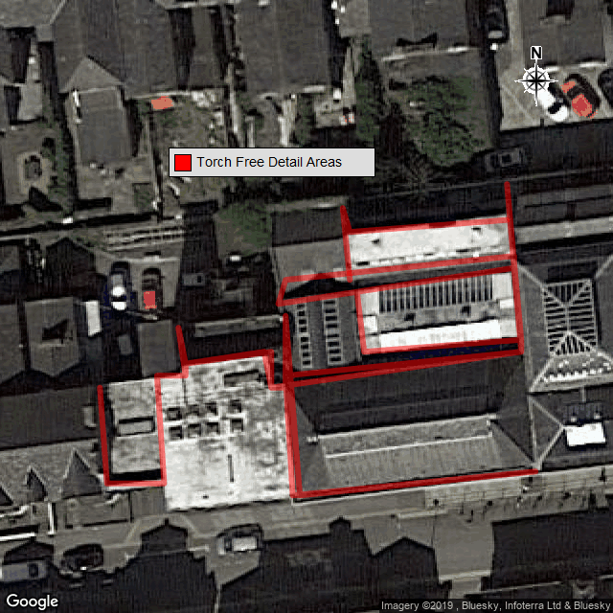
Any measurements displayed on the map above are approximated and are therefore not to be used in tenders.
- Detail under all abutments to roof tiles, slates and thatch.
- All abutments with open cavities (open perpends).
- Change in level details with fixed timber/plastic fascia and/or soffits, gutters or restricted spaces.
- Window sills and frames, door sills, louvered vents, air ducts, intakes and outtakes.
- Junctions to existing waterproofing with flammable insulation/deck materials.
- Vulnerable plastic kerbs, domes, pipes and the like.

