QUOTATION REQUEST FOR REFURBISHMENT OF THE SPLASH PARK PUMP ROOM AT STOKES BAY.
Gosport Borough Council invites quotations to supply equipment and undertake works to the water supply and cleansing system at the Splash Park, Stokes Bay – Gosport.
The works are to be completed by 21st April 2023
GENERAL CONSIDERATIONS
The Supplier must take the physical constraints of the works locations into account when submitting their quotation.
Materials
All materials are to be supplied by the Supplier and should conform to applicable British Standards or equivalent.
The Supplier shall be responsible for calculating required quantities.
The Supplier will specify the materials to be used within their returned quotation. The specified materials will be installed as specified by the manufacturer or industry good practice to produce the required outcomes.
Site Safety
Ensure all Health and Safety requirements are in place to protect the general public for the duration of the works Including site and task specific risk assessment and method statements for undertaking of the works.

The Government regulations and guidance on COVID-19 are to be adhered to – Details for specific work sites / locations can be found on the Governments website at https://www.gov.uk/guidance/working-safely-during-coronavirus-covid-19
All operatives must be provided with and use / wear appropriate Personal Protective Equipment (PPE) All PPE shall be to relevant British Standard or equivalent. All operatives shall wear safety footwear and Hi-Visibility waistcoat or jacket of the appropriate class at all times for the duration of working on site
Documents
The Supplier shall provide evidence of Public Liability Insurance with minimum cover of £10 million along with £5 million employers liability insurance, appropriate industry accreditation for these works, such as SPATA, CIPHE, IoS or PWTAG along with a valid waste carriers licence with details for the disposal of the waste generated by these works or a valid trade waste agreement.

DETAIL OF REQUIRED WORKS
Site information
Stokes Bay Splash Park, Pebble Beach Car Park, Stokes Bay Road, Gosport PO12 2BL.
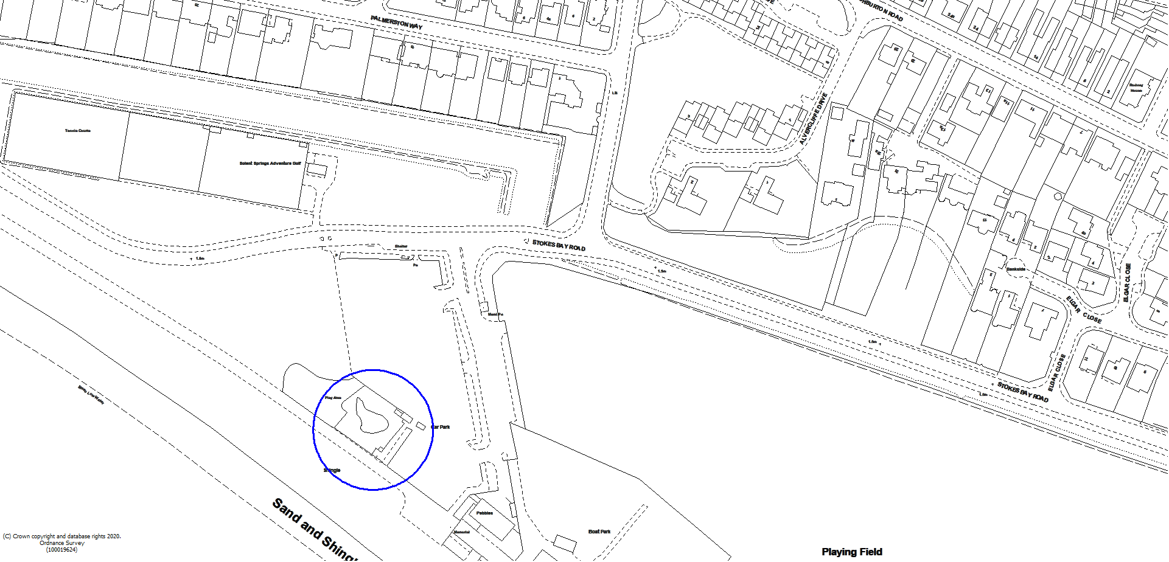
Location plan – the blue outline shows the location of the splash Park.

Requirements
- Remove and dispose of the existing sand filter (please see photograph 1 in Appendix A).
- Install two new deep bed filters.
- Reconfigure the existing pipework to accommodate the deep bed filters ensuring the flow rate is not compromised in the process. (Please see photograph 2 in Appendix A showing the current pipework configuration).
- Modify the drain off point on the main balance tank to facilitate drain down during decommissioning.
- Empty and clean out the balance tank.
- Repair or replace the fibreglass access panel to balance tank.
- Drill and re-tap bolt holes.
- Supply new drain bungs to block the drains for overwintering.
- Replace valves and solenoids that control flow to splash park features (please see photograph 3 in Appendix A - note the photograph does not show all of the valves)
- Inspect all metal parts on the system for wear and rust and de-rust or replace as necessary.
- Ensure system functions correctly following works – if system does not function correctly undertake any remedial works necessary to get the system functioning correctly.
- Leave plant room and surrounds in a clean, tidy and safe condition.
- Remove and dispose of all waste generated by these works.
Whilst undertaking these works, should any further works be identified the supplier should make the client aware so that they may be considered to be carried out to ensure efficiency and value for money.
Quotations are to be submitted by 12:00 hrs Friday 3rd March 2023.
Evaluation
These works will be awarded on best value price, provided the quotation closely matches the materials and works cover all of the required works detailed above and the documentation listed below is submitted as part of the quotation.
Documentation checklist below.
Document
Public Liability Insurance Certificate
Employers Liability Insurance Certificate
Waste Carriers Licence
Waste disposal agreement (if applicable)
Industry accreditation

Award
The award decision will be notified via the Proactis portal after the deadline for responses has passed and quotes have been evaluated.
GBC reserve the right to decline to make an award for all or only part of the service requirements, or to abandon or cancel the procurement process. GBC will not be responsible for any costs or expenses incurred as a result of following this course of action.
Any costs incurred by the service provider in responding to this ITQ or in support of activities associated with the response to this ITQ are to be borne by the service provider and are not reimbursable by GBC.

A site visit to provide an opportunity to assist the quotation process will take place on the 21st February 2023 at 11.00 at Stokes Bay Splash Park, please confirm your attendance via Proactis before this date.

QUOTATION PROCESS & TIMETABLE
Timetable
Quotation Request Issued | w/c 6th February 2023
Deadline for site visit booking | 11.00 20th February 2023
Site Visit | 11:00 21st February 2023
Quote submission Deadline | 12:00 pm 3rd March 2023
Award notification | w/c 6th March 2023

Any questions must be submitted by messaging through the Proactis South East Business Portal to provide an overview of the system and the specific pump requirements.
Please return quotes through the South East Business Portal, also known as Proactis, and break the quote down to show cost of materials and labour, this must be your full and final price.

