Coalville Christmas Lights – Inventory as at April 2022 (including location map)

Stock and installation information

Product / Specification | Condition overview | Visual | Qty | Location
Decoration Type Pole Mount  Decoration Design Paide  Age 1 year (2021)  Length 250 cm  Width 95 cm | No. Type Style % working rope % working string Last used Currently usable Comments  1 Pole Mount Paide 100% 100% 2021 Yes New in 2021  2 Pole Mount Paide 100% 100% 2021 Yes New in 2021  3 Pole Mount Paide 100% 100% 2021 Yes New in 2021  4 Pole Mount Paide 100% 100% 2021 Yes New in 2021 | 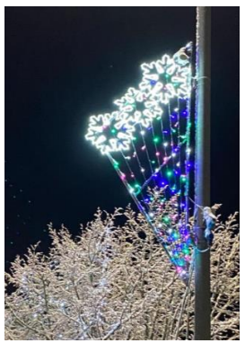 | 4 | Memorial Square
Decoration Type Pole Mount  Decoration Design Salute  Age 1 year (2021)  Length 200 cm  Width 110 cm | No. Type Style % working rope % working string Last used Currently usable Comments  1 Pole Mount Salute 100% 100% 2021 Yes New in 2021  2 Pole Mount Salute 100% 100% 2021 Yes New in 2021  3 Pole Mount Salute 100% 100% 2021 Yes New in 2021  4 Pole Mount Salute 100% 100% 2021 Yes New in 2021 | 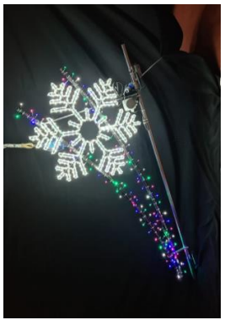 | 4 | Memorial Square
Decoration Type Pole Mount  Decoration Design Kaunas  Age 1 year (2021)  Length 300 cm  Width 120 cm | No. Type Style % working rope % working string Last used Currently usable Comments  1 Pole Mount Kaunas 100% 100% 2021 Yes New in 2021  2 Pole Mount Kaunas 100% 100% 2021 Yes New in 2021  3 Pole Mount Kaunas 100% 100% 2021 Yes New in 2021 | 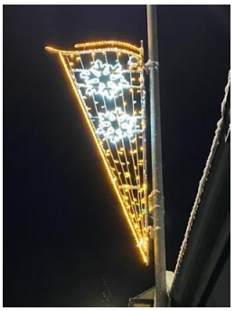 | 3 | Marlborough Square
Decoration Type Pole Mount  Decoration Design Orge  Age 1 year (2021)  Length 260 cm  Width 135 cm | No. Type Style % working rope % working string Last used Currently usable Comments  1 Pole Mount Ogre 100% 100% 2021 Yes New in 2021  2 Pole Mount Ogre 100% 100% 2021 Yes New in 2021  3 Pole Mount Ogre 100% 100% 2021 Yes New in 2021 | 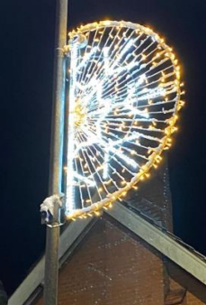 | 3 | Marlborough Square

Product / Specification | Condition overview | Visual | Qty | Location
Decoration Type Pole Mount  Decoration Design Paide  Age 0+  Length 250 cm  Width 95 cm | No. Type Style % working rope % working string Last used Currently usable Comments  1 Pole Mount Paide 100% 100% n/a Yes New for 2022  2 Pole Mount Paide 100% 100% n/a Yes New for 2022  3 Pole Mount Paide 100% 100% n/a Yes New for 2022  4 Pole Mount Paide 100% 100% n/a Yes New for 2022  5 Pole Mount Paide 100% 100% n/a Yes New for 2022  6 Pole Mount Paide 100% 100% n/a Yes New for 2022 | 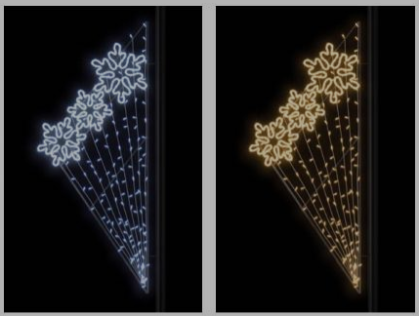  Bright white snowflakes and warm white lights | 6 | Ashby Road / Belvoir Road / Jackson Street
Decoration Type Pole Mount  Decoration Design Salute  Age 0+  Length 200 cm  Width 110 cm | No. Type Style % working rope % working string Last used Currently usable Comments  1 Pole Mount Salute 100% 100% n/a Yes New for 2022  2 Pole Mount Salute 100% 100% n/a Yes New for 2022  3 Pole Mount Salute 100% 100% n/a Yes New for 2022  4 Pole Mount Salute 100% 100% n/a Yes New for 2022  5 Pole Mount Salute 100% 100% n/a Yes New for 2022  6 Pole Mount Salute 100% 100% n/a Yes New for 2022 | 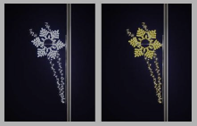  Bright white snowflakes and warm white lights | 6 | Ashby Road / Belvoir Road / Jackson Street

Product / Specification | Condition overview | Visual | Qty | Location
Decoration Type Clock Tower wall mount  Decoration Design Top piece 4 snowflakes  Age 1 year (2021)  Length 300 cm  Width 120 cm | No. Type Style % working rope % working string Last used Currently usable Comments  1 Wall mount Snowflake – clock tower top panel 100% 100% 2021 Yes New for 2021  2 Wall mount Snowflake – clock tower top panel 100% 100% 2021 Yes New for 2021  3 Wall mount Snowflake – clock tower top panel 100% 100% 2021 Yes New for 2021  4 Wall mount Snowflake – clock tower top panel 100% 100% 2021 Yes New for 2021 | 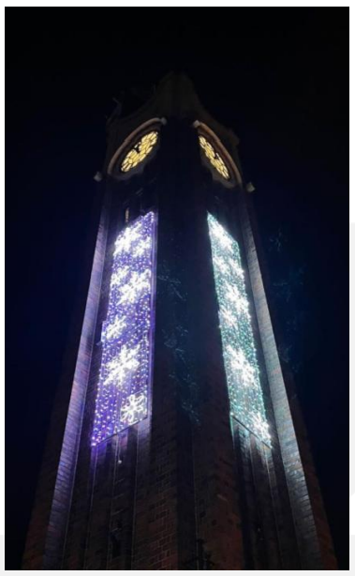  Upper section only | 4 | Memorial Square – Clock Tower
Decoration Type Clock Tower wall mount  Decoration Design Bottom piece 3 snowflakes  Age 1 year (2021)  Length 300 cm  Width 120 cm | No. Type Style % working rope % working string Last used Currently usable Comments  1 Wall mount Snowflake – clock tower bottom panel 100% 100% 2021 Yes New for 2021  2 Wall mount Snowflake – clock tower bottom panel 100% 100% 2021 Yes New for 2021  3 Wall mount Snowflake – clock tower bottom panel 100% 100% 2021 Yes New for 2021  4 Wall mount Snowflake – clock tower bottom panel 100% 100% 2021 Yes New for 2021 | Lower section only | 4 | Memorial Square – Clock Tower

Product / Specification | Condition overview | Visual | Qty | Location
Decoration Type Pole Mount  Decoration Design Blue & White Stars  Age 6+  Weight 11.81kg  Length 243 cm  Width at top 102 cm  Width at bottom 61 cm  Width at widest point 102 cm | No. Type Style % working rope % working string Last used Currently usable Comments  1 Pole Mount Blue & White Stars 100% n/a 2021 Yes Old product (6+ years)  7 Pole Mount Blue & White Stars 100% n/a 2021 Yes Old product (6+ years) | 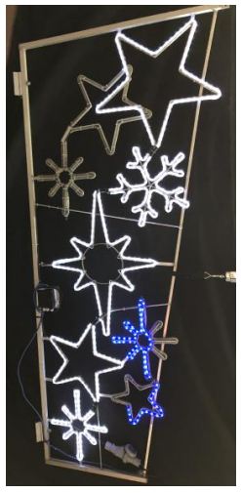 | 2 | Hotel Street

Product / Specification | Condition overview | Visual | Qty | Location
Decoration Type Pole Mount  Decoration Design Red & White Stars  Age 7+  Weight 11.81kg  Length 243 cm  Width at top 102 cm  Width at bottom 61 cm  Width at widest point 102 cm | No. Type Style % working rope % working string Last used Currently usable Comments  2 Pole Mount Red & White Stars 100% n/a 2021 Yes Old product (7+ years) *90% working – full replacement of rope light required  3 Pole Mount Red & White Stars 100% n/a 2021 Yes Old product (7+ years)  4 Pole Mount Red & White Stars 100% n/a 2021 Yes Old product (7+ years)  6 Pole Mount Red & White Stars 100% n/a 2021 Yes Old product (7+ years) | 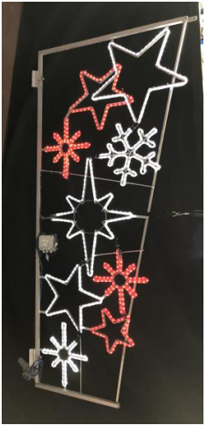 | 4 | Hotel Street

Festoon and pealights on various trees, High Street and Memorial Square, Coalville
Location | Decoration  Type | Decoration Style | Length | Percentage Working | Last Used (In year) | Age (Years) | Currently usable | Comments
High St (Miner Statute) | Tree | Festoon | 60m | 85% | 2021 | 7+ | Yes
High St (opp. Holmes and Son) | Tree | Festoon | 50m | 90% | 2021 | 6+ | Yes | Original replaced with product off Old Market Hall
High St (opp. Argos) | Tree | Pealights | 55m | 100% | 2021 | 4+ | Yes
High St (behind the bus stop) | Tree | Pealights | 40m | 100% | 2021 | 4+ | Yes
High St (opp. Tandoori) | Tree | Pealights | 60m | 90% | 2021 | 7+ | Yes | 10% out on 5 out of 6no. 10m strings
High St (opp. Turkish Rest) | Tree (x2) | Festoon | 50m | 100% | 2021 | 2+ | Yes
High Street (in front of library opp. Elite Gaming) | Tree | Festoon | 50m | 100% | 2021 | 2+ | Yes
High Street (corner of library) | Tree | Festoon | 50m | 100% | 2021 | 2+ | Yes
Memorial Square | Tree 18 | Pealights | 30m | 100% | 2021 | 3+ | Yes
Memorial Square | Tree 19 | Pealights | 35m | 100% | 2021 | 3+ | Yes
Memorial Square | Tree 20 | Pealights | 30m | 100% | 2021 | 3+ | Yes
Memorial Square | Tree 21 | Pealights | 45m | 100% | 2021 | 3+ | Yes
Memorial Square | Tree 22 | Pealights | 20m | 100% | 2021 | 3+ | Yes
Memorial Square | Tree 24 | Pealights | 30m | 100% | 2021 | 3+ | Yes | Corroding pin – risk of becoming faulty

Large Christmas Trees – Memorial Square and Marlborough Square

- Memorial Square – new product ordered in 2022 (from 2021 – 2022 budget)
- Marlborough Square – new product required for 2022 (funded from 2022 – 2023 budget)

Type of product | Location | Length / number of bulbs | Percentage working | Age | Comments
Festive lights for large Christmas tree (full colour) | Memorial Square | 3600 no.  LEDS | 100% | 0+ | New in 2022 (ordered March 2022)
Festive lights for large Christmas tree (bright and warm) | Marlborough Square | 3600 no. LEDS | 100% | 0+ | New in 2022 (to be ordered)

New pealights (to replace hired stock) – warm white – Various trees on High Street

Type of product | Location | Length | Percentage working | Age | Comments
Pealights (warm white) | High Street Bus Stop Roadside | 40m (tbc) | 100% | 0+ | New in 2022 (to be ordered)
Pealights (warm white | High Street Birch Tree | 55m (tbc) | 100% | 0+ | New in 2022 (to be ordered)
Pealights (warm white | High Street Big Tree Roadside | 35m (tbc) | 100% | 0+ | New in 2022 (to be ordered)
Pealights (warm white | High Street Children’s Sign | 75m (tbc) | 100% | 0+ | New in 2022 (to be ordered)
Pealights (warm white | Various locations on High Street to ensure good illumination on trees | TBC | 100% | 0+ | New in 2022 (to be ordered)

Key
Current stock in 100% working order and suitable for installation in the 2022 Christmas Lights scheme
Product required to complete the 2022 Christmas Lights scheme – costings currently being prepared

Location map – Coalville Town Centre
4 of each design (8)
Pole mount designs

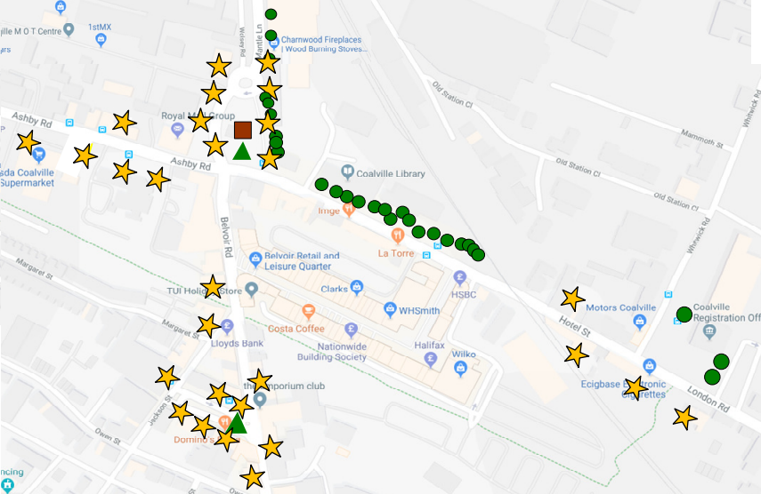
3 of each design (6)

Bright white snowflakes and warm white lights*
mixture of each design (10)
*New for 2022

X
X
X
2 of each design (4)

 | 2x 9 metre Christmas Trees  - Multi coloured lights  - Warm and bright white lights |  | Numerous trees on Memorial Square (bright white lights)
 | 28 x pole mount decorations |  | Clock tower – 8x wall mounted panels
 | Numerous trees along High Street (warm and bright white lights | X | *Removed from 2022 scheme (due to building works)  *introduce a new scheme in this area in 2023

