PIN Additional Information
Together with Parents (Supporting Parents to Build Resilience and Self-Help Strategies)
- The new service will offer robust and consistent support to parents and carers whose child has either received a diagnosis, awaiting diagnosis, or considering a referral to the Neurodevelopmental (ND) Pathway. The scope of the new service aims to offer a range of options, facilitated with lived experience, that can be delivered in addition to services currently on offer across the County.

- The scope of the new service aims to address the need for more neurodevelopmental related early intervention, pre-diagnosis and self-help support for parents alongside the evidence-based Programmes, such as Cygnet. The expectation will be to work closely with partners across the county to ensure a wraparound offer is delivered in addition to services currently on offer. All delivered with Parent -Facilitators at the heart.
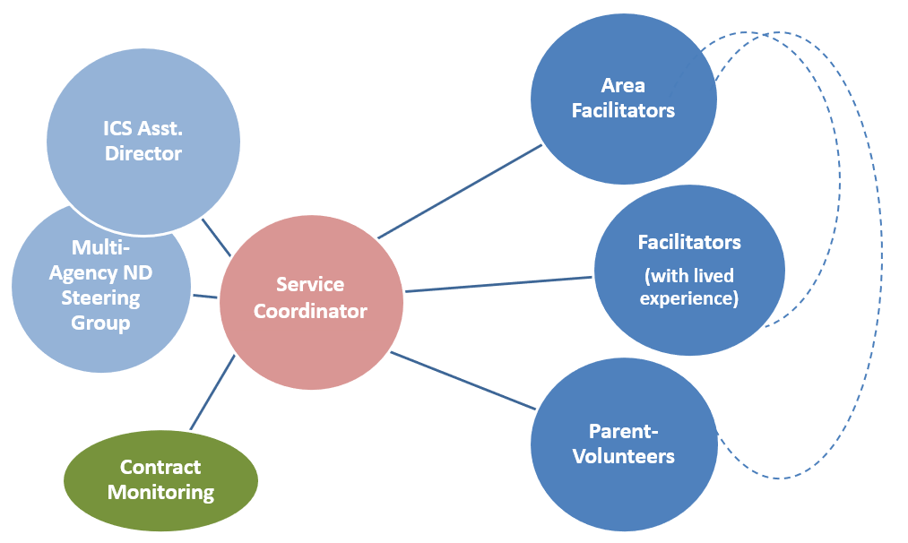
- The model will be delivered in two phases:
Phase One - Provision will focus on supporting all those parents and carers of children and young people currently on the Neurodevelopmental Pathway in receipt of an Integrated Children’s Service intervention (either Social Care or Early Help).
Phase Two - will extend eligibility to all families that are either on the Neurodevelopmental Pathway or are being considered for a referral onto the pathway.

- It is proposed the service will be delivered in two Lots:
Lot 1 – North & West Kent, (Dartford, Gravesham, Sevenoaks, Swale, Maidstone, Tonbridge & Malling and Tunbridge Wells)
Lot 2 – South & East Kent, (Ashford, Canterbury, Dover, Folkestone & Hythe, Thanet)

- The service will deliver the following offer countywide (blend of face to face and virtual):
- 1:1 Support Sessions with parents and carers.
- Workshops focusing on key shared family issues, e.g., sleep.
- Self-help parent/carer Peer Support Groups.
- Evidence-based programmes (Cygnet)
- Signposting to supporting materials such as videos, books, etc.

- The service will be facilitated by Area Facilitators, Facilitators (with lived experience) and Parent-Volunteers, placing lived experience at the heart of all activity, building resilience and developing self-help strategies amongst fellow parents. A Service Co-ordinator will oversee the countywide delivery of the service and will sit within KCC Integrated Children Services, ensuring a direct reporting line and oversight of the Countywide service.

Estimated total value: financial envelope of up to £1,200,000 over 3 +1 years (£400k in Years 1 to 3 with option to extend for a further year)
Lot 1 – North & West Kent Estimated Percentage = 55%
Lot 2 – South & East Kent Estimated Percentage = 45%

