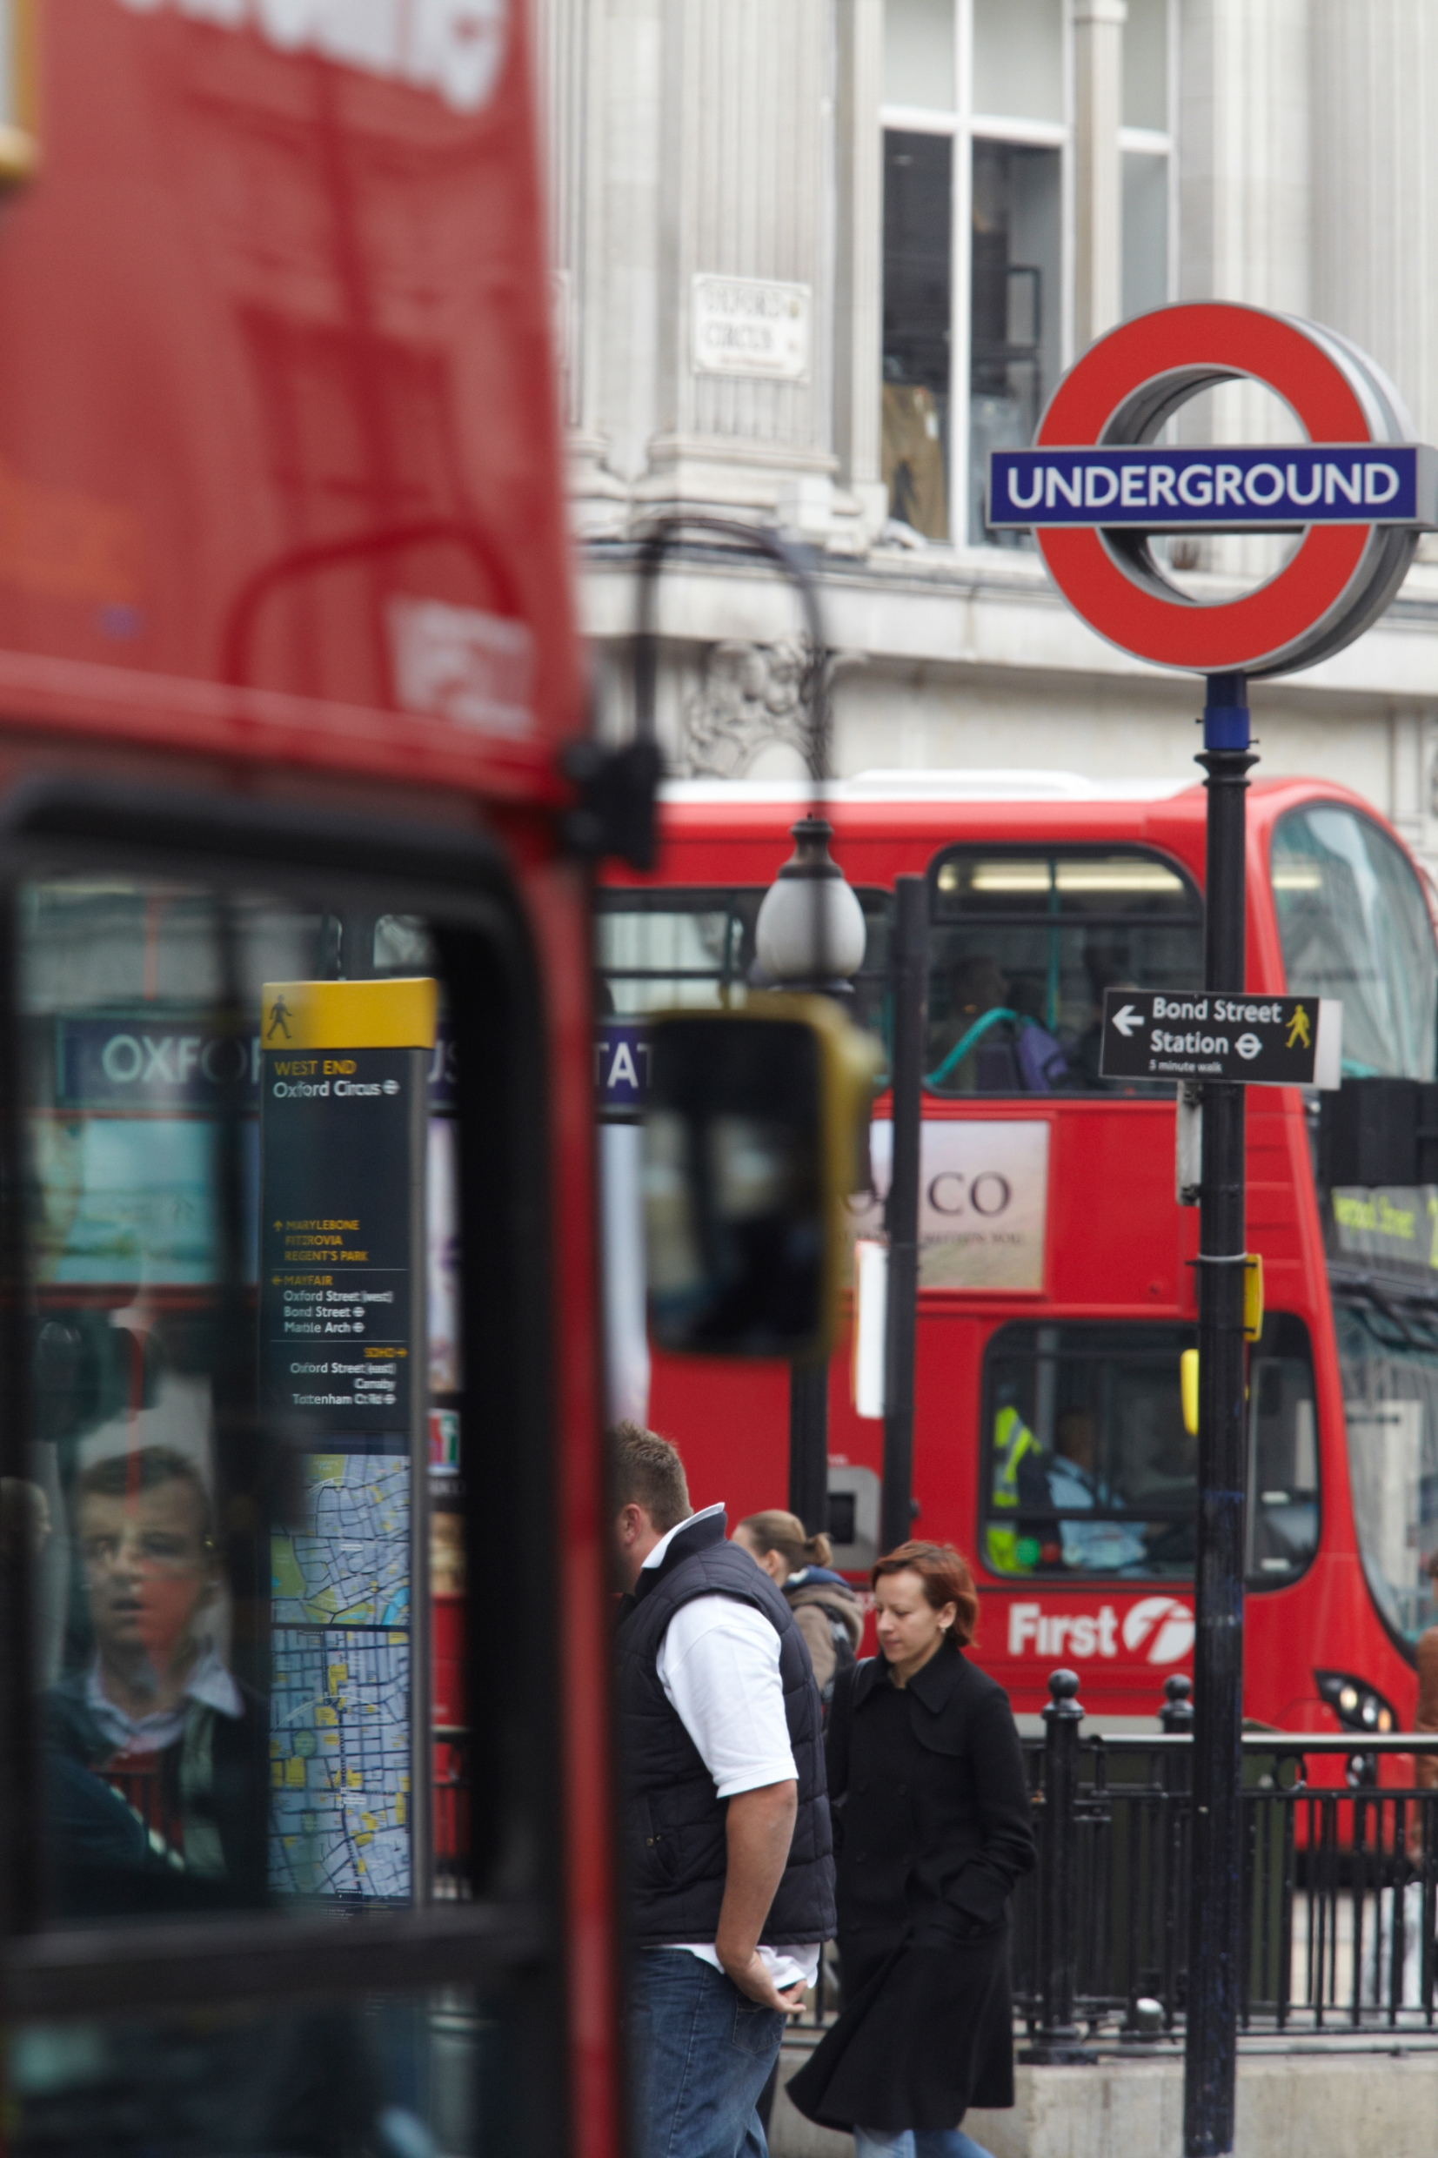
Market Sounding Questionnaire
Forklift Trucks, MEWPs & Battery Powered Pallet Trucks
- Introduction
This Market Sounding Questionnaire (MSQ) is issued by Transport for London (TfL) and seeks to obtain market feedback in relation to the procurement of the below, for forklift trucks (FLTs), Mobile Elevated Working Platforms (MEWPs) and battery powered pallet trucks:

- Maintenance services for the machinery which we own
- Supply of machinery for purchase
- Supply of machinery for hire

The primary focus is to better understand market/supplier appetite, capacity and capability, as well as perceived risks and opportunities.

Transport for London is part of the Greater London Authority family led by Mayor of London. We are the integrated transport authority responsible for delivering the Mayor’s aims for transport.
TfL runs most of London’s public transport services, including the London Underground, TfL Rail (pre-cursor to Crossrail), and London Trams. To support the operation of the many railway lines requires an intensive maintenance effort. Maintenance takes place at depots across the network. Forklift and battery powered pallet trucks are a key part of the maintenance process, transporting heavy train parts going through overhaul, and receiving deliveries. MEWPs are used for safe working at height.

Additional company information about Transport for London can be found by following the below links:
Annual Report 18/19: https://www.tfl.gov.uk/corporate/publications-and-reports/annual-report
Mayor’s Transport Strategy: https://www.london.gov.uk/what-we-do/transport/our-vision-transport/2020-vision
Business Plan: http://content.tfl.gov.uk/tfl-business-plan-december-2017-.pdf
Further information on how we work: https://tfl.gov.uk/corporate/about-tfl/how-we-work?intcmp=2668
- Feedback Request
Feedback is requested in relation to the proposal described within this document. Your feedback is important as it will allow views from the market to inform the development and finalisation of the procurement strategy.
TfL would greatly appreciate your feedback in the form of a response to the questionnaire in Section 4. Please submit your responses via TfL’s e-procurement portal ProContract.
Responses will be treated confidentially in accordance with the Mutual Company Confidentiality Agreement (MCCA) signed between TfL and your company. Following analysis, a summary report will be issued to participants of the market engagement giving an overview of the general themes and findings, but no participant will be mentioned by name in the report.
For your feedback to be considered, your completed MSQ must be received by 5pm on 26 June 2020.
- Proposals for Consideration and Feedback
Short description of the nature and scope of services
- Maintenance:

TfL currently owns 152 vehicles in this category. We intend to run a competition for the maintenance work on these assets. This includes servicing (planned preventative maintenance) and remedial work for faults such as punctures, fork damage or battery replacement.

There is a diverse range of manufacturers, model and type of vehicle. Some examples are below:

Manufacturers:

- Bendi
- BT Cargo
- Yale
- Toyota
- Linde
- Caterpillar
- Flexi
- Jungheinrich

- Lansing Henley
- Manitou
- Takeuchi
- JCB
- Toyota
- Hyster
- Aislemaster

Types of Vehicle:

- Forklift Trucks (x63)
- MEWPs (x30)
- Battery Powered Pallet Trucks
- Scrubber Cleaner
- Pedestrian Stackers
- Scissor Lifts
- Cleaner Vehicle
- Upright Stacker
- Boom Lifts

- Purchasing and Hiring

TfL currently hires 38 forklift trucks. Procurement has compared costs and considers it cost-inefficient, in many cases, for the consistent requirements which we have. We intend to set up a 5-year framework during which time, vehicles will be competitively purchased.

In addition to these large purchases, TfL will also purchase MEWPs, battery powered pallet trucks, stackers, scissor lifts, boom lifts and other miscellaneous pieces of equipment.

A number of vehicles will continue to be hired. Through this framework future hire arrangements will be processed. Short-term hire arrangements will also arise on an ad-hoc basis.

- Questionnaire
As part of this market sounding exercise, TfL wishes to seek your views on the extent of your capabilities and appetite for providing maintenance, sales and hiring services described in Section 3.
The feedback from this questionnaire will help inform decisions on the final procurement strategy.
TfL would appreciate your feedback in the form of a response to the following questionnaire, with the specific questions to be answered in the blank tables/boxes provided. Should you consider a particular question is not applicable to your organisation, please state “not applicable” in the tables/boxes provided.

Forklifts, Battery Powered Pallet Trucks & MEWPs – Market Sounding Questionnaire
Please complete:
Organisation Name
Company Registration Number
Key Contact Name
Email Address
Telephone Number
This exercise does not form part of any formal procurement process. All responses will be carefully considered but will not bind TfL to any approach to the procurement, nor will responses be treated as conveying any promise or commitment on the part of the respondent.

Interest and capability
- a) Please specify which of the following services you are interested in providing:
Services required | Capability(Y/N) | Comments
Maintenance of our fleet of forklift trucks and battery powered battery powered pallet trucks:
- Regular servicing / planned preventative maintenance.
- Resolution of faults which occur such as punctures or battery failure.

Maintenance of our fleet of MEWPs:
- Regular servicing / planned preventative maintenance.
- Resolution of unforeseen faults which occur.

Sale and some hiring of forklifts, battery powered pallet trucks, MEWPs:
- Participation in the earlier described framework for purchasing vehicles.
- Most often will be pre-owned or refurbished vehicles in terms of forklifts, but battery powered pallet trucks, MEWPs and others may be purchased new.
- Long and short-term hire

What is your opinion on the below contract arrangement? Would your organisation find this suitable or would an alternate arrangement be preferable? If not, please suggest a preferable arrangement.
- TfL are considering letting these works as a framework divided into lots. Two lots for maintenance and one lot for supply of vehicles for purchase and hire.
- Maintenance for forklifts and battery powered pallet trucks will be awarded to one supplier, and another lot for MEWPs (same supplier could be successful).
- The third lot would contain more then one supplier so that when vehicles are required for purchase and hire mini-competitions can be run.

b) If you are not interested in delivering any of these services, please explain your reasons below (e.g. risk of services, complexity of services etc.).

- Have you provided similar services in the past? Yes/No? If yes, please provide very brief details below.

Q3. Would you intend to subcontract any elements of the requirements mentioned?

Q4. Are you able to comply / already compliant with FORS Bronze, Silver or Gold(for further guidance please familiarise yourself with WRRR (Work Related Road Risk)? If applicable, does your firm comply with Direct Vision Standard (DVS) requirements?

Legal
Q5. TfL has minimum legal requirements which it wishes to reflect in its relationship with any service provider. TfL believes these requirements are market standard and reasonable but would like to gauge whether the following requirements are acceptable in principle:
Requirements | Acceptable: Yes/No | Additional Comments
Restrictions and notification requirements regarding sub-contracting and change of ownership
Regular conflict of interest checks to be performed by service provider
Maintenance and retention of records regarding contractual activities by service provider, right of access for TfL to audit records at any time
Maintenance by service provider of:
- employer’s liability and motor insurance cover as required by law and insurance cover in the sum of not less than £5 million per claim;
- TfL’s interest noted on each and every policy or that any public liability, product liability or employer’s liability insurance includes an Indemnity to Principal clause;
- public liability insurance to cover injury and loss to third parties;
- insurance to cover the loss or damage to any item related to the services;
- product liability insurance; and
- professional indemnity insurance or, where professional indemnity insurance is not available, a “financial loss” extension to the public liability insurance
Compliance by service provider with data protection legislation (including GDPR) and National Cyber Security Centre’s 10 Steps to Cyber Security
Compliance by service provider with all laws (including Bribery Act 2010, Modern Slavery Act 2015, Freedom of Information Act 2000 and Equality Act 2010)
TfL right to terminate immediately for service provider’s
- persistent or material breach;
- insolvency;
- change of ownership where not notified;
- failure to properly sub-contract services, including failure to obtain TfL’s prior written consent to sub-contracting;
- failure to satisfy TfL on any conflict of interest issue;
- committal of money laundering offences;
- committal of bribery offences;
- failure to comply with legal obligations in the fields of environmental, social or labour law
Service provider to provide assistance at no further cost to TfL with handover of services following expiry or termination
Service provider to assist in the preparation and performance of a cessation plan in the event of a declaration of ineffectiveness by the courts or where TfL terminates under its termination rights under the Public Contracts Regulations 2015
Service provider to ensure computer systems used in the supply of the services:
- do not have their functionality or performance affected, or be made inoperable or be more difficult to use by reason of any date related input or processing in or on any part of such software, electronic or magnetic media, hardware or computer system;
- not cause any damage, loss or erosion to or interfere adversely or in any way with the compilation, content or structure of any data, database, software or other electronic or magnetic media, hardware or computer system used by, for or on behalf of the either or both of TfL or any other member of the TfL Group, on which it is used or with which it interfaces or comes into contact;
- comply with the Government’s open standards principles as documented at https://www.gov.uk/government/publications/open-standards-principles/open-standards-principles#open-standards-principles;
- be capable of supporting the Euro as a currency/dual currency (Sterling and Euro).

Indicative Procurement Programme (tentative, may be modified slightly)
What comments or observations do you have on the following proposed procurement timeline:
Market Sounding
Issue PIN and Market Sounding Questionnaire Jun 2020
Receive market feedback Jun 2020
Incorporate feedback into documents and process July 2020
Internal Governance July / Aug 2020

Invitation to Tender (ITT)
Issue ITT Aug / Sep 2020
Tender Returns & Evaluation Autumn 2020
Negotiations Period Autumn 2020 / Winter 2021
Final governance and award Autumn 2020 / Winter 2021

Contract start Winter 2021 / Spring 2021

Q6. Is this programme realistic? Yes / No. If No, then please explain why and what TfL could do to deliver this requirement on time.

Q7. TfL is proposing a 5-year contract term with the option of a 1-year plus 1-year extension, what comments or observations do you have on this proposed contract term?

Constraints (inc Risks), Interfaces and Opportunities
Q8. What does your organisation consider to be the top risks (up to 3 in order of criticality) to the successful delivery of these services? What mitigating action do you think can be taken by TfL and/or suppliers?
Rank | Risk and description (up to 3) | Mitigation | Who is best placed to manage this Risk (TfL or Supplier... etc)
1
2
3
Q9. What other innovations / alternative products / solutions not included in the lists above you think TfL might be interested in/should consider for the procurement?

Q10. From your experience, and review of this document what technology and innovation can you recommend to TfL to enable further cost saving and improvement of processes?
Other
Q11. Would you be prepared to follow up this market engagement questionnaire with further engagement activity, for example through a 1-2-1 engagement session? Yes/No?

Q12. Do you have any other comments regarding the proposals set out in this market engagement questionnaire?

We would like to thank you for taking the time to respond to this questionnaire.

TfL Commercial

