Cycling event delivery including skills and training, bike maintenance and group rides along the Tyne Derwent Way.

Gateshead Riverside Partnership

INVITATION TO QUOTE FOR

PERIOD: July 2024 – September 2024

QUOTATION DETAILS

Contract Name: Cycling event delivery including skills and training, bike maintenance and group rides along the Tyne Derwent Way.

Portal Reference Number:

PROCUREMENT TIMETABLE
Event | Date
Issue of Invitation to Quote | 26/03/2024
Deadline for receipt of Quotes | 19/04/2024
Contract Award Date | 01/05/2024
Contract Start Date | 01/05/2024

This timetable is indicative only. The Council reserves the right to change it at its discretion.

SPECIFICATION

Introduction
The Tyne Derwent Way is a 9-mile green corridor running from St Mary’s Heritage Centre to Gibside, National Trust, along cycle route 14. It will launch publicly on 11th April.
The project is being delivered by Gateshead Riverside Partnership:
- Gateshead Council (lead partner)
- National Trust
- Tyne and Wear Building Preservation Trust
- Newcastle University
- Northumbria University
The partnership has secured funding from UK SPF, including funding to deliver a range of cycling activities during 2024. We are looking for a supplier who can plan and deliver these activities.
The Tyne Derwent Way route:
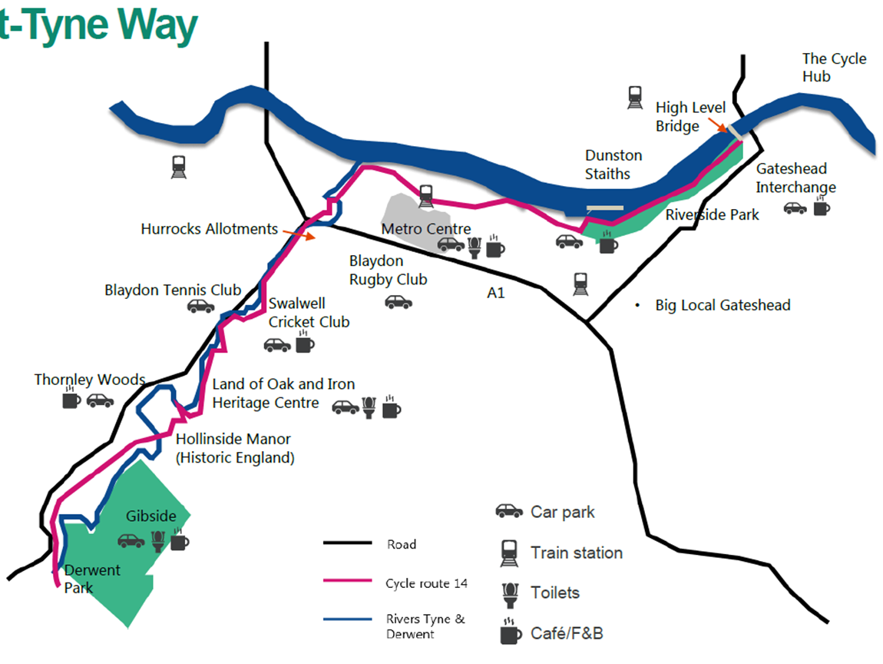
Cycling events
We would like to appoint a supplier who can run seven cycle events at different locations along the Tyne Derwent Way (a map of the Tyne Derwent Way is attached for reference) on seven different days throughout the summer holidays. Each of the seven events should include:
- Bike maintenance classes teaching bike maintenance skills
- Dr Bike/ similar bike maintenance session offering a bike ‘MOT’
- A group cycle along some or all of the Tyne Derwent Way
- Lessons for children to learn to ride at about a Bikeability Level 1
- A fleet of bikes appropriate for these activities
- A booking system for these events

The events would take place at locations that could be decided upon with the appointed supplier, but could include the following locations:

- Rose Street Hub, where Big Local Gateshead meet – by Eslington Primary School
- Community centre sports halls along the Tyne Derwent Way
- Swalwell Visitor’s Centre car park
- Land of Oak and Iron – somewhere around the heritage centre, perhaps the car park or the overflow car park
- St Mary’s heritage centre car park.
We would like these to take place weekly throughout the summer holidays (19th July 2024 – 2nd September 2024). We would like at least one of these events to include provision for Disabled people to join the activities including the group cycle and the learn to ride lesson, with appropriate bikes in the fleet provided.

All of these sessions should be accessible to neurodivergent participants and cater to their access needs.

Purpose
The purpose of these events is to provide cycling opportunities for local communities along the Tyne Derwent Way, and to improve use and knowledge of the Tyne Derwent Way as an active cycle route. We also want to test different locations along The Way for cycling, with the potential of -creating a cycle hub in future.
Audience
The primary audience for this activity will be local residents, with a different focus for the different elements of provision:
- Families with small children for the learn to ride lessons
- Families with older children for the group cycles
- All including adults for the bike maintenance classes and Dr Bike
We do not require any delivery of Bikeability training, but the supplier must have an awareness of Bikeabilty training up to level 3.
Cycle activities must be fully planned to suit the needs of the group and offer participants the opportunity to explore the Tyne Derwent Way area by bike to allow them to develop an understanding of travel by bike. We do not expect rides to require transport to another location. The group cycles will be publicly advertised and promoted through our stakeholders. The details of the ride should be cemented once it is clear who has signed up and what their capabilities are.
The supplier must be able to
- Provide appropriately qualified and experience staff to plan and deliver cycle skills and training
- Supply bikes in a range of ages to ensure lack of access to a bike is not a barrier to participation
- Evidence of experience in delivering a similar type of activities.
- Ensure all sessions are inclusive to meet the groups needs and requirements, with at least one event delivered with special attention to Disabled cyclists.
Community engagement
As part of the Tyne Derwent Way delivery, we require support to deliver community engagement events to collate feedback from participants about the support they feel is needed to cycle more.
The supplier will be required to engage with project participants effectively and collect qualitative feedback on cycling.
We are also working with Teams Wheelers, a cycle group that runs from Big Local Gateshead in Teams. The supplier will be asked to meet with this group to engage with them about the cycle events and whether one could take place on their premises, with members of the group taking part.
Bike maintenance
Lack of understanding of basic bike maintenance and repair has been identified as a barrier to cycling. We therefore require the supplier to be able to deliver bike maintenance activities in a wide range of settings to provide basic repairs to bikes and advice to participants on how to keep active by bike.
The supplier will be required to:
- book events using provided contact details – booking will be for the Learn to Ride events and the group cycles.
- provide suitably qualified staff and evidence of experience of planning and delivering similar activities at a range of settings
- monitor all events using pre agreed data collection (including participant counts, user surveys and feedback collection)
We welcome any effort by the supplier to utilise low carbon transport when delivering these activities.
Delivery Requirements
The provider must be able to
- Undertake all bookings and liaison including obtaining consent where required; the Gateshead Riverside Partnership will provide key contacts to support activity booking
- Plan activities which fulfil the requirements of the brief
- Monitor activities and provide reports as per agreed timescales
- Provide suitably skilled and qualified staff to deliver the activities. Evidence of qualifications and experience should be included in the response to this brief
- Offer an alternative activity in the event of poor weather where a session may be cancelled (e.g. a puncture repair session or the learn to ride session in a sports hall)
- Begin delivery from July 2024
- Provide bikes and helmets for participants to ensure that all participants can participate regardless of whether they own a bike
- Transport any equipment to/from/between activities
- Agree to undertake all provided monitoring and evaluation, details to be supplied upon award of work
- Have an awareness of National Standard Bikeability training
We will support the appointed supplier to engage appropriate sites for activities, including provision of contacts and introductory meetings.
Monitoring
The provider will be required to collect monitoring and evaluation data throughout delivery, including but not limited to;
Number of sessions delivered
Number of participants
Participant information
Pre and post activity questionnaires.
The supplier will be required to ensure any data collected at an activity is entered on to the relevant system (Microsoft forms, Excel or other survey tool). Full details will be provided upon award. The monitoring of this and associated projects is still being finalised and will be shared with the supplier upon award of contract.
Budget and outputs
A maximum budget of £9,000 is available for this project. A project plan to define the outputs will be developed with the appointed supplier.
For the purpose of responding to this request, please provide a quote based on the scenario below. The total cost for the scenario will be used for scoring. Please use the table provided to itemise the cost breakdown.
A programme of activity comprising of the following activities:
- 7 cycle events each lasting a day. We would like these events to be distributed evenly throughout the Gateshead school holidays, which are: 19 July - 2 Sept 2024. These could be split into half day sessions if that was organisationally better.

EVALUATION CRITERIA AND METHODOLOGY

Evaluation Criteria

Quality  The Council will evaluate quotations to determine the quality of the bids with relation to: | 80% Overall Weighting
- Providers are required to submit their proposed Methodology for delivering the requirements of the contract as detailed in the Specification  - Responses to this question should be no longer than 500 words.  Please provide details within Section A below | 40% weighting
- Providers must provide details of their experience of delivering services similar in nature to those required under this contract, i.e. delivery of cycle activities with children and adults  - Responses to this question should be no longer than 500 words.  - Please provide details within Section B below | 40% weighting
Price  The Council will evaluate Quotes as to financial acceptability including:  - Providers must complete the provided table detailing costs for the scenario provided.  All prices shall be stated in pounds sterling and exclusive of VAT.  Providers must also indicate all other costs that will be associated with the contract e.g. rates, expenses etc. No claim for additional payment will be considered for items that have not been specified.  Providers are required to hold your pricing structure for the term of the contract. | 20% weighting
An evaluation panel made up of the Tyne Derwent Way team and Gateshead Council Officers will carry out the evaluation of Quotes in accordance with the criteria set out above.

The Council, as lead partner does not undertake to accept the lowest or any Quote and reserves the right to accept the whole or any part of any Quote submitted.

The Council reserves the right to seek clarification from any supplier during the evaluation period. This may be in writing or by means of a clarification meeting. This is to help the Council in its consideration of their Quotes.

The Council will not be liable for any additional charges that were omitted from the Quote.

Evaluation Methodology

Evaluation Methodology:
SCORE | CLASSIFICATION | DEFINITION
0 | Unacceptable Response | Failed to answer the question or is unable to meet any of the requirements of the question or the response is entirely without merit having regard to the requirements of the question and Specification.
2 | Poor response | Poor response which addresses only a limited number of requirements of the question or addresses the requirements of the question but with little merit having regard to the requirements of the question and Specification (for example, containing insufficient detail and/or containing inconsistencies).
5 | Fair response | Response addresses the requirements of the question but lacks details on how the requirements will be fulfilled and/or contains minor inconsistencies or addresses most of the requirements of the question and specification well but with some omissions.
8 | Good response | Response addresses the requirements of the question and Specification providing robust details of how the requirement is to be met with any omissions being of a minor nature. It is sufficiently detailed and demonstrates a good understanding of and ability to deliver the requirements of the question.
10 | Excellent response | The response addresses all the requirements of the question and Specification and demonstrates a thorough understanding of the requirements of the question. It provides clear and comprehensive details of how the requirements will be met in full.

PASS / FAIL | PASS / FAIL | PASS = Yes, meets requirements/confirms compliance  FAIL = No, does not meet requirements/does not confirm compliance etc
Price | The total cost will be evaluated by taking the lowest price submitted, dividing it by your total tendered price and then multiplying it by the weighting;  =(Lowest price/Tendered price) * Weighting

Terms and Conditions

The Council is bound by procurement rules, including the Public Contracts Regulations 2015 and internal Contract Procedure Rules and cannot enter into any negotiations on the Quote or the Contract. In submitting a Quote, a supplier is agreeing to the Council’s terms and conditions (attached as a separate document) to this ITQ. Any amendments to the Council’s terms and conditions or alternative terms and conditions to the Council’s terms and conditions submitted by a supplier shall not be acceptable or considered by the Council. To the extent that any part of a Quote is inconsistent with the Council’s terms and conditions then the terms and conditions shall prevail.

Any resulting Contract will consist of:

- The Invitation to Quote; and
- The Standard Terms and Conditions for Services (attached as a separate document)
- The successful Quote documentation

The Contract will be subject to English law and the exclusive jurisdiction of the English Courts.

RESPONSE TO INVITATION TO QUOTE

To be completed and submitted by Provider

Project Name: Cycling event delivery including skills and training, bike maintenance and group rides along the Tyne Derwent Way.

Date:

Reference Number:
From: Name of Provider

Address of Provider

Proposal – Section A - Methodology

Providers to submit specific details that are required in the response:

Proposal – Section B - Experience

Providers to submit specific details that are required in the response:

Proposal – Section C - Timescales

Providers to submit specific details that are required in the response:

Price Proposal

Please provide the total cost for the scenario provided

Cost breakdown
Activity | Cost
7 cycle events consisting of:
A bike maintenance class
Dr Bike/ similar
A group cycle along some or all of the Tyne Derwent Way
Lessons for children to learn to ride at about a Bikeability Level 1 level
A fleet of bikes appropriate for these activities
A booking system for these events

Please state settlement terms
Please provide details of any additional discount for early payment of invoices
Please confirm you agree to the 12-month fixed price period
Please confirm that no minimum order value will be applied

FORM OF QUOTE

Dear Sir/Madam

Quote for the Contract for Cycling event delivery including skills and training, bike maintenance and group rides along the Tyne Derwent Way.

I/We the undersigned, Quote and offer to provide the Contract as listed below which is more particularly referred to in the Invitation to Quote supplied to me/us for the purpose of Quoting for the provision of the Contract and upon the terms of the Contract.

Attached to this Form of Quote are the following:
- My/our response to the Quote
- The completed Pricing Schedule
- Any other documents necessary for return with the Quote

I/We confirm that I/We can supply the Contract as specified in the Invitation to Quote at a cost as detailed in the Pricing Schedule

I/We confirm that:
- We accept the Contract as issued with the Invitation to Quote
- In the event of acceptance of our Quote to execute the Contract [within 15 business days of acceptance (or otherwise agreed by the Council), and in the interim, provide the Contract in accordance with the Contract
- The information supplied to you forming part of this Quote is true and accurate in all respects.
- This Quote will remain valid for 90 days from the date of this Form of Quote.

I/We confirm and undertake that if any such information becomes untrue or misleading that I/We shall notify you immediately and update such information as needed.

I/We confirm that I/We are authorised to commit the supplier to the Contractual obligations contained in the Invitation to Quote and the Contract.

I/We understand that the Council reserves the right to accept or refuse this Quote whether it is the lower, the same, or higher than any other Quote.

Signed By
Name(s)
Position
For and on Behalf of | [Insert Organisation Name]
Name(s)
Position
For and on Behalf of | [Insert Organisation Name]

