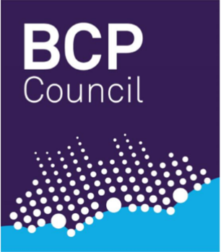

Dear Provider
We are holding a Market Engagement Event for a contract that we will be tendering for the Provision of a Befriending and Mentoring Service to Carers.
Volunteer Befriending will be provided to unpaid family carers of vulnerable or disabled people, alongside a Mentoring scheme using experienced ex-carers as guides for people new to caring. The contract will cover carers of people living in the Bournemouth, Christchurch and Poole conurbation.
The aim of the contract is to enable carers to connect with their local community, reduce social isolation, to signpost new carers to information and advice that will be useful to them, to understand some of the challenges they may encounter and how they might manage them.
The event will be held on:
Wednesday 5th June 2019 from 14:00 until 16:00.
Venue: Kinson Community Centre, Pelhams Park, Millhams Road, Kinson, Bournemouth, BH10 7LH.
Booking: If your organisation would like to find out more about this contract, we hope you are able to join us. To book a place or for further information please call Debbie Hyde on 01202 458714 or email deborah.hyde3@bcpcouncil.gov.uk. Booking is essential and will end on 31st May 2019
Registration and coffee/tea on arrival at 14:00.

