Responding as a supplier
Purpose:
This document will guide you through responding as a supplier to a tender opportunity. It is not intended for use by suppliers.

Cornwall Council is introducing an electronic Tendering and Contract Management System; tender documents and supplier responses are to be submitted electronically. The new system will host its own advertising portal which will sit on the Supplying the South West website.

Suppliers have been encouraged to register free at: www.supplyingthesouthwest.org.uk to receive notifications of new Cornwall Council contract opportunities. Suppliers already registered on Supplying the Southwest do not need to do anything further. Any suppliers previously registered on Tenders in Cornwall will not automatically be migrated onto the new system.
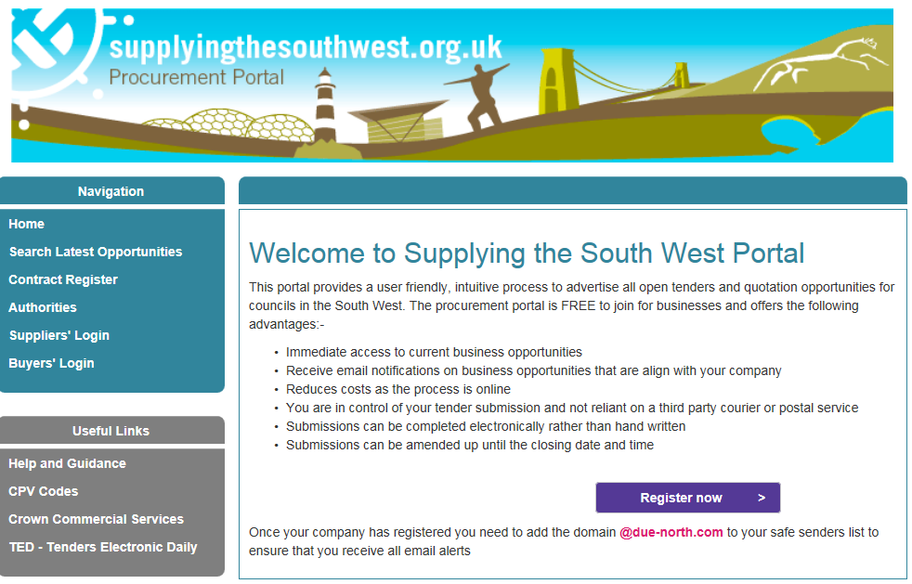

Once registered, the supplier must log into the Due North system using their own supplier user id, password and memorable information.

Finding Opportunities and Registering Interest
A supplier registering at the procurement portal specifies which regions of the UK (and Europe) their company can supply and which Common Procurement Vocabulary (CPV) advertising codes are important for their company. Once specified, these regions and CPV codes ensure the supplier is notified about new projects they might want to respond to. The supplier can also find opportunities in the Opportunities panel on their Home page and register interest.

To search for opportunities and register interest:
Step | Action
Log into Due North as a supplier. You will need to put your User name and password into the relevant boxes and click the Continue button.
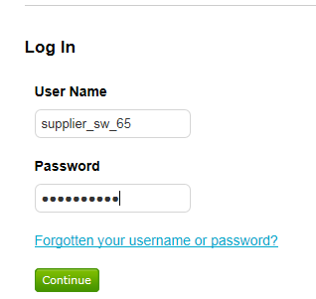

You will be asked for your memorable information. Enter the correct characters into the three boxes provided and click the Log In button.
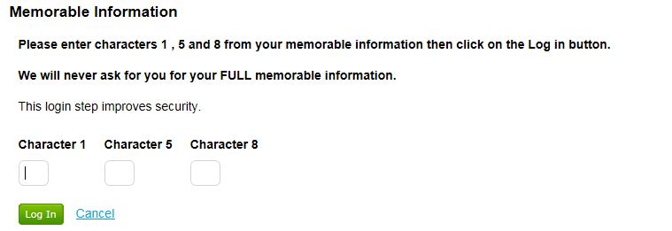

You will be taken to your Home page.
 | 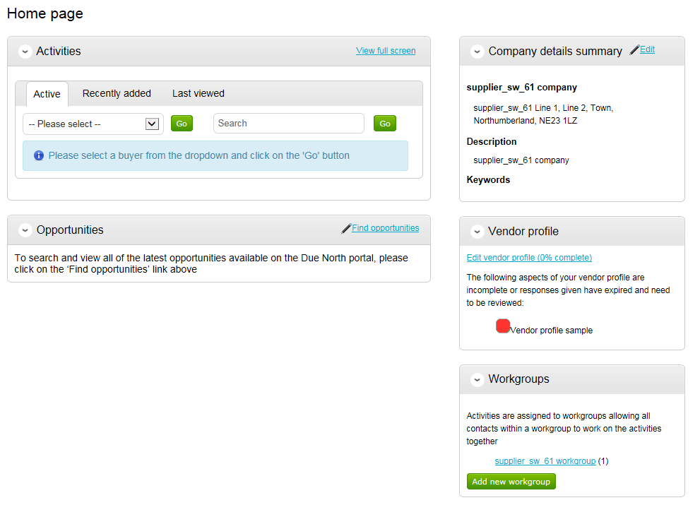
 | Click Find opportunities.
Use the Narrow your results panel at the left.
Click the Portals list box and select Cornwall Council from the list.
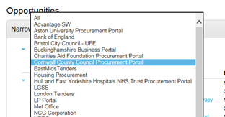
 | Scroll to the bottom of the panel to click Update.
You will be presented with a list of opportunities that match your search criteria.
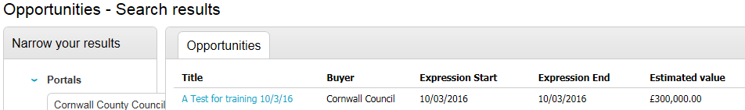

Click a link to a project in the Opportunities list to see the project description, key dates, contact details and attached documents.
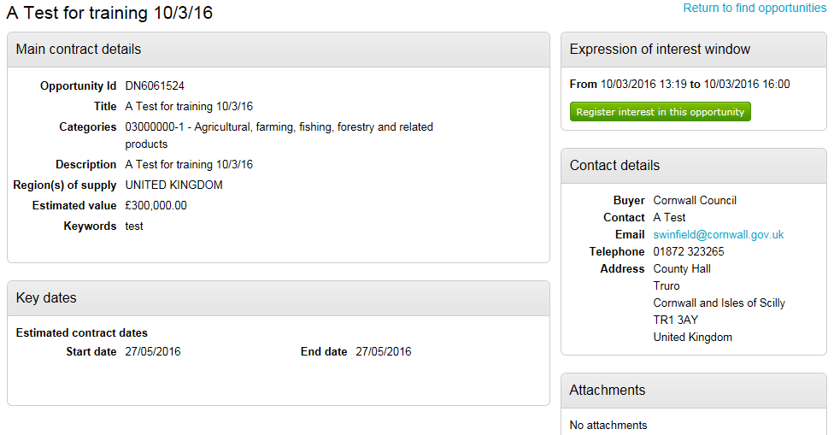
 | Click Register interest in this opportunity.
7. | Click Return to find opportunities to return to the list of projects.
Note: Registering an interest is necessary to enable the supplier access to the quotation/tender opportunity (e.g. the documents). The supplier will then be required to respond to the tender it is interested in.

Responding to a Tender
If the ITT is set to automatically invite suppliers who express interest, the supplier can start their response immediately.
Step | Action
 | Click the My activities menu to search for tenders you can respond to.
Use the Narrow your results by selecting– select Cornwall Council from the pull down menu and click the Go button.
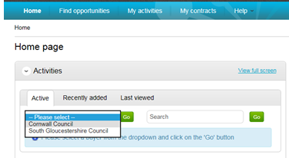
The list of projects is displayed; click a link to open the project.
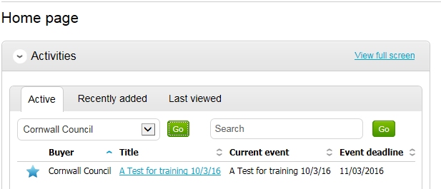
 | Click Start at the right of the project.
This screen displays the time remaining before the response deadline, a collection of documents (for example, specifications and guidance), terms and conditions and evaluation question sets.
There may also be messages.

 | 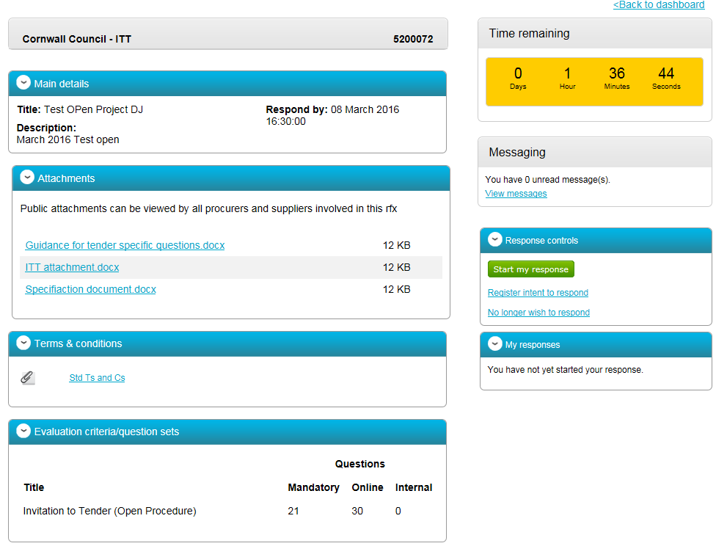
Click Start my response (the button is in the Response controls pane at the right of the window).
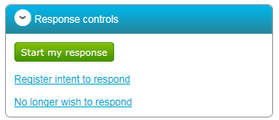
You will be taken through the response using a response wizard which consists of 5 steps.

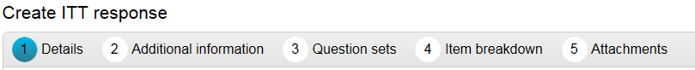
Click Continue after reading the details in Step 1 of the Create ITT response wizard.
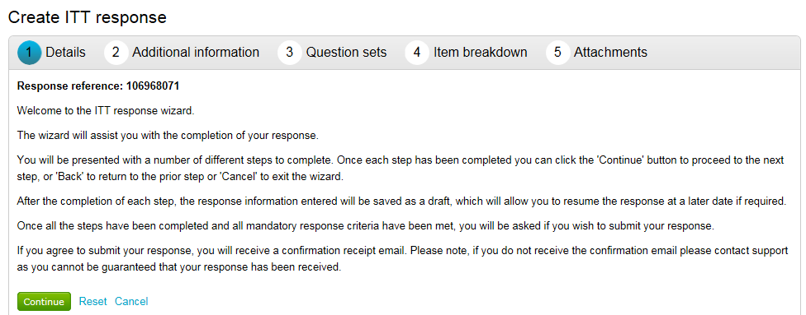
In Step 2, Additional information, enter your supplier reference and any extra information and comments you might want to include. Click the Continue button.
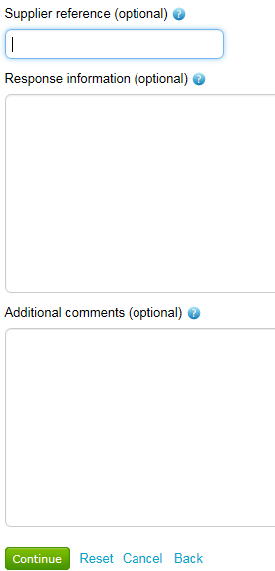

In Step 3, click Edit response link to respond to the ITT questions.
If you have already answered questions in a previous tender exercise the answers your answers may already be populated. 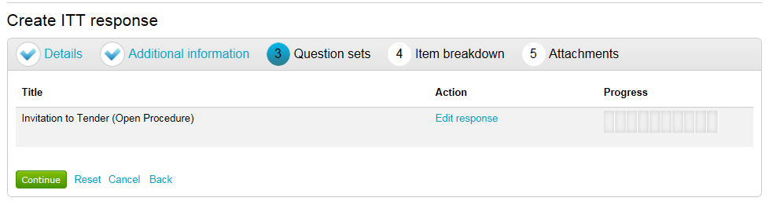
Look at the key to see which questions are fully answered, which need to be reviewed and which need to be answered.
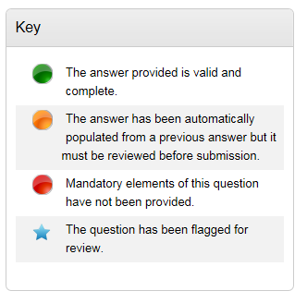
Click Answer question link to respond to each question.

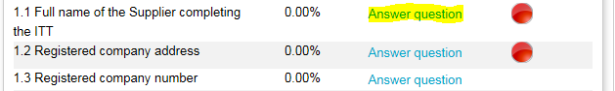

 | When you have entered your response to a question click the Save and close button.
 | 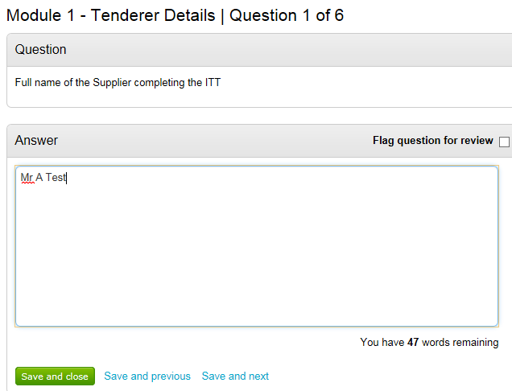
 | You will be taken back to the full list of questions. You will notice the question you have just answered will be marked green indicating you have entered a valid and complete answer.
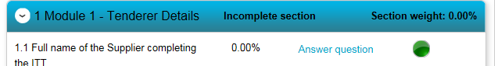

There is a variety of question types. You may need to attach documents, click Yes or No, select from a list or enter text.
Complete all the question so that each question is marked green and the progress bar in the top right of the window is fully green.
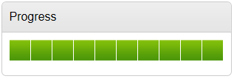
 | Scroll down to the bottom of the page and click Back to return to the wizard after completing the questions.
 | Click Continue.
 | In Step 4. If there is an attached item breakdown click the Export item template button this will open the template the buyer has uploaded in Excel. Complete the item breakdown, save it outside of the system, then click the Upload completed template button.
 | 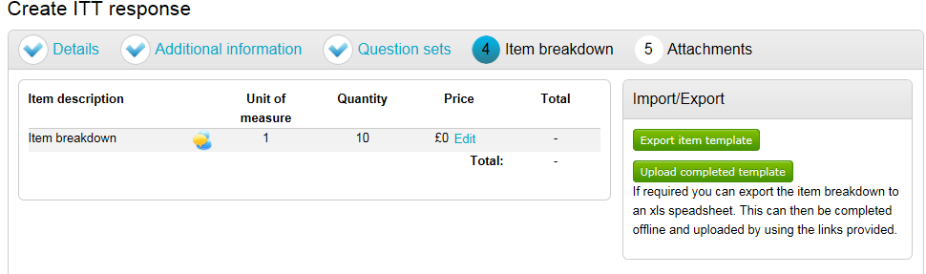
 | Click the Confirm upload button.
 | 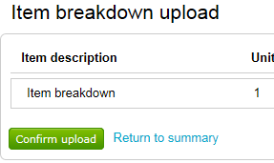
Click Save and continue

Add attachments (see below for details).
 | In Step 5 click the Terms & conditions link to view them, then Accept (or decline) the terms and conditions.
Check the progress on questions is complete, that the terms and conditions have been accepted and click Submit Response.
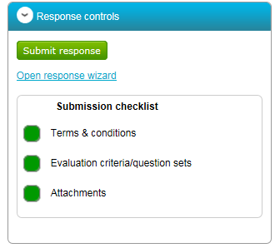
You will be asked to whether you are sure to want to submit your response. Click the Submit response button.
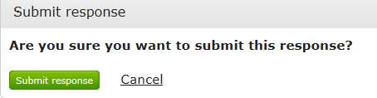
 | You will notice that your response has a status of submitted.
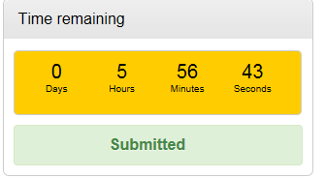

Adding attachments
Step | Action
 | Click Add at the top right of the Attachments pane.
 | 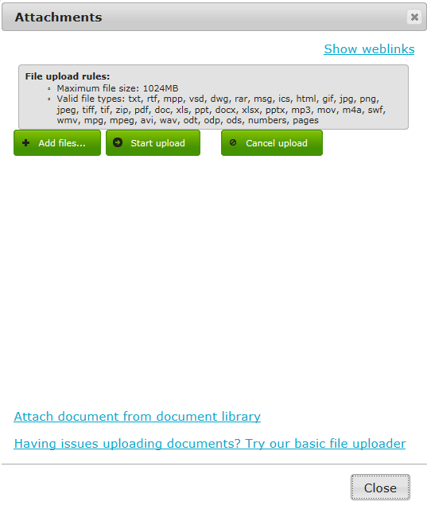
 | Click +Add Files and browse to where your files are located. Double click on your file and then click the Start upload button.
 | A progress bar shows while the documents are uploading.
Note | Valid file types and size limits are detailed at the top of the Attachments dialogue box.
 | The publication checklist displays green square to show attachments have been added.
Note: A supplier is able to edit their response after submitting as long as the close date hasn’t passed. Click the I would like to edit my response link which will open the ITT again. Once the amendments have been made click the Submit response button again. You will notice that you have two versions of the response now.
 | 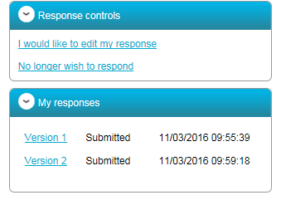
Note: Extensive supplier guidance including video tutorials are available on the South West Portal. There is also a DueNorth Helpdesk facility that suppliers are encouraged to use available 8.30 to 17.30 Monday to Friday (excl public holidays).

