Finding Opportunities, Expressing an Interest (Registering an Interest) and accessing documents

North Tyneside Council issues the majority of its procurement opportunities via the NEPO Portal electronical tendering portal (the Portal). To access any opportunities, register an interest and access the documents to find more information and submit a response follow this guide.

Unregistered suppliers
Go to the website https://procontract.due-north.com/Register to register on the NEPO Portal. Once you have received a Login and Password and followed any instructions provided by NEPO to access the Portal. Go section 1 to access an opportunity you wish to find and access the opportunity documents.
Login Website:- https://procontract.due-north.com/Login?openForm&Login

Registered suppliers
log in to the NEPO Portal using your login and password..
Website:- https://procontract.due-north.com/Login?openForm&Login

If you have received an email notification from the NEPO Portal advising there is an opportunity, select the link in the email and you will be taken direct to the opportunity, Go to section 2 to locate the opportunity documents.

- Finding or searching for opportunities without an email notification from the Portal.
From the home page select ‘Find Opportunities’
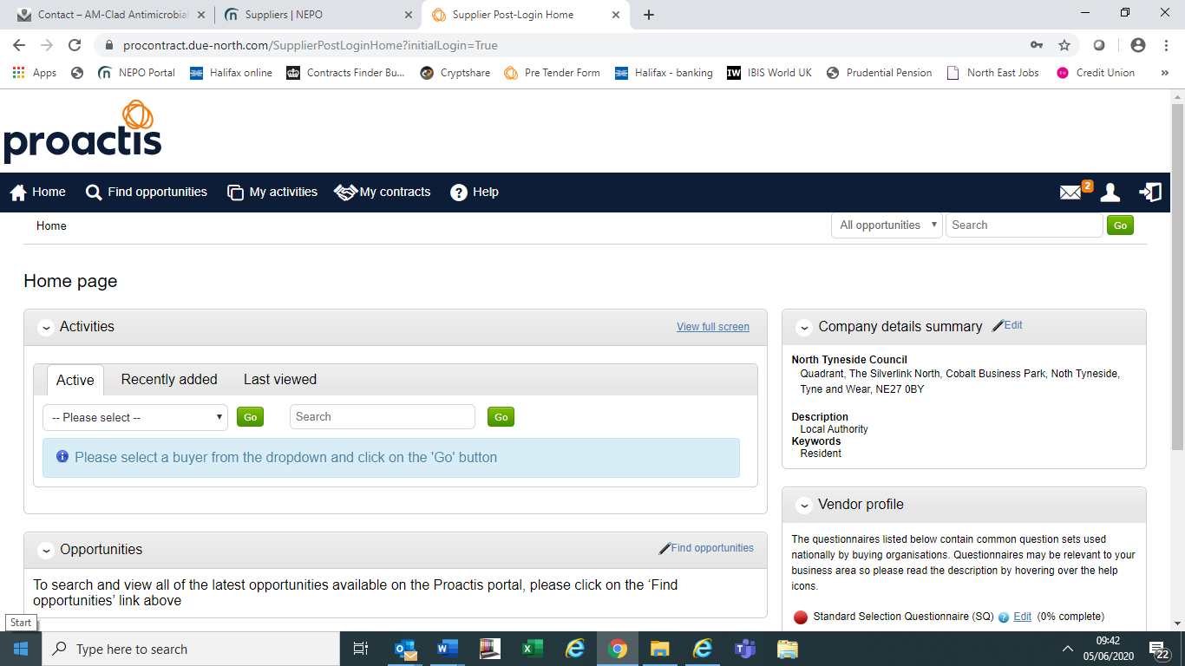

The following screen should open. You can either search the all the Portal Organisations (there are a lot) or filter to the one you would prefer to do business with either via Name/Category (type of services required) etc. as the Portal is a national system and a lot may be suitable to your location/work.
Filter the results by using ‘Narrow Your Results’.
You can filter using any of the fields within this section and or using the free text ‘Search’ Field For this example we have filtered using ‘North Tyneside Council’ as we only offer services within this area and specifically for Construction.
Once you have found an opportunity you are interested in, select the title in blue and underlined and another screen should open.
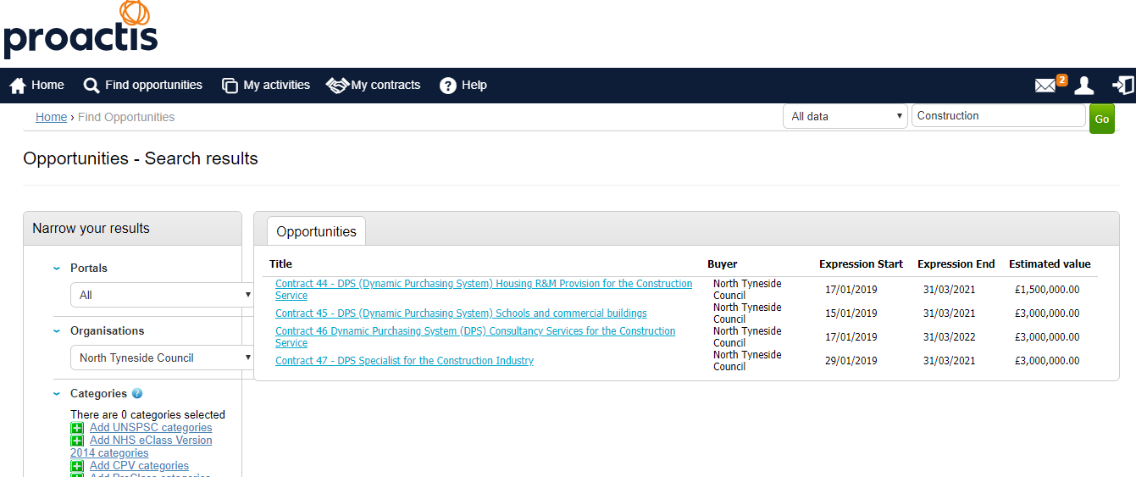

- Registering an interest
Select ‘Register an interest in this opportunity’ once selected screen 2 should appear.
(if you have already done this and did not accesses the documents immediately go straight to section 5).
- Select ‘To view this DPS (or Project/Tender) event now, click ‘here’ once selected screen 3 should appear.

- Scroll to the bottom of the screen to view all documentation and download all document, ensure you read the Instructions and full suite of documents, the Instructions will detail which documents MUST be fully completed and returned in the NEPO Portal as your response.
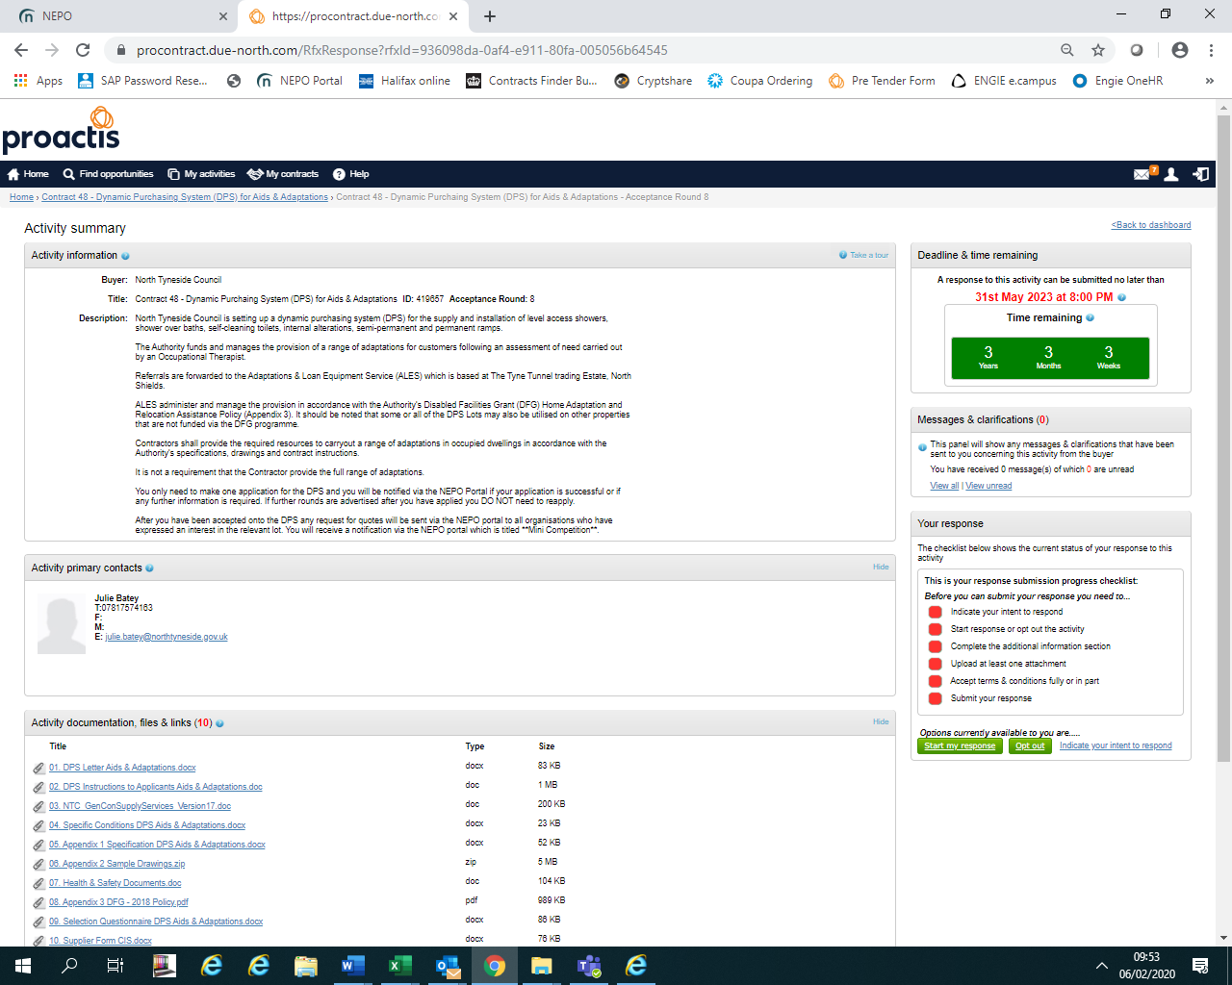

- ACCESSING THE OPPORTUNITY DOCUMENTS
SUPPLIERS WHO HAVE EXPRESSED AN INTEREST ON THE NEPO PORTAL AND DID NOT VIEW DOCUMENTS IMMEDIATELY:
If you log out after registering an interest/expressing an interest in an opportunity and did not select the option identified in section 3, follow these instructions to access the opportunity documents, use the ‘Help’ on the top of the screen if you have any difficulties which includes contact details of NEPO.
Once logged into the NEPO Portal, from the home page select ‘My Activities’. Follow the guidelines further below for further assistance.

- Screen 6a, using ‘Narrow your results’, filter to the Buyer, then select ‘Update’ and there is an option to reduce the list further either by searching using a word with the title and select ‘Go’, e.g. DPS which will reduce the list to ones only containing that word, alternatively, check page by page. Shown in screen 6b.

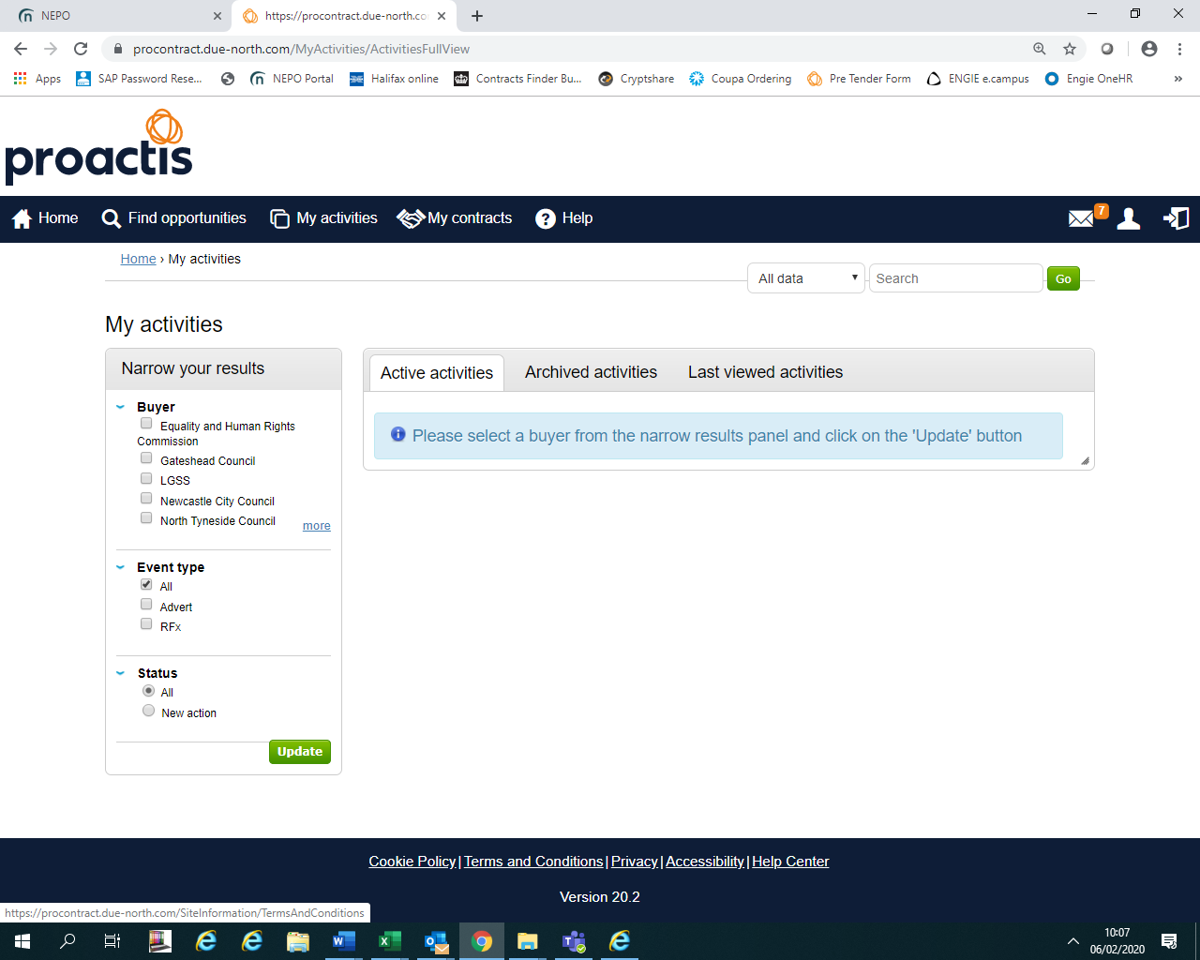
a

Screen 6b shows the list of current activities once NTC and DPS had been selected, you can select the one you wish to view; anything underlined in blue is a link to another page in the Portal.
b

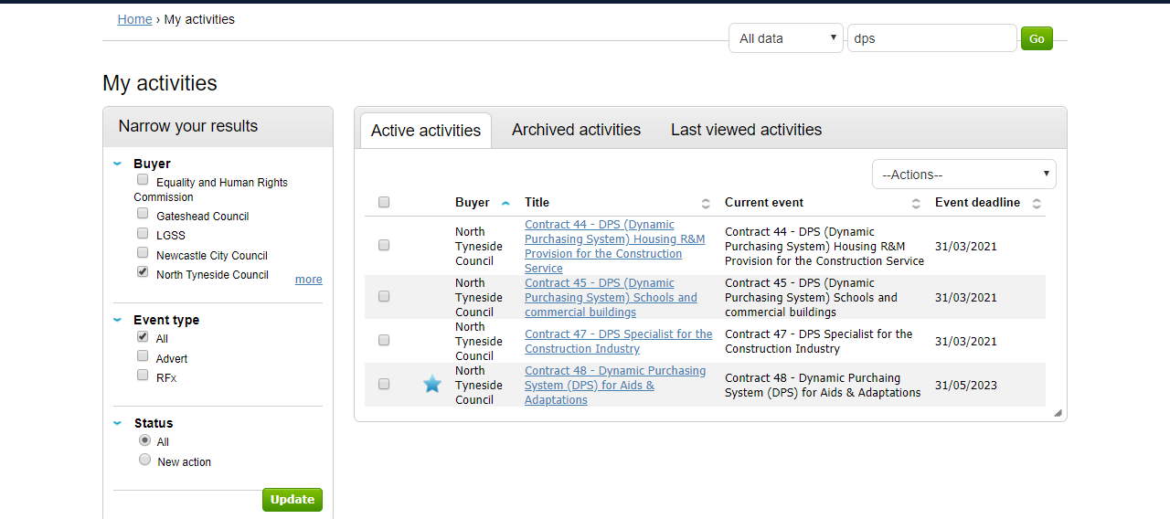

- Once you have selected the link to the opportunity, the following screen should open, select ‘open’.

DOWNLOADING THE DOCUMENTS
The opportunity, containing the deadline date for submissions and the opportunity documents, should open in the next screen, showing the date for the deadline of submissions with a deadline clock, all the documents for fully completing and returning via the Portal are listed at the bottom of the screen.

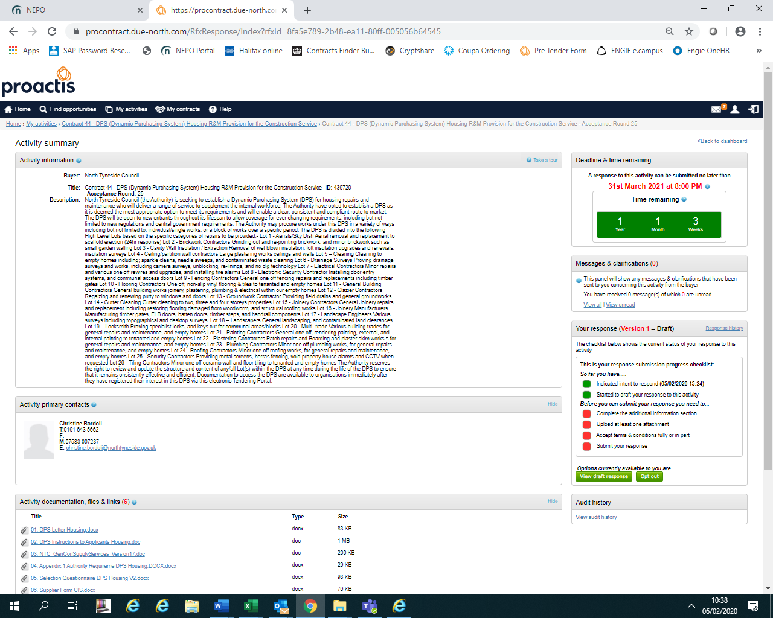

ALL OPPORTUNITIES:

Ensure you read ALL the documentation including the Instructions.
Ensure you upload ALL the required documents FULLY COMPLETED including any supporting documents, BEFORE THE DEADLINE to avoid missing out.
QUERIES - If you have any queries in relation to the opportunity document, not the NEPO Portal. You can ask further information by using the messaging/clarification section, which is similar to sending an email, however, there is an audit trail of all requests and responses and where necessary responses will be made public for all interested bidders to see.
A screen shot identifying where you can locate this section is below:

DPS FRAMEWORKS ONLY
NOTE – FOR DPS Frameworks the deadline date is until the end of the Framework which will be the date shown, therefore, you can apply immediately, the sooner you apply the sooner you could be accepted and receive requests for services/works required.
Rounds are closed when the Authority receives an application, another Round opens automatically, you DO NO NEED TO RE-APPLY in another Round unless we specifically ask you to do so due to an issue with your application.

MESSAGING/CLARIFICATION SECTION (ALL OPPORTUNITIES)
If you need to ask a technical question in relation to the Specification/Scope/Pricing or any of the documents please submit any via the messaging section of the Portal only with in the deadline stated for queries in the Instructions paragraph 1.8.
HELP AND FURTHER ASSITANCE ON USING THE NEPO PORTAL SYSTEM OR ISSUES WITH THE NEPO PORTAL
If you need assistance in relation to the NEPO Portal please use the HELP section, there is also contact details for the administrators of the Portal within this HELP section at the top of the screen.

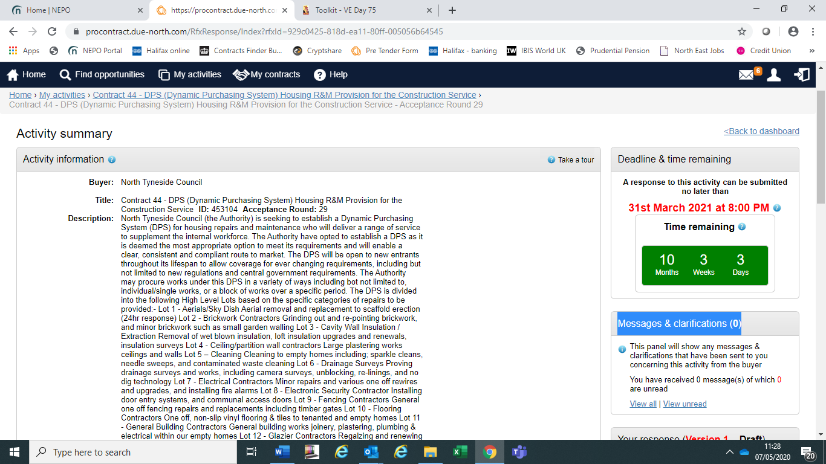

EXAMPLE ONLY

