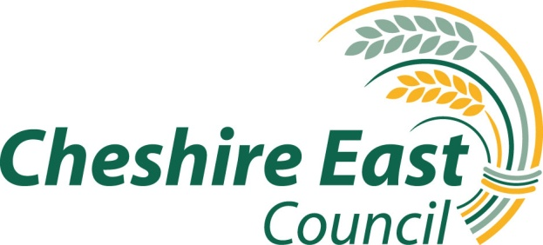

SPECIFICATION FOR THE PROVISION OF GENEALOGY SERVICES

PERIOD: 9TH SEPTEMBER 2020 – 8TH SEPTEMBER 2025

CHEST REF: DN480280

INTERNAL REF: 20 065

© 2020

Copyright – Cheshire East Council - All rights reserved
No part of this publication may be reproduced,
stored in a retrieval system or transmitted
in any form or by any means electronic,
mechanical, photocopying, recording or
otherwise without the prior written permission
of the Council

INTRODUCTION
Version 1.1

Author Nick Kelly
Date 30th April 2020

Cheshire East Council has a statutory duty, under the Public Health (Control of Disease) Act 1984, to provide suitable funeral arrangements for anybody who has died within the Cheshire East area and where there is no one else prepared to make suitable funeral arrangements. In addition, to public funerals the Council also acts as financial advocates for a number of vulnerable residents of the borough and when they pass away there is a requirement to ensure their estate/assets are passed to those entitled to inherit and as part of the Council’s debt recovery process from estates.

Currently the council deals with approximately 20 to 40 referrals per year, however these numbers vary and no assurances can be given with regard to actual numbers of genealogy searches which will be required in future years. As part of this service, the Council must attempt to trace any next of kin to determine if they will undertake the funeral and to pass on any estate/assets to those entitled to inherit.

PERFORMANCE REQUIREMENTS

- The contractor must be able to meet the requirements detailed below:

- When instructed by the Council, the contractor will undertake all searches for next of kin in relation to public funerals or other related services as required.
- Pass to the relevant team/service all information found relating to any next of kin.
- Pass to relevant team/service all information of any person who wishes to undertake the funeral arrangements for the deceased discovered during the search.
- Initial results passed to the relevant team/service within 3 working days of referral and keep them updated with all on going searches, whether successful or otherwise. Confirmation of the initial results to be supplied within 10 working days.
- Pass on all relevant documentation or information regarding any family, next of kin or friends, found as part of the search.
- Provide all relevant help, support and documentary proof to the relevant team/service when verifying and passing on estates to those entitled to inherit or referrals to the Treasury solicitor or equivalent
- Provide a breakdown of costs and disbursements for undertaking individual searches.
- The service shall be conducted in a dignified and professional manner at all times.
- The contractor shall ensure that adequate security is in place for storing of all data and assets gained as part of this contract, which must be retained for a period of at least 12 months.
- All data and assets gained must not be shared with any third party unless permission is granted by the relevant team/service.
- Provide missing beneficiary insurance for suitable cases
- In the case of Public funerals, the contractor must work with the Council’s appointed undertaker as required and if required provide relevant details to assist compiling the eulogy.
- When required, to assist any relatives or next of kin with undertaking funeral arrangements and with the costs of the funeral.
- Over see all house clearances as required to check for any relevant documents or assets.
- Provide advice and assistance as required to the Council or entitled relatives.

CONTACT(S)

Nick Kelly (Environmental Protection Team Leader) – Regulatory Services and Health
Amanda Peters (Social Work Support Officer Money Management & Deferred – Social Care Business Support & Finance) – Adult Social Care & Health

